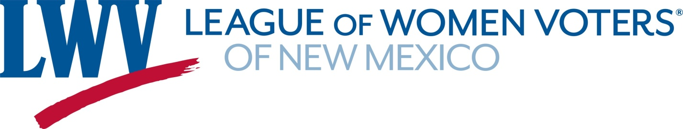

Legislative Priorities for the 2021 Legislative session

Tax Reform & Funding – Making our tax system fairer and generating revenue. That includes tapping the Permanent Fund to fund early childhood programs.
LWVNM believes that the tax system should be progressive and equitable, taking into consideration relevant differences in annual income. The tax system should generate adequate revenue to meet essential needs. Also, LWVNM believes that the Legislature should consider new progressive revenue generators. Although regressive, the LWVNM may support “sin taxes” if they achieve a socially desirable goal.
Reproductive Rights – Decriminalize Abortion & other legislation
The League of Women Voters believes that public policy in a pluralistic society must affirm the constitutional right of privacy of the individual to make reproductive choices. LWVNM supports legislation that acknowledges the need for reproductive health care and opposes legislation designed to eliminate access to safe and legal abortion

Redistricting reform New Mexico’s redistricting process
LWVNM supports a redistricting process and standards that provide the people with a meaningful choice in electing their representatives and facilitate holding government accountable.
The League will be supporting the recommendations of the New Mexico First Redistricting Task Force.

The LWVNM will be supporting some election law legislation. That includes legislation that builds upon some of the provisions of SB 4 that was passed in the 2020 First Special Session. Most of those provisions sunset on December 31, 2020. The LWVNM will be taking the lead a bill that would centralize and make public the GIS and other data used in elections. The LWVNM will also be supporting any legislation that is consistent with the LWVUS resolution on racial equity. The LWVNM will also be supporting natural resources and health care legislation that are consistent with our positions – see tracking sheet

