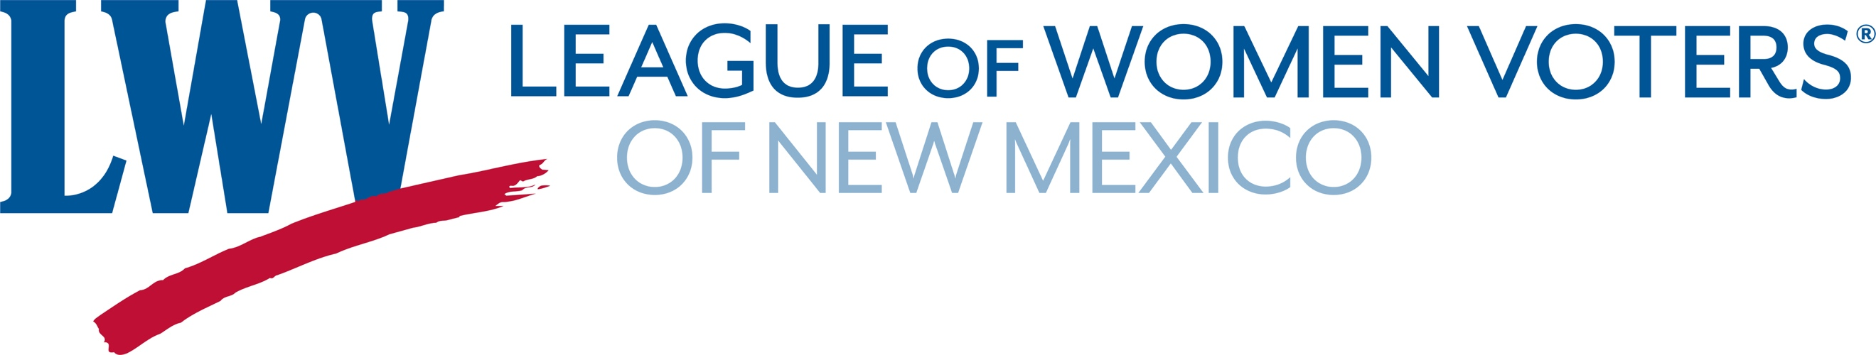
Legislative Priorities for Fairness, Finance, and Taxes 2023
Increase the Child Tax Credit

LWVNM believes that the tax system should be progressive and equitable, taking into consideration relevant differences in annual income.

As part of the overall tax package the LWVNM is supporting an increase in the Child Tax Credit.
This would make our overall tax system more progressive.

Policies like the Child Tax Credit (CTC) that boost economic opportunity for families are shown to reduce childhood poverty and improve outcomes for kids and their families. What’s more, they allow families to determine how best to spend the money based on their needs, and families spend the credits quickly and locally, benefiting businesses and the economy too. In addition, the CTC will increase racial, gender and income equity.
New Mexico recently enacted a new state-level CTC that will provide benefits to every single child throughout the state. Increasing the credit to an even more meaningful amount will only build on this progress and provide greater economic security to our families.

Some proven benefits include:
Improvements in infant and maternal health
Decreased poverty
Reduced childhood hunger
Better test scores
Higher graduation and college attendance rates6
More earning power as adults

Temporary expansions in the federal Child Tax Credit helped New Mexico parents meet the basic needs of their families. The credits were used to purchase basic necessities such as food and housing, and to pay off debt. That temporary expansion was not renewed. That is even more reason the state must continue to take the lead and ensure all New Mexico families can meet their needs and thrive.

Contact Information:
Richard Mason (505) 239-3804 act@lwvnm.org
Hannah Burling (505)603-1601 president@lwvnm.org

