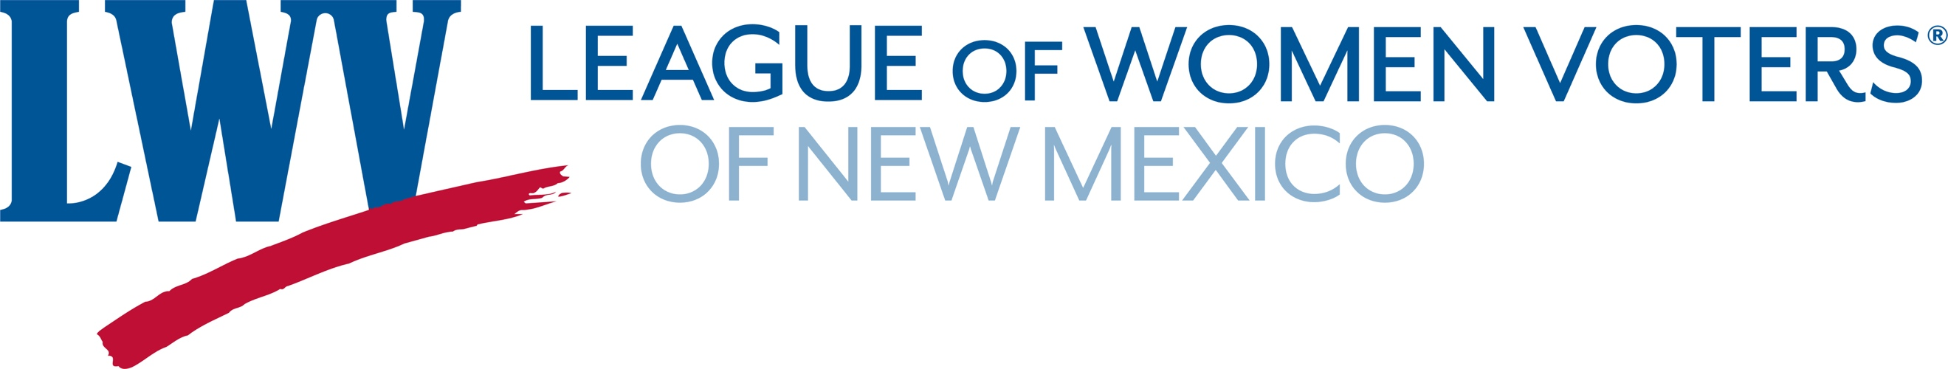
Legislative Priority – Redistricting Reform 2025
The League of Women Voters of New Mexico believes that responsibility for redistricting should be vested in an independent redistricting commission with membership that reflects the diversity of the population.

LWVNM supports a redistricting process and standards that provide the people with meaningful choices in electing their representatives and facilitate holding government accountable.
LWVNM supports: SJR9 Independent Redistricting Commission
Senators Natalie Figueroa, Leo Jaramillo, Michael Padilla, Antionette Sedillo Lopez,
Liz Stefanics and Representative Kathleen Cates
What would SJR9 do? If approved by the Legislature, it would put the question of creating an Independent Redistricting Commission on the 2026 general election ballot. The Commission would develop district maps for the New Mexico Senate and House. The responsibility for the developing the Congressional district maps would remain with the Legislature.
Let the Voters Decide
Why we need it: The 2021 Citizen Redistricting Committee (CRC) showed the value of a semi-independent redistricting entity. In a short time-frame, the seven-member CRC conducted more than 14 public meetings around New Mexico and provided three sets of recommendations for each set of district maps to be considered by the legislature. The CRC did an admirable job in a very compact period of time.
However, the CRC proposed maps were only recommendations. That means the legislators did not have to choose one of the CRC maps, but could create their own. Thus, they were able to choose their constituents rather than having constituents choose their legislators. The Legislature should approve SJR9 and provide voters the opportunity to vote for an independent redistricting commission. This would go a long way toward furthering public trust in government.
A 2022 poll by the UNM Center for Social Policy supports passage of SJR. According to the survey results, the public wants new redistricting laws. Seventy Seven percent (77%) of likely voters supported the creation of an independent redistricting commission. Only 12% opposed.
Contact:
Dick Mason 505-239-3804 fairdistricts@lwvnm.org
Hannah Burling 505-603-1601 president@lwvnm.org

