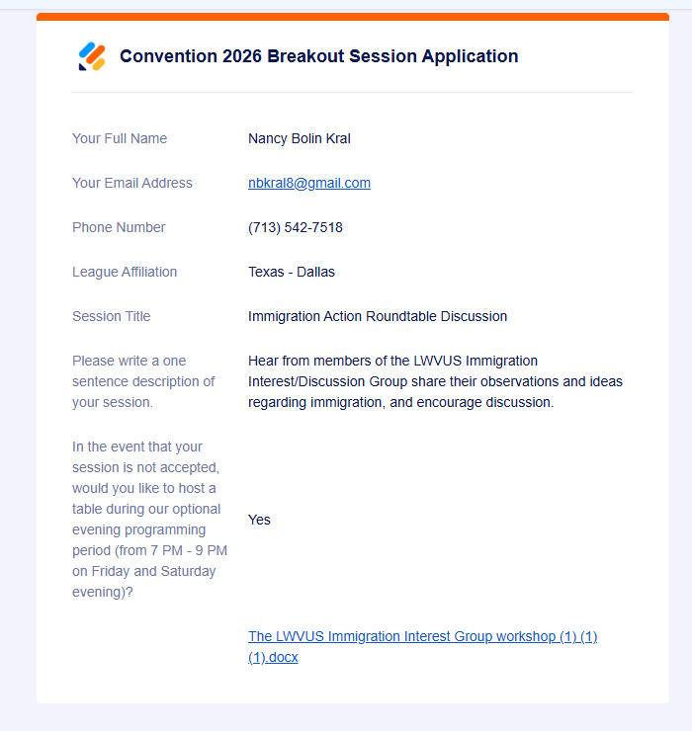

Submission: The LWVUS Immigration Interest Group submits a workshop session where group members will share with attendees their experiences and observations and discuss recommendations to protect democracy as it relates to immigration.
The following League of Women Voters chapters are co-sponsors:
LWV Illinois
LWV New Mexico
LWV Colorado
LWV City of New York
LWV Houston
LWV Dallas
LWV Pasadena Area (CA)
LWV San Diego
LWV San Juan Islands (WA)

I. A Detailed Description of What the Session is About.
Session Title: A Conversation about Immigration
We intend to have a roundtable discussion moderated by Jane Andrews, LWV-San Diego and speakers by Kim Reed, LWV-Illinois, Laura Quigg, LWV-New York City, and Nancy Kral, LWV-Texas. They are members of the LWVUS Immigration Interest/Discussion Group Leadership Team, all from areas deeply affected by large numbers of immigrants, ICE/CBP, and questionable immigration enforcement practices.
The speakers will present updated information about issues and concerns regarding due process and legal accountability for all persons in our immigration justice system, including persons held in detention camps, and immigrants' access to healthcare. They will also share their personal experiences working with immigration in their states.
After a brief presentation, attendees will be encouraged to share pertinent information from their states and raise their questions and concerns about immigration policy.
II. An outline of the content
1. Observations and ideas about Immigrant and Immigration legislation
2. Observations and ideas about Immigrant and Immigration policies
3. Immigration Healthcare Issues
4. Current role of LWVUS: litigation, lobbying, partnering, communicating
6. Discuss what local and state leagues are doing, or can do, supporting LWV, immigrants, and their communities
7. Encourage attendees to share relevant information, questions, and where they could use assistance and guidance.
III. An explanation of why this session is of broad interest to other Leagues around the country.
Immigration and immigrant rights/justice are a core concern of many LWV members. We have seen increased focus in the United States regarding not just immigration and border crossing, but also how immigrants and their families live, work, and are integrated into our communities. We’ve also seen increased concern for how immigrants and community members are treated by immigration enforcement processes.
Additionally, since LWVUS is now partnering with LULAC, it seems appropriate for us to discuss Latin Americans, and others, immigrating to the United States. Finally, protecting the rights of everyone, including immigrants, is a key pillar for the recommended program “Women Defend Democracy: Democracy Under Siege.”
IV. An explanation of how this session fits into the Unite & Rise 8.5 framework.
Unite & Rise 8.5 begins with the principle that voters can and should seek to bring about change through nonviolent protest. We’ve seen many protests involving immigration rights, frequently met with shows of government force and lack of due process. This threatens our democratic values and lays bare the Constitutional Crisis that exists.
The Commitment to Action includes addressing the many perceived constitutionally unlawful actions toward people taken by ICE and border patrol. In addition, many voters are immigrants and some citizens live in mixed status households. There is often fear in voting, so the goal to Protect Equal Voting Rights is also pertinent.
Much immigration enforcement involves imposing federal authority over states in ways that arguably conflict with states’ rights as spelled out in the Constitution, so the principle that we should Oppose Federal Interference in DC applies here.
Finally, United and Rise 8.5 states explicitly: Raise your voice about illegal deportations: join mobilizations around immigrant rights and due process with organizations.

V. A list of proposed speakers (Maximum of 5 people including yourself). Please confirm that all proposed speakers have been contacted and agreed to participate if the session is selected.
All four speakers have agreed to participate and enthusiastically hope to have this session selected.
Kim Reed, LWV-Illinois
Laura Quigg, LWV-City of New York
Nancy Kral, LWV-Texas
Jane Andrews, Moderator, LWV-San Diego

Thank you for your consideration.

