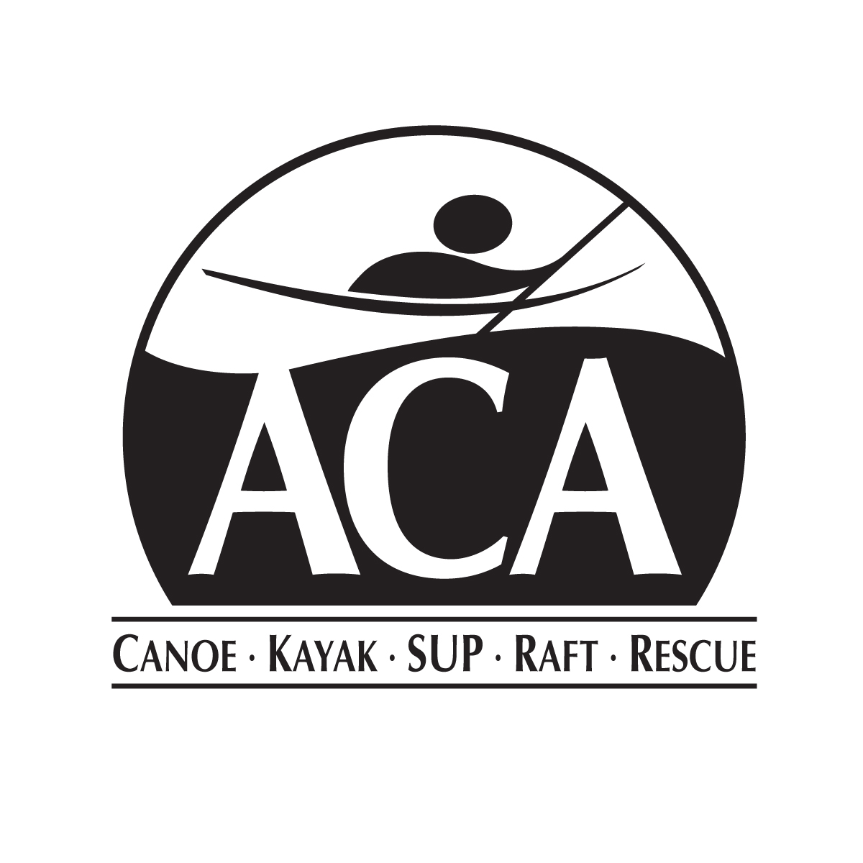
ACA | Canoe - Kayak - SUP - Raft - Rescue
503 Sophia Street, Suite 100
Fredericksburg, VA 22401
Phone: 540-907-4460
Fax: 888-229-3792

www.americancanoe.org

ACA Selects Christine Mollo as New Mexico State Director
05/20/2014
Albuquerque, New Mexico

The ACA officially launched its new volunteer State Director Program on March 14, 2014, when it began accepting applications for State Directors.

The mission of the State Director Program is to increase the effectiveness of the ACA at the state level by:

- Facilitating communication between paddlers and the ACA National Office
- Fostering community responsibility in protecting and preserving paddling environments
- Assisting others with acquiring the necessary skills to safely enjoy local waterways
- Promoting paddlesport competition at the local and state level

State Directors will have the opportunity to enlist additional volunteers in the form of an Executive Council to aid the distribution of responsibilities.

For more details, please visit: www.americancanoe.org/StateDirector.

Founded in 1880, The American Canoe Association (ACA) is a national nonprofit 501(c)(3) organization serving the broader paddling public by providing education related to all aspects of paddling; stewardship support to help protect paddling environments; and sanctioning of programs and events to promote paddlesport competition and recreation. The ACA has over 30,000 members and sponsors over 4,300 events each year, including 200 races. The ACA education program has an annual estimated outreach of 800,000 people. For more information, please visit www.americancanoe.org.

