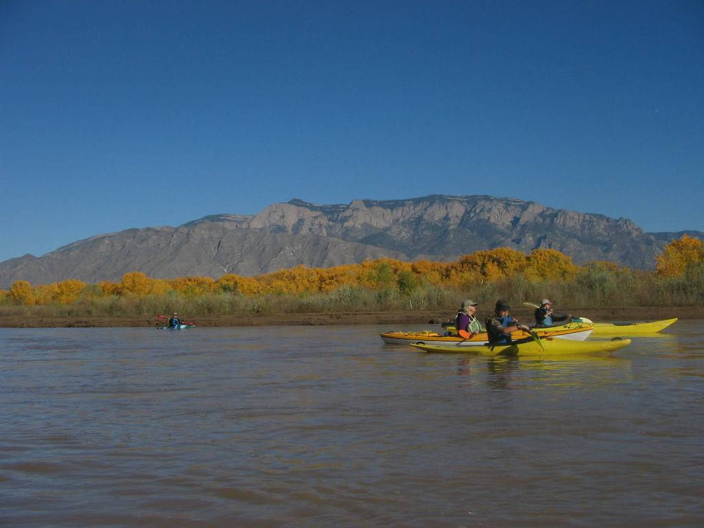

**Agenda:**

**4:30-5:30pm –register, select a seat, enjoy happy hour with live music, learn about each of the organizations, and bid on silent auction items**

**5:30-6:45pm – multicourse dinner, short program, and socialization**

**($20 adult $10 child +service and tax if registered by Nov 28; additional $5 adult /$2.50 child at door)**

**6:45pm and on - evening entertainment options include the water park (special discount), paddling movies (free), or socializing (free)**

*The Adobe Whitewater Club of NM, Greater ABQ/Santa Fe Kayak Meet-Up and Kayak New Mexico 501(c)3 invite you to:*

*New Mexico Paddlers’ Holiday Party*

*Saturday December 6, 4:30-10pm at Hotel Cascada in Albuquerque, NM*

*Register at AdobeWhitewater.org or Greater Albuquerque/Santa Fe Meet-Up*

Hotel Cascada has offered a special discounted room rate of $69 plus tax (vs. $125) the night of our party.  This rate is dependent on room availability and you must book as soon as possible. To make your reservation, contact Hotel Cascada at 505 888 3311 and reference the NM Paddlers’ Holiday Party.