JOIN US IN THE “ALBUQUERQUE RIDES” LEAGUE

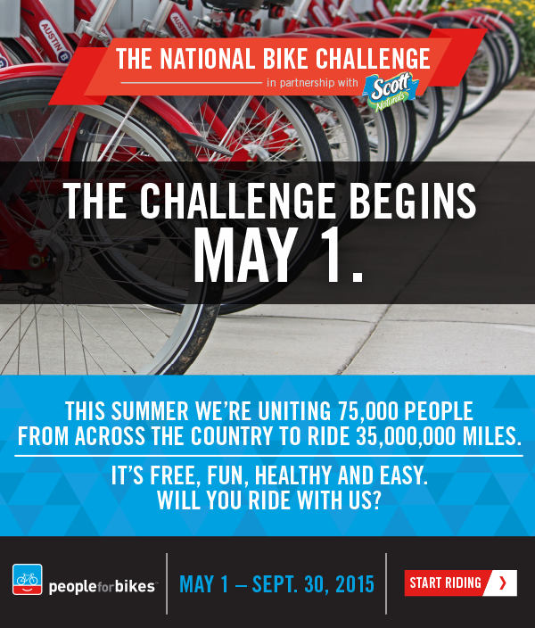

IT’S SIMPLE TO SIGN UP, CREATE A TEAM, AND JOIN THE LEAGUE

gO TO WWW.NATIONALBIKECHALLENGE.ORG

Once you have registered for the Challenge, you will be prompted to create or join a team. To join a team already in existence, type in the name in the search box to find it or create a team on the existing form. A team captain, the rider that created the team, has the option of making their team private or public, so not all teams are open to join. yOUR CHOICE. Leagues are created so that teams and workplaces may compete in additional categories. “aLBUQUERQUE rIDES” IS OUR LOCAL LEAGUE. CLICK ON SEARCH FOR A LEAGUE AND JOIN “ALBUQUERQUE rIDES”.

