Time Trial bike for sale size medium, cranks 172.5 chainring 55-42
Transition Expert Carbon, Ultregra 10 speed, wheels Mavic.
With Quarq power meter $1600. With no Quarq - $1100

Quarq power meter $750

Wheelset - Front Zip 1080 tubular and Renn disk rear (10 speed) $1200
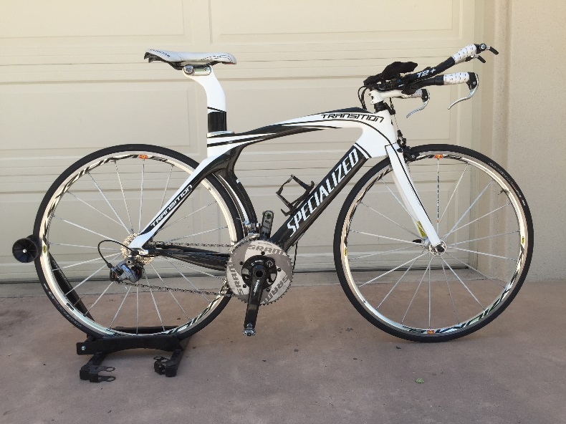
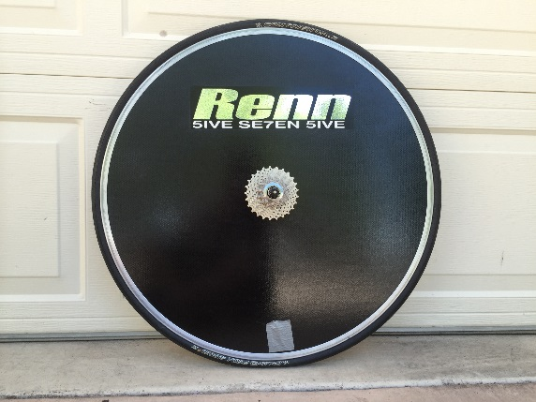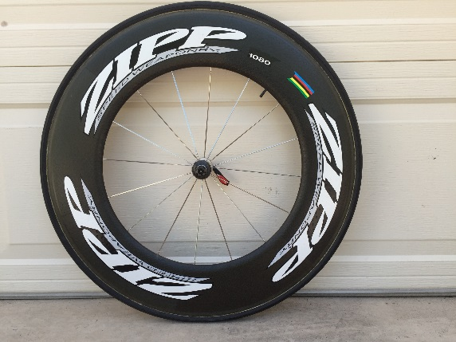
Contact Tony Pachelli 239-3853

