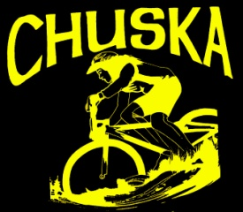

22nd Annual Chuska Challenge
Weekend Schedule of Events – October 14-16, 2016

All events are based in the Chuskas, west of Red Valley, Arizona on Navajo route 13, about one mile east of Buffalo Pass. Camping is available on campus both Friday and Saturday night.
The proceeds from the silent auction, raffle and donations benefit NavajoYES’ bike initiatives in communities across the Navajo Nation.

Camping available both Friday and Saturday nights.
Saturday, October 15
- Breakfast and rider registration/check-in, 7:00-9:00 a.m.
- Race begins at 9:00 a.m.
- Ride begins at 10:00 a.m.
- Lunch and hearty aid stations along the route
- Dinner, 4:00-7:00 p.m.

- LIVE MUSIC STAGE!!
  - DJ Ray Paytiamo, 12:00 -2:00 p.m.
  - Ethnic Degeneration – native metal sound from Kayenta, 2:00-4:00
  - Martin Sisters – traditional and contemporary sounds, 4:15-4:45
  - Gary Elthie – hand drum, 5:00-5:30
  - Razor Saltboy – folk and blues from the Chuskas, 5:45-6:30
  - Larry King – Navajo storyteller, 6:30-7:00
  - Talibah Begay – Dine’ recording artist, 7:00-8:00
  - Jimmy Keith – native flute, 8:00-
Sunday morning breakfast for all campers, between 8:00-9:00 a.m.
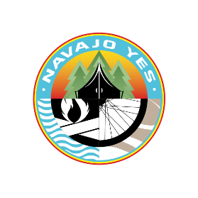
www.navajoyes.org cell: 928.429.0345 facebook.com/NavajoYES

