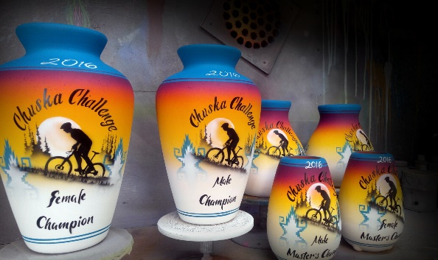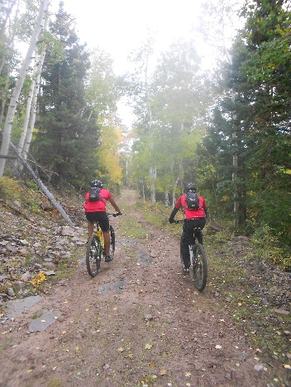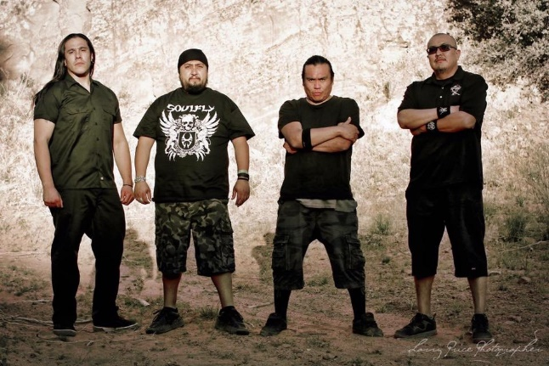
Chuska Challenge Mountain Bike Festival
Saturday, October 15 - Chuska Mountains (one mile east of Buffalo Pass)
Race – 9:00 a.m. Tour – 10:00 a.m. Ethnic Degeneration – 2:00 p.m 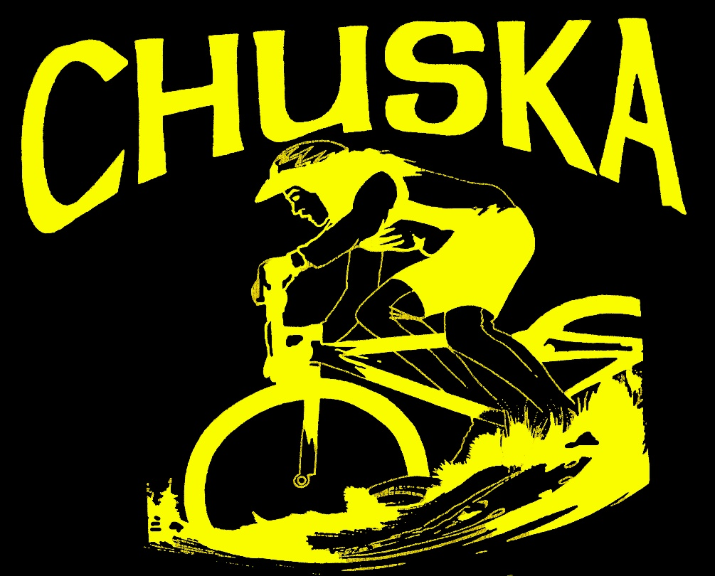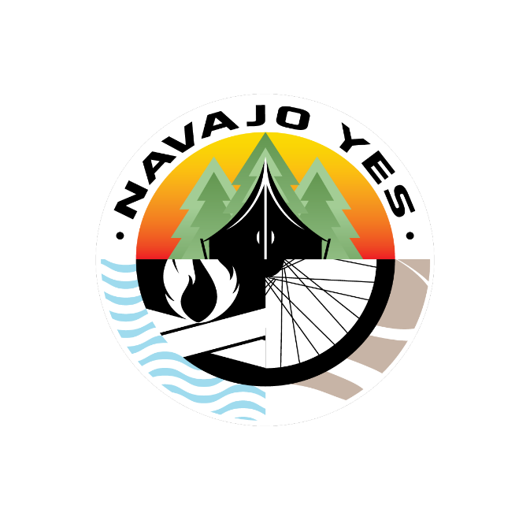
LIVE MUSIC STAGE!! Martin Sisters, Razor Saltboy, Talibah Begay, Jimmy Keith & Dine’ storteller Larry King
Plus Navajo Code Talker John Kinsel, Sr. & World-class adventurer “Doom” - - - - Camping available both nights
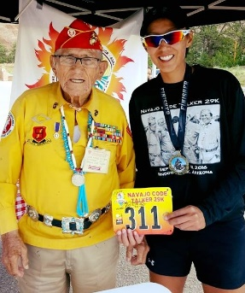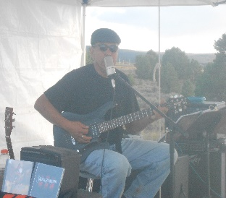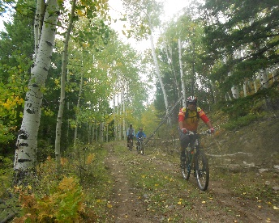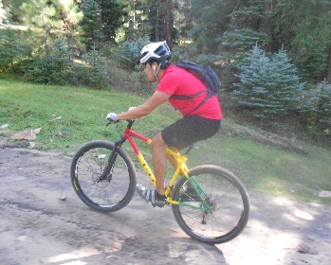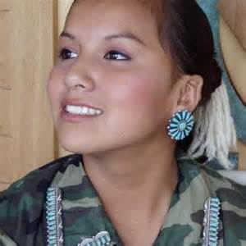
INFO: 928-429-0345 chuskaman@yahoo.com REGISTER: www.navajoyes.org/bike-events/

