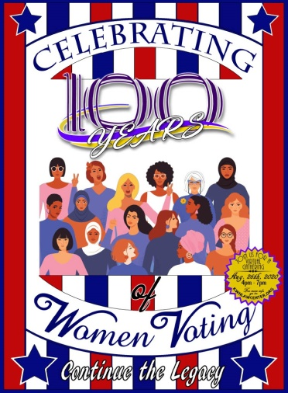

*Celebrating 100 Years of Women Voting*

*Wednesday, August 26, 2020 4:00 - 7:00 pm*

***

**A virtual event honoring the struggle for an inclusive democracy**

Links to Join the Event:

<https://youtu.be/sA4mqaSChFo>

<https://www.facebook.com/events/2433123916980590/>

Enjoy a tapestry of women standing together, showing the strength and power of their vote. An 18-year-old woman from each of NM’s counties will speak the first year they are permitted to vote along with a woman from each of the 50 states and D.C. briefly stating why they vote. One Native American, one Black, one Hispanic, and one White woman will share their history about the struggle to vote accompanied by songs from those cultures. Other performance pieces will honor the women’s vote. The program includes brief remarks by some NM women leaders--including Governor Lujan Grisham, SOS Toulouse Oliver, Supreme Court Justice Nakamura, Congresswomen Deb Haaland and Xochitl Torres Small. A new program that will help survivors of domestic violence access low interest loans will be launched. Martha Burk will speak on Economics, Women and the Power of Voting, and Olivia Friedman will read excerpts from her book, 2020 and Beyond, The Next Steps for Women.

***List of Sponsors***

City of Albuquerque

American Association of University Women (AAUW)

KWH Law Center for Social Justice and Change

League of Women Voters of New Mexico

Vote411.org (LWV’s online voter guide)

Planned Parenthood of the Rocky Mountains

Rape Crisis Center of Central New Mexico

NOWSantaFe

Bernalillo County

Santa Fe County

Gutiérrez-Hubbell House

McHard Firm

Omega Psi Phi Fraternity

Rio Grande Credit Union

U.S. Eagle Federal Credit Union

CU SAFE

Suffrage centennial week events and election information: <https://www.cabq.gov/culturalservices/the-womens-vote>

Please share information about our event widely! Get out the vote!

For more information, contact

Meredith Machen

League of Women Voters of New Mexico

[505-577-6337](tel:505-577-6337) c

[projects@lwvnm.org](mailto:projects@lwvnm.org)

**Empowering Voters - Defending Democracy**

Pamelya Herndon

KWH Law Center for Social Justice and Change

AAUW-NM/

(505) 385-4518

[pamelyaherndon@gmail.com](mailto:pamelyaherndon@gmail.com)

__

*"Right is of no sex. Truth is of no color." Frederick Douglass, North Star, 1847*

*"All men and women are created equal." Elizabeth Cady Stanton, Declaration of Sentiments, 1848*