## WHAT IS RANKED CHOICE VOTING (RCV)?

Ranked choice voting is a simple, but powerful, election reform that allows you to rank all candidates from favorite to least favorite. RCV promotes positive, inclusive and fair elections, which encourages a diversity of candidates and saves money by eliminating the need for run-off elections.

## HOW DOES RCV WORK?

On Election Night, first choice votes are counted to determine who voters like the best. If a candidate receives a majority of votes, they win. If no candidate receives a majority, the candidate with the fewest first-choice rankings is eliminated. If your favorite candidate is eliminated, your vote is instantly counted for your next choice. This repeats until one candidate reaches a majority and wins.

## RCV ELIMINATES "VOTE-SPLITTING"

In RCV elections, you always get to vote for your favorite candidate, even if they don't have a good chance of winning. If your favorite candidate gets eliminated, then your vote immediately counts for your next choice. You can truly vote your conscience without worrying about wasting your vote. Ranking your 2nd, 3rd, and 4th choices will never hurt your favorite candidate. It simply amplifies your voice in the process.

## RCV INCREASES VOTER TURNOUT

Cities that have RCV elections, now including Santa Fe, have seen a steady increase in voter turnout. When voters feel their vote will matter, they turn out in greater numbers.

## RCV FOSTERS CIVIL ELECTIONS

In RCV elections, candidates often need 2nd and 3rd choice votes to win a majority of the vote. As such, they will ask for your first choice vote, but if another candidate is your favorite, they will also ask for your second and third choices. Candidates are not likely to get your second or third choice

vote if they have been engaging in negative "mudslinging" personal attacks against your favorite candidate.

## RCV ELIMINATES SEPARATE RUN-OFF ELECTIONS

With RCV, you don't need to show up to vote twice in the event of a runoff. Instead, you get an immediate majority winner in a single, higher-turnout election. This saves money by preventing the need to run a second election.

CHOOSE YOUR FAVORITE COLOR

**SAMPLE** RCV **BALLOT**

-

|  |  |  |  |
| --- | --- | --- | --- |
|  | 1st Choice 2nd Choice 3rd Choice | | |
|  |  |  |
| **PLUM** |  |  |  |
| **GOLD** |  |  |  |
| **TEAL** |  |  |  |

# -

-

HOW THE VOTES ARE COUNTED

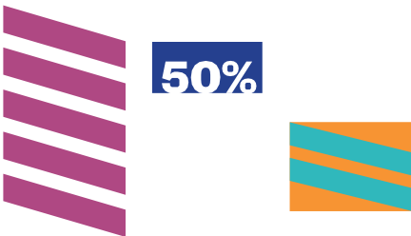

...·..=...

====

ml

ff:m

ml

GOLD HAS THE LEAST AMOUNT OF FIRST CHOICE VOTES.

GOLD VOTES ARE **ADDED** TO THE TOTALS OF EACH GOLD VOTER'S SECOND CHOICE.

WITH SECOND CHOICES ADDED, PLUM IS THE CLEAR MAJORITY WINNER.