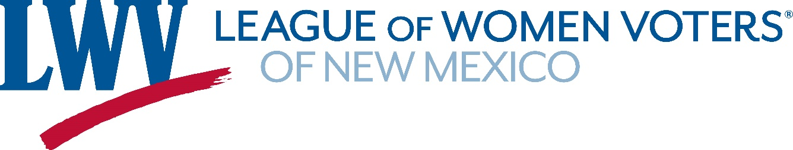

**News Release**

**VOTE411 Online Voter Guide Now Available**

The League of Women Voters of New Mexico has published a statewide online voter guide at [VOTE411.org](https://www.vote411.org/). League members throughout the state have worked hard over the last three months to contact every candidate in every race in New Mexico.

“We believe this is the only statewide effort to collect information from every candidate,” said LWVNM president Hannah Burling. “We have noticed that there are very few opportunities for voters to compare the positions of candidates in the smaller races. We think it is important for voters to actually read what the candidates have to say.”

Voter Services Director Judy Williams put together the complex effort. “We also have detailed information about the constitutional amendments, and local and state bond issues. There are many elements on this ballot and voters need to be prepared before they walk into the polling place.

[VOTE411.org](https://www.vote411.org/) allows voters to enter their address in the software. They will then see their candidates in both statewide and districted races, and have an opportunity to read how candidates answered a series of questions.

The [VOTE411.org](https://www.vote411.org/) software is used by chapters of the League of Women Voters throughout the United States. It requires candidates to submit their own photos and to enter their answers directly into the system. No one from the League edits answers in any way. Candidates also have the options to edit their answers as frequently as they wish. The LWVNM does not collect or keep voter addresses entered in the software.

Contacts:

Judy Williams (505) 920-7817

Karen Wentworth (505) 263-9066

Hannah Burling – (505) 603-1601

