Dear _____,

We are all familiar with, and have used, the Voter Guide published by our local League of Women Voters (LWVCNM), right?

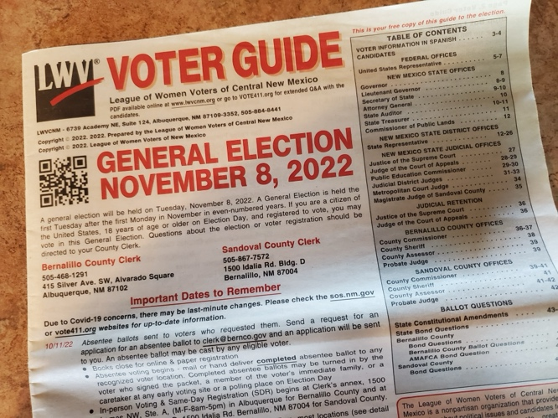

Well, they need $25,000 to print the hard copy for the general election in the fall.
Won’t you join me in the effort to raise the money? Just click on the link below to donate. Then please pass this message on. Be sure to include the link!

https://www.zeffy.com/en-US/fundraising/86d56404-5cdb-4056-8e9d-5544ff81adb6

We can do this!

____________

