**Sponsored by:** **For Students, Parents and**

**AlbuCORE- Caucus of Rank and File Educators**

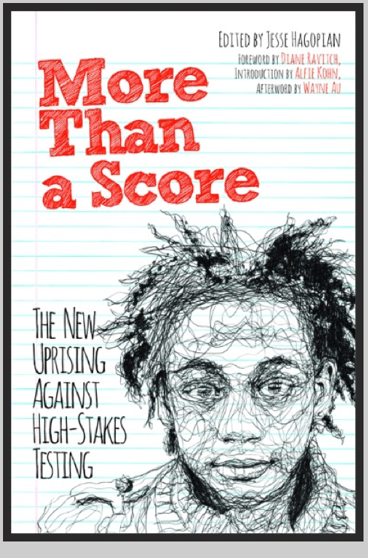

If So, Then Please Join Us

for a conversation about democracy in our public schools

with author & activist

**Jesse Hagopian**

WEDNESDAY, APRIL 13

4:00-5:30

ATF Union Hall

530 Jefferson St NE

Jesse Hagopian is a high school history teacher and associate editor for [*Rethinking Schools*](http://www.rethinkingschools.org/index.shtml) magazine. He recently gave a TEDx talk in Seattle and has appeared on *Education Nation* and *Democracy Now*. He is an advocate for alternatives to standardized testing and reframing the purpose of education. He led the test boycott in Seattle and recently published the book, *More Than a Score, The New Uprising Against High Stakes Testing.*

“Jesse brings parents, students, and teachers together for the greater good. He is a tireless advocate for his students and his coworkers. His voice is for social justice.”

–Bob George, Save Our Schools National Director

**Educators**

Do you wish there was more art, music and authentic learning in our classrooms?

Have you witnessed the loss of autonomy in our profession?

Have you wondered about the effects of high stakes testing on our students?

**Community Members:**

