February 4, 2021

HISTORIC PRESERVATION COMMITTEE REPORT:

The Nob Hill Neighborhood Association welcomes Steven Moffson, State and National Register Coordinator for the New Mexico Historic Preservation Division and Lecturer II at the UNM School of Architecture and Planning, who will host a **Zoom** meeting on **Monday February 22** at **6:30 pm** to explain a history project that is underway.  This semester, Professor Moffson is working with his UNM class in historic preservation to research and document the historic neighborhoods of University Addition, Granada Heights Addition, and Broadmoor  Addition of Nob Hill Albuquerque.  The final product will be National Register nominations that will be made available to the community.  Professor Moffson will introduce his students, describe the project, and the explain the National Register of Historic Places.  **Q&A to follow**.  We hope you can attend.

NHNA Historic Preservation Committee welcomes all interested Nob Hill residents to join our Historic Preservation Committee. Please contact Shani Madden [shanikm@me.com](mailto:shanikm@me.com) to find out how to get involved.

Neighborhoods listed on the State Register allow home and business owners to take advantage of the state’s historic preservation tax incentive program; this program allows for up to 50% of up to 50,000.00 in tax deductions for pre-approved historic preservation projects. Property owners in areas listed on the New Mexico Register of Historic Places have used these tax incentives on projects such as, sewer-main replacement, roofing, stucco and hardwood flooring We hope Nob Hilleños will continue the conversation and high regard for our historic neighborhood--imagine the possibilities!

Photos:

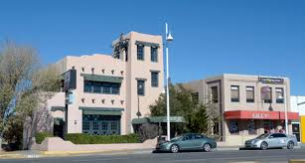

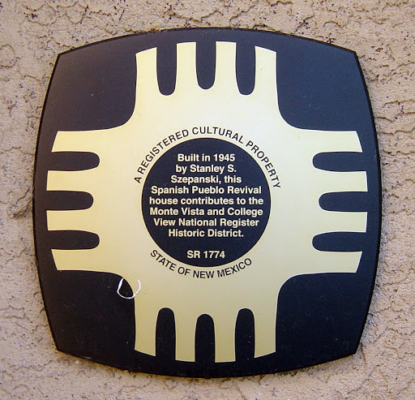

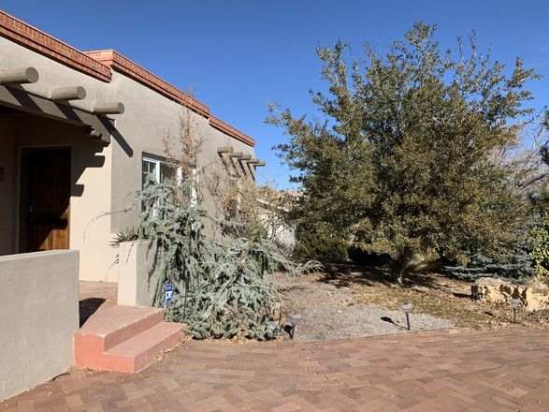

Shani Madden

Co-Chair Historic Preservation Committee