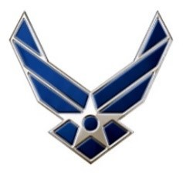
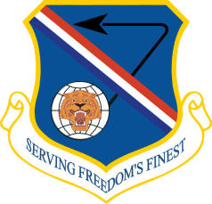
Air Force Press Release
377th Air Base Wing Public Affairs
2000 Wyoming Ave SE
Kirtland AFB, NM 87117
(505) 846-5991 377ABW.PA@us.af.mil

Release No. 25-03
Date: 28 January 2025
Kirtland Restarts Prescribed Burns
KIRTLAND AIR FORCE BASE, N.M. – Between January 29 to February 5, Kirtland will conduct prescribed burns in wildfire-prone remote areas of the base to reduce combustible plant material that could fuel potential wildfires.
Our prescribed burns are carefully managed under a multi-agency approach to maximize safety and effectiveness, while minimizing risk.
Prescribed burns will create smoke, but compared to wildfires, prescribed fires are shorter in duration and are conducted under weather conditions to minimize the public impact of smoke.
Fire crews start early in the morning and end ignitions early in the afternoon to allow for the most ventilation possible throughout the burns and divide treatment areas into smaller units to minimize limit smoke impacts. However, smoke may be visible from local communities until the burning vegetation is consumed.
KAFB has been conducting prescribed burns since 2018, directly reducing the chances of a wildland fire from occurring in areas that are vulnerable. The season typically begins in the fall and ends around spring.
-30-

Any questions, please contact the 377th Air Base Wing Public Affairs office at 505-846-5991 or by email, 377ABW.PA@us.af.mil.

