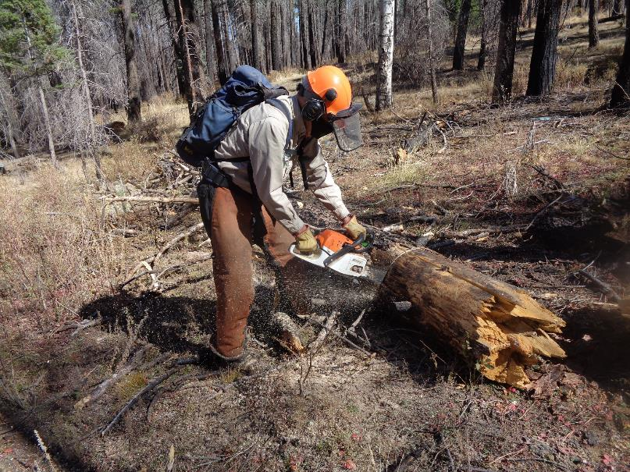

Sam Beard bucking a log on Ladera Trail on Los Griegos Mountain. Photo by Cliff Giles

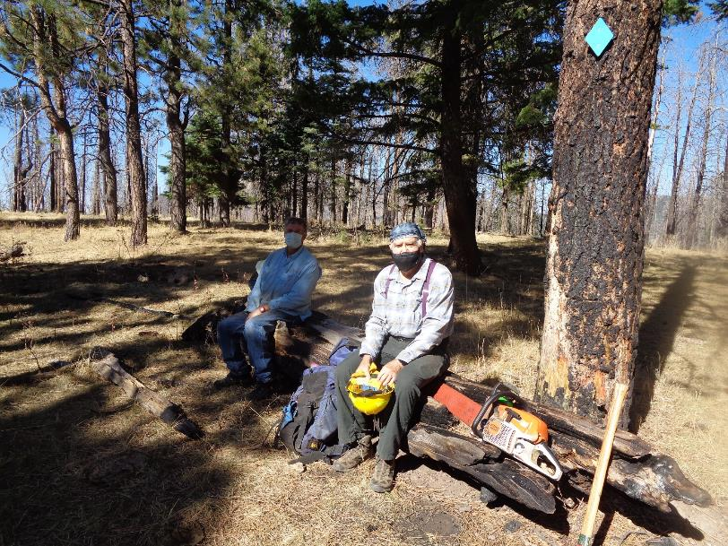

L to R: Dave Gabel and Cliff Giles sitting on the “lunch log” at Griegos Junction below the switchbacks on the upper mountain.

The surrounding forest and the lunch log were burned in the Cajete Fire several years ago. Photo by Sam Beard