**Report of Maintenance of Coyote Call Trail on the Valles Caldera National Preserve**

**on Saturday, October 31, 2020**

Sam Beard

New Mexico Cross Country Ski Club

November 3, 2020

On Saturday, October 31, 2020, eight volunteers completed fall maintenance of Coyote Call Trail on the Valles Caldera National Preserve (VCNP). They are members of either Los Amigos de Valles Caldera or the New Mexico Cross Country Ski Club. The group was divided into two teams – 3 volunteers in the crosscut saw team and 5 volunteers in the chain saw team.

1. Crosscut Saw Team – This team removed at total of 35 obstructions on the trail, fallen trees and trunks protruding into the trail corridor. The maximum log diameter cut with the crosscut saw was 12 inches. The diameter of many of the removed trees was 2 inches to 8 inches. These volunteers were Bill Savage (crosscut saw), Byron Garner (pruning saw), and Wendy Cox (loppers).
2. Chain Saw Team – The five volunteers in this team removed 20 down trees with the largest log having a diameter of 21 inches. In addition to removing down trees, this team removed a 16-inch hang-up over the trail with the top resting high in another tree. The volunteers on the chain saw team were Michael Arndt, Jim Counce, Dennis Crowther, Jerry Carroll, and Sam Beard.

The maintenance crew had the unusual benefit of several photos of down trees taken by Mike and Frances Meier who hiked this trail on Sunday, October 25. Some of these “before” photos are included in this document with “after” photos of the work done on October 31. Mike’s photos were used in planning the project. For example, we knew the diameters of several trees and decided to carry a Stihl MS-251 saw with an 18-inch bar and a Husqvarna Model 440 saw with a 16-inch bar.

The volunteers enjoyed working on the trail and appreciated the opportunity to work on the VCNP provided by Michael Hodgkinson, VCNP Facilities Manager.

Project photos are presented below.

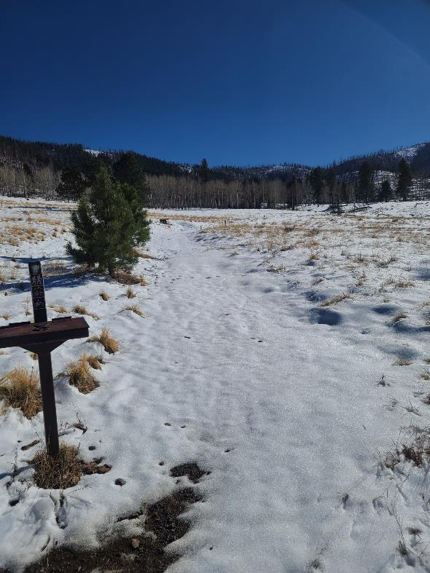

Jim Counce, who lives near La Cueva in the Jemez Mountains, took this photo of the snow

at Coyote Call Trailhead on Thursday afternoon, October 29.

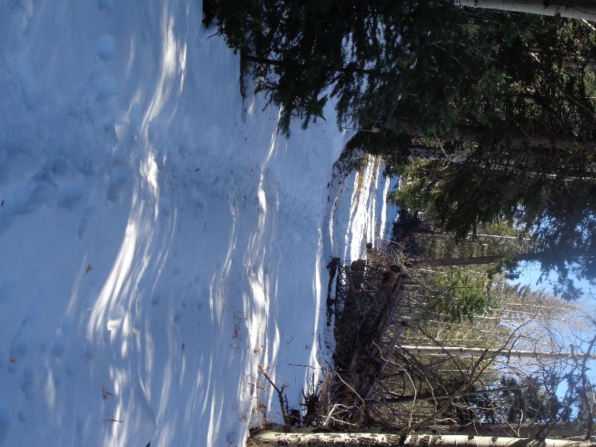

Snow on the lower level of Coyote Call Trail just above NM-4 on Saturday, October 31.

Photo by Sam Beard

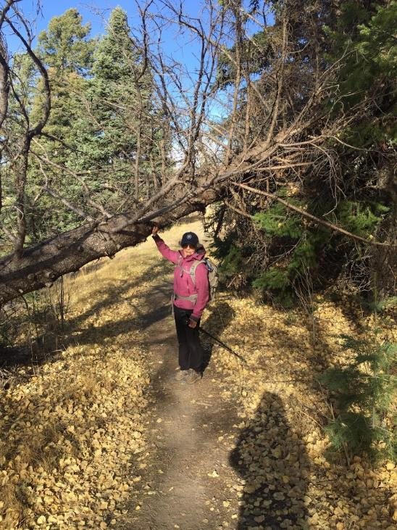

Mike Meier, Ski Club member who lives in Los Alamos, took this photo of Frances Meier

under a large hung-up tree on the lower level of Coyote Call Trail on Sunday, October 25.

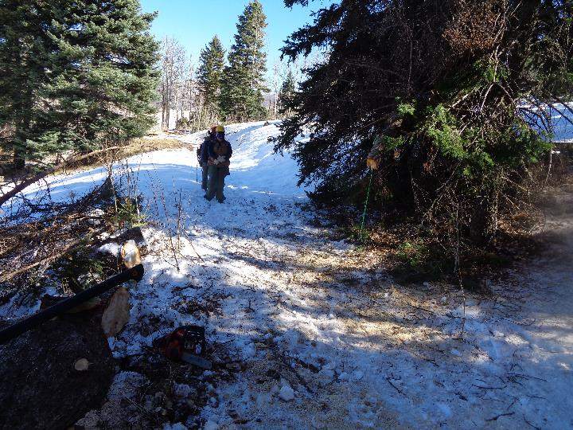

On Saturday, October 31, Ski Club volunteers removed the trunk of the hung-up tree in the preceding photo, but

two 6-foot long pieces of the trunk were still up in the tree in the upper right corner of the photo. Photo by Sam Beard

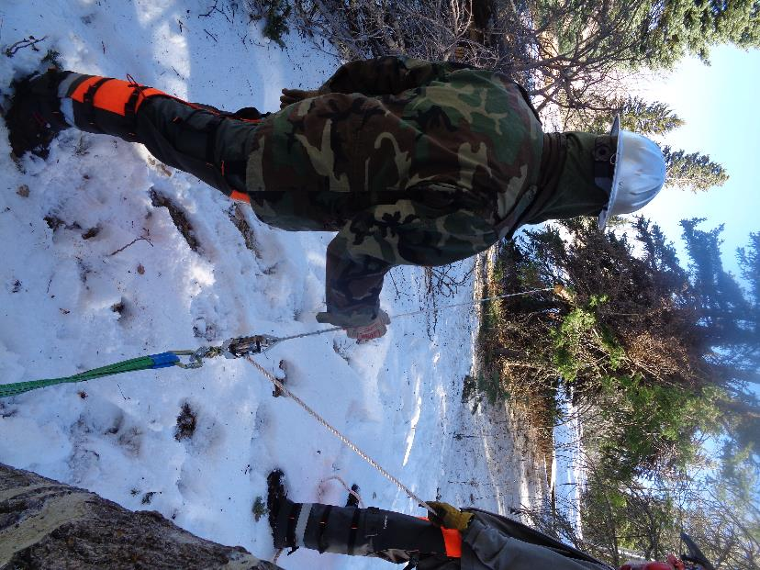

L to R: Michael Arndt and Jim Counce are using Michael’s rope hoist to safely pull the first upper trunk

piece down. Photo by Sam Beard

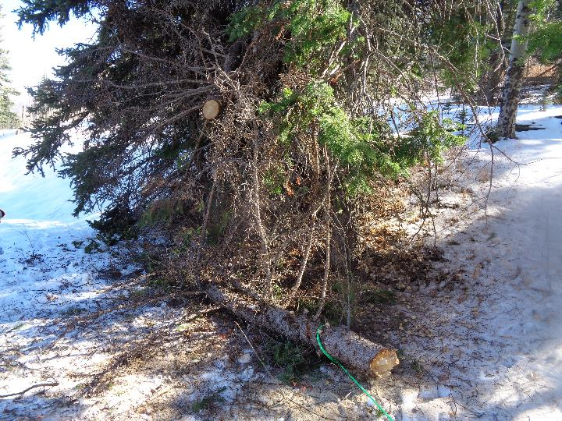

The first piece of the upper trunk is on the ground. Photo by Sam Beard

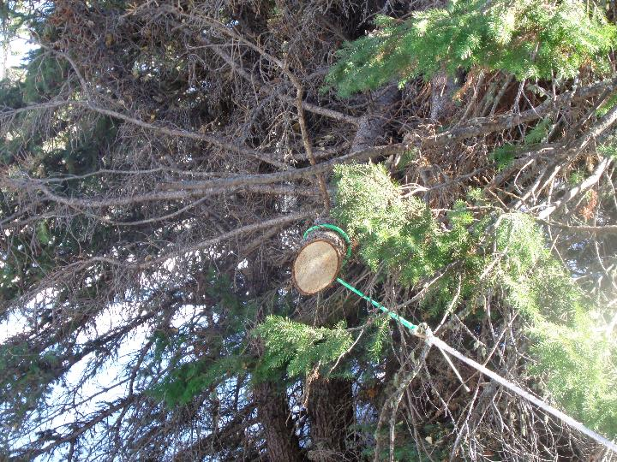

The second piece of the upper trunk is being pulled down. Photo by Sam Beard

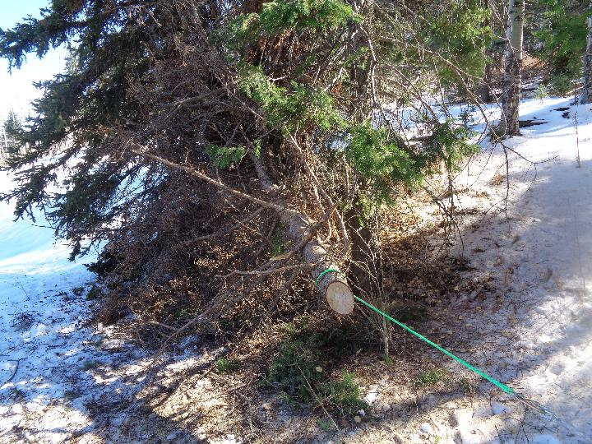

The second piece of the upper trunk is safely on the ground. Photo by Sam Beard

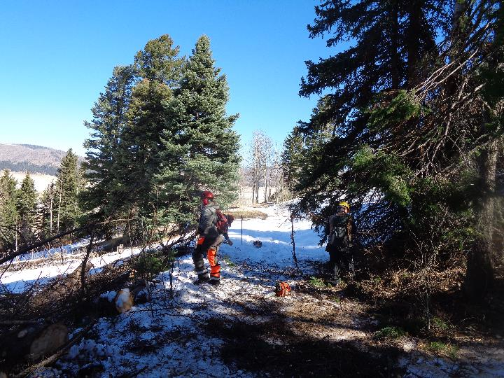

The tree trunk and the two pieces of the upper trunk that were in the tree in the upper right corner

of the photo have been removed, and this segment of the trail is safe for visitors. Photo by Sam Beard

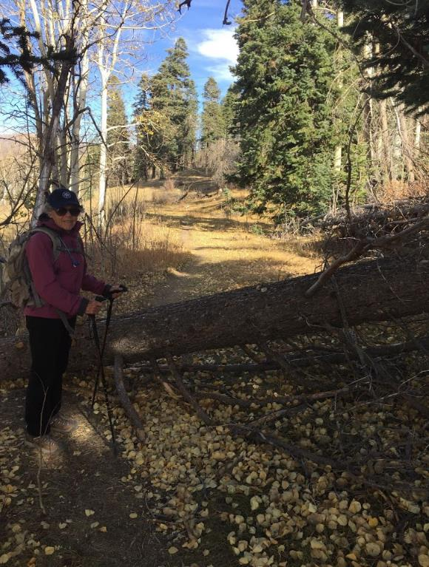

Frances Meier standing at a 12-inch diameter tree on the trail on Sunday before the snow storm.

This tree was a short distance east of the tree in the preceding photograph. Photo by Mike Meier

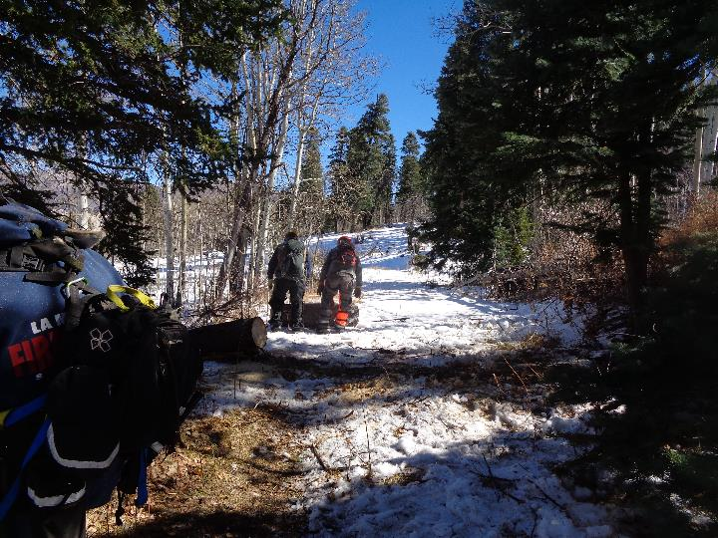

The tree in the preceding photo has been removed. Photo by Sam Beard

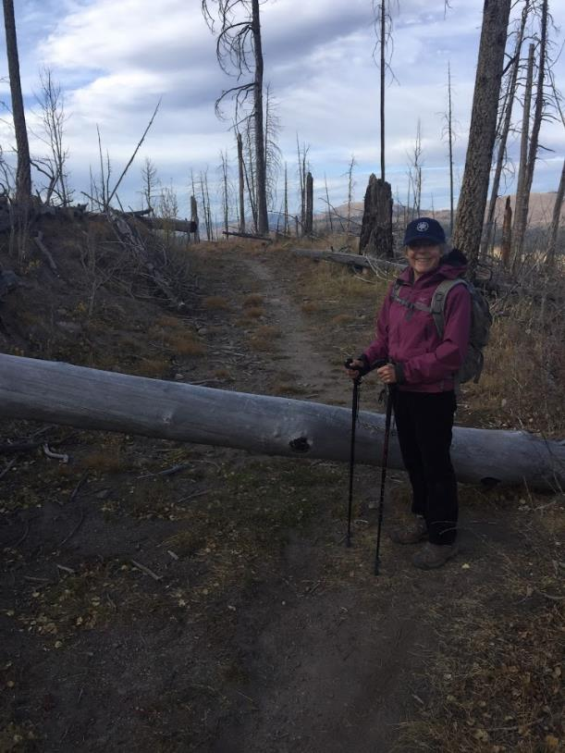

Frances standing at 10-inch diameter aspen on the upper level of Coyote Call on Sunday. This log

was a short distance west of the curve in the trail in the saddle between Rabbit Ridge and Scooter Peak

where we usually eat lunch on ski tours. Photo by Mike Meier

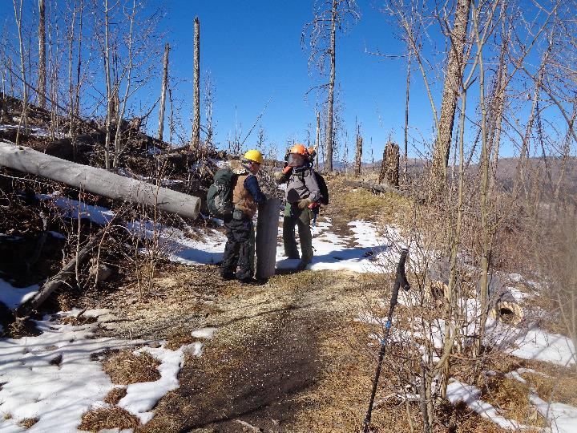

L to R: Dennis Crowther is moving a piece of the log in the preceding photo after Jerry Carroll cut the it

with his chain saw. Photo by Sam Beard

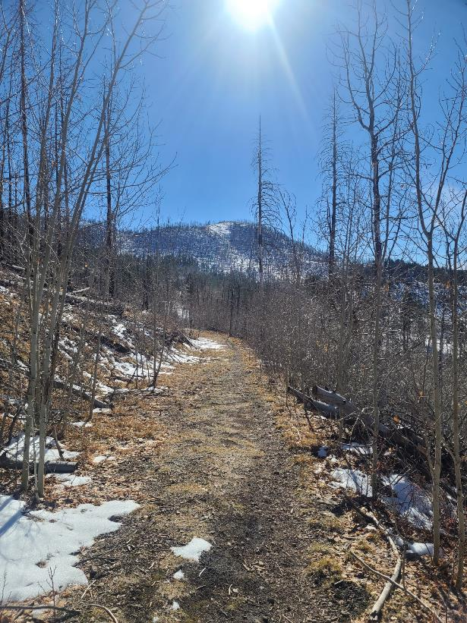

A segment of the upper part of Coyote Call Trail where direct solar radiation has melted all the snow.

Photo by Jim Counce

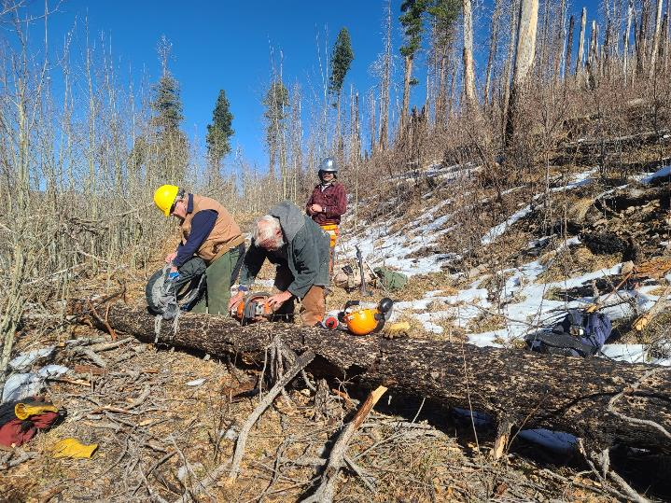

L to R: Dennis Crowther, Sam Beard, and Michael Arndt. Sam is preparing to refuel the Husqvarna chain saw before

bucking the log across the trail. Photo by Jim Counce

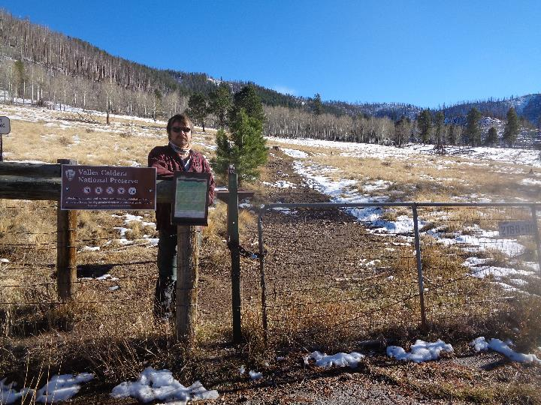Michael Arndt standing at Coyote Call Trailhead after we had completed the trail maintenance on Saturday.

Most of the snow shown in the first photo on Thursday has melted. Photo by Sam Beard