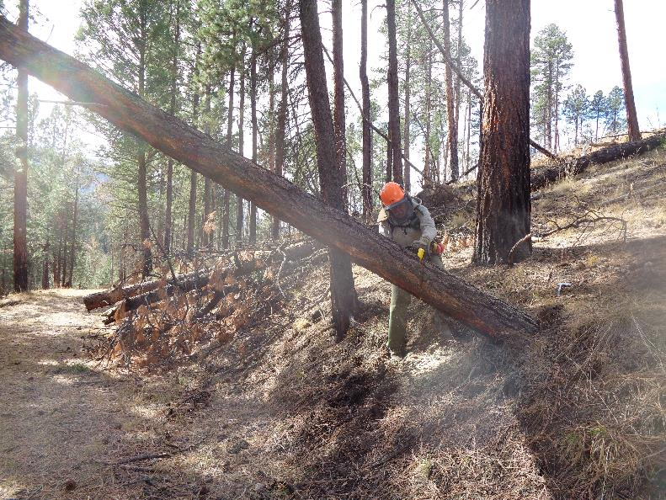

Jerry Carroll making the first cut in this 12-inch pine hang-up near the highway.

All photos by Sam Beard

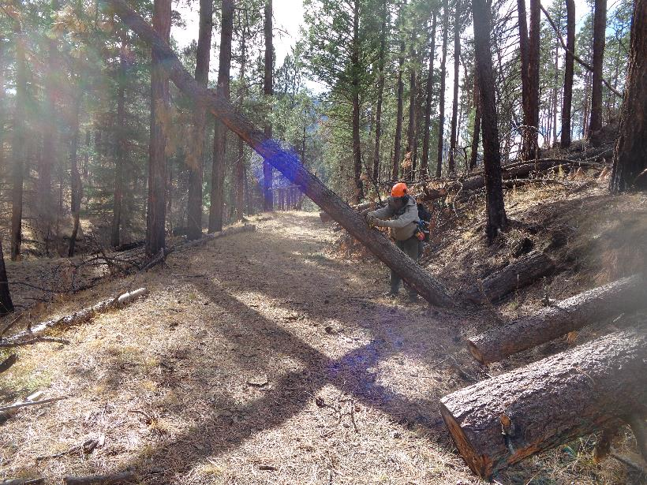

Jerry is making the third cut in the process of walking this tree cross the trail.

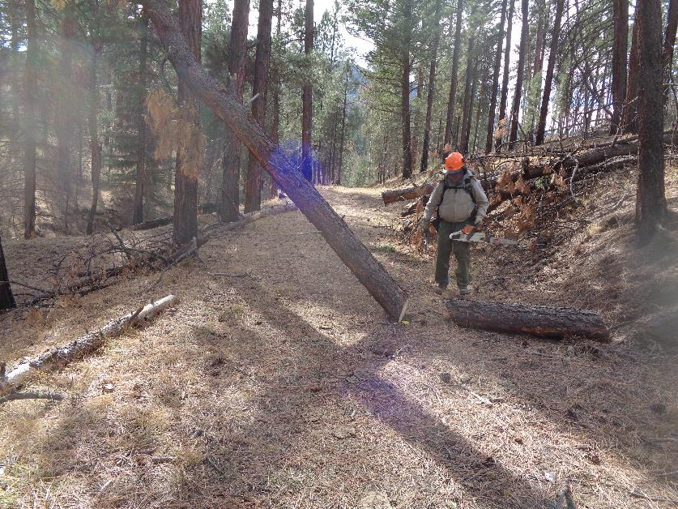

Jerry has “walked” the lower end of the tree farther across the trail.

Jer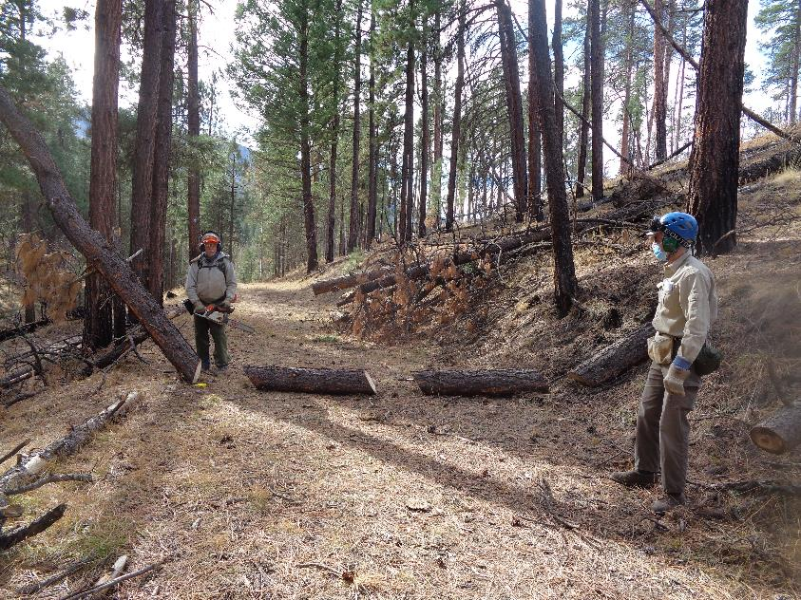

Jerry has successfully “walked” the lower end of the tree completely across the trial with three cuts.

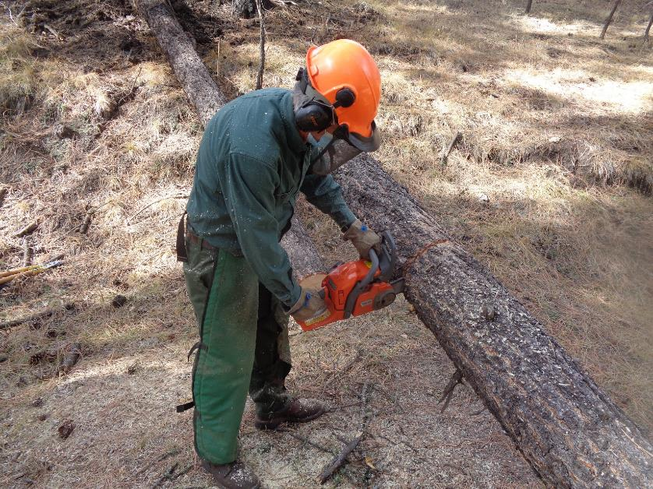

Bill Savage is making the first cut in this pine tree.

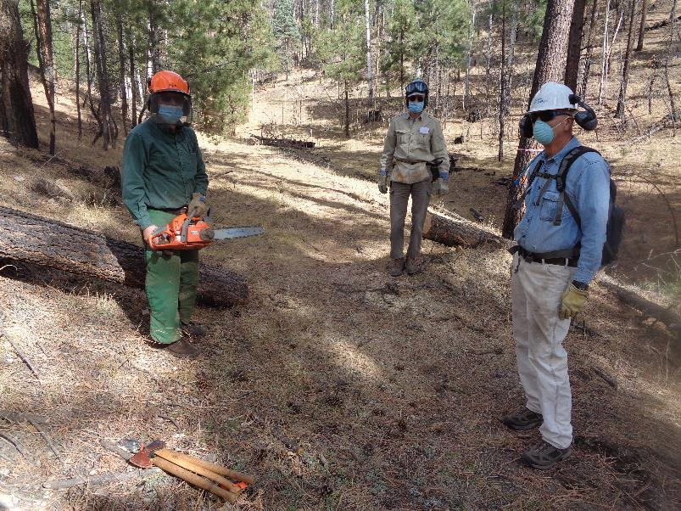

Bill make a couple of cuts in this 10-inch diameter pine and (L to R) Neil McCasland and Mike Meier moved the pieces off the trail.

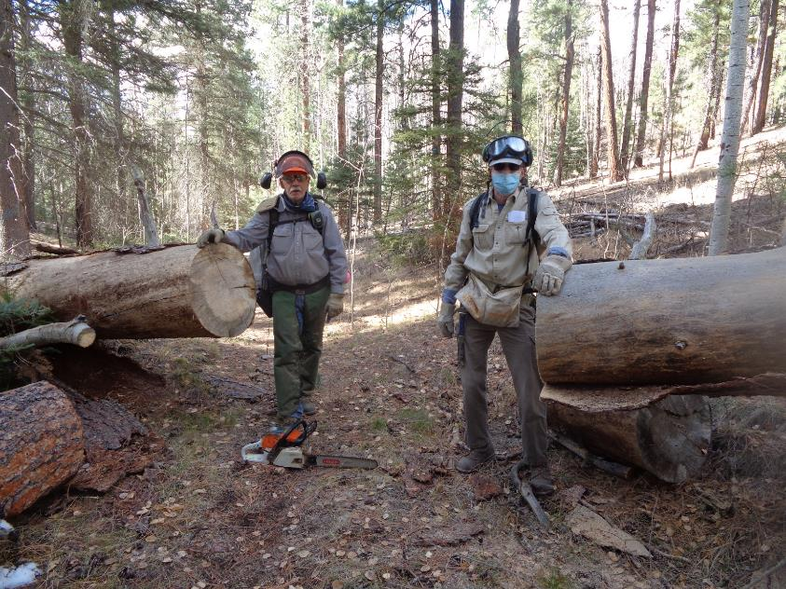

Jerry make a cut in this large log to make the opening larger for skiers going downhill, and Neil moved the piece off the trail.

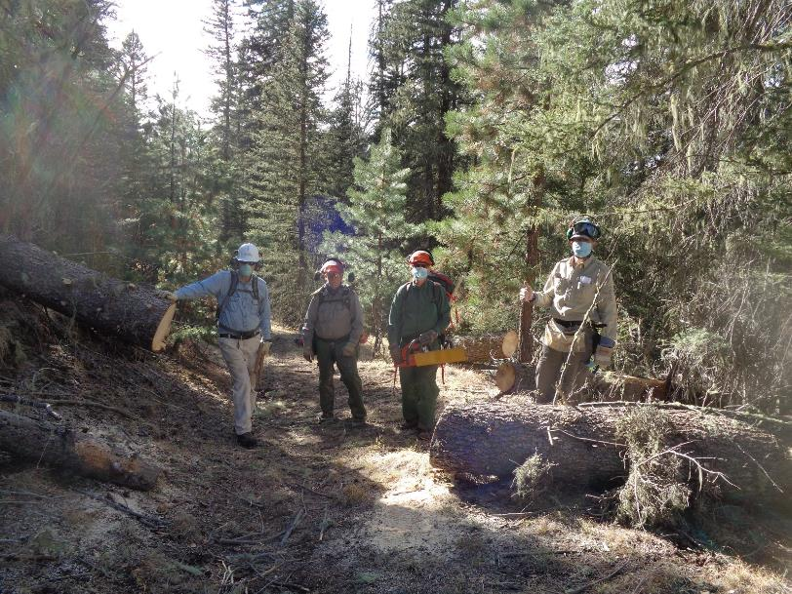

L to R: Mike Meier, Jerry Carroll, Bill Savage, and Neil McCasland removed a long piece from this 18-inch diameter log on the north side

of the loop Just west of the very large log that the Ski Club volunteers bucked several years ago when Carl Smith was working with us.

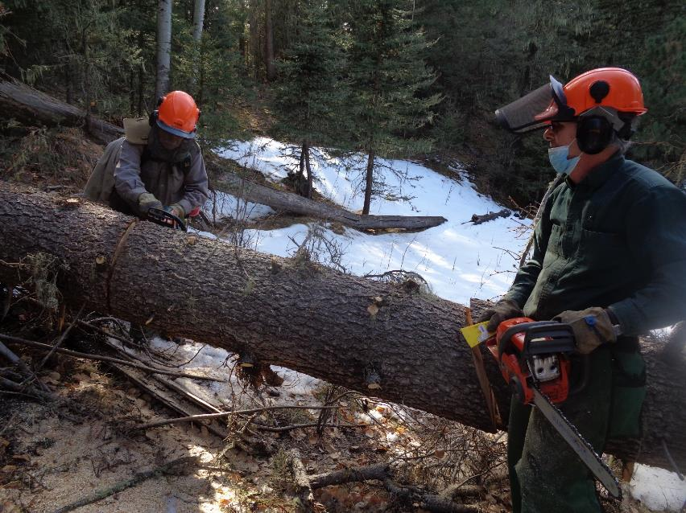

L to R: Jerry Carroll and Bill Savage. Bill has completed his cut so that the piece on the left will fall away from the remaining log on the right.

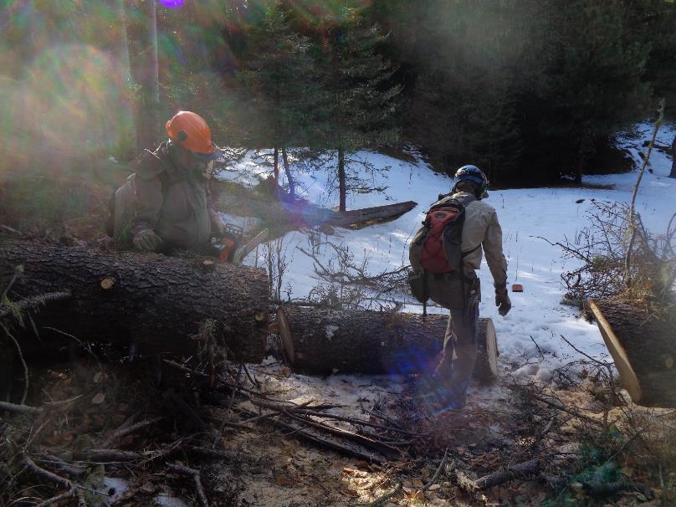

Jerry completed his cut, the piece fell to the ground, and Neil McCasland is rolling the log away.

This location is near the west end of the East Loop.

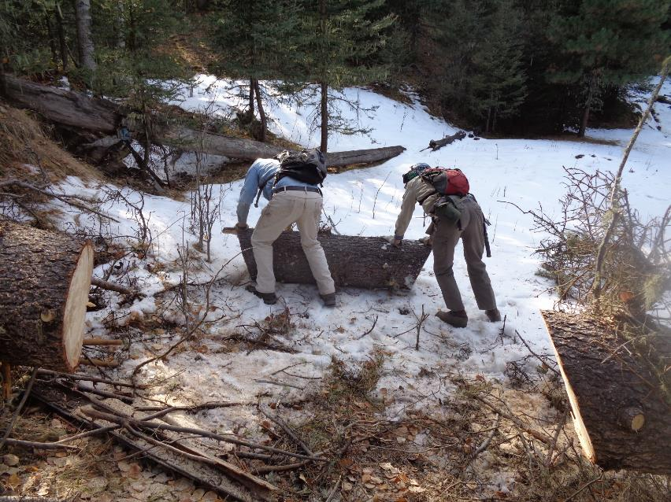

L to R: Mike Meier and Neil McCasland. They are moving the log off the path where Club members will be skiing.

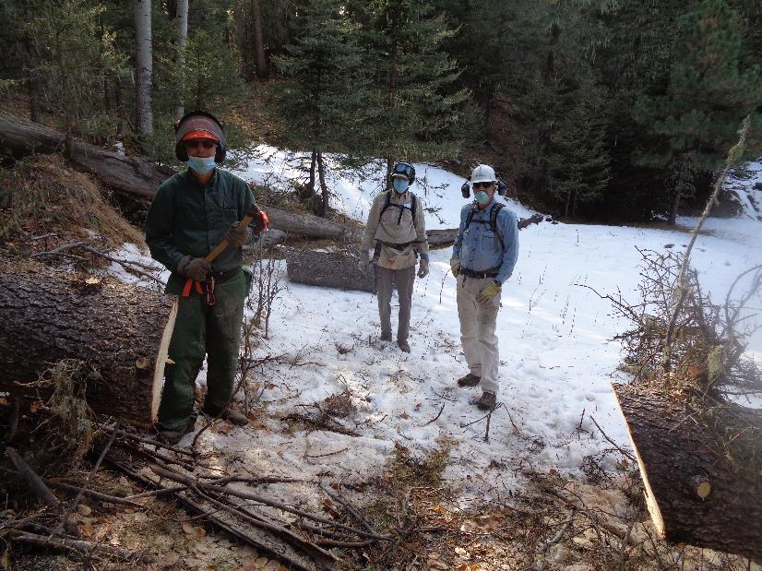

L to R: Bill, Neil, and Mike. The log has been moved out of the way of skiers. The snow here was about 4 inches deep on the north

side of the Loop and in the shade.