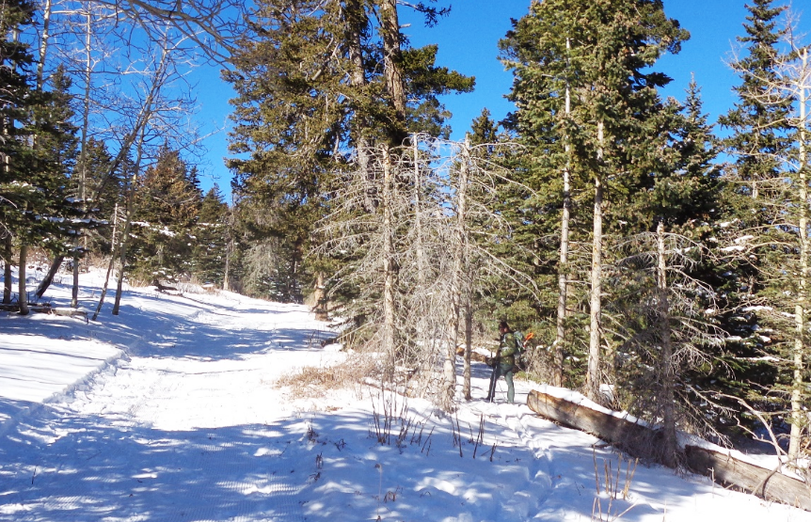

The ski trail groomed by the Sandia Nordic Ski Club is on the left. Michael Arndt at the upper end of the log is standing on an alternate ungroomed route

that leads about one-quarter mile to Sam’s/Kerry’s Trail to the west. This area is directly south of the 10K South Trailhead.

All photos by Sam Beard

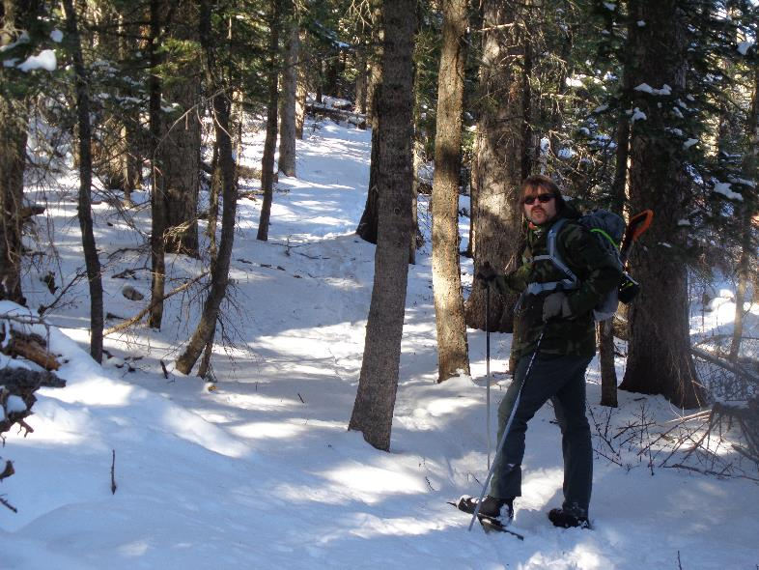

Sam’s/Kerry’s Trail is a narrow ungroomed one-half mile trail that is in the forest parallel to the Crest Highway. From the 10K South

Trailhead, it goes uphill and leads to the upper meadow at the first highway switchback below Ellis Trailhead. In Kerry Wood’s Master

Trail Plan for this area, Challenge Trail would be moved to this route so that it would not go through the groomed area.

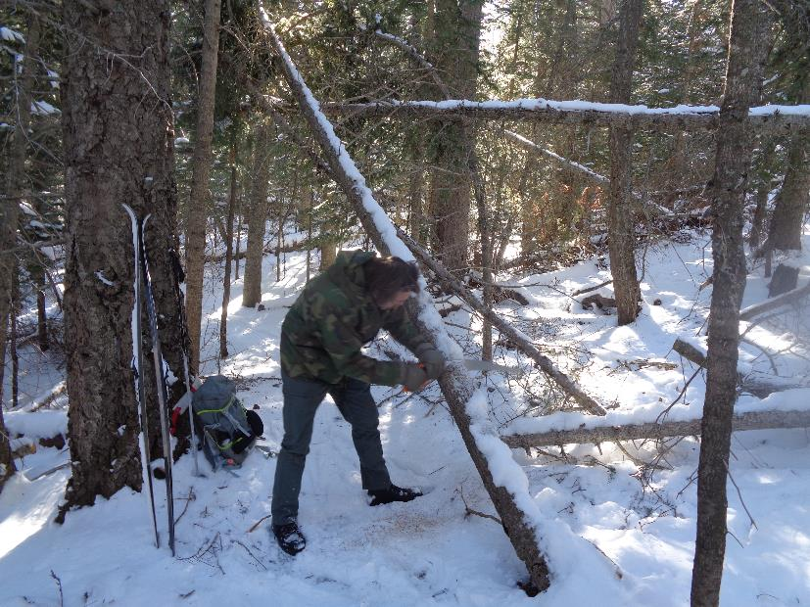

Michael is moving a small hang-up from the trail.

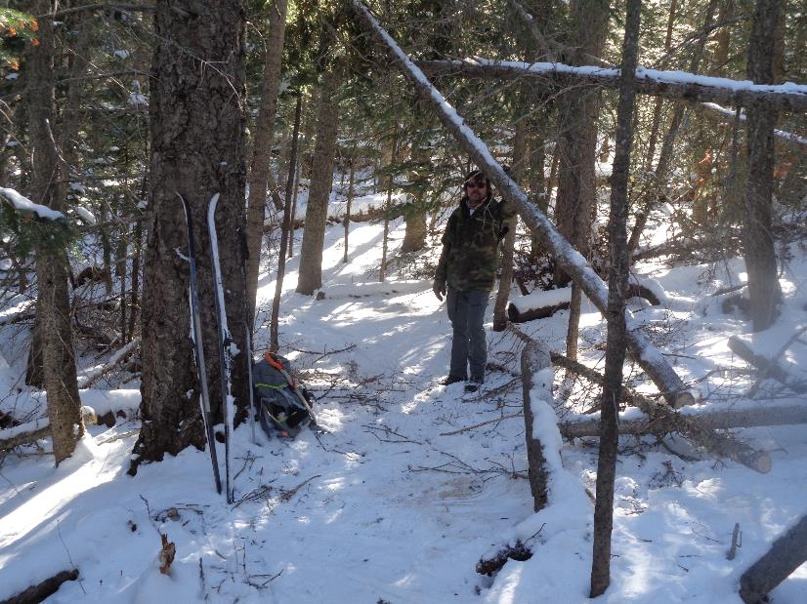

The trail is now clear.

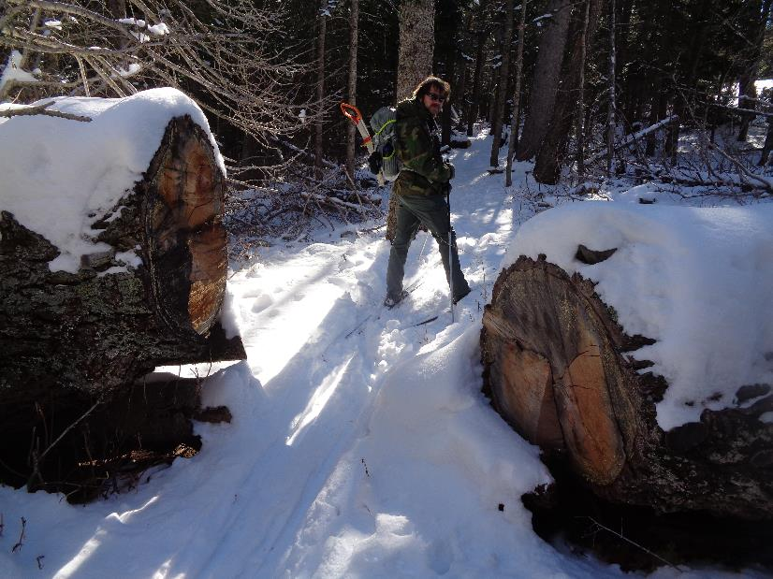

This log is the “Large Log” on Sam’s Trail that was cut with a chain saw several years ago. It is one of the largest logs that Ski Club

volunteers have ever cut.