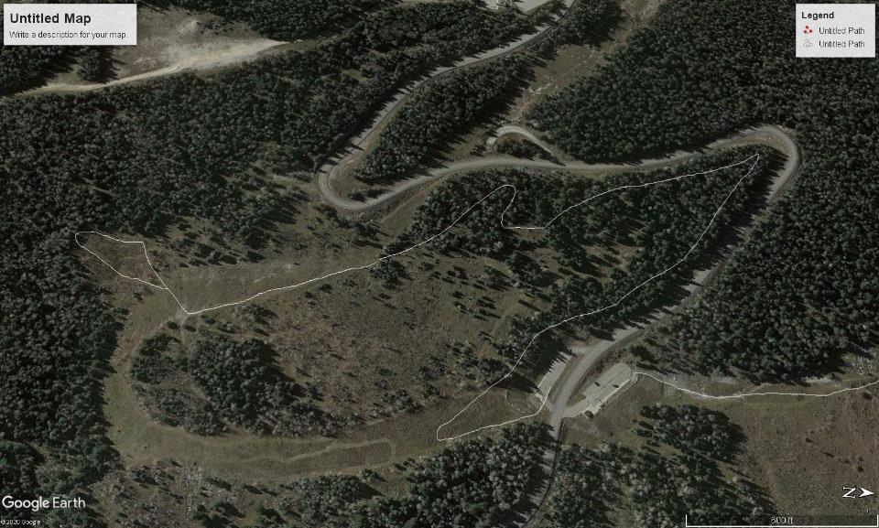

The narrow white line is approximately the route that Michael Arndt and I skied on Sat., Dec. 5. The part of the route in the forest is Sam’s/Kerry’s Trail. I rotated the Google Earth Satellite photo 90 degrees clockwise in order to show the 10K Trailhead parking clearly. North is to the right. From the 10K South parking lot, we went to the south up into the meadow and turned to the right (NW). We started skiing on S/K Trail when we entered the forest with a groomed trail on our left. We followed the white line in the forest parallel to the Crest Highway to the meadow in the center of the photo and the end of S/K Trail. We skied south along a groomed trail and turned to the right (SW) into an aspen grove. We made a loop in the aspen grove, skied back to the groomed trail, and followed S/K Trail back to the 10K South parking lot. The round-trip distance is less than 2 miles.