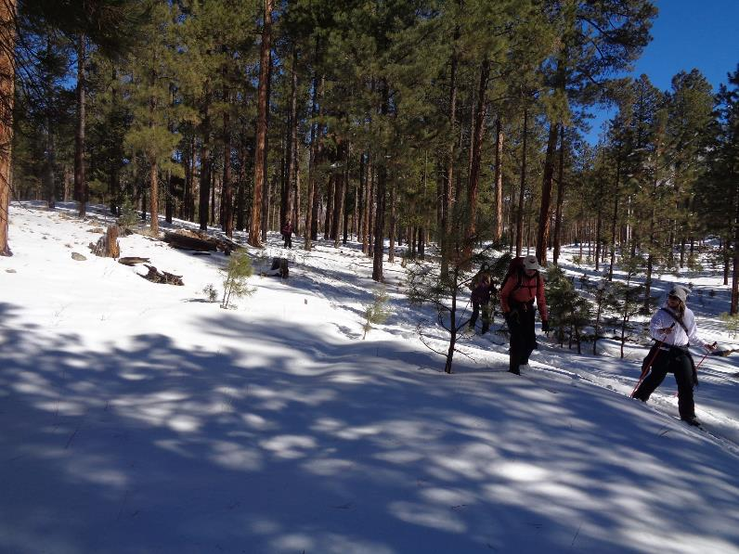

Skiing down a hill on the east side of the Redondo Loop Trail. All photos by Sam Beard

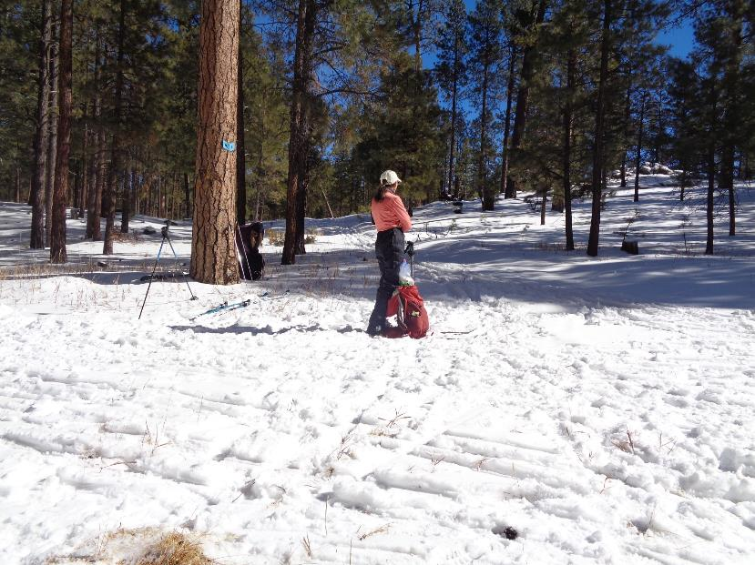

Ruth Bargman-Romero at the junction of Redondo Loop Trail (on the left) and Crater Spur Trail in the center of the picture.

The hill in the upper right corner of the picture is the west rim of the large crater.

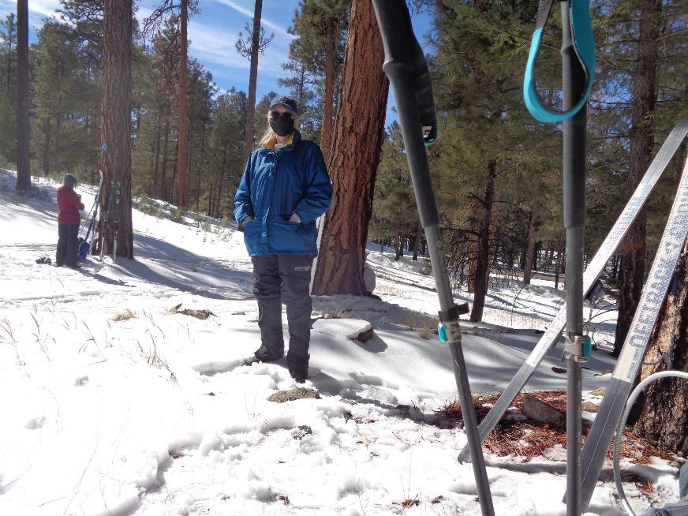

Nancy Jenkins at the lunch spot where the Loop Trail returns to the highway that can be seen on the right side of the photo.

Some skiers applied MaxiGlide at lunch, because the snow was getting warm and sticky.

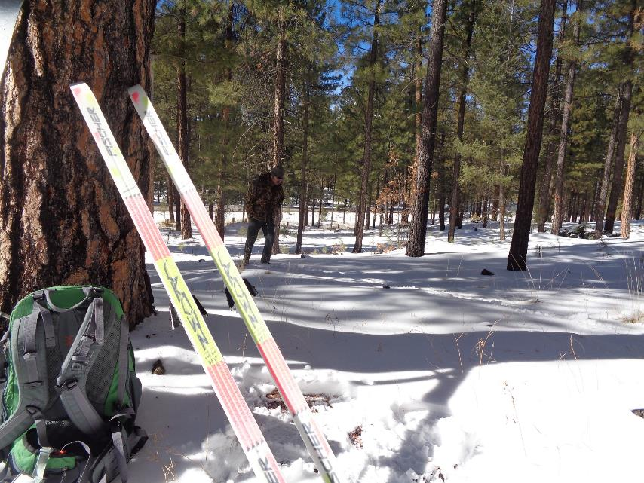

Michael Arndt at the lunch spot.

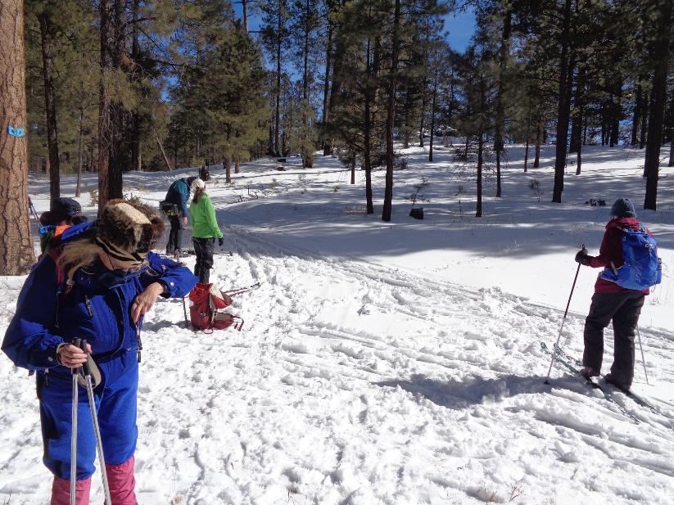

Several skiers preparing to return to the campground and the vehicles or preparing to ski the Crater Spur Trail

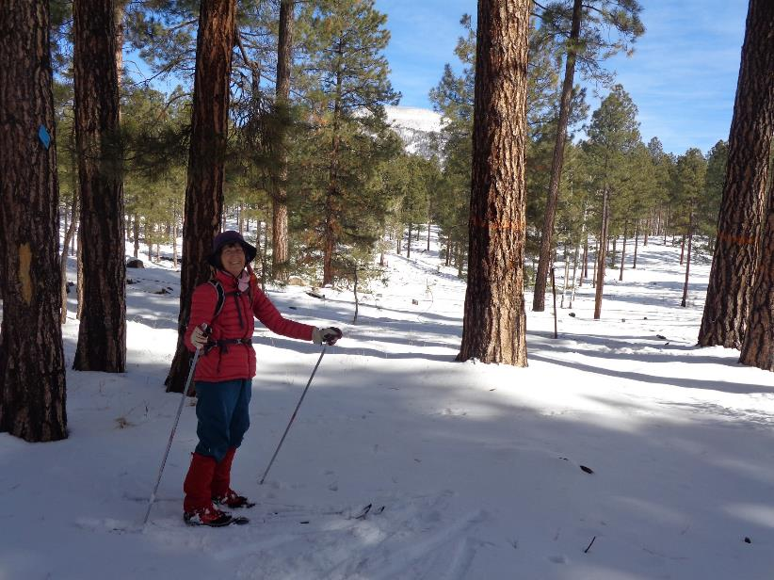

Marcia Congdon at the east end of the loop on Crater Spur Trail with Redondo Peak in the background. The thinned forest

beyond the barbed wire fence is on the Valles Caldera National Preserve (VCNP).

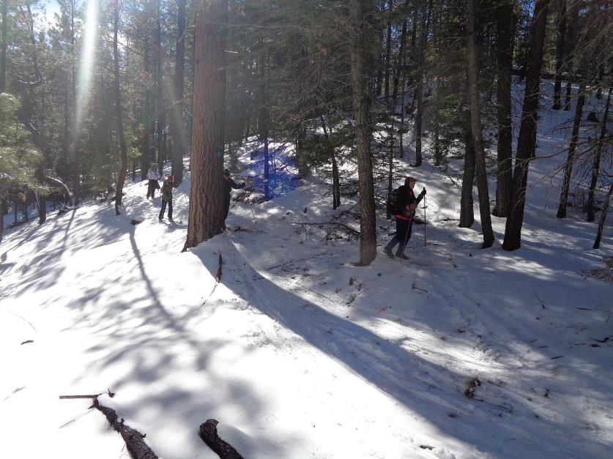

Skiers returning from the Crater Spur Trail loop and skiing along the west side of the small crater left of the picture.

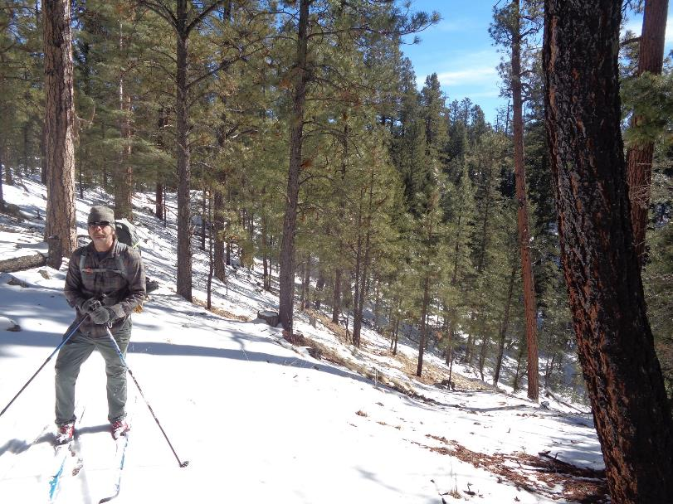

Michael Arndt standing on the rim of the large crater. The slope behind Michael goes down to the right to the bottom of the crater.

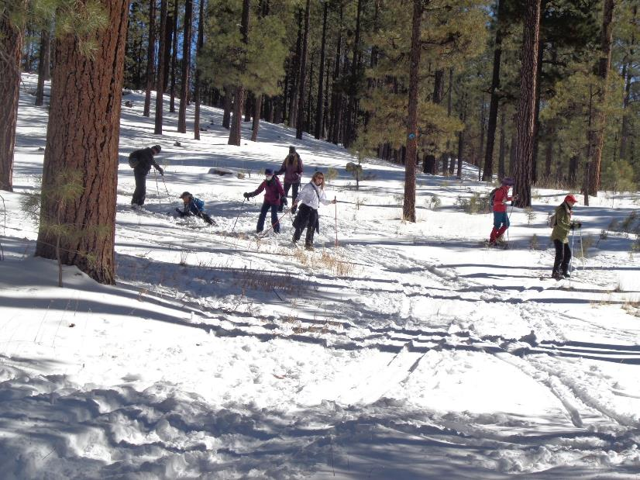

These skiers have returned from the Crater Spur Trail and are skiing from the lunch spot down to Old Highway 4 that leads to the left

to the campground.

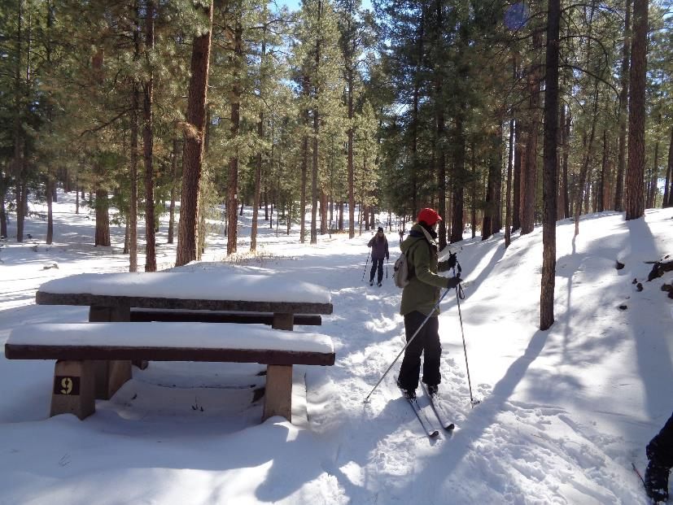

Skiers entering the campground from the old highway in the background.

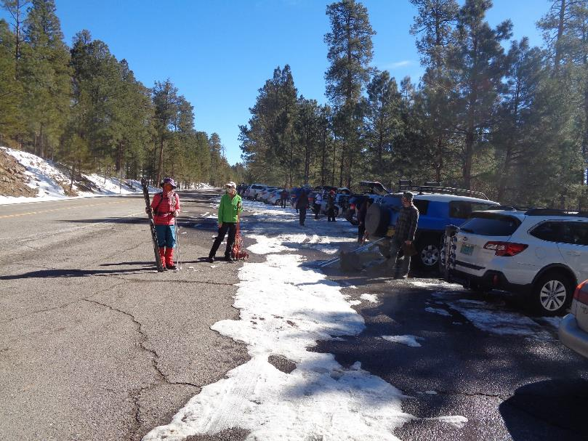

When we returned to the San Diego Canyon Overlook, the large parking lot was almost full of vehicles.

L to R: Marcia Congdon, Ruth Bargman-Romero, and Michael Arndt.