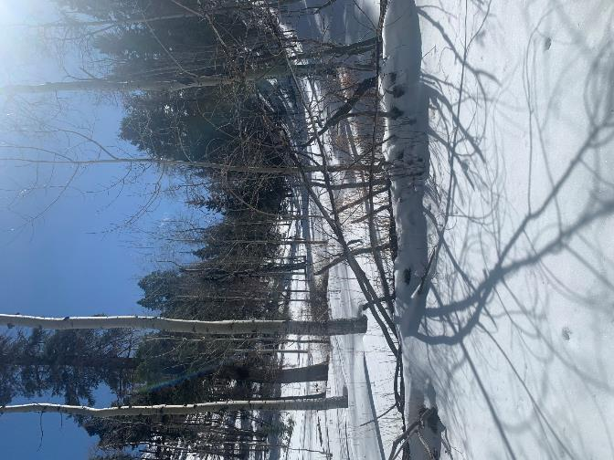

Sequence of six pictures of Sam Beard and Bob Moore skiing down into the aspen grove in Big Pine

Canyon on Los Griegos Mountain in the Jemez on Saturday, February 27, 2021. Sam and Bob are

barely visible in the center of the picture. Photos by Michael Arndt

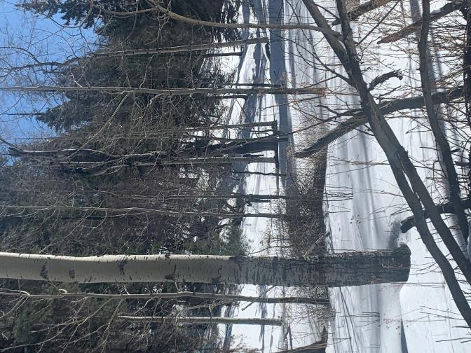

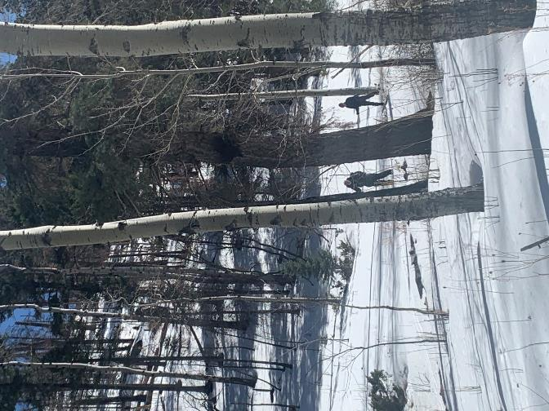

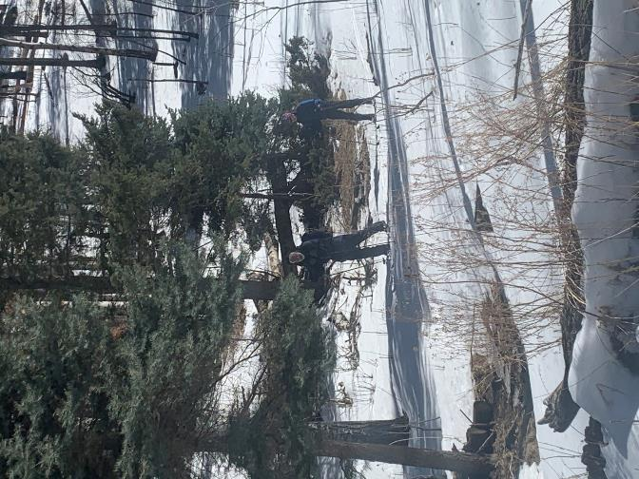

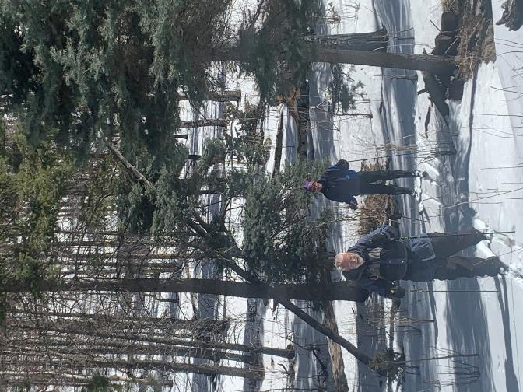

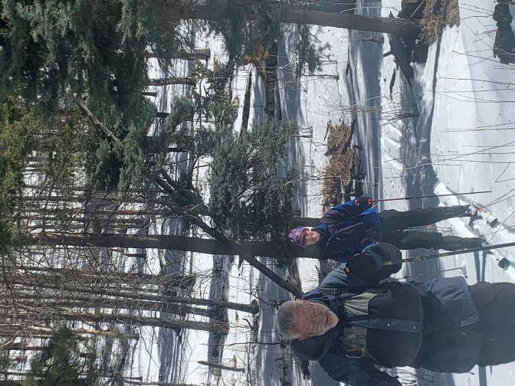

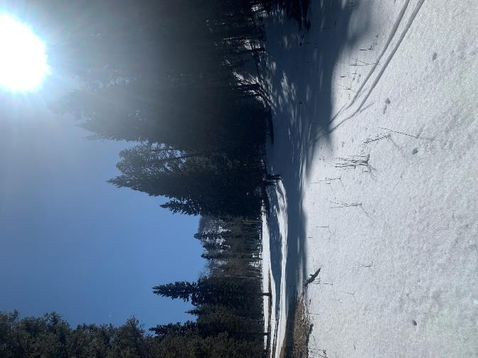

Sequence of three pictures of Sam and Bob skiing in the lower meadow in Big Pine Canyon near the highway.

