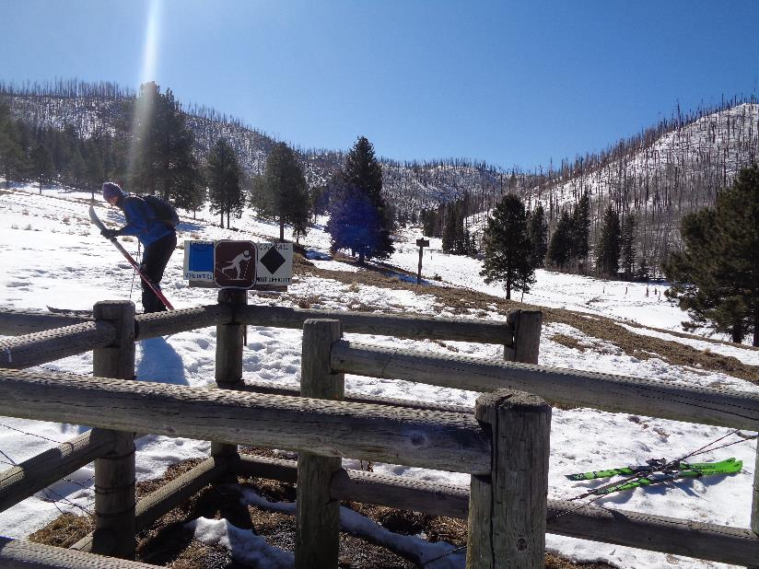

Bob Moore preparing to put on his skis at the Corral Canyon/Calzada Trailhead in the Jemez Mountains. We skied across the clearing

on the left side of the photo to where Calzada Trail enters the burned forest. All photos by Sam Beard unless noted otherwise

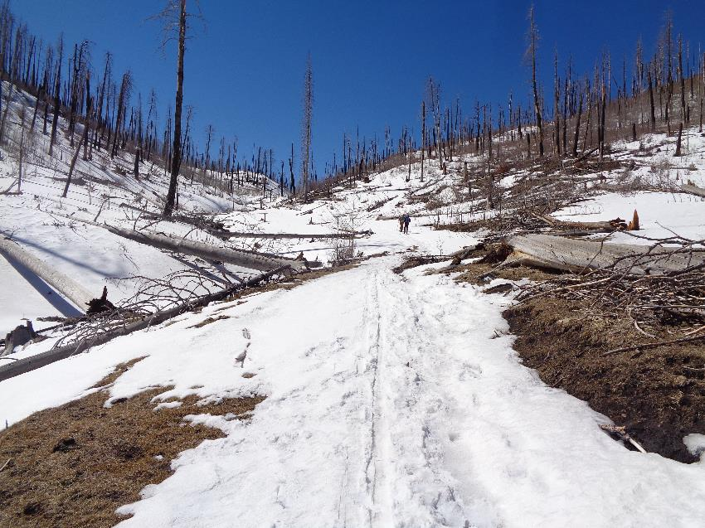

Corral Canyon Trail leading to Junction Meadow just south of the ridge on the right. After skiing Calzada Trail about one mile on the hillside

on the left, we were having problems skiing on the hard sloping crust and decided to walk down to Corral Canyon Trail.

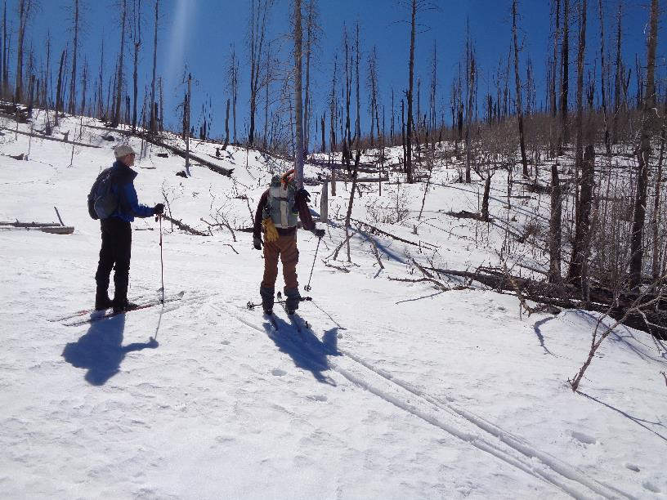

After crossing Forest Road 280 just east of Junction Meadow, we continued skiing to the upper part of Corral Canyon leading to the

low point on the horizon where we turned to the southwest and started skiing around the ridge on the right.

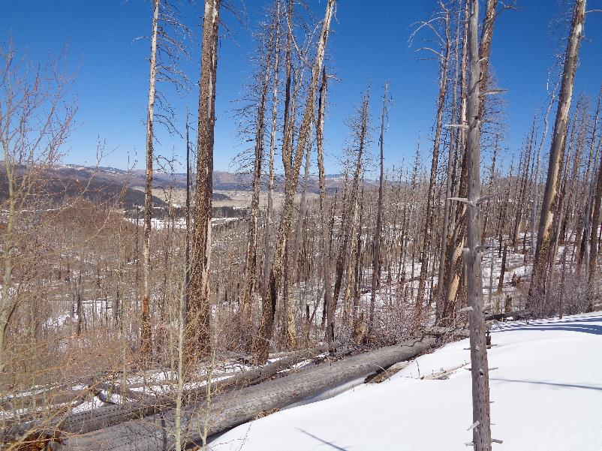

View of Valle Grande and small La Jara Mountain at the check-in station for the Valle Caldera National Preserve.

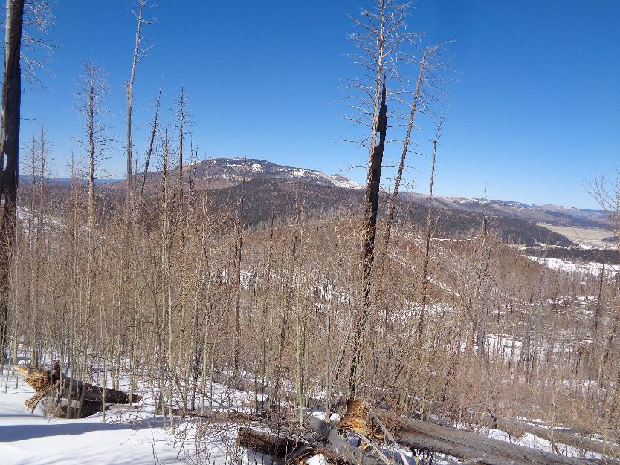

Redondo Peak and small Redondito Peak to the right.

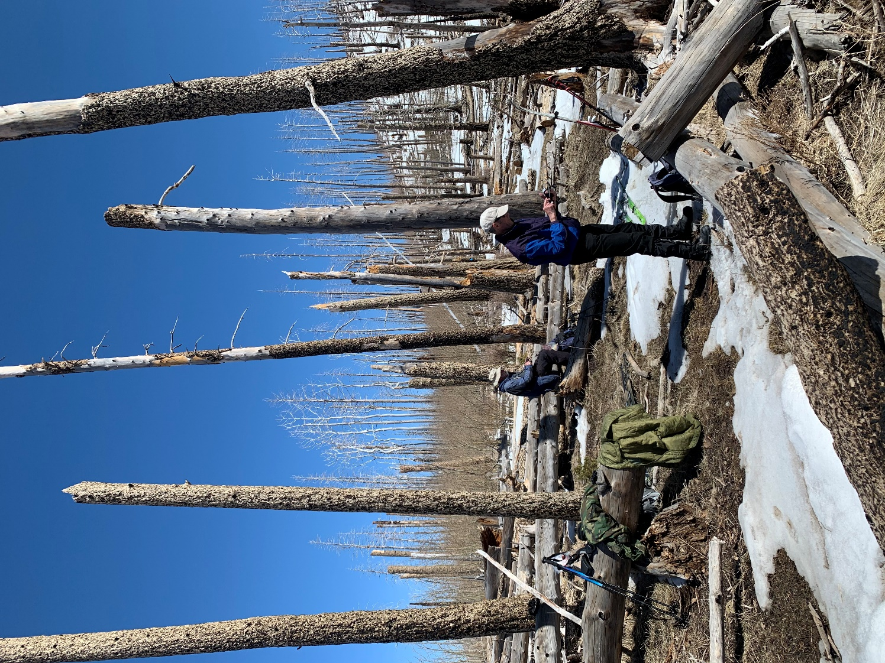

Sam and Bob on top of the ridge where we ate lunch. Photo by Michael Arndt

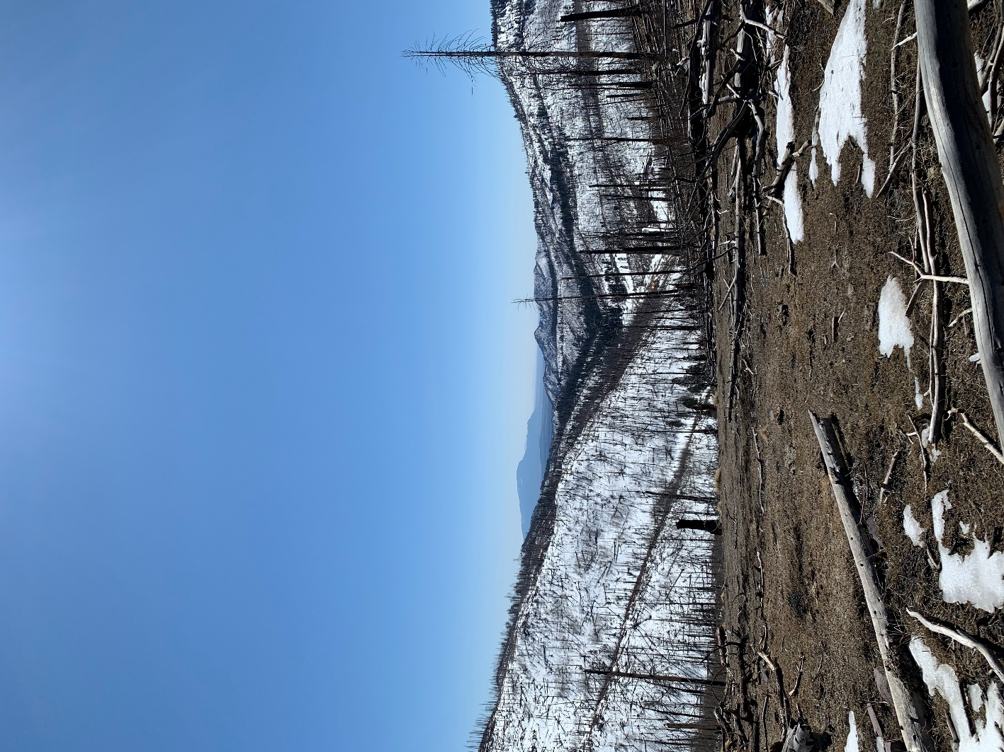

The Sandia Mountains and Rincon are visible in the haze to the south.

Photo by Michael Arndt

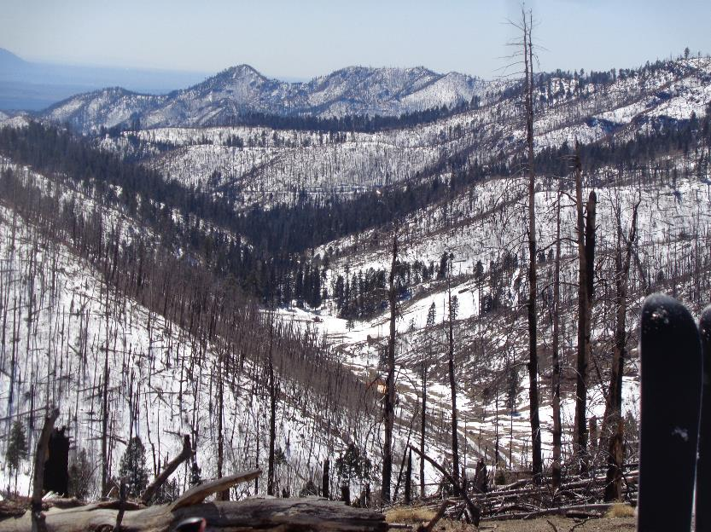

The mountains surrounding Peralta Canyon. The road to the south at Tee Intersection leads to several cabins in the bottom of the canyon.

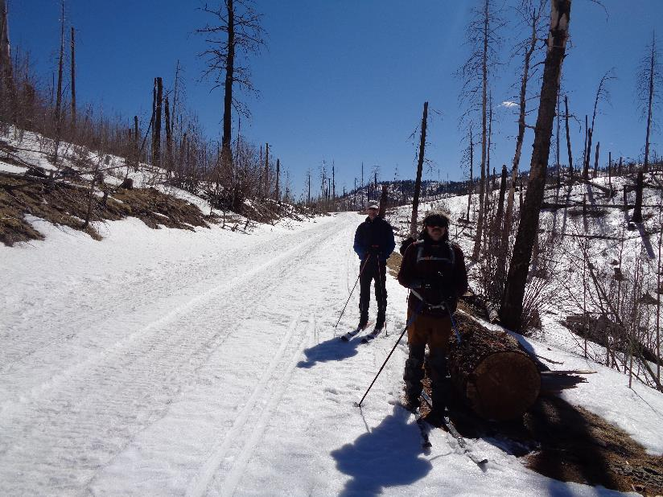

Bob and Michael on FR-280 with Tee Intersection in the background. We skied back toward the highway on the snow cat tracks on the left.

Maintenance personnel use a snow cat to go to the communications towers southwest of the intersection.

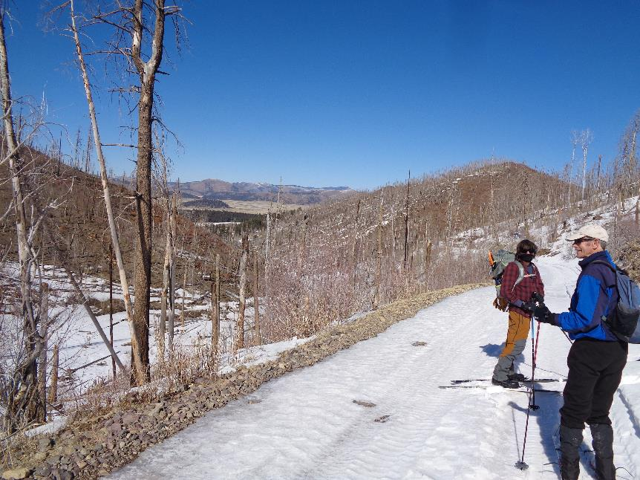

View of Valle Grande and La Jara from FR-280.

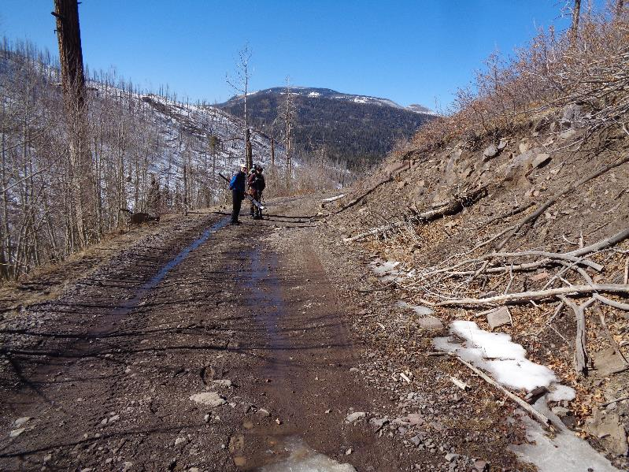

All the snow had melted on a one-quarter mile segment of the road.

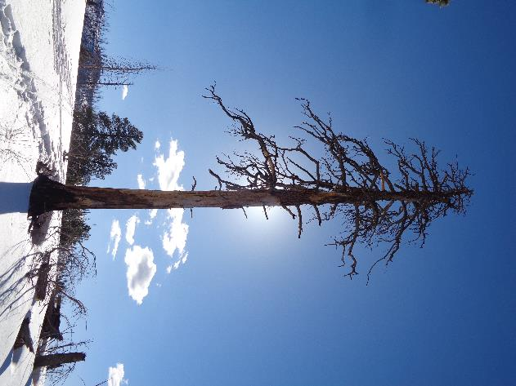

A large tree killed in the La Conchas Fire in 2011.

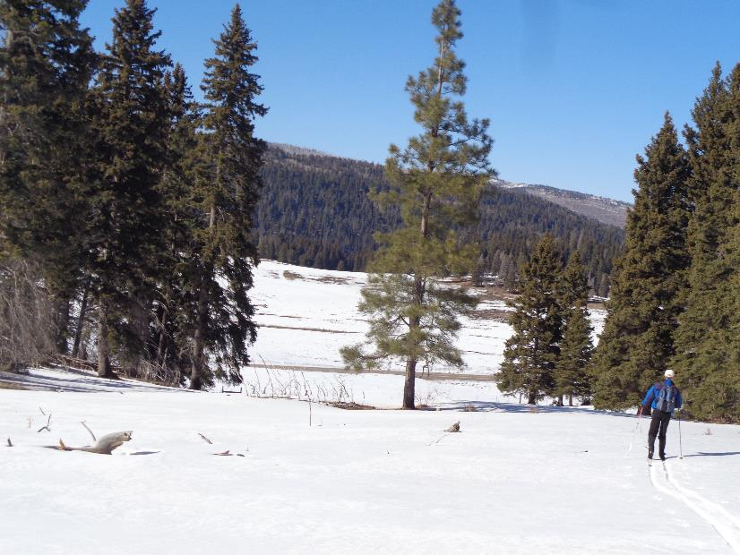

We skied back to the highway on ridges east of the trailhead. Fortunately, we found two gates open so that we did not have to cross any fences.