**Maintenance of Steep Segment of Elk Ridge Trail and Lower Part of Calzada Trail**

**on the Jemez Ranger District on Sunday, November 7, 2021**

Sam Beard and Michael Arndt

On Sunday, November 7, Michael and Sam removed about a dozen trees from Elk Ridge Trail on the steep segment above the power line.

We then went to the Corral Canyon parking lot and hiked up Calzada Trail to the 30-inch diameter pine tree across the trail. We placed small tree trunks on both sides of the tree and cut a notch in the tree to make skiing across it easier. Calzada Trail was clear from the highway to the big pine tree.

Photographs of our outing are presented below.

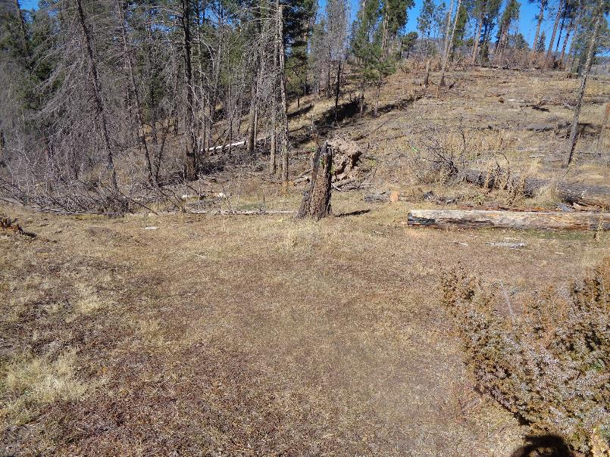

Looking down Elk Ridge Trail from the power line saddle. The trail down the old logging road is located on the left side of the photograph

where the tree with many branches is lying. To avoid having to remove that tree, we cleared a route on the right side of the stump

that turns to the left and joins the road just below the porcupine tree. Photos by Sam Beard

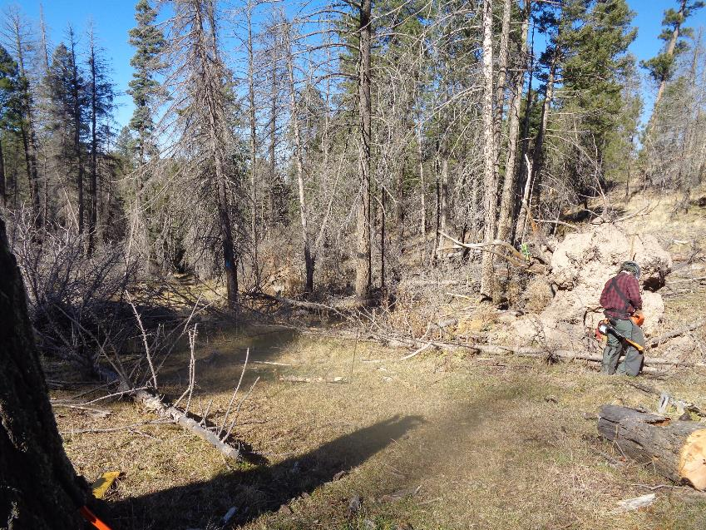

Michael Arndt preparing to cut and remove down trees on the rerouted segment of the trail.

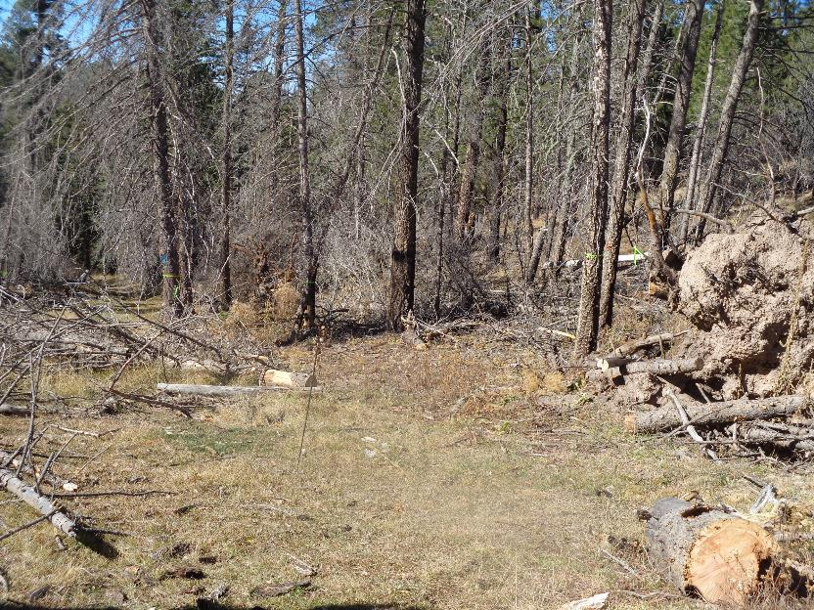

The rerouted trail segment is marked with lime green flags and passes just left of the tree with the blue diamond in the background.

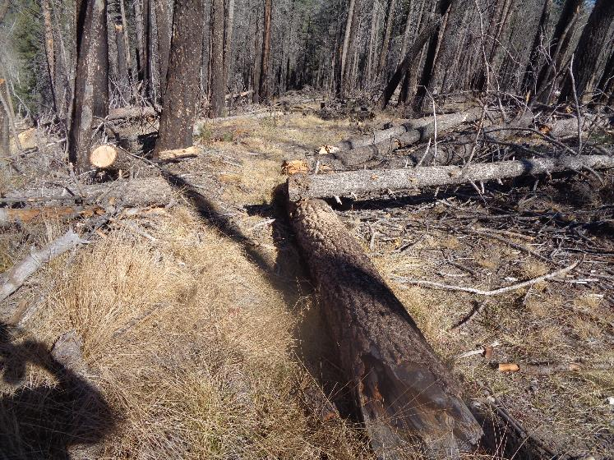

View down the steep part of Elk Ridge Trail north of Lower Road. We did not have enough time or chain saw fuel to completely remove

all the logs from this segment of the trail. It will be necessary to ski around the ends of logs here.

Lower down the trail near the power line, no trees are across the trail.

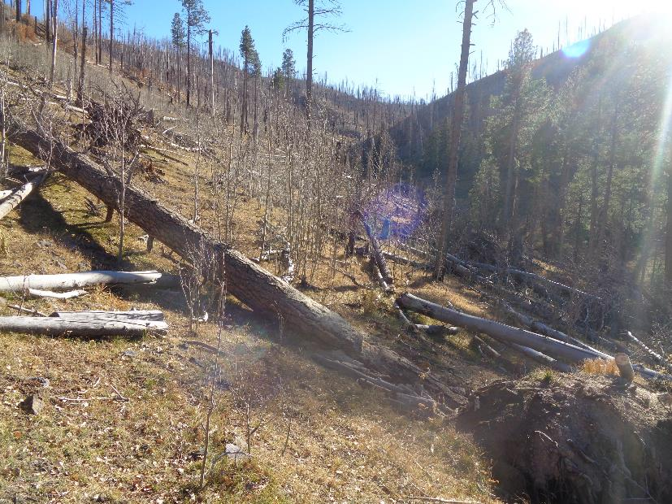

The large pine log across Calzada Trail about one-half mile from NM-4.

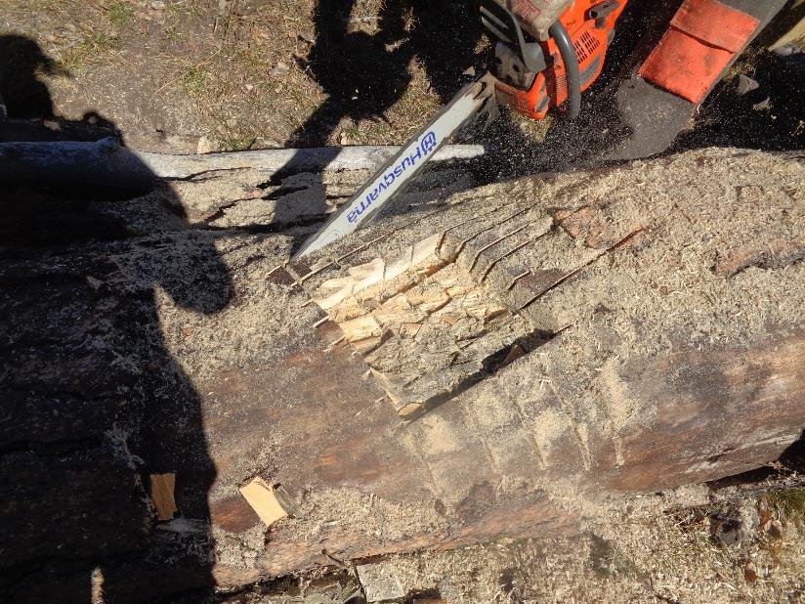

The log was too large to remove on Sunday; therefore, we cut a notch in the top to make skiing over it easier.

Here Michael is making cuts in two directions so the square blocks of wood can the chopped out.

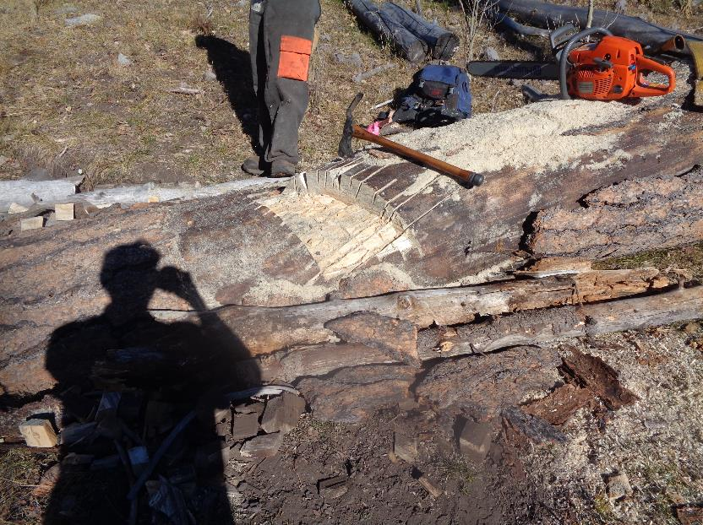

I used the tool shown on the log to remove the blocks of wood. The upper part of the tool has a blade like an adz that I used to

remove the blocks.

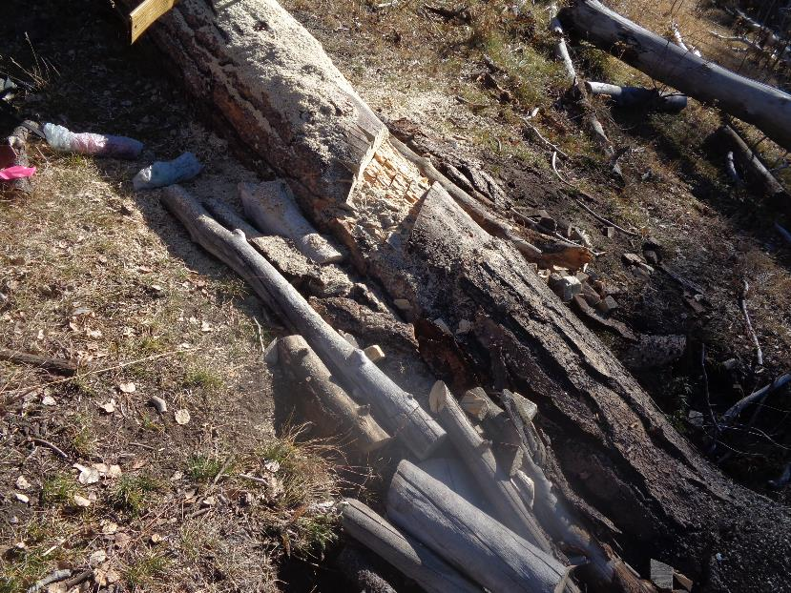

The 4-inch-deep notch in the log and ramps on each side of the log to make skiing over it easier.