**Report of Maintenance of Elk Ridge Trail on Los Griegos Mountain**

**by New Mexico Cross Country Ski Club Volunteers on November 13, 2021**

Michael Arndt and Sam Beard, November 16

On Saturday, November 13, five New Mexico Cross Country Ski Club (NMCCSC) members completed fall maintenance of Elk Ridge Trail on Los Griegos Mountain on the Jemez Ranger District. They parked about one-half mile east of the usual Los Griegos parking lot on NM-4 at a gate leading to a recently thinned area. From here they hiked about one-quarter mile to Elk Ridge Trail at the power line. They worked from the power line up the steep part of the trail, crossed Lower Road on the almost level part of the trail, and hiked to Ladera Trail. In this segment of Elk Ridge Trail, they removed 12 logs with diameters of 12 to 18 inches. This trail is now clear from the lower end at Ladera Trail to the upper junction with Ladera Trail just past Lower Road.

The volunteers were Michael Arndt (crew leader), Mike Meier, Steven Reuter, Jerry Carroll, and Vincent Amendolagine.

Project photos are presented below.

Note: You may have noticed that Sam Beard was not working on this project. I was in an accident with a vehicle that ran a red light at Indian School Road and Tramway Blvd on Thursday evening on my way home from the Ski Club meeting. The Prius was totaled, and my injuries were a fractured sternum, a fracted rib, and a large hematoma on my right leg. I am home, and the sternum and hematoma will require weeks to heal.

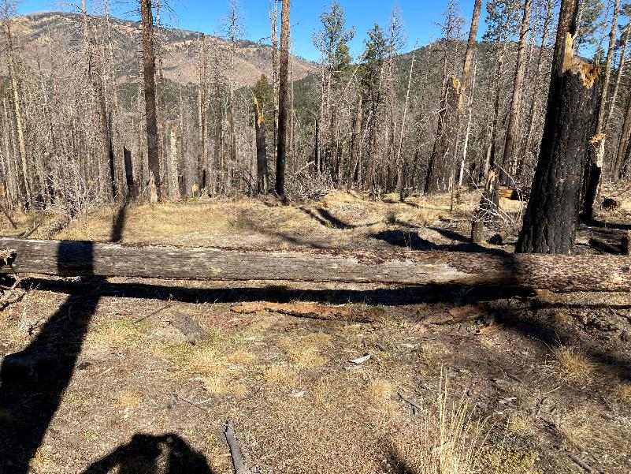

16-inch log across the less steep upper part of Elk Ridge Trail in the Los Griegos Mountain area in the Jemez

Mountains. Note Redondo Peak in the upper left corner of the picture and the many trees that were killed in the

Cajete Fire several years ago. All photos by Michael Arndt

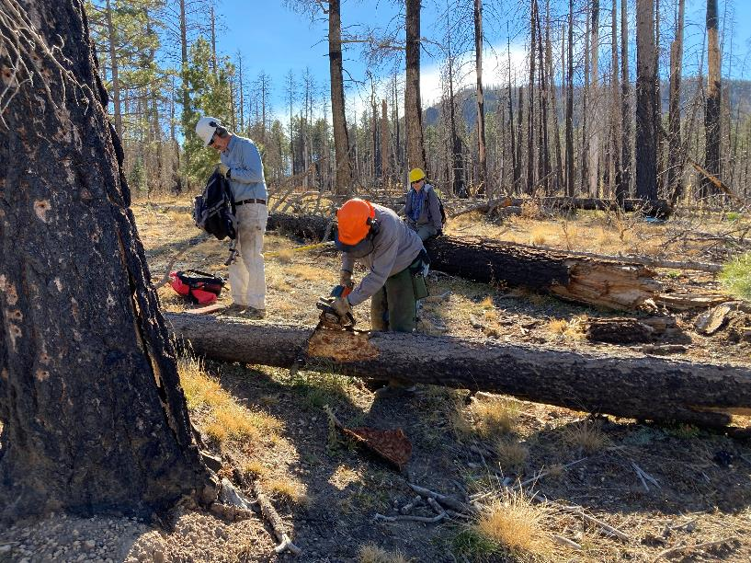

Jerry Carroll is bucking the log with Mike Meier on the left and Vincent Amendolagine behind Jerry. The dead trees are now

rotten enough that many of them are falling, and a large number break several feet up the trunk.

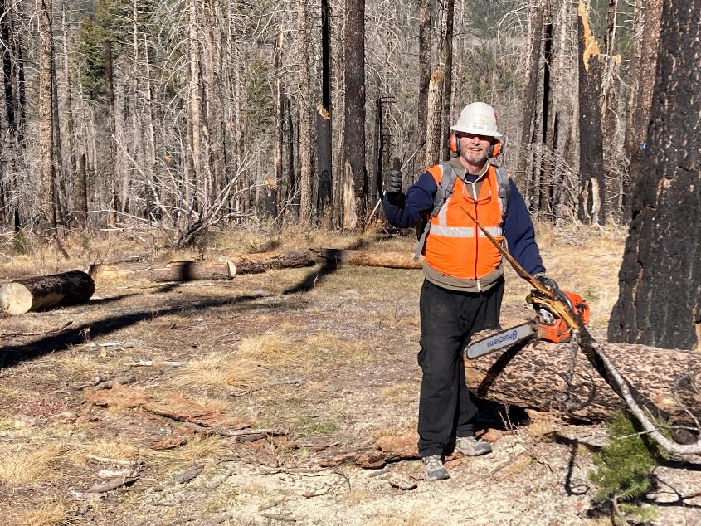

Steven Reuter standing by the chain saw with the pieces of the log rolled off of the trail behind him.

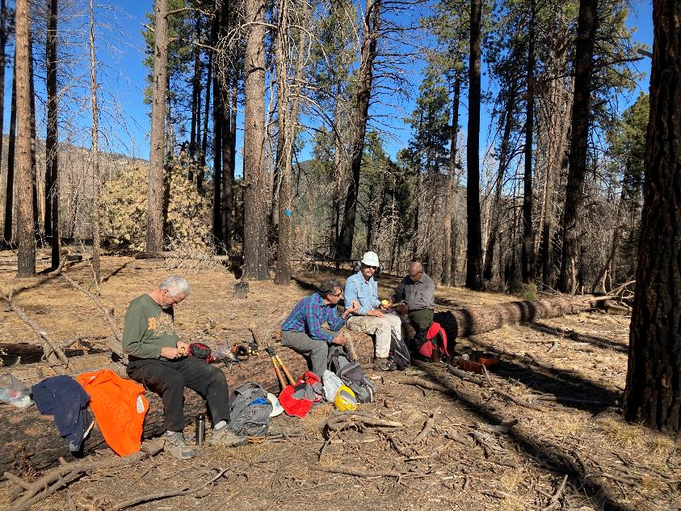

The crew having lunch sitting on a large log. L to R: Steven Reuter, Vincent Amendolagine, Mike Meier, and Jerry Carroll.