Report of Maintenance of Crater Spur Trail and Calzada Trail in the Jemez Mountains on Sat., Dec. 4
Sam Beard, Dec. 6

On Saturday, December 4, 2021, Michael Arndt and Sam Beard completed fall maintenance on Crater Spur Trail near Redondo Campground and the lower part of Calzada Trail between NM-4 and Junction Meadow located on the south side of the highway about one-half mile west of Valle Grande.
Michael removed the following trees from Crater Spur Trail: 5-inch hang-up, dead 12-inch pine leaning over the trail, and eight small trees lying across the trail, a total of ten trees. On Calzada Trail, Michael removed nine down trees ranging in diameter from 3 inches to 18 inches.
Photographs are presented below.

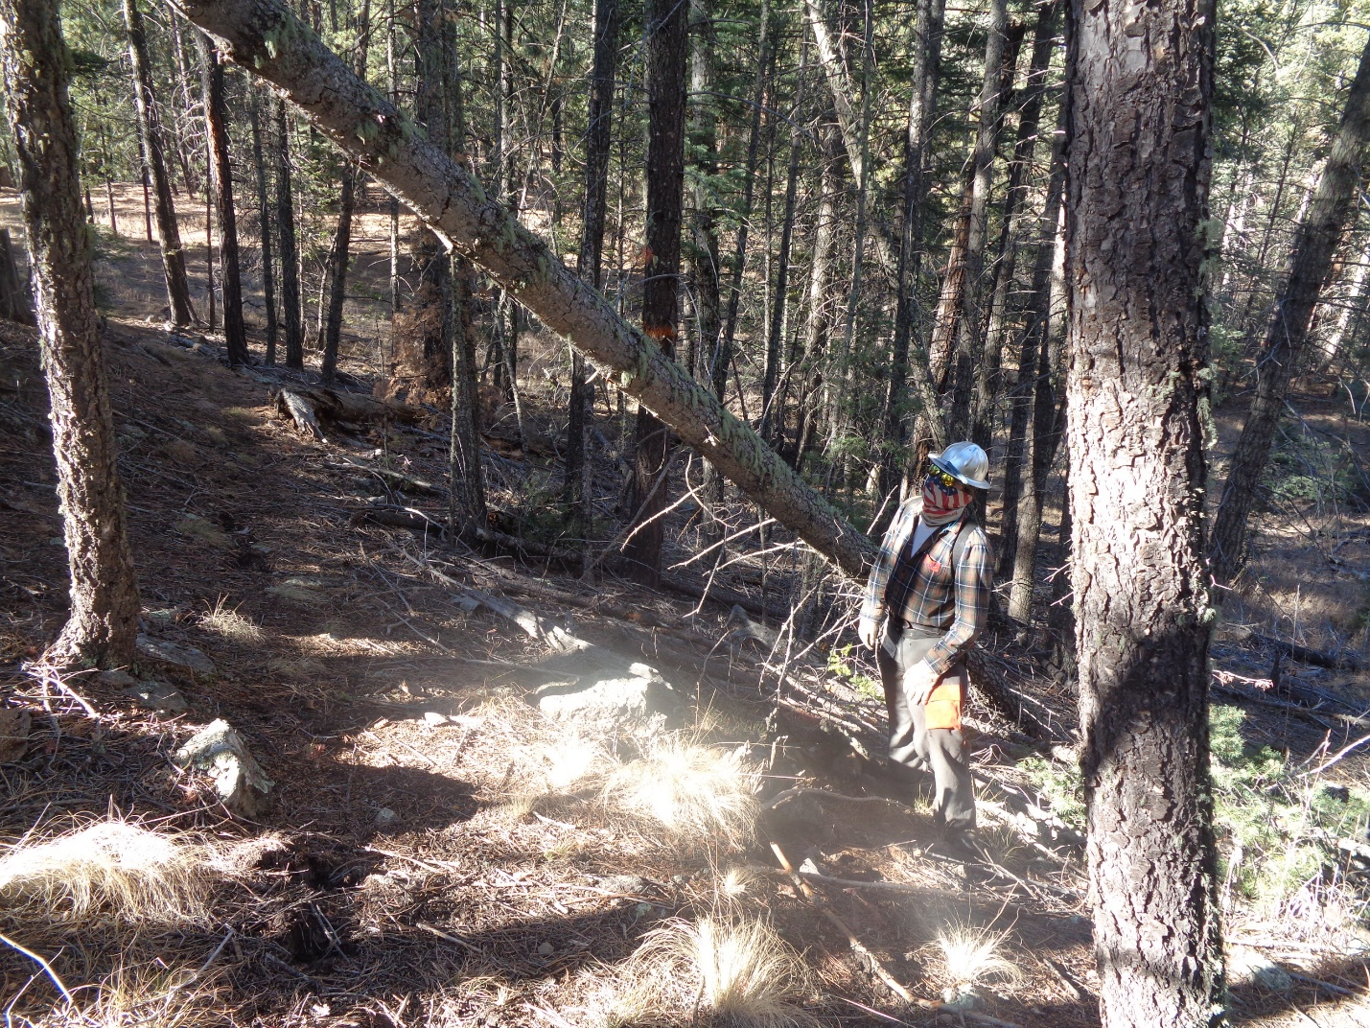
Michael Arndt looking at hung up tree over Crater Spur Trail.
All photos by Sam Beard unless stated otherwise.

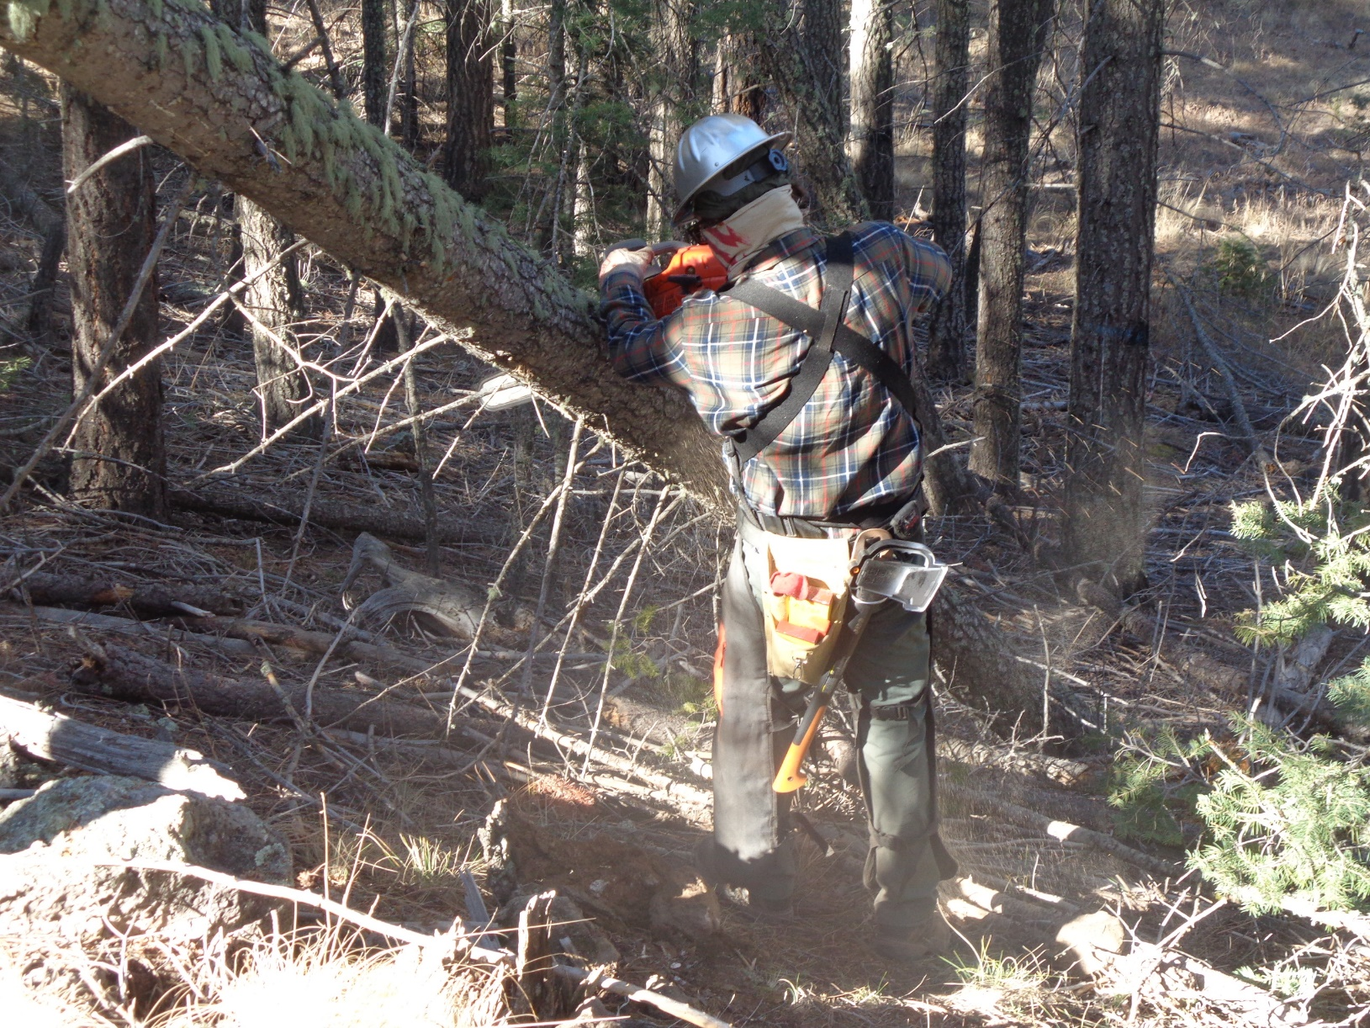
Michael making the first cut on the hang up with his chain saw.

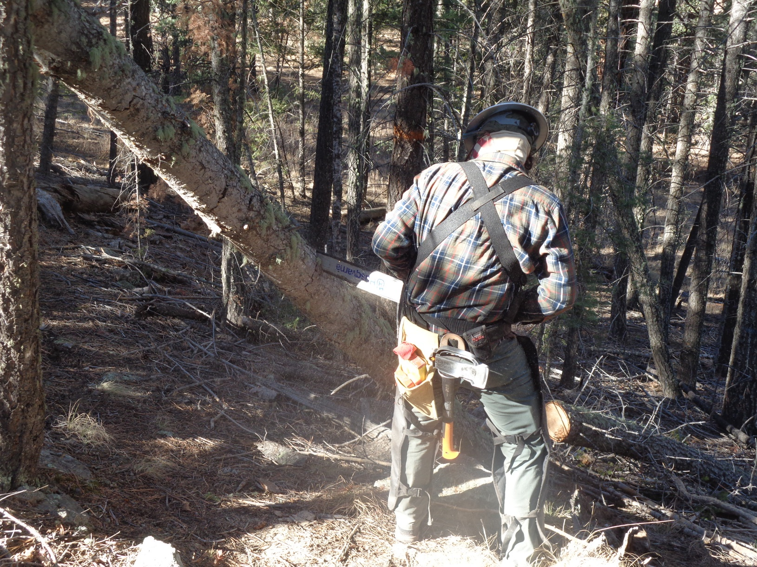
After the first cut on the tree, the lower end dropped down so that the tree was still hung us over the trail.
Here Michael is making the second cut on the tree.

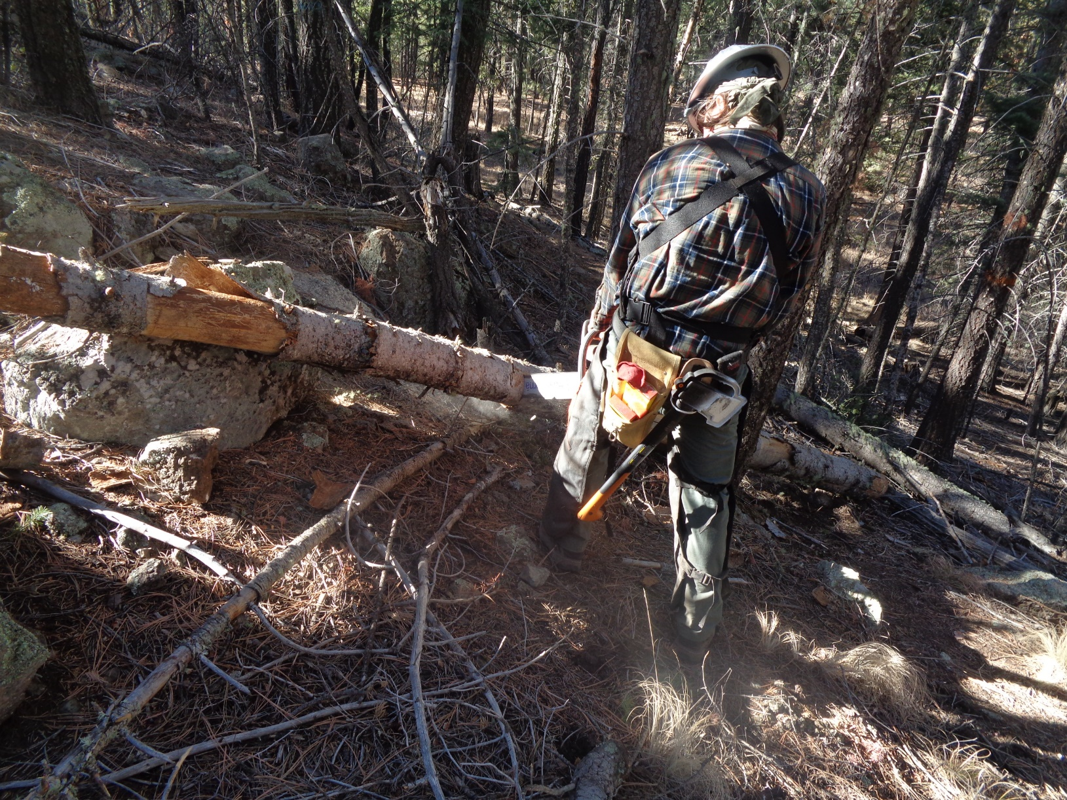
The tree fell to the ground and Michael is cutting it in order to move it off the trail.
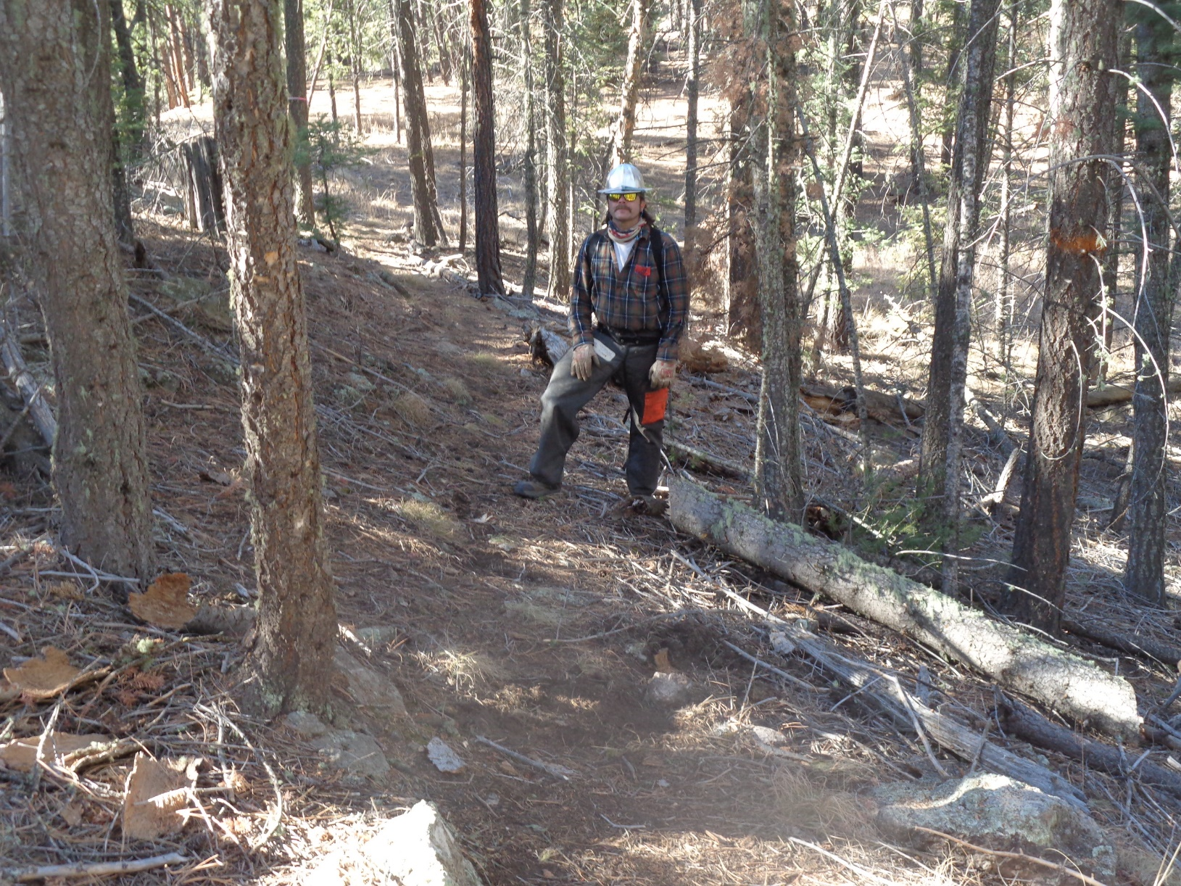
Michael standing beside the open trail.
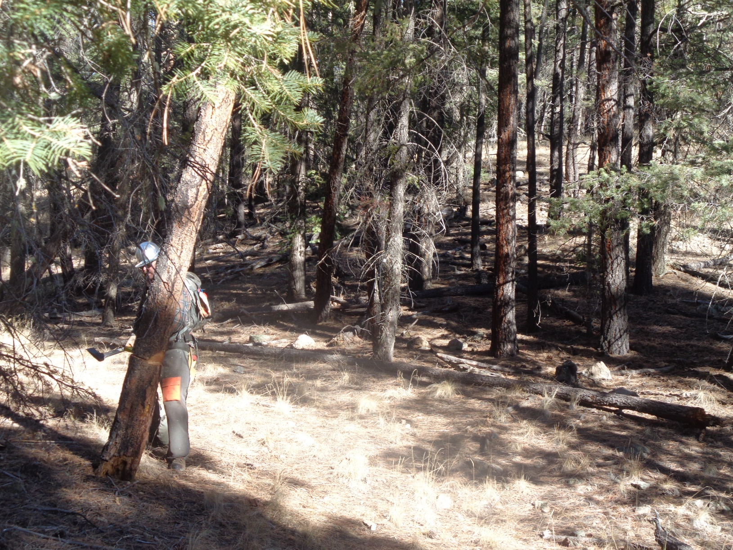
Michael is felling a dead pine tree that was leaning over the trail. It would have eventually fallen over the trail.
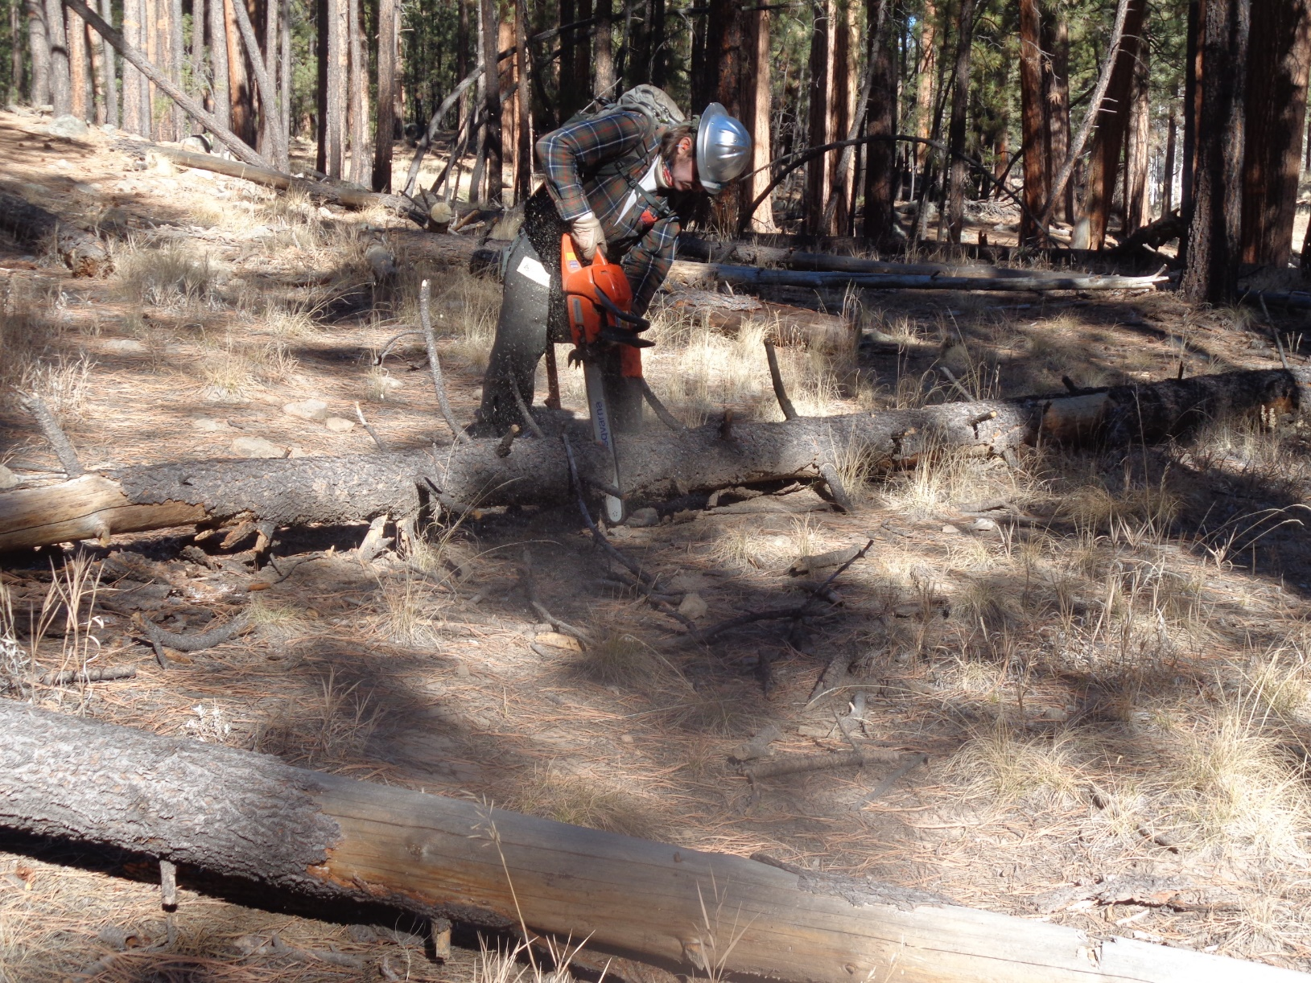
Michael cutting an 8-inch tree down on Crater Spur Trail near the south end of the trail. At this location, there
was a total of six trees down on the trail.
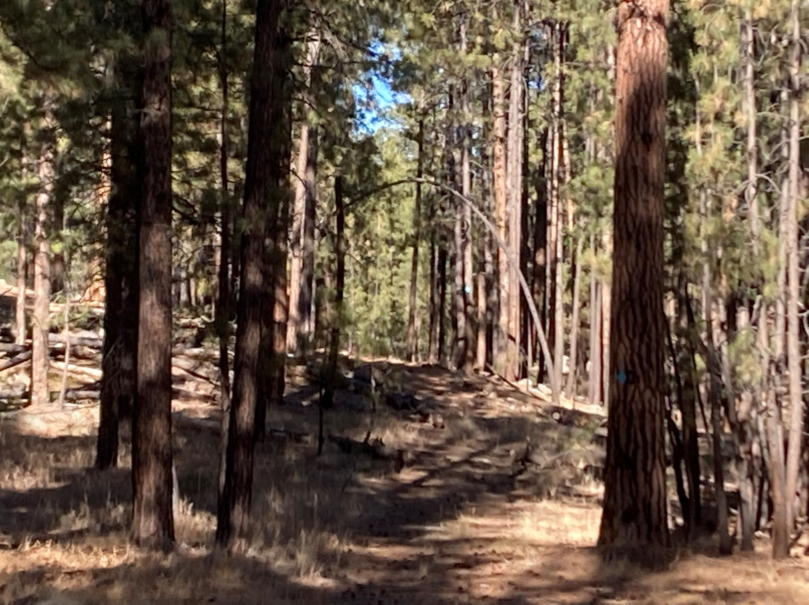
The area on Crater Spur Trail where Michael cut six trees that were down. Club members will be skiing under the arched tree
shown in this photo. Photo by Michael Arndt
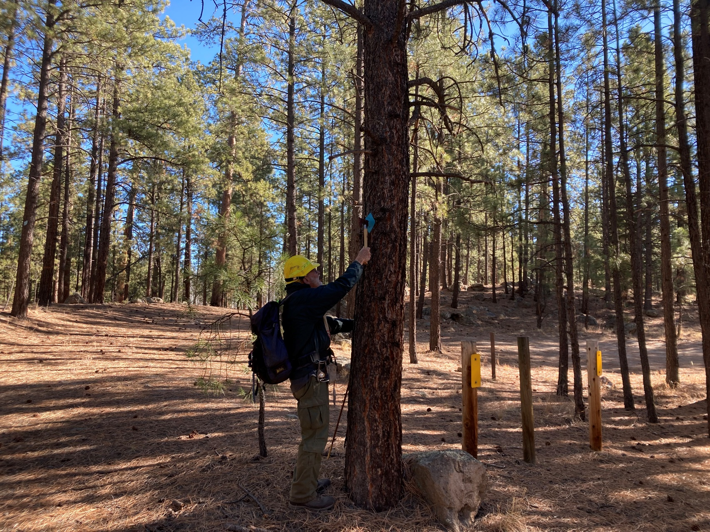
Sam nailing a blue diamond on a pine tree at the south end of the trail.
Photo by Michael Arndt
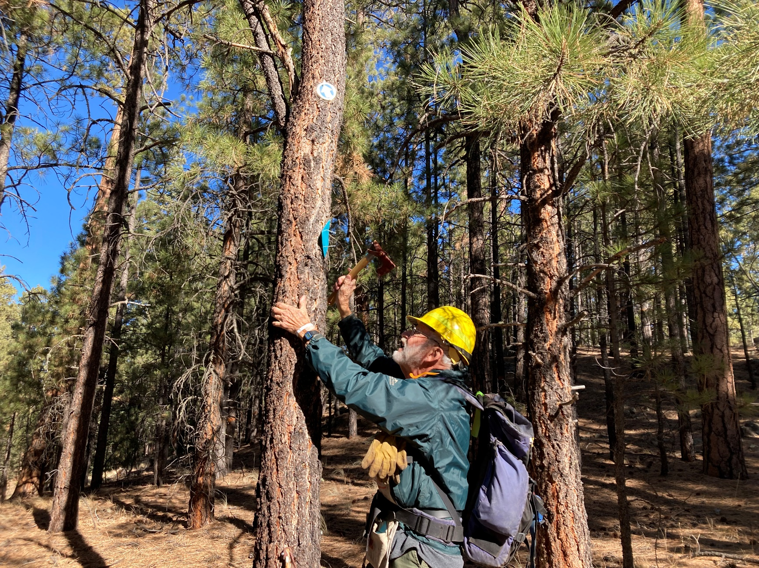
Sam nailing another diamond to a pine tree. The large blue diamond is much more visible than the small round blue aluminum marker
higher on the tree. Photo by Michael Arndt

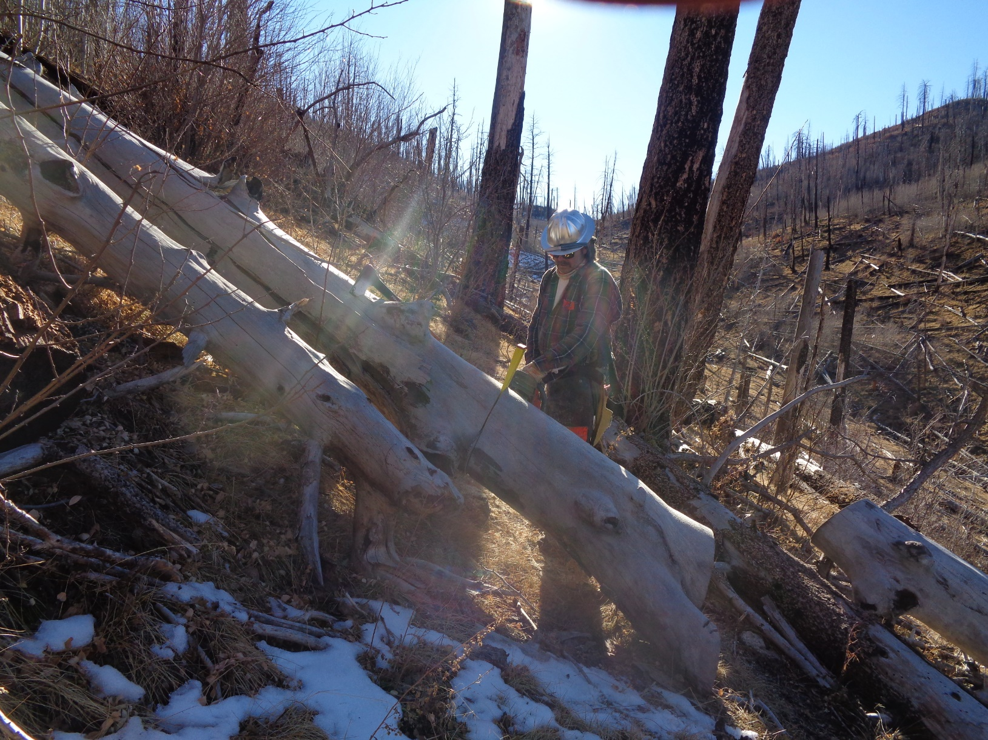
Michael cutting a 16-inch log across Calzada Trail located south of NM-4 about one-half mile west of Valle Grande.
Note that all the trees are dead. They were burned several years ago in the Los Conchas Fire.
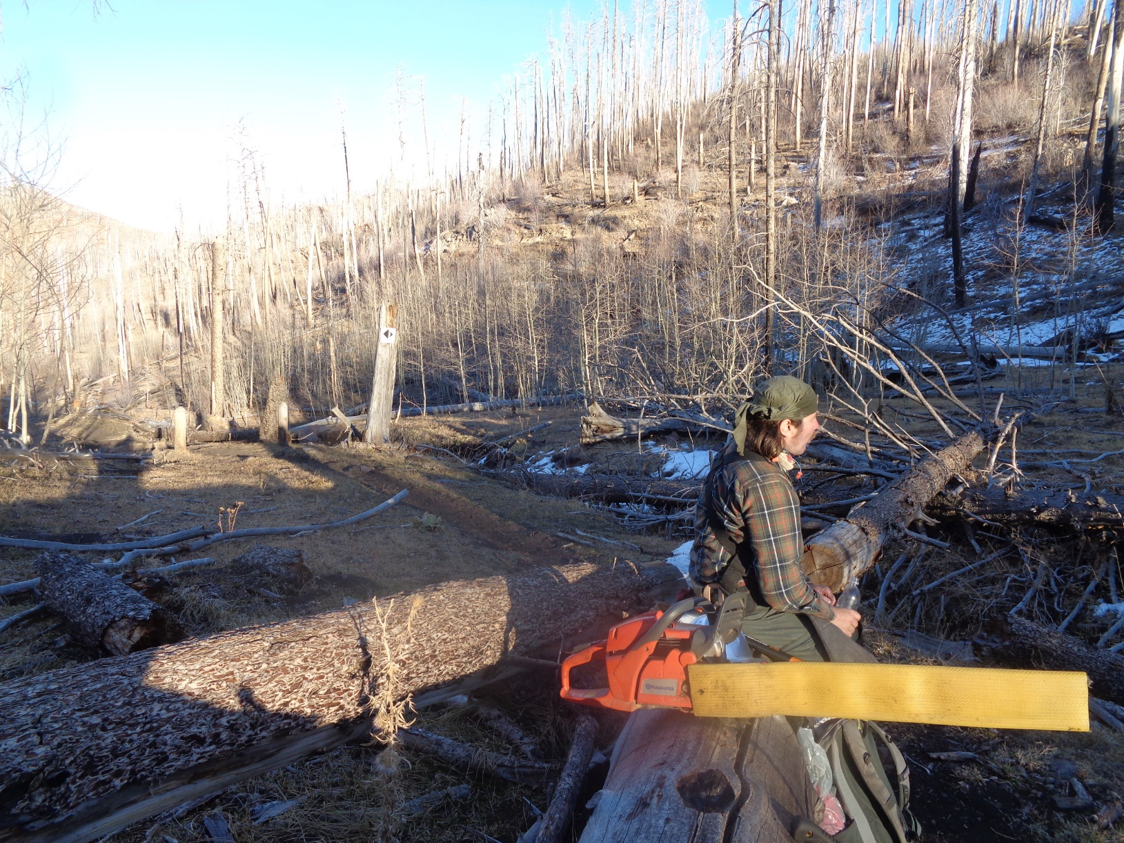
We are resting here, eating a granola bar, and drinking water after completing the work on Calzada Trail located in the background
in the shade. We are sitting at the upper end of the lower steep part of Corral Canyon Trail. Note the long shadows at 4 pm. The
sun set behind a nearby ridge a few minutes later as we hiked down Corral Canyon back to Michael’s pickup.

