**Report of the Installation of Blue Diamonds on the New Challenge Trail Segments**

**between Dry Camp and Tree Spring Trail and between 10K South Trailhead**

**and the First Highway Switchback below Ellis Trailhead on December 22, 2021**

Sam Beard, December 23, 2021

On Wednesday, December 22, Dan Benton and Sam Beard nailed blue diamonds on trees along two new segments of Challenge Trail.

1. **Challenge Trail Extension** – This segment leads from a meadow on the hillside across the highway from Dry Camp to Tree Spring Trail a short distance from the parking lot. From the Dry Camp parking lot, cross the Crest Highway (carefully, watching for vehicles) and hike up the open hillside to the trail. Go south approximately ¾-mile to Tree Spring Trail.
2. **Challenge Trail Reroute from 10K South TH to First Crest Highway Switchback below Ellis Trailhead** – This segment follows the Crest Highway up to the first highway switchback below Ellis Trailhead. From the parking lot go to the south across the low bridge and up the trail to where 10K South Trail goes to the southeast. **Do not follow 10K South Trail to the southeast,** instead follow the new hiking/ski trail to the south a short distance and turn to the north at a switchback. The approximately 0.7-mile reroute passes to the north on the mountainside just above the parking lot. Continue along this trail that follows the Crest Highway through a switchback and past Dan’s Loop (not visible from the trail) to the next switchback in the highway. If coming down Switchback from Ellis Trailhead, the new reroute makes a left turn where the original trail is blocked with logs and branches. A left-turn arrow is nailed to the tree at this 90-degree turn in the trail. We found eight trees down across this segment of the trail leading to the 10K South Trailhead. It is relatively easy to walk around all the down trees. FOSM volunteers will probably remove these trees in the week.
3. **Diamonds on Extension from the Base of the Sandia Peak Ski Area** **to Dry Camp Trailhead –** Recently blue diamonds were also installed on the trail extension from the base of the Sandia Peak Ski Area to the Ski Area Overflow Parking lot and to Dry Camp Trailhead. Diamonds have been installed on all the trail extension from the Ski Area base to Tree Spring Trail.

Photographs of the trail marking project are presented below.

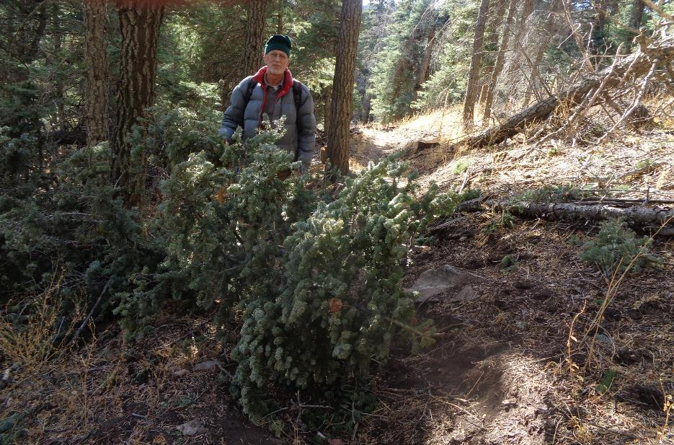

Dan Benton at a small tree that was across the Challenge Trail Extension from Dry Camp to Tree Spring Trail.

All photos by Sam Beard unless noted otherwise

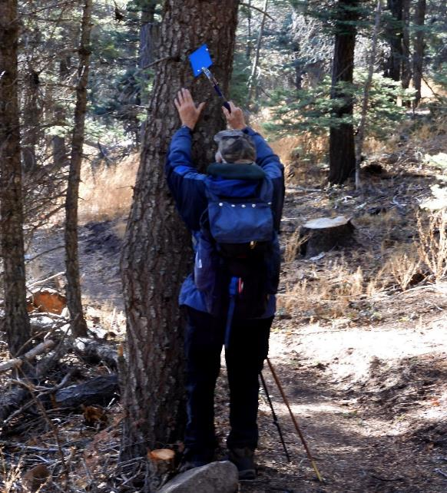

Sam Beard nailing a diamond to a tree. Photo by Dan Benton

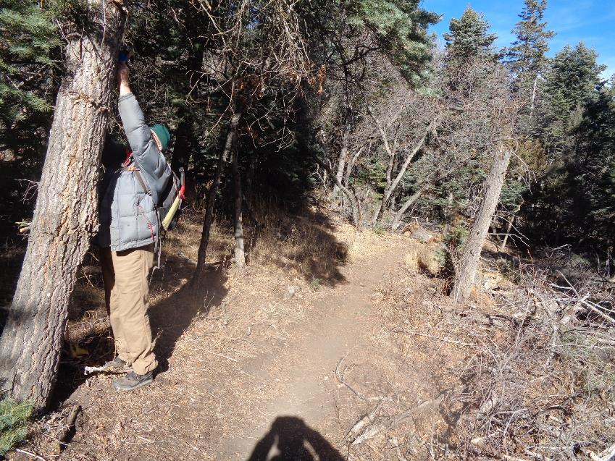

Dan nailing a diamond on a tree. Note that there is no snow on the trail here.

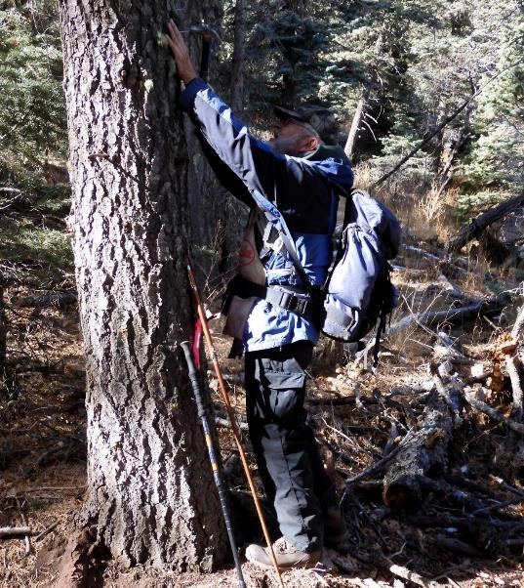

Sam nailing another diamond to a tree. The distance between diamonds is approximately 200 feet.

Photo by Dan Benton

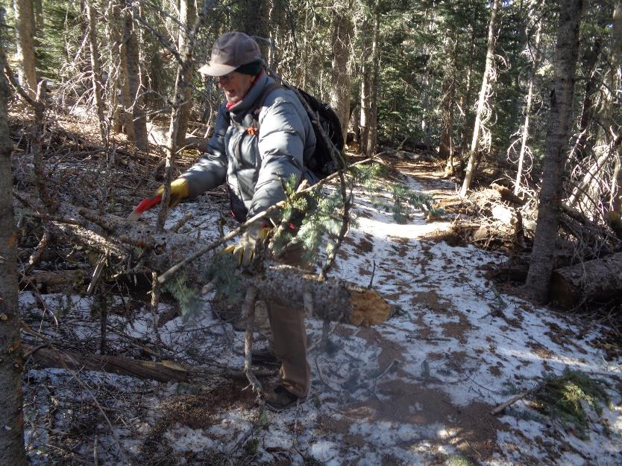

Dan cutting a small tree on the reroute between 10K South Trailhead and Ellis Trailhead.

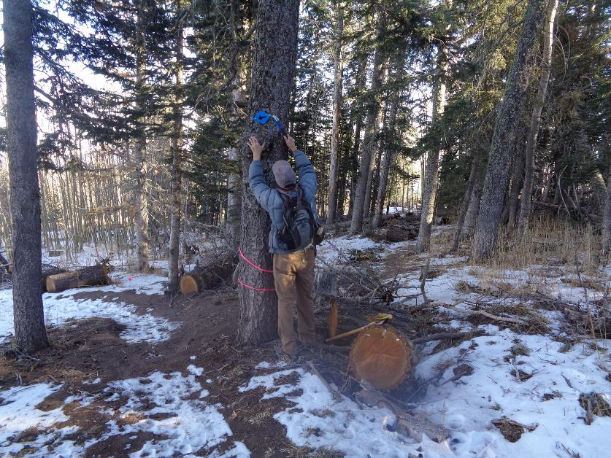

Dan nailing a left-turn arrow on the tree where the reroute turns to the left from the original trail. Note the log and branches

across the old route to the right of the tree.

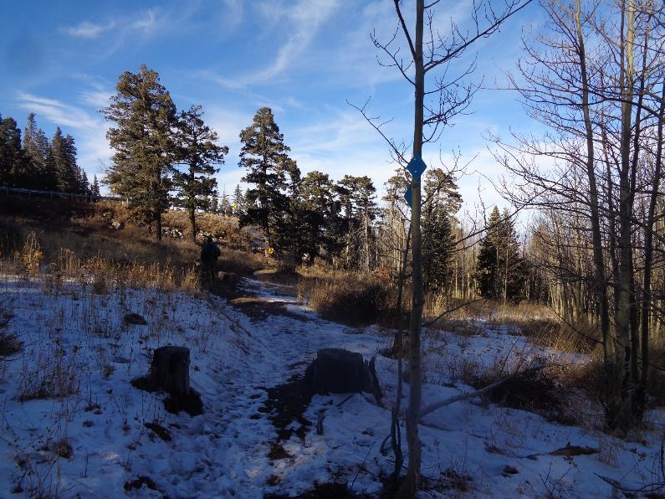

The only tree along this piece of the rerouted trail was this small aspen, and diamonds were nailed to both sides of it.

Note the guard rail on the highway switchback in the upper left corner of the photograph. Dan is the dark object on the trail

to the left of the photo center.

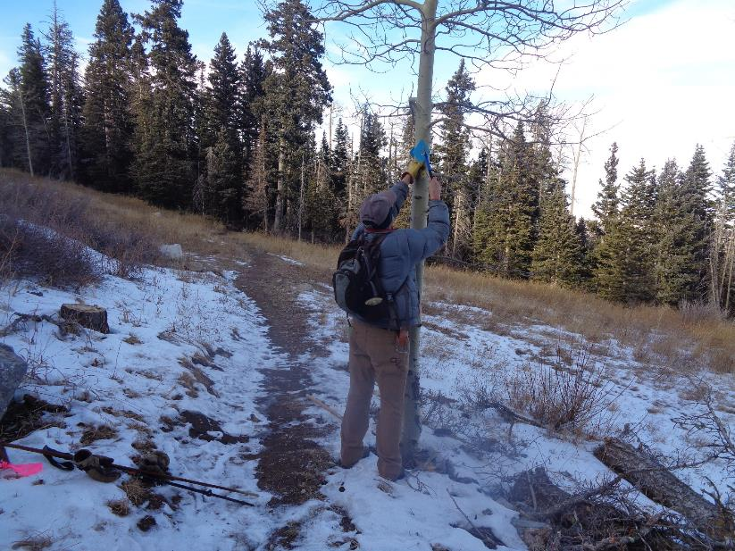

Dan nailing a blue diamond on a small aspen where the reroute crosses a meadow that was originally the right-of-way

for a highway that was not constructed.

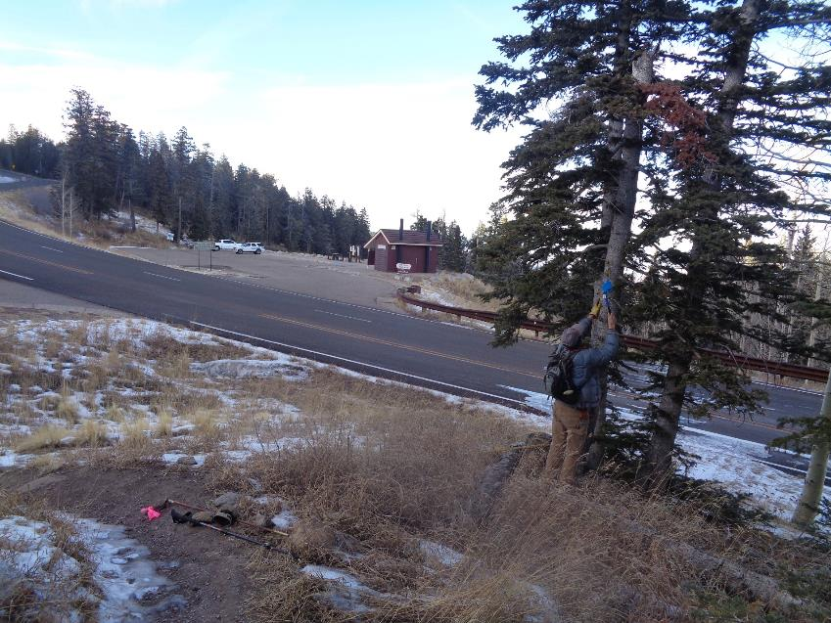

Dan nailing the last diamond on the reroute on a tree at 10K South Trailhead. The parking lot is just to the left of the photo.