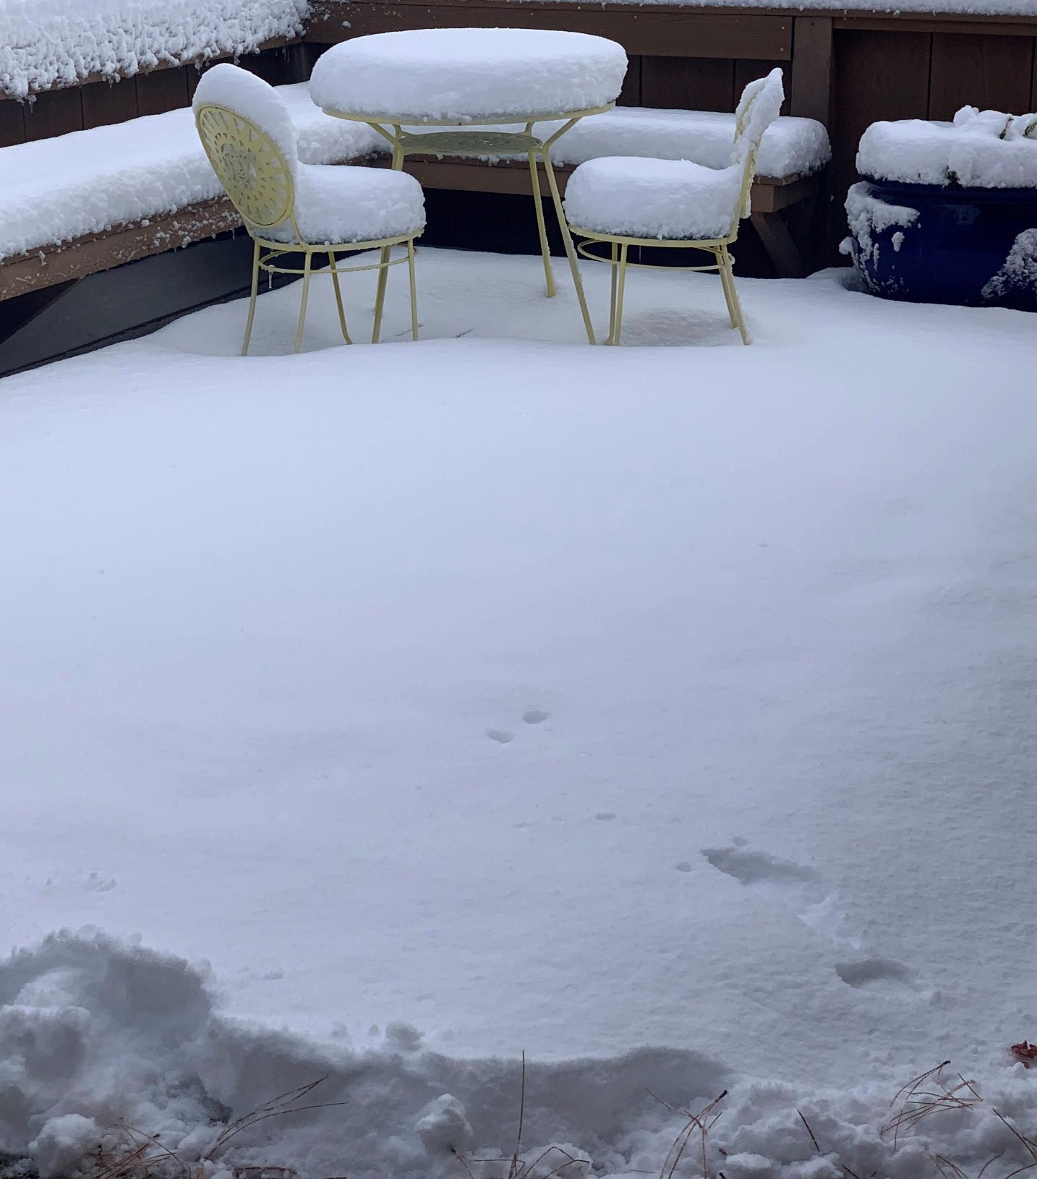

Snow at Mike and Frances Meier’s house in Los Alamos this morning, January 1, 2022.