**Report of Maintenance of Survey Ski Trail on Snowshoes on Wednesday, January 5, 2022**

Sam Beard and Byron Garner, January 6

On Wednesday, January 5, Sam Beard and Byron Garner led an outing of FOSM (Friends of the Sandia Mountains) and N. M. Cross Country Ski Club members to remove fallen trees from Survey Trail near Ellis Trailhead in the Sandia Mountains. Sam led a crew with chain saws to remove trees from the Crest Highway crossing to the Wilderness boundary. Byron led a crew with a crosscut saw to remove trees across the trail in the wilderness. The temperature was about 30F, and the snow depth was about 18 inches. The highway condition was generally good, but there were a few icy patches.

1. **Chain Saw Crew outside the Wilderness – Leader: Sam Beard.** The chain saw crew with Eric Russell, Jerry Pekarek, Lou Romero, Jerry Carroll, Dan Benton, and Neil McCasland started hiking the trail at the end of the guard rail where the trail crosses the Crest Highway. This crew carried two gasoline powered chain saws and one battery powered chain saw. A total of 20 down trees with diameters up to 12 inches were removed. Dan used the Husqvarna battery-powered saw to cut several logs, and about half of the energy of the first battery remained when he completed his work. The largest log that this crew cut was between the power line and the wilderness boundary. (Sam Beard)
2. **Crosscut Saw Crew in the Wilderness – Leader: Byron Garner.** The crosscut saw crew with Rav Nicholson, Paul Karas, and Dave Gabel snowshoed past the power line and began removing down trees in the wilderness segment of the trail. A short distance beyond the boundary we encountered a 24" Engelman Spruce across the trail which resulted in a 3-hour and 3-cut effort to remove.  The little remaining time was applied to limbing an estimated 20" fir and clearing the debris which left the trail reasonably passable. (Byron Garner)

Project photographs are presented below.

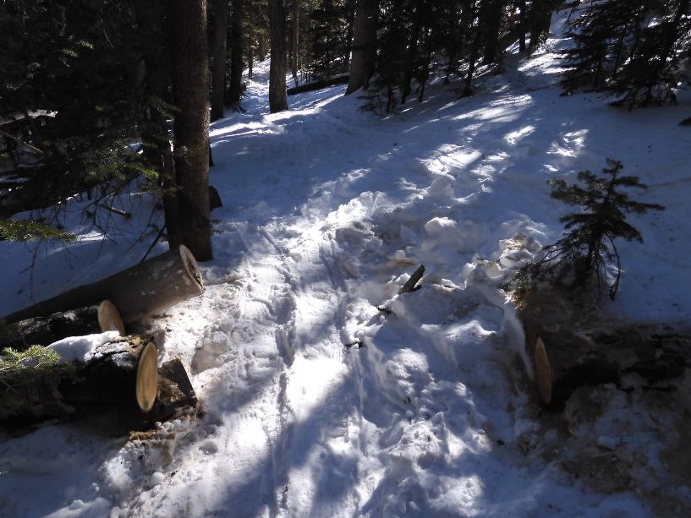

These two 8-inch logs outside the wilderness were cut with a chain saw. Photo by Dan Benton

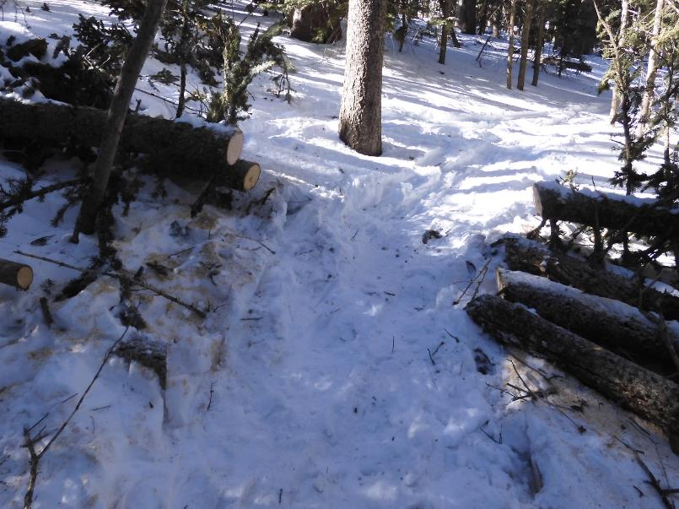

A group of three logs (2-inch, 4-inch, and 5-inch) were cut at this site. Photo by Dan Benton

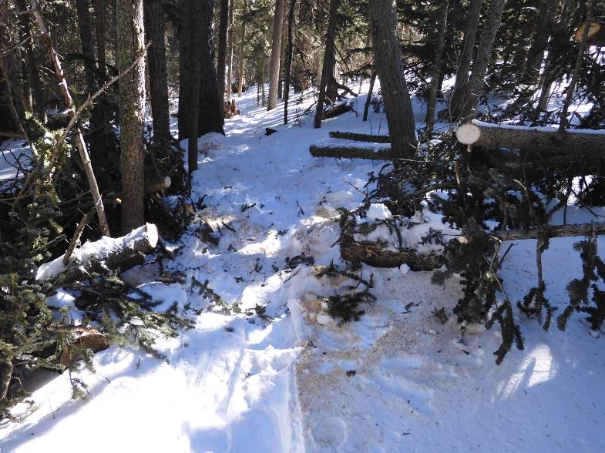

Two small fir trees were cut here, and numerous branches were cut. Photo by Dan Benton

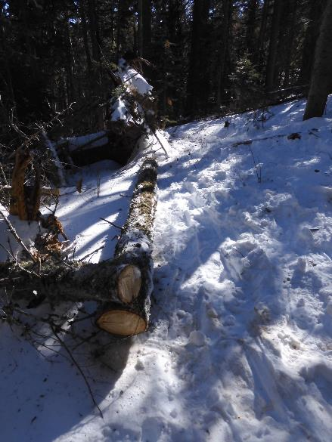

This log was cut and moved from the trail tread. Photo by Dan Benton

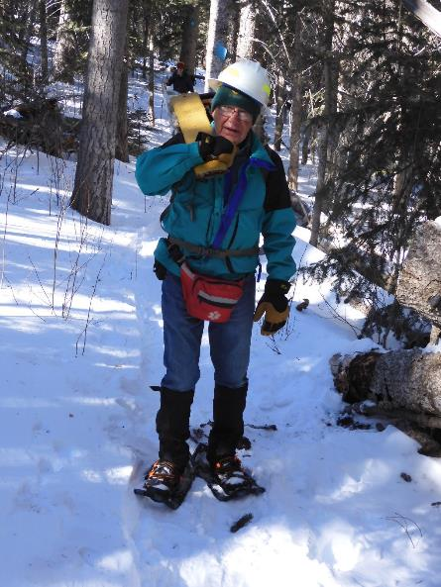

Jerry Pekarek carrying a gasoline chain saw back to the trailhead, Photo by Dan Benton

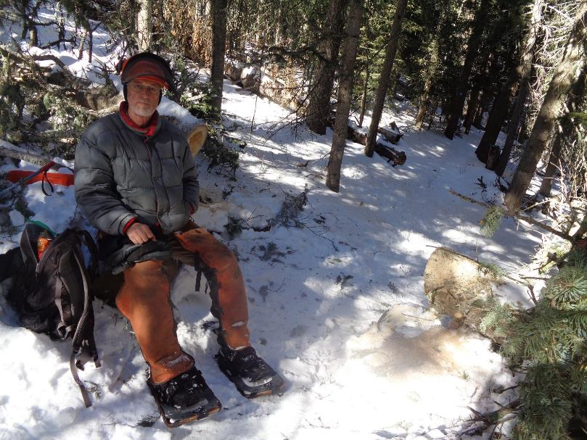

Dan Benton preparing to have lunch just outside the wilderness near the power lines. Photo by Sam Beard

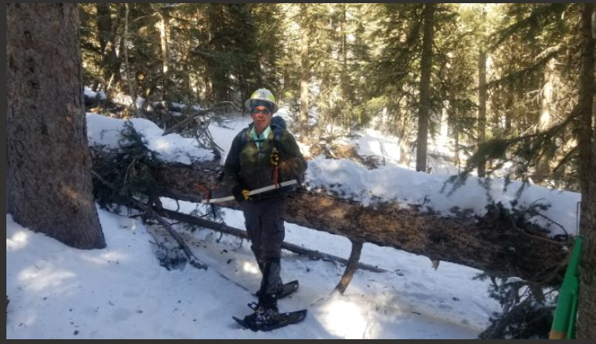

Dave Gabel at the 24-inch Engelman spruce in the edge of the wilderness. Photo by Paul Karas

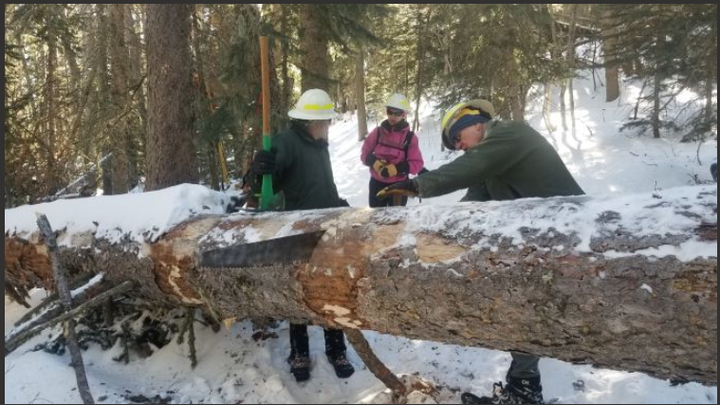

L to R: Bryon Garner, Rav Nicholson, and Dave Gabel who is bucking the large spruce with a crosscut saw. Photo by Paul Karas

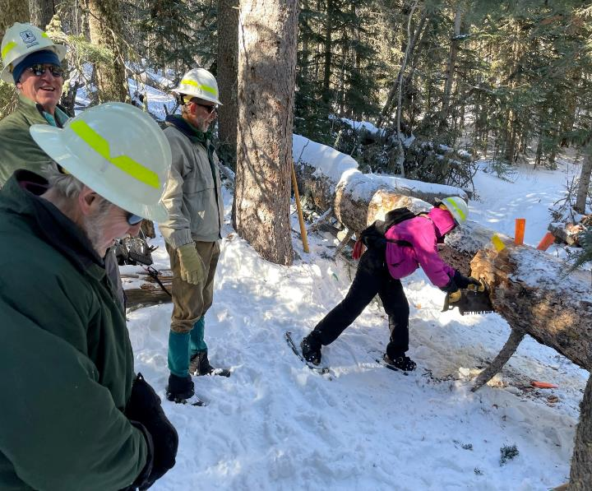

Byron, Dave, and Paul supervising Rav who is completing the bucking of this large log. Photo by Neil McCasland

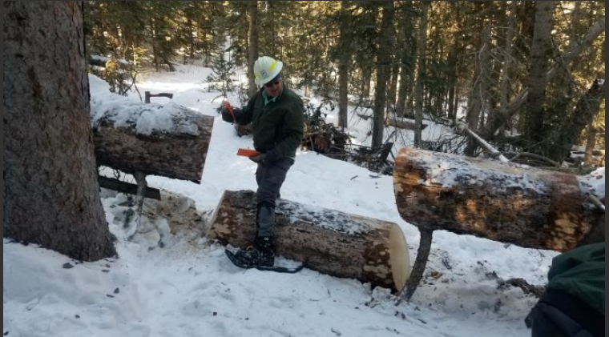

Dave Gabel retrieving the bucking wedges after the cuts were completed. Note that the cuts were made at an angel so that the log would fall away from the

remaining segments of the log and not bind. Photo by Paul Karas

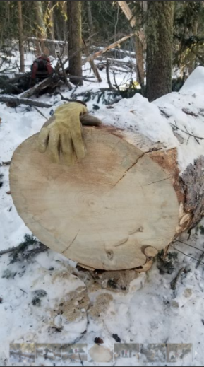

One end of the cut log. Note the glove that was included to show the scale of the photo and the large diameter of the log.

Photo by Paul Karas

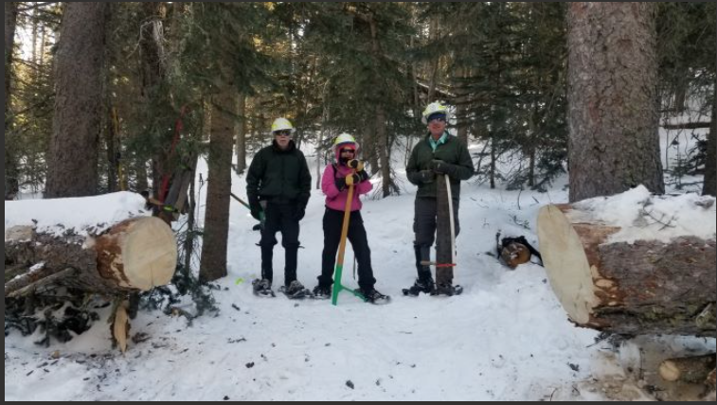

L to R: Byron, Rav, and Dave. Bucking the large log was completed with the crosscut saw, and the trail is open. Photo by Paul Karas

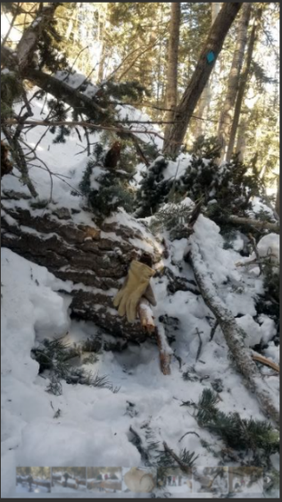

A very large log in the snow with many branches. Note the glove in the photo to show scale

and that the diameter of the log is approximately three to four times the length of the glove.

Photo by Paul Karas

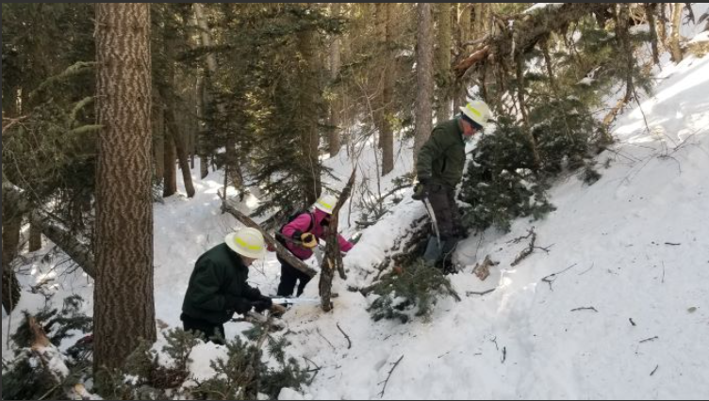

L to R: Byron, Rav, and Dave cutting branches off the large log. Photo by Paul Karas

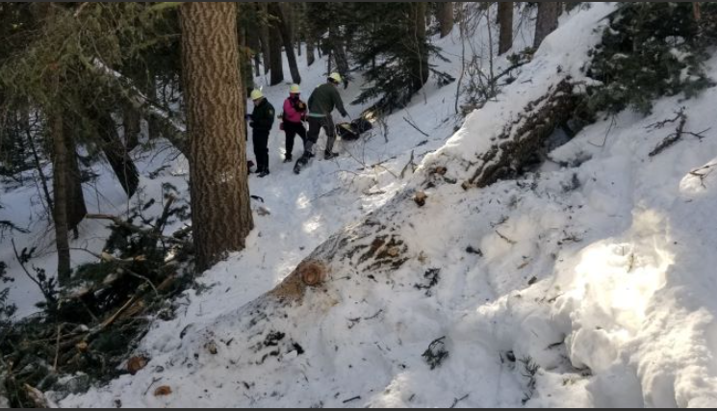

All the branches in the trail corridor have been removed, and skiers will be able to ski over the lower part of the log on the left.

Photo by Paul Karas