Report of Removal of Logs across Coyote Call Trail on the Valles Caldera National Preserve

on Saturday, January 29, 2022

Sam Beard and Michael Arndt, February 2, 2022

On Saturday, January 29, 2022, Michael Arndt and Sam Beard skied clockwise around Coyote Call Trail on the Valles Caldera National Preserve and removed six down trees from the trail. We used skins while skiing up the steep east segment. The largest diameter was about 8 inches. Approximately a dozen large trees remain on the trail. A few are about 16 inches in diameter and are in the snow. Several other somewhat smaller trees remain, and it is possible to ski around most of them. Many of these trees fell during the high wind event a few weeks ago. We thank Alan Shapiro for photos and location information about these trees that let us know what was in front of us as we skied. Also, thanks to Dave Gabel for removing all the down trees from the lower segment of the trail. The excellent fresh snow was about 4 inches deep. About four families snowshoed past us, and the groups included several children. We saw no other skiers.

The photos below show our cutting the smaller logs. We did not attempt to cut the larger logs with the time available considering that the round-trip driving time was about four hours. We were on the trail about five hours including skiing, eating lunch, and cutting logs. The day was sunny, and temperatures were fairly warm.

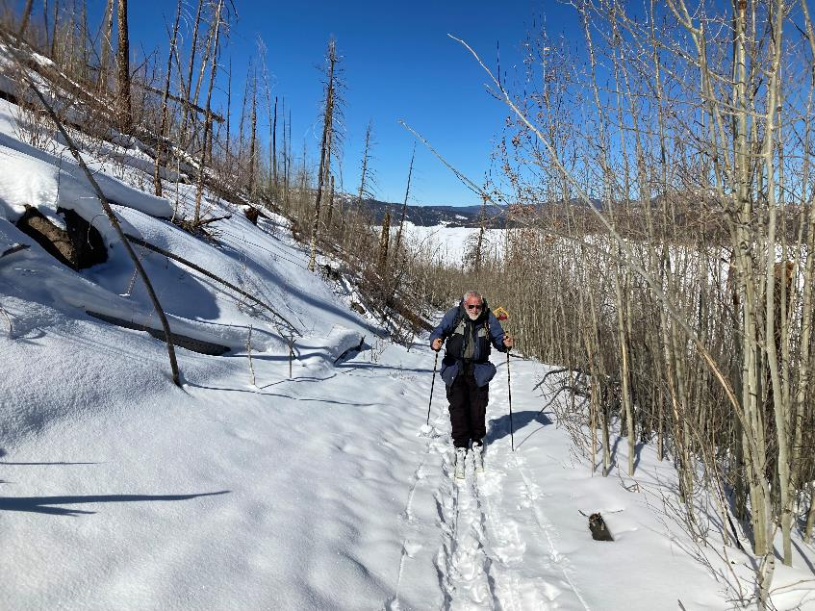

Sam skiing on the lower segment of Coyote Call Trail with Valle Grande on the right side of the photo. Photo by Michael Arndt

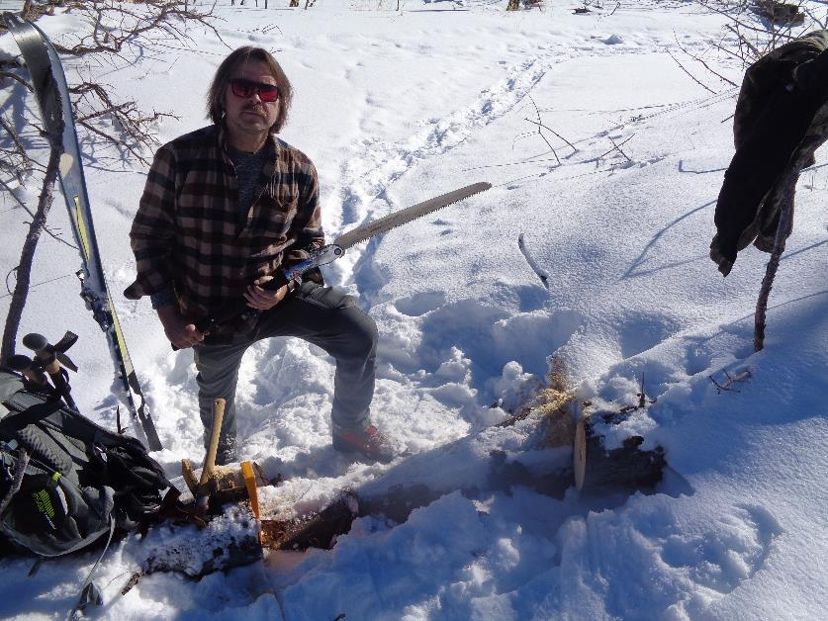

Michael cut this 6-inch log to make an easier path around a large log on his right. Photo by Sam Beard

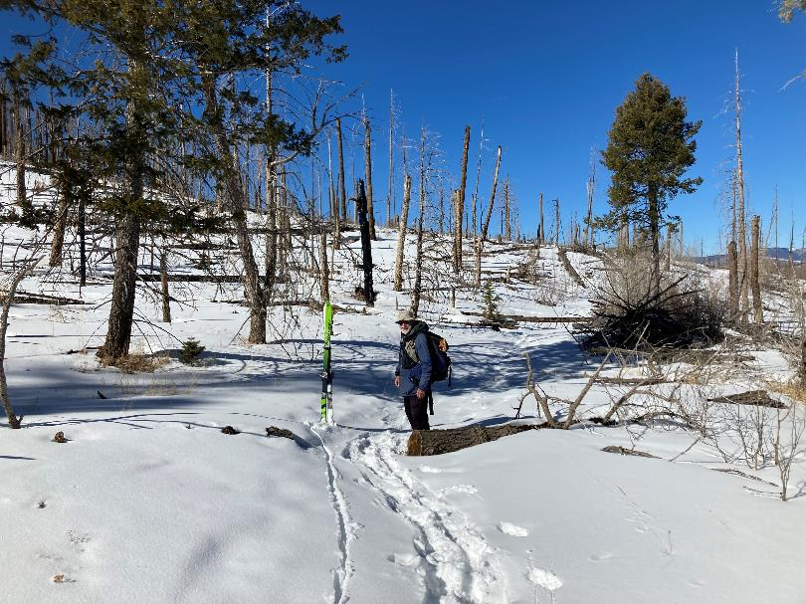

Sam at the log where we ate lunch. The route behind him is the upper level of Coyote Call Trail that goes to the west.

Photo by Michael Arndt

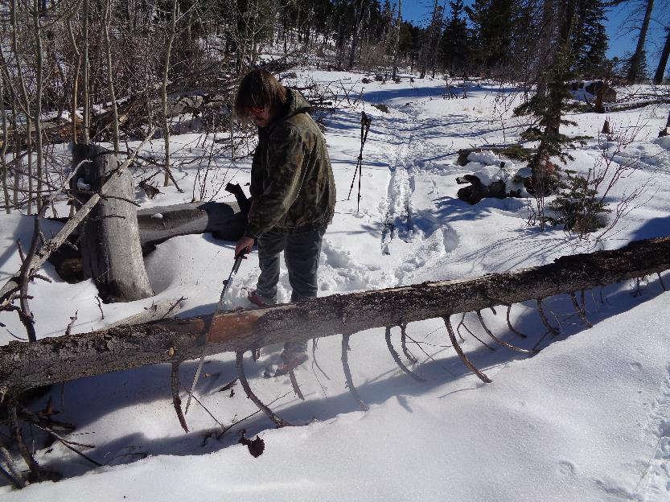

Michael cutting a 6-inch log near our lunch logs. Photo by Sam Beard

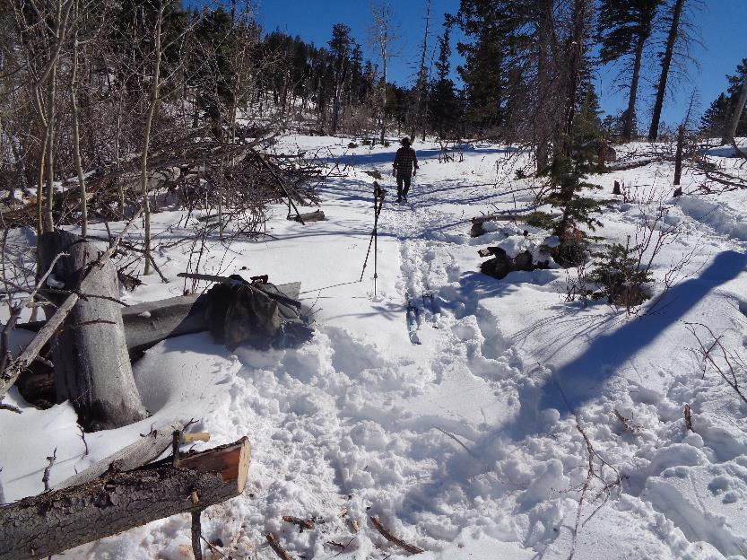

The trail is now open. Photo by Sam Beard

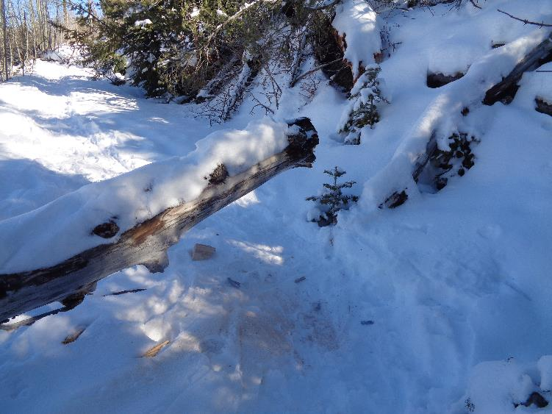

I cut the rotten end off of this log so that skiers could go around it. Photo by Sam Beard

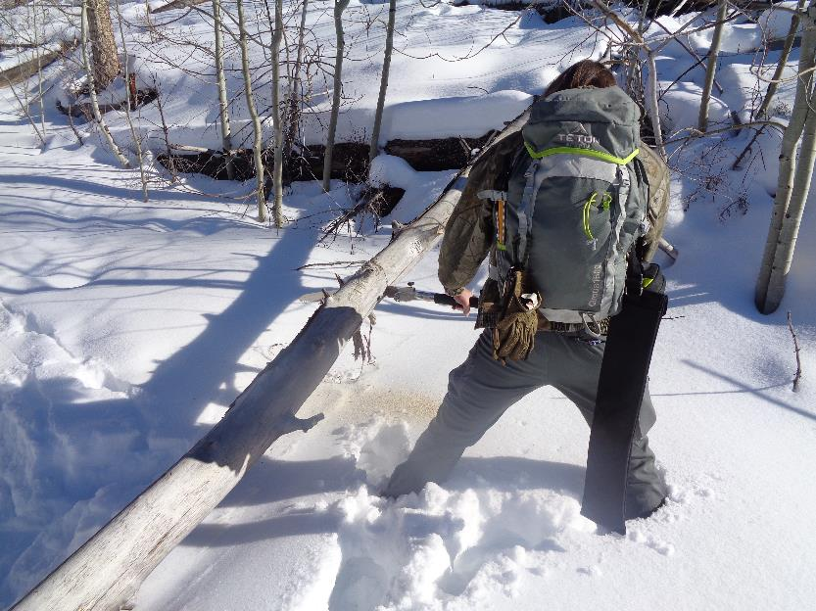

Michael cutting a 4-inch log with a Silky Katanaboy 500 saw (500 mm long blade, about 19 inches). Photo by Sam Beard

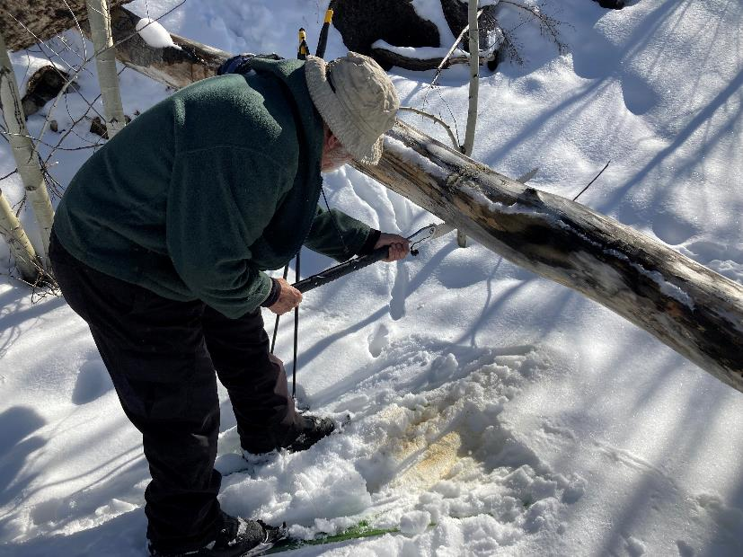

Sam making the first under bucking cut on this log that had top bind. Photo by Michael Arndt

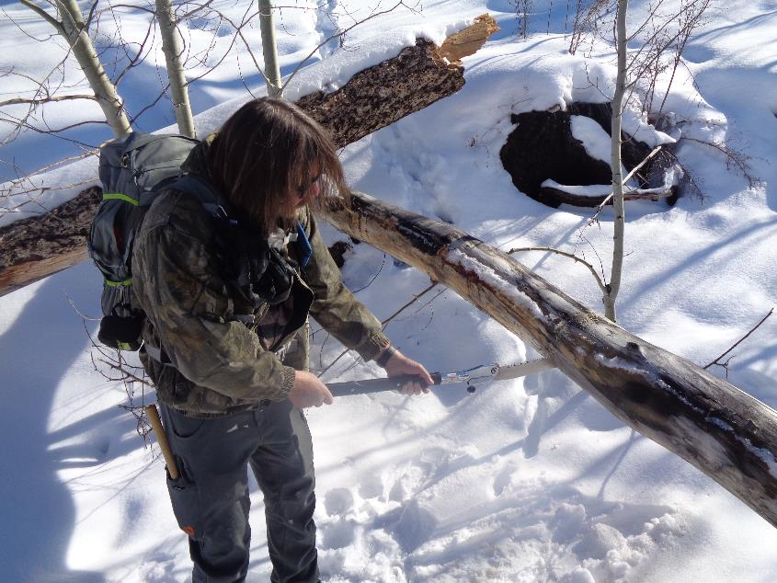

Michael completing the cut. Photo by Sam Beard

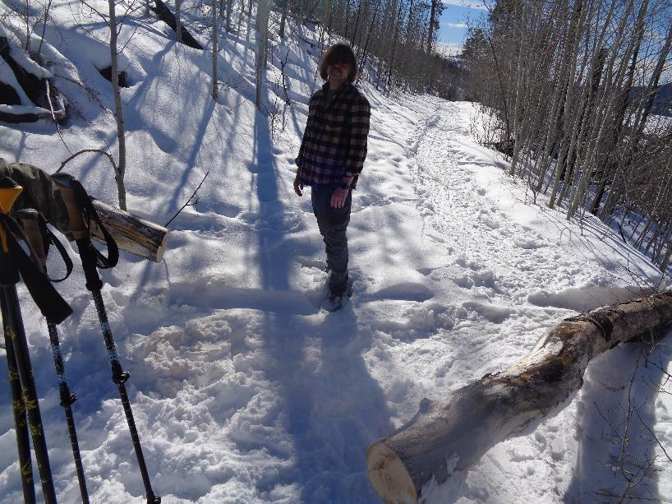

The trail is now open. Photo by Sam Beard

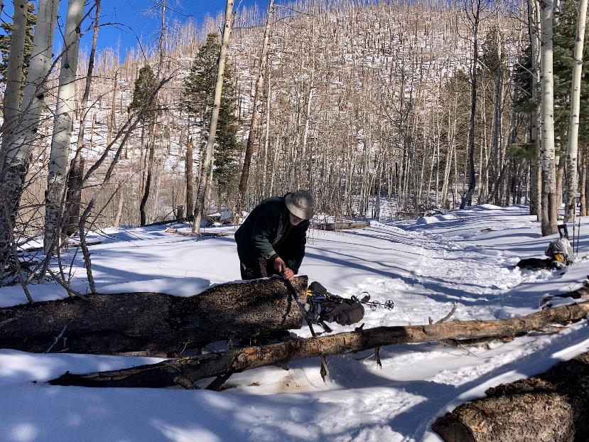

Sam making the first cut in this 5-inch log at the west end of the loop. Photo by Michael Arndt

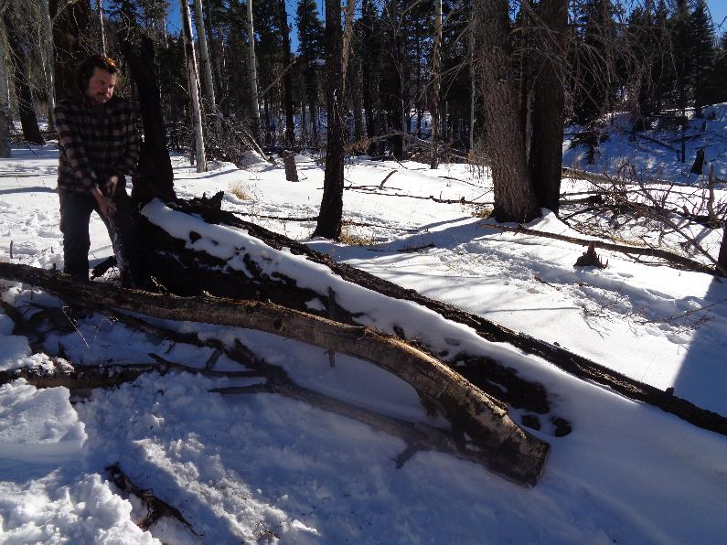

Michael dragging the log off the trail. The trail descends to the highway from this point. Photo by Sam Beard