**Report of the Outing to Coyote Call Trail on the VCNP on February 12, 2022**

Sam Beard and Michael Arndt, Feb. 13

On Saturday, February 12, Bet Gendron, Michael and Kyleen Arndt, and Sam Beard skied Coyote Call Trail and removed one log and branches on several logs so that skiers can now enjoy skiing the upper segment of this trail without removing their skis. With the branches off of the down trees, skiers may now side step over the logs. The temperature was 27F when we started skiing and 35F when we returned to the trailhead. Snow conditions on the sunny day varied from powder to crust, and the trail had been packed by snowshoers and skiers. We used skins all day to make climbing easier and to reduce our speed on the descents. We saw about 8 snowshoers and two skiers.

Photos are presented below.

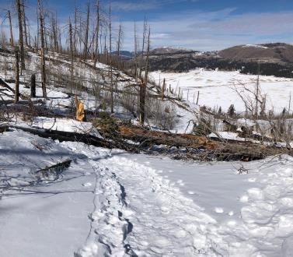

This photograph by Alan Shapiro on January 21 shows the large log across the top of the steep east segment of

Coyote Call Trail on the Valles Caldera National Preserve. When Michael Arndt and I skied this trail on January 29,

we and most of the other skiers went around the left end of this log by side stepping up and down steep slopes.

Photo by Alan Shapiro on 1-21-22.

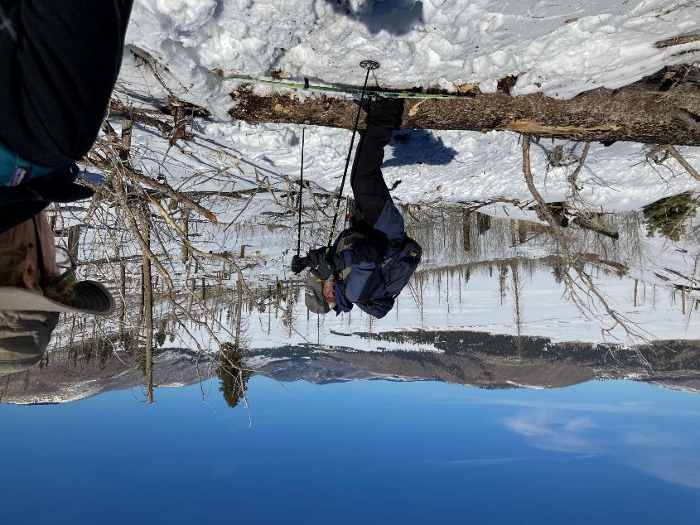

On Saturday, February 12, Ski Club members Michael Arndt and Bet Gendron removed the long branches

on the east end of the log so that it was possible to side step over the log as Sam is doing. Photo by Michael Arndt

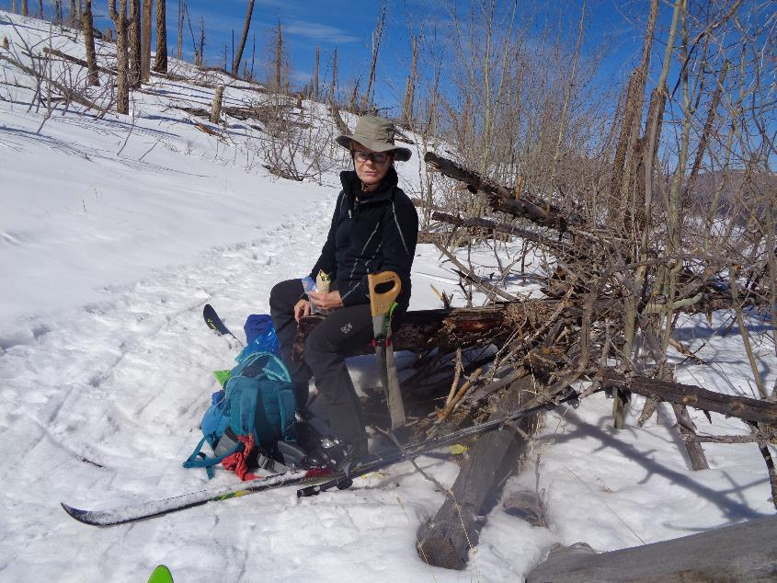

Bet Gendron eating lunch at the east end of the Coyote Call Loop Trail. All photos by Sam Beard unless noted otherwise.

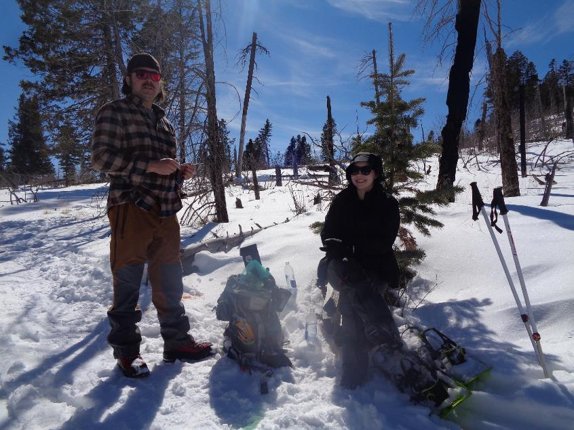

Michael and Kyleen Arndt enjoying lunch in the saddle between Scooter Peak and Rabbit Ridge.

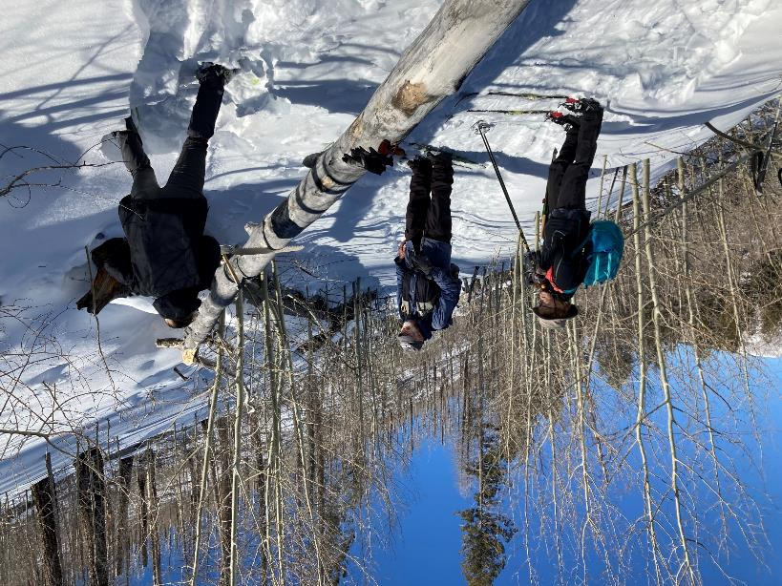

Kyleen Arndt starting to cut this log with a Silky Katanaboy 500 saw with a 19-inch blade while Bet and Sam observe. Note the dense

aspen forest growing where the Las Conchas Fire killed most of the trees 11 years ago. Photo by Michael Arndt

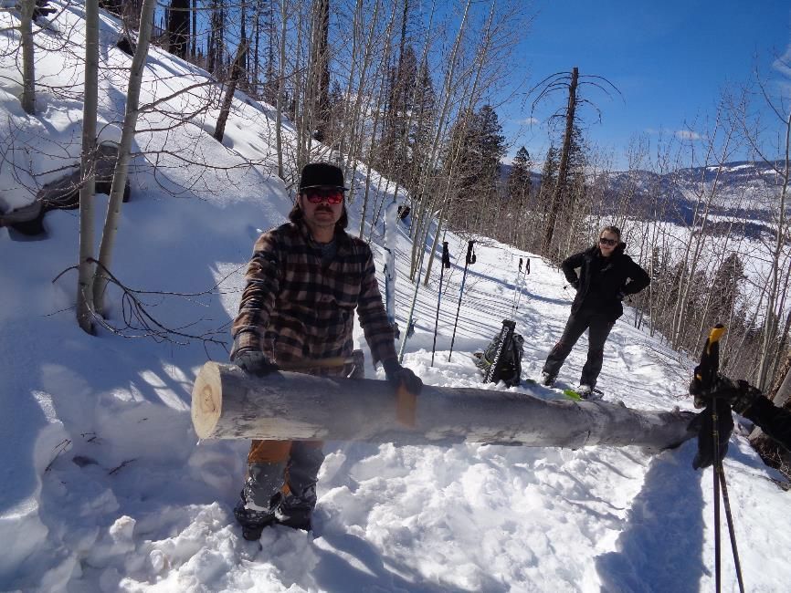

Michael at the log cut by the Ski Club members so that skiers can easily go around the log.

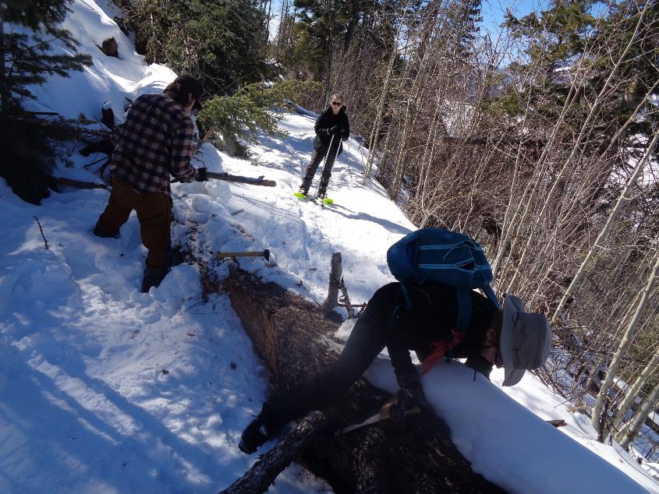

Michael and Bet removing branches so that skiers can side step over this log.

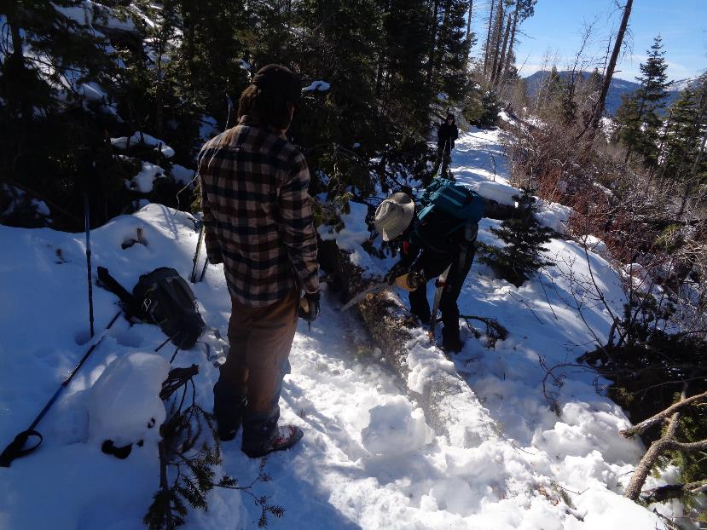

Michael and Bet removing branches from another log on Coyote Call Trail.

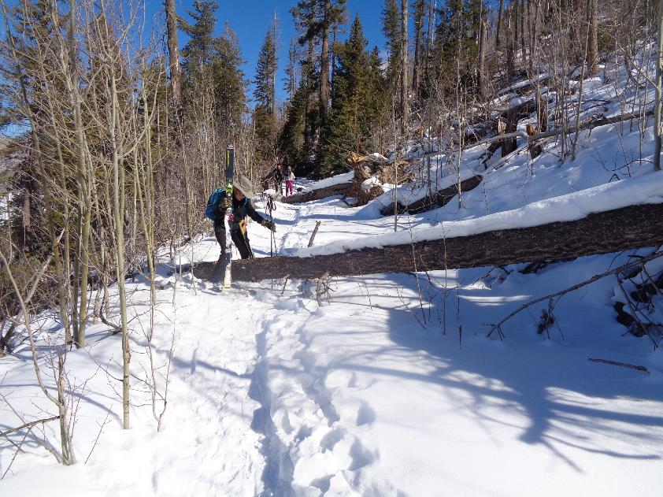

Bet stepping over this log. The two skiers in the background later passed us at the log with the large root ball.

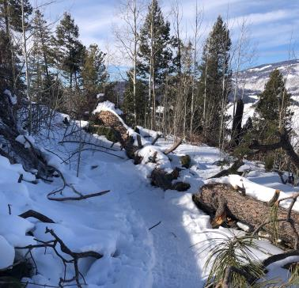

The large Ponderosa pine with a huge root ball on Coyote Call Tail. This tree had been growing on the mountainside

left of the root ball and above the road. Due to the high winds several weeks ago, the tree was blown done

to the east, and the trunk and root ball rolled down onto the road. Photo by Alan Shapiro on 1-21-22

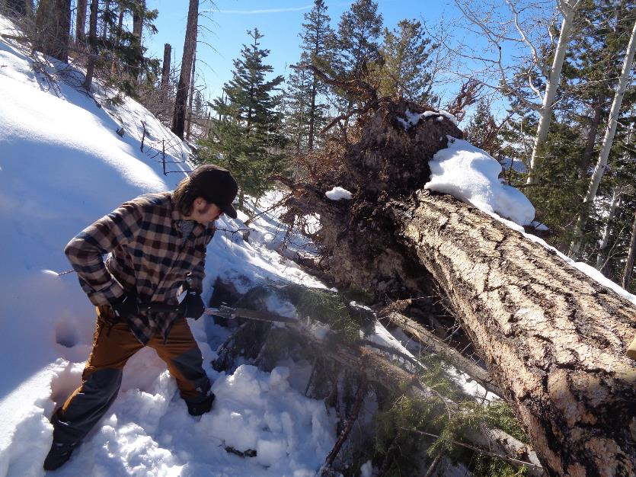

When the tree rolled onto the road, it came down on this small tree that Michael is cutting. After the small tree was removed, we cut

off some of the roots on the root ball so that skiers can easily pass the tree.

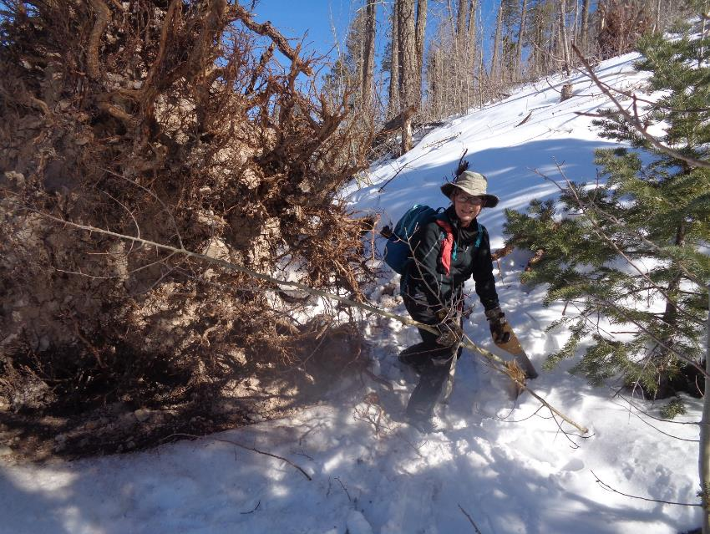

Bet removing a small aspen tree on the path around the root ball.

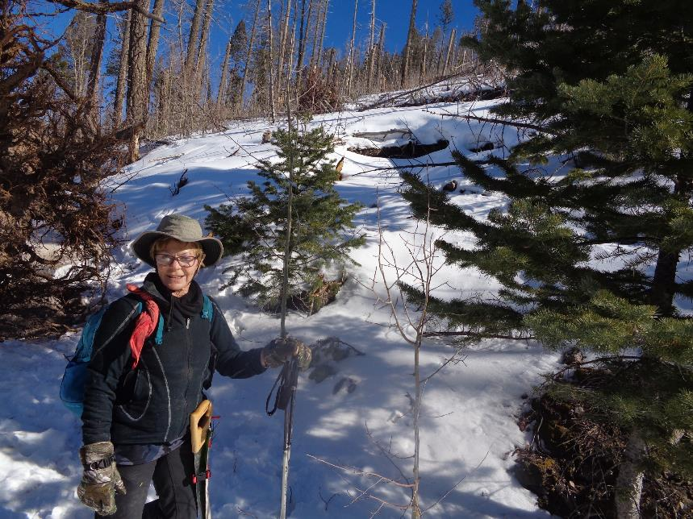

The tree was growing on the mountainside right of Bet and behind the small green tree where part of a depression can be seen.

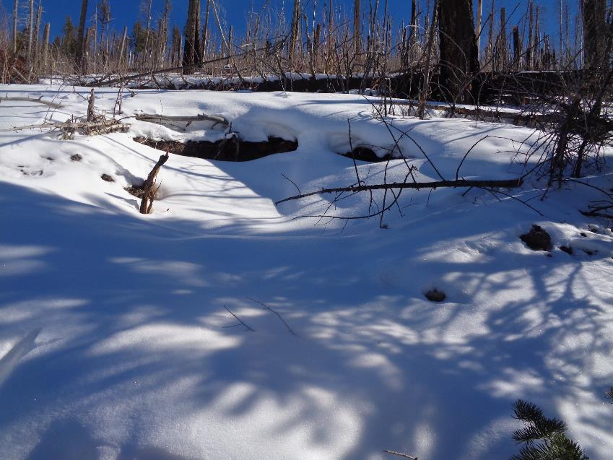

The depression on the mountainside where the root ball was located before the tree was blown over.

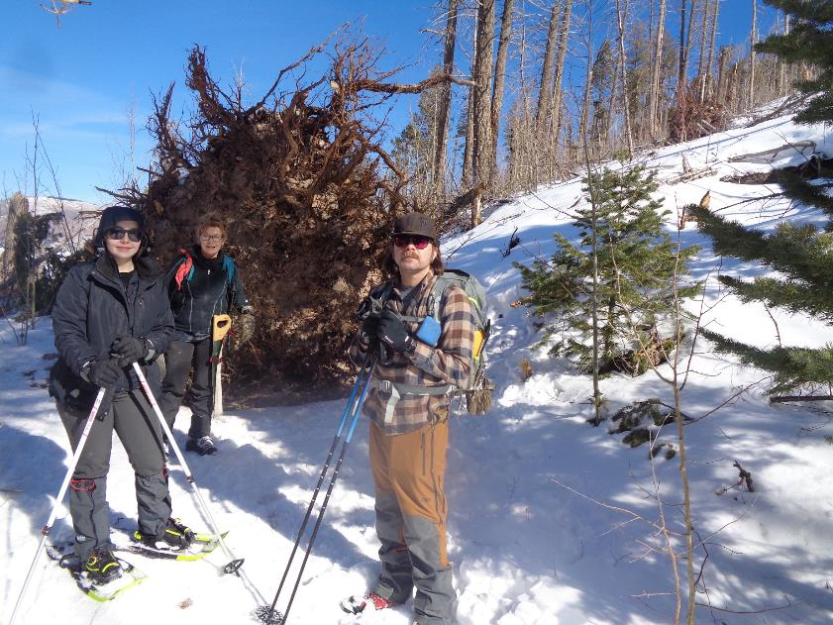

L to R: Kyleen, Bet, and Michael beside the huge root ball. The path that we cleared around the root ball is behind Michael.