Report of Exploring Easy Class I Trail on Coyote Call Meadows and Road
on Valles Caldera National Preserve on Saturday, March 5, 2022

Sam Beard and Michael Arndt, March 9
On Saturday, March 5, Michael Arndt and Sam Beard parked at the Coyote Call Trailhead on NM-4 across the highway from Valle Grande. The objective of the tour was to ski west across the meadows and on an old road in search of an easy Class I trail to add to the short list of such trails in the Jemez Mountains. Currently, the popular Class I trails are Redondo Loop Trail, Fenton Hill Road (Forest Road 144), Jemez Falls Campground Road, Frijoles Trail System on Bandelier National Park, and Missing Cabin Trail and Trails in Valle Grande on the Valles Caldera National Preserve. Advantages of the Coyote Call Meadow Trail are the higher elevation and northern exposure that mean better snow conditions and a longer ski season.
Photographs are presented below.

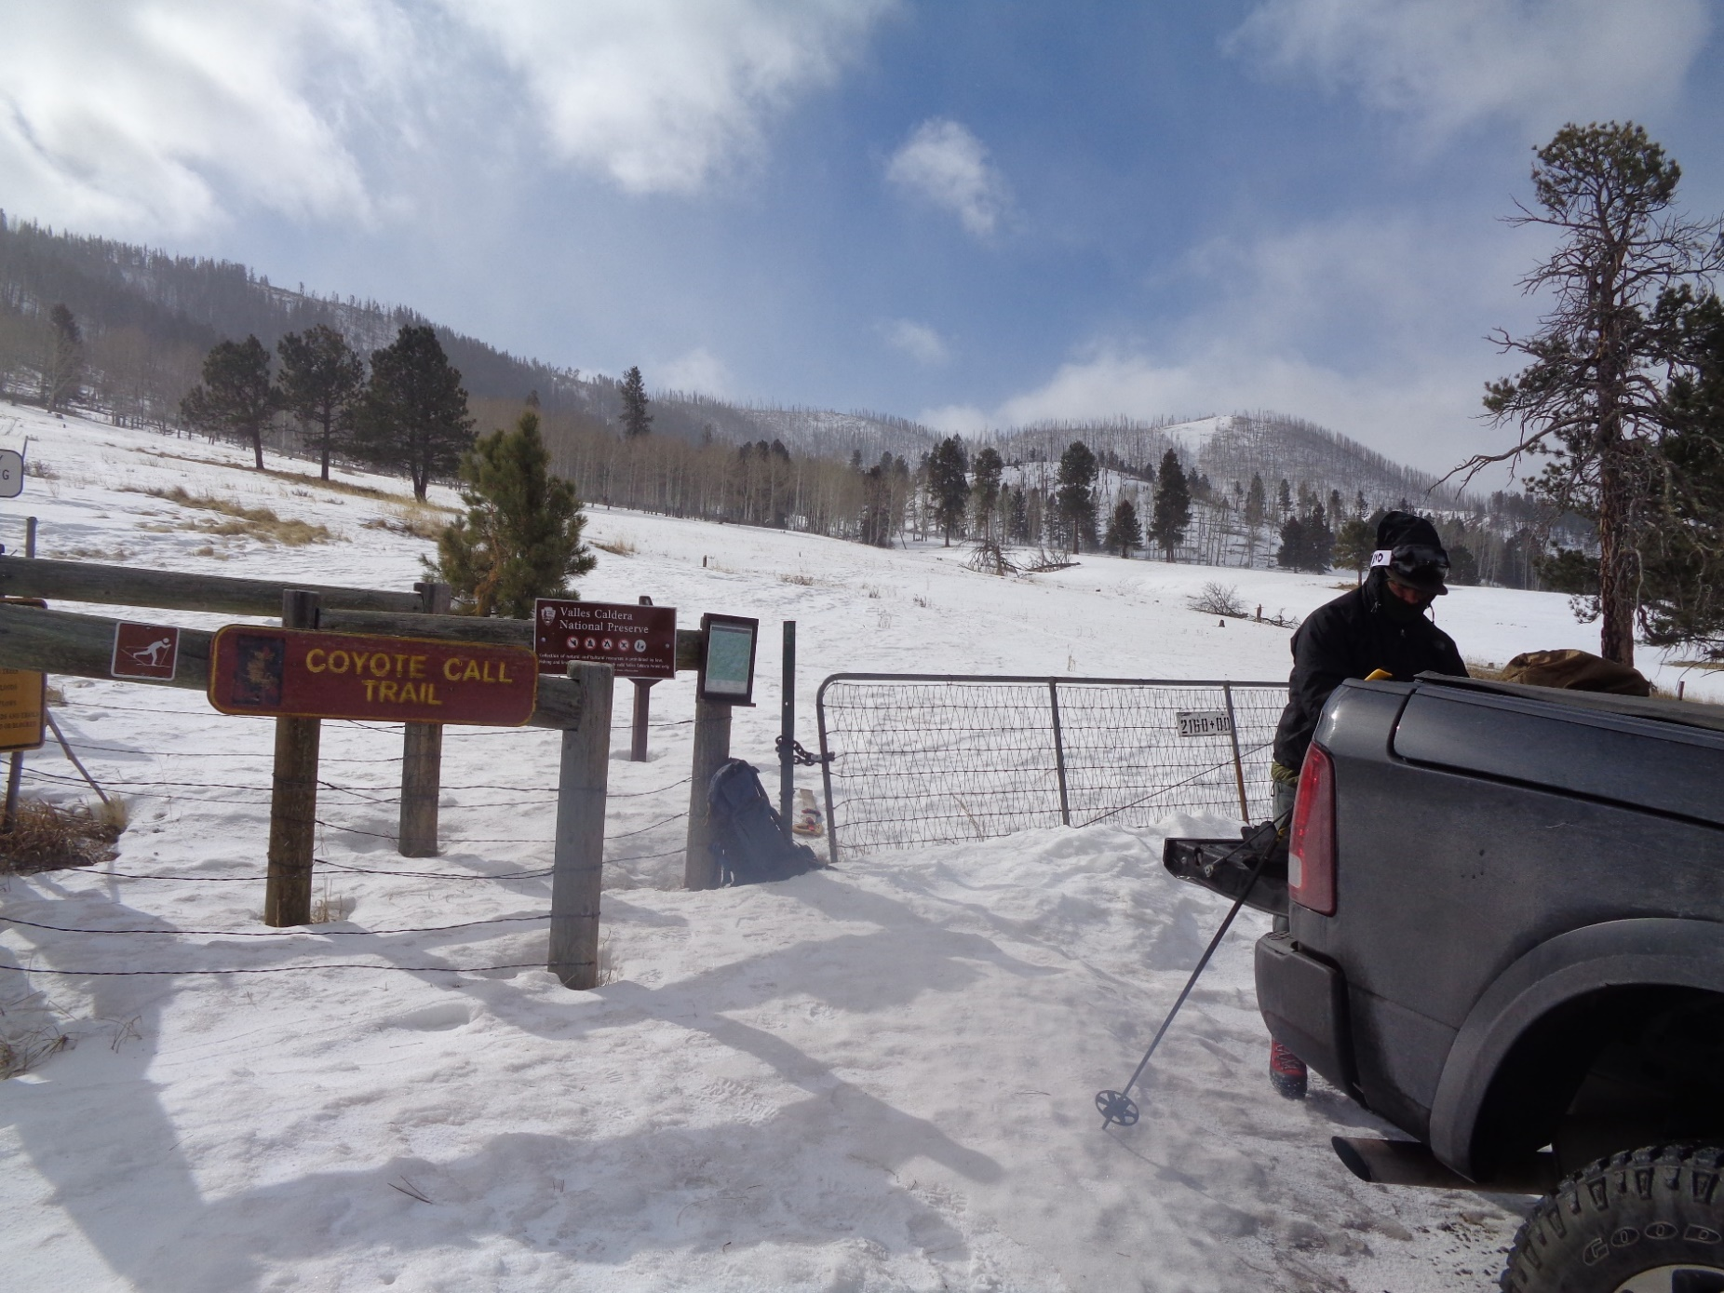
The conditions at 10 am were a temperature of 27 F, high wind, blowing snow, partly cloudy, and crusty and settled snow. We skied to
to the SW from the trailhead about one-quarter mile on the loop trail and then went to the west on an old road. As you can see, most
of the area was still covered with snow. Photos by Sam Beard unless noted otherwise
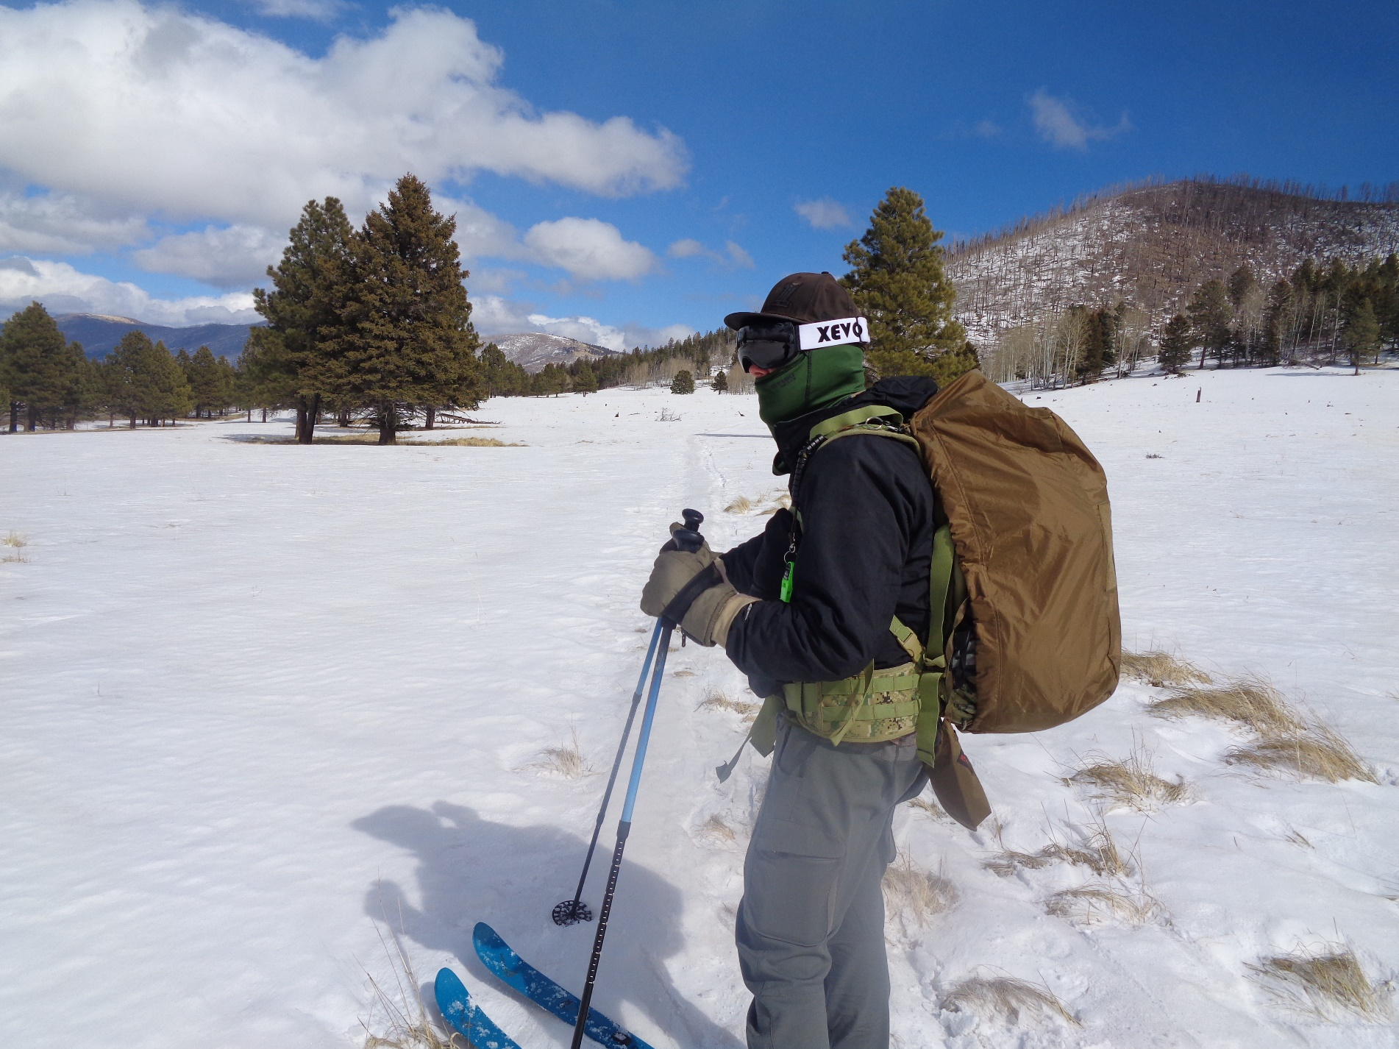
Michael was well dressed for the cold windy conditions. The meadows with gentle slopes are excellent for beginning skiers and skiers with
little experience. Also, the route is less than a quarter mile from the highway, if it is necessary for a skier to picked up by a vehicle.

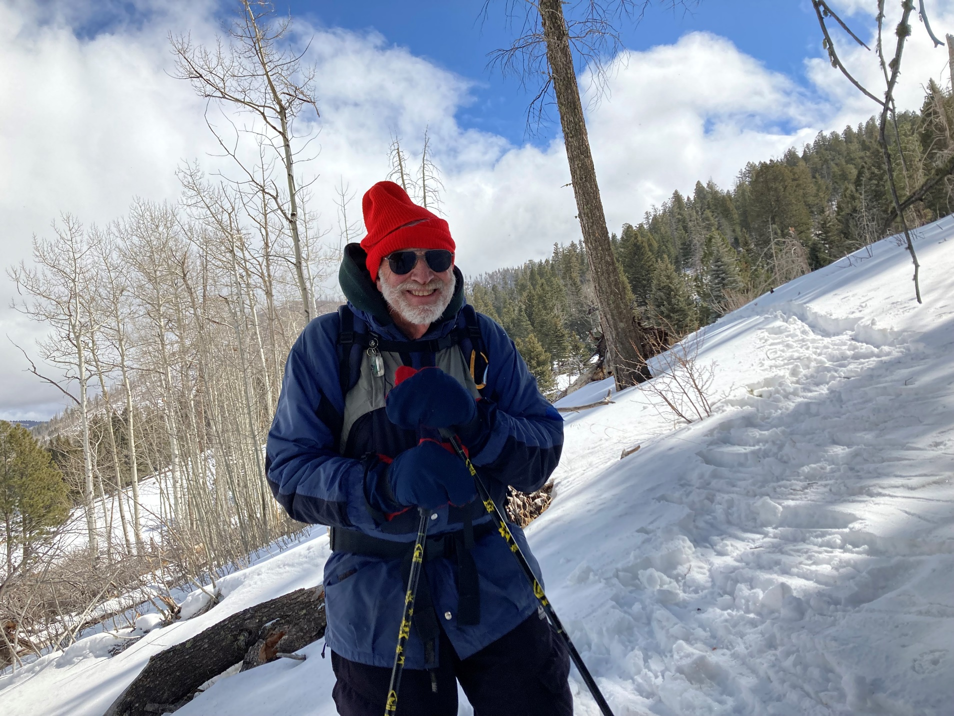
We went off the road to get around a log and had to side step down to get on it again. Photo by Michael Arndt
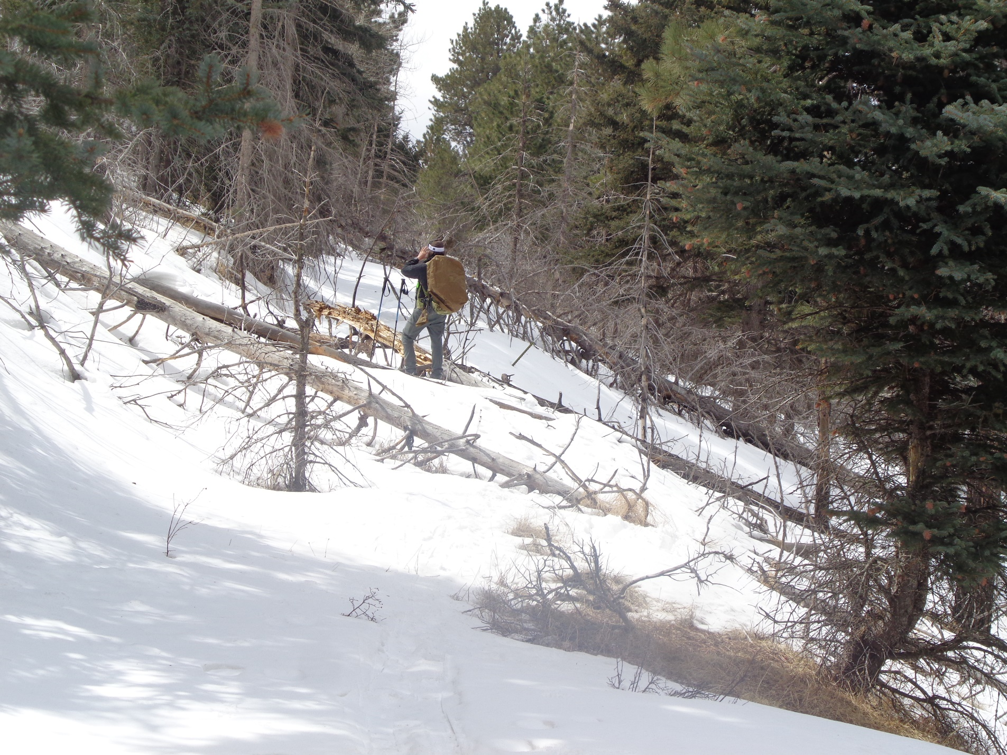
Michael on the old road where we found fallen trees. We could ski over and around these trees. Parts of these trees would be removed
before we would lead a Class I tour here.
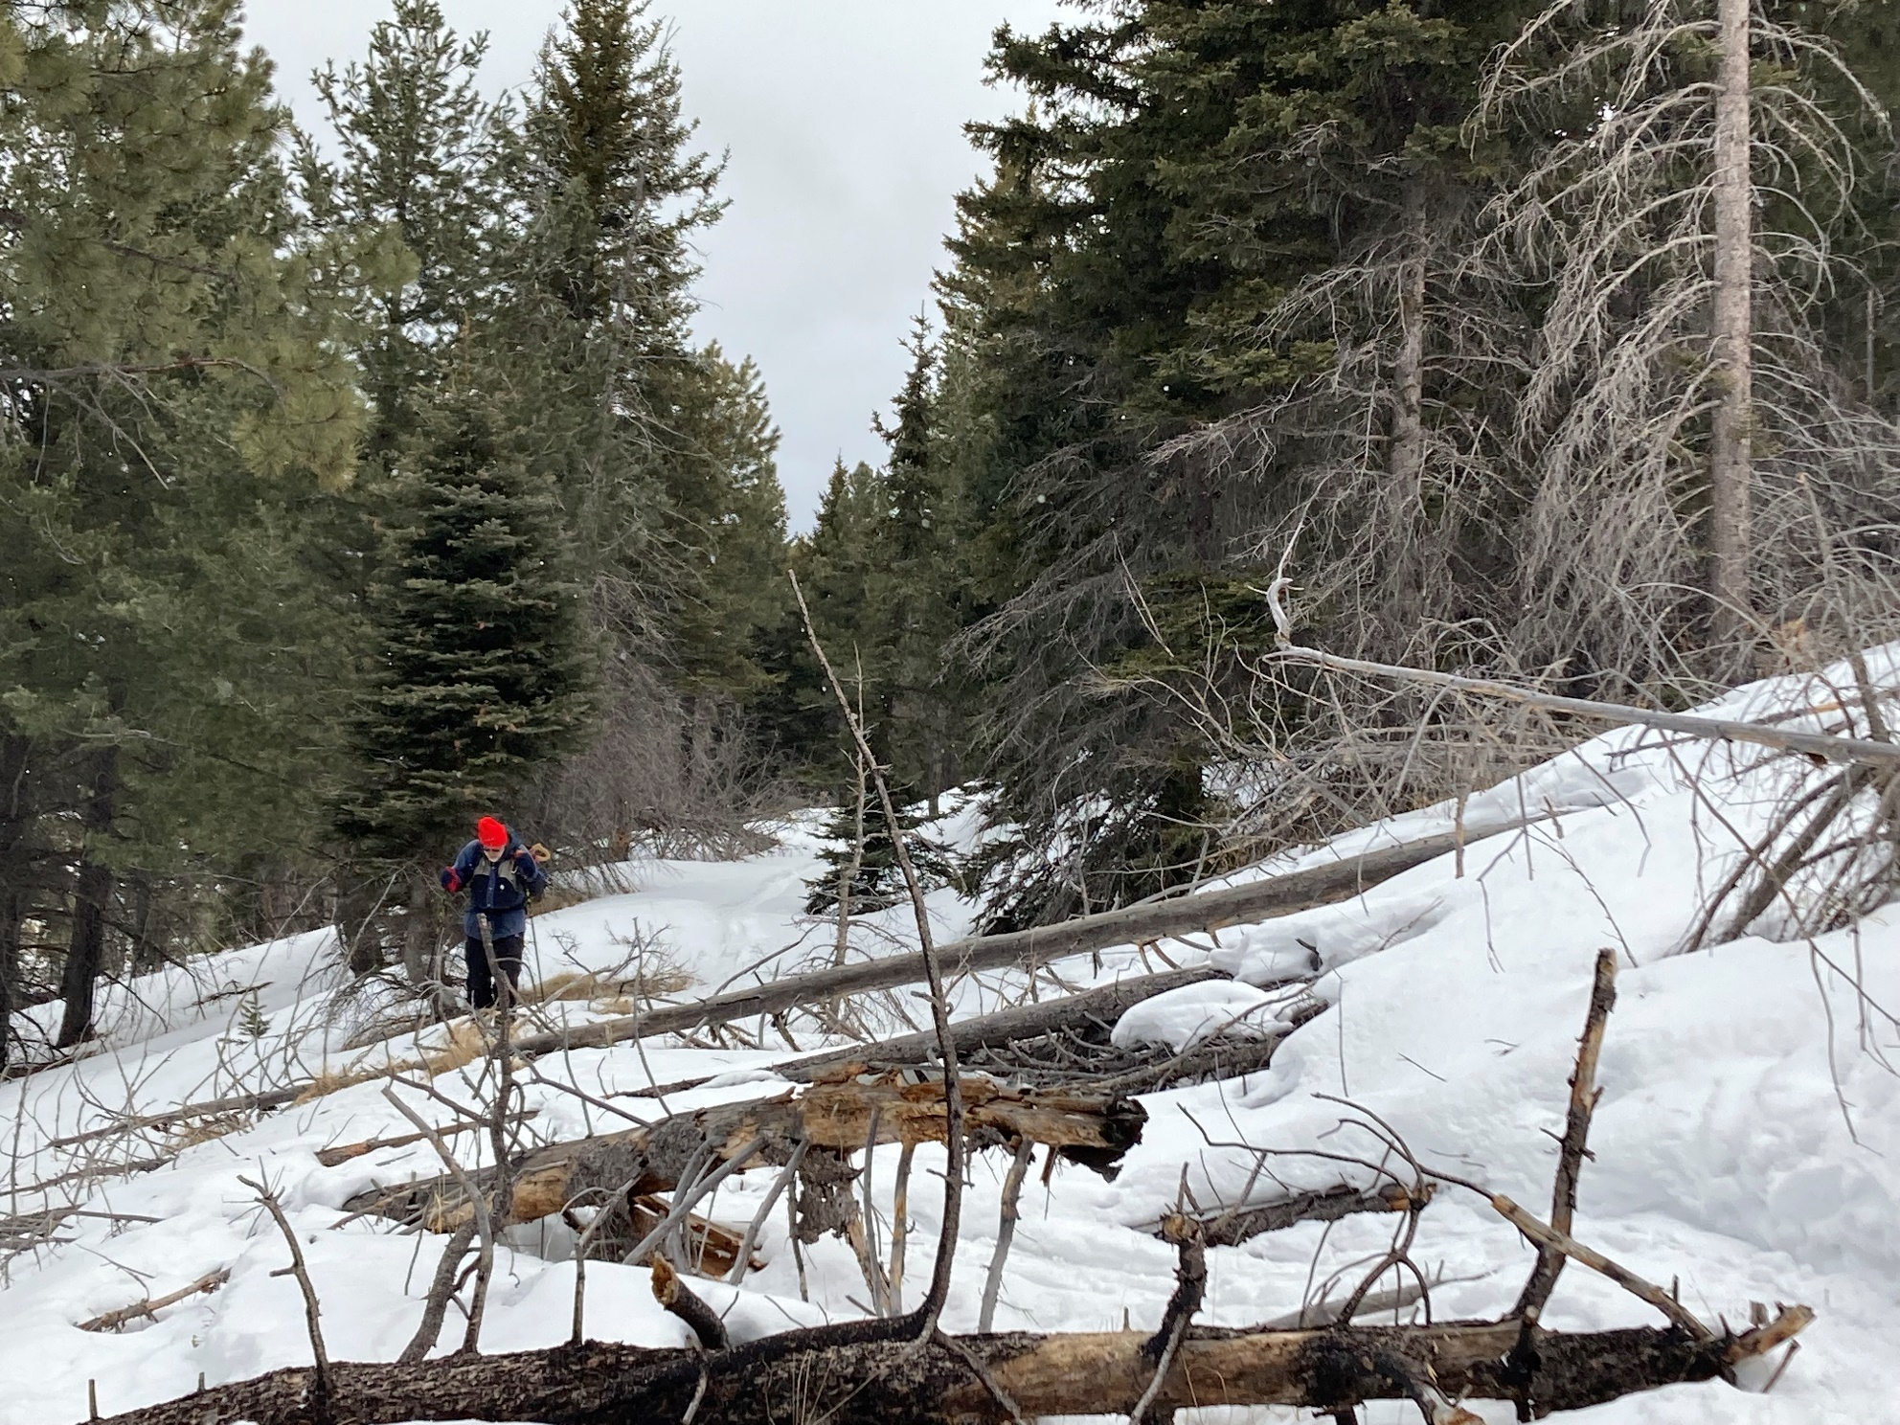
Now it is Sam’s turn to get through the obstacles. Photo by Michael Arndt
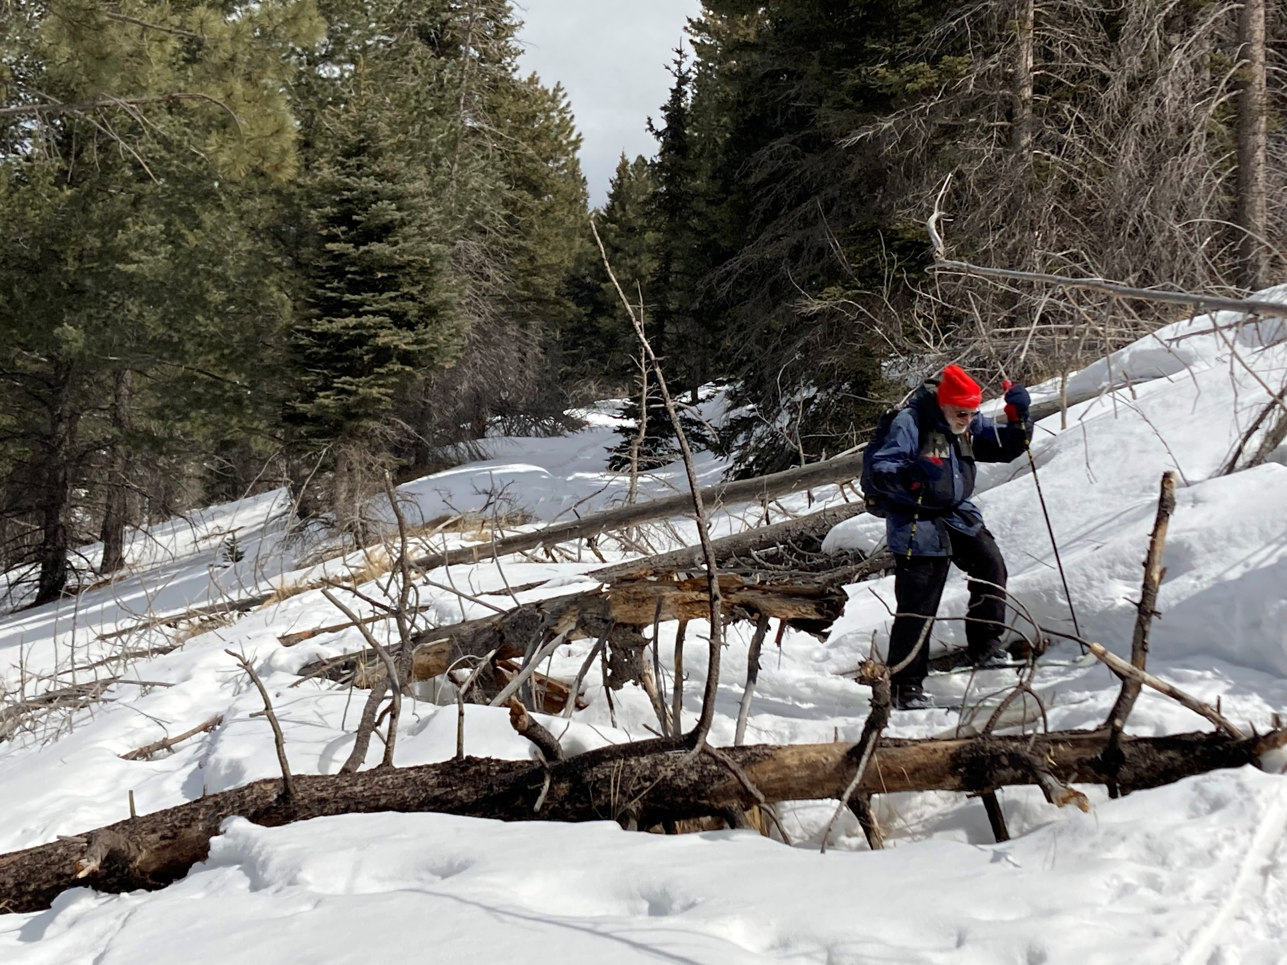
One more log to “ski” around. Photo by Michael Arndt
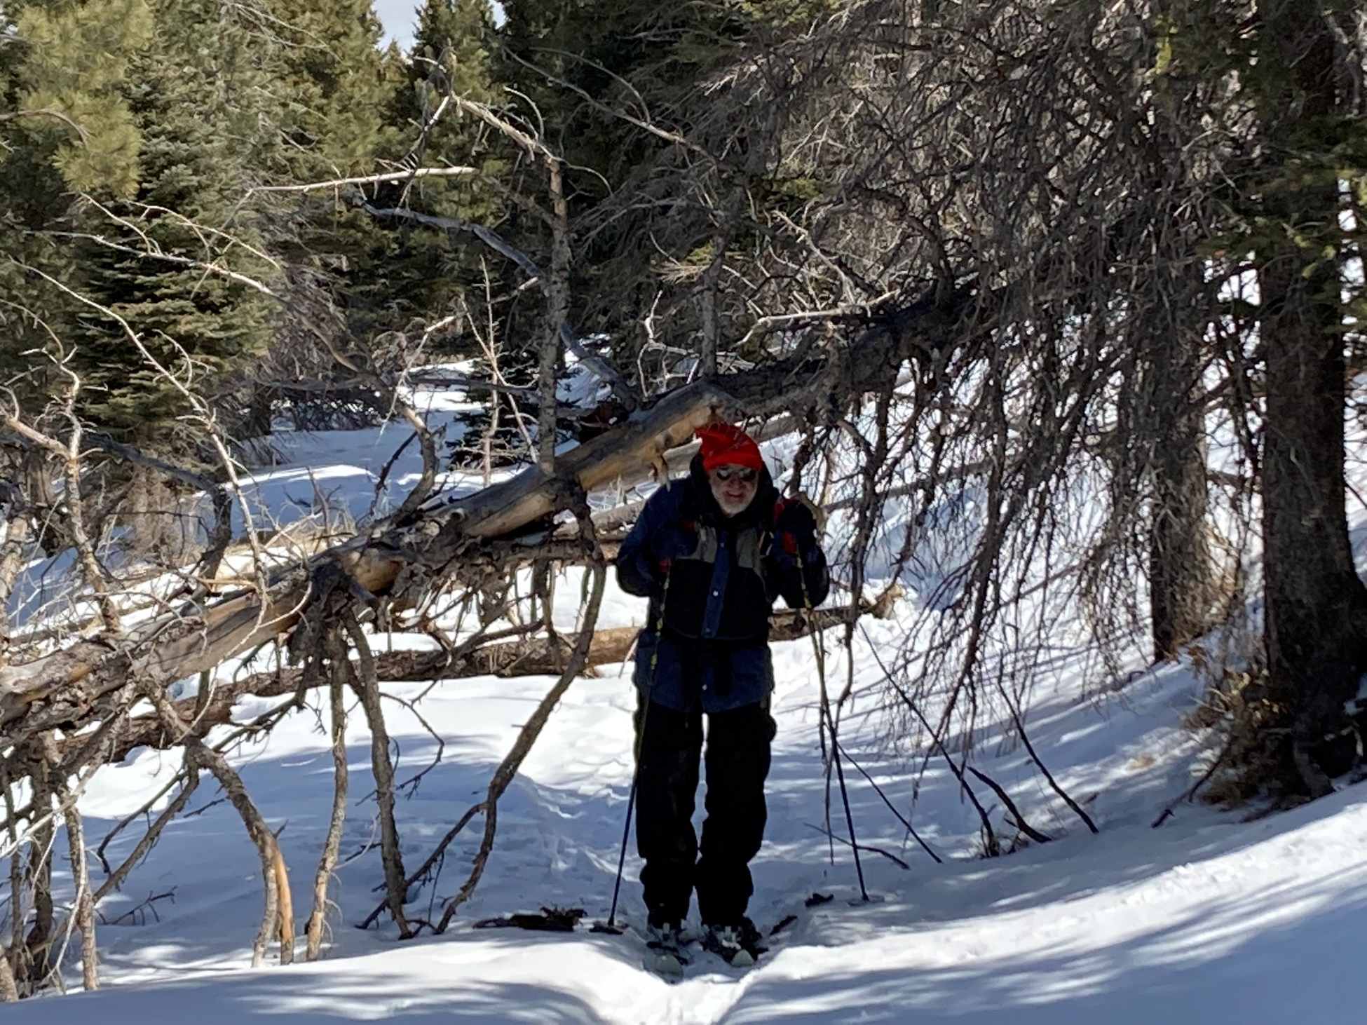
We could go under this one. Photo by Michael Arndt
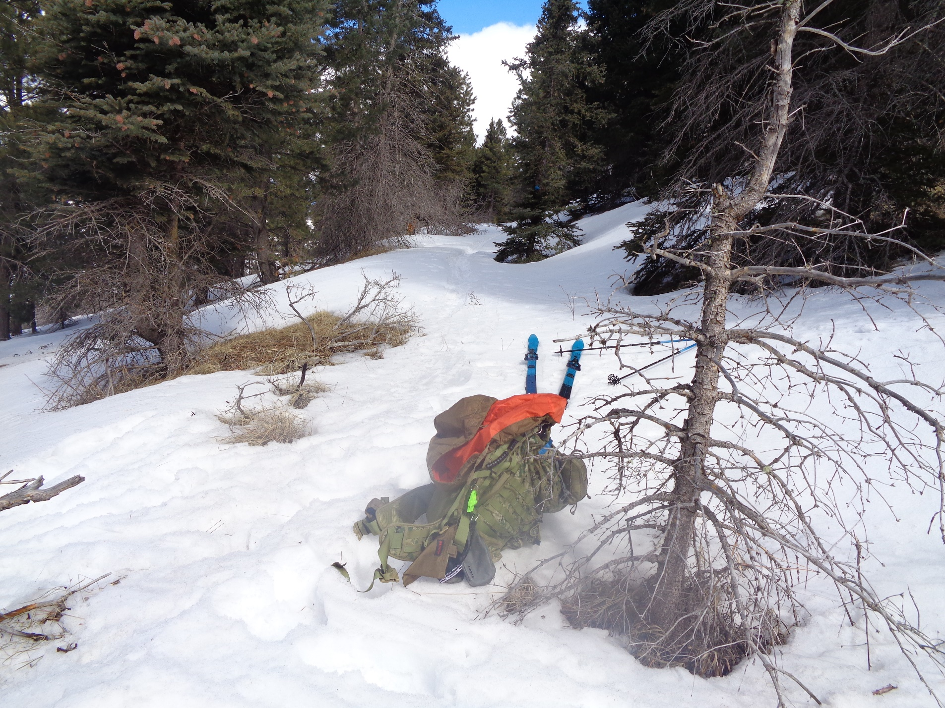
The road is wide and much of the route in the unburned forest has few fallen trees across it.
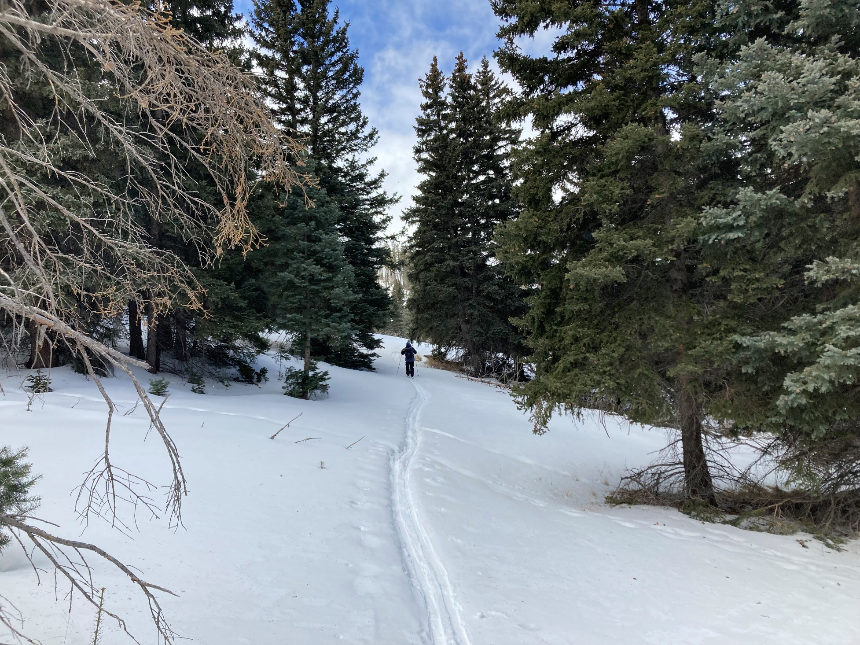
A clearing on the route. Photo by Michael Arndt
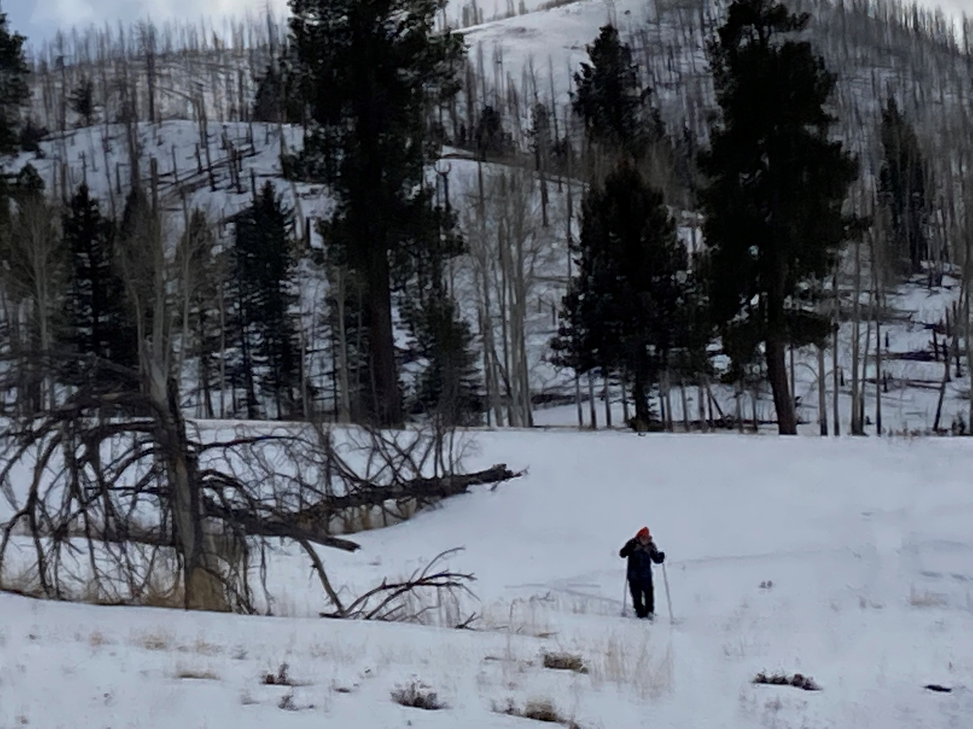
Parts of Rabbit Ridge burned in the Las Conchas Fie in 2011. This trail lies just north of Rabbit Ridge and south of NM-4.
Photo by Michael Arndt

