**Report of Maintenance of Ladera and Elk Ridge Trails on Las Griegos Mountain**

**in the Jemez Mountains on Saturday, March 26**

Sam Beard, March 28

On Saturday, March 26, Michael Arndt and Sam Beard removed twelve trees from Ladera Trail and Elk Ridge Trail on the lower part of Los Griegos Mountain. These trees fell during the high wind event in the Jemez Mountains several weeks ago. The tree diameters ranged from 2 inches to 21 inches. The first group of fallen trees was only 500 feet from the parking lot.

Project photographs are presented below.

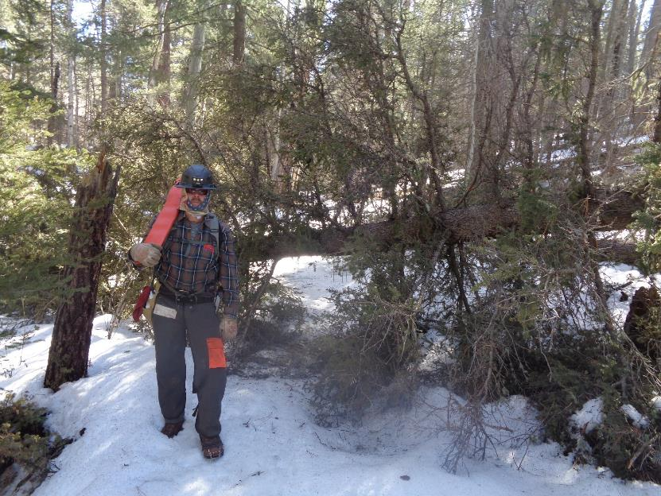

Michael Arndt at the first spruce on Ladera Trail only 500 feet from Los Griegos parking lot.

All photos by Sam Beard unless noted otherwise

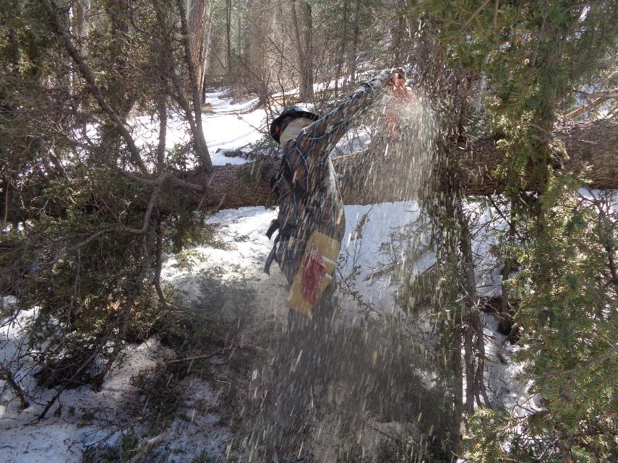

Michael cutting the first spruce on Ladera Trail.

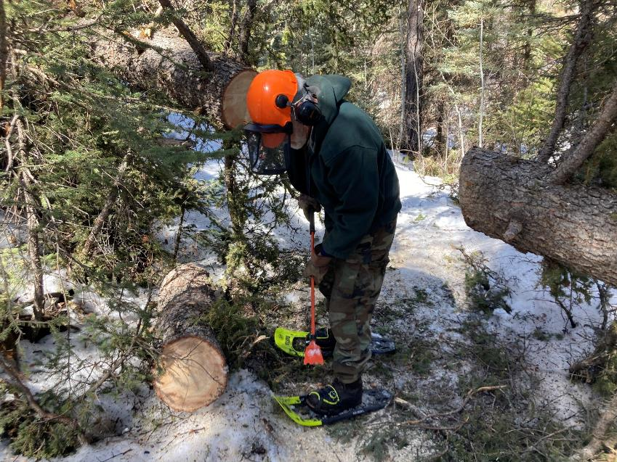

Sam has just used Michael’s short steel cant hook to roll the log off the trail. Photo by Michael Arndt

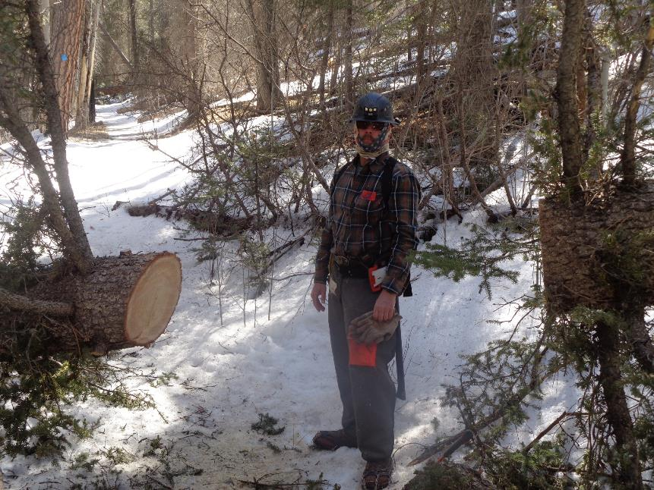

Michael at a larger spruce that he has just cut.

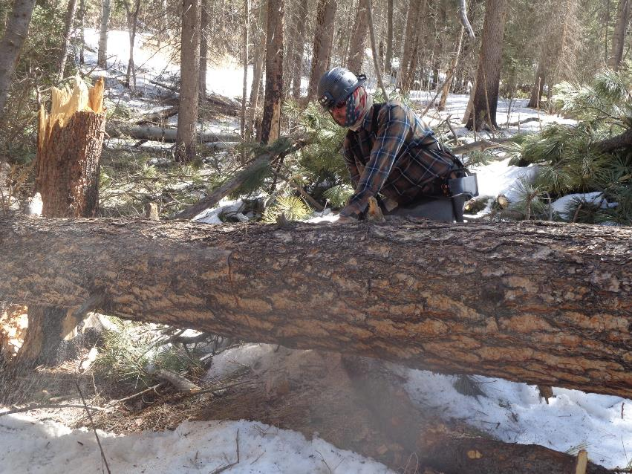

Michael making the first cut in a 21-inch diameter pine across Ladera Trail.

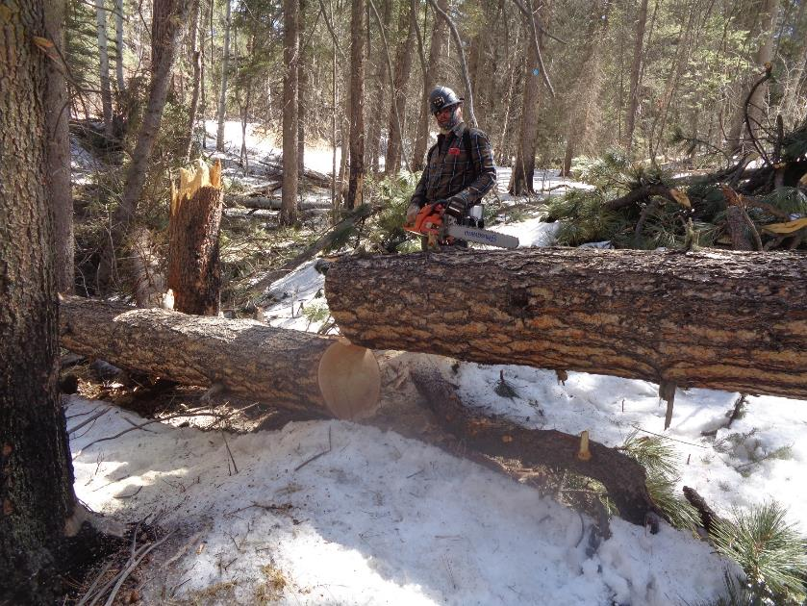

Michael has just completed the first cut in the large pine. Note that the cut was made at an angle so that the top part of the tree

could fall away from the larger trunk on the right.

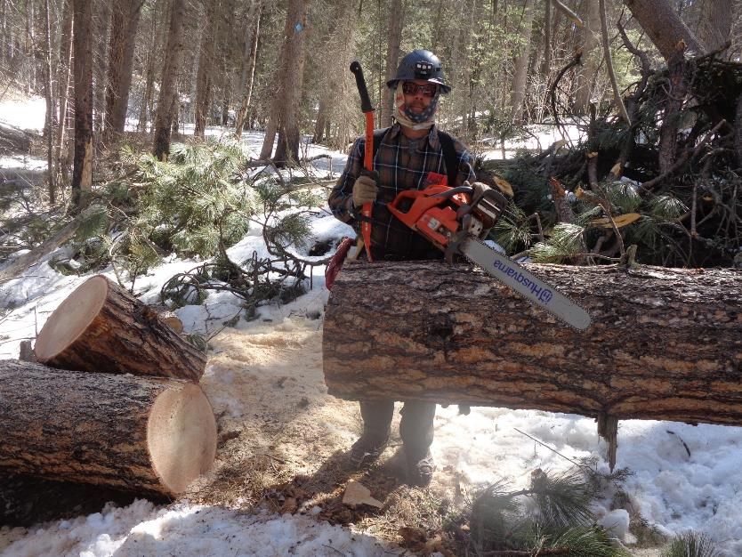

Michael has completed cutting an opening in this large pine. Note the large pile of pine branches behind Michael. Another large

trunk lies below the branches.

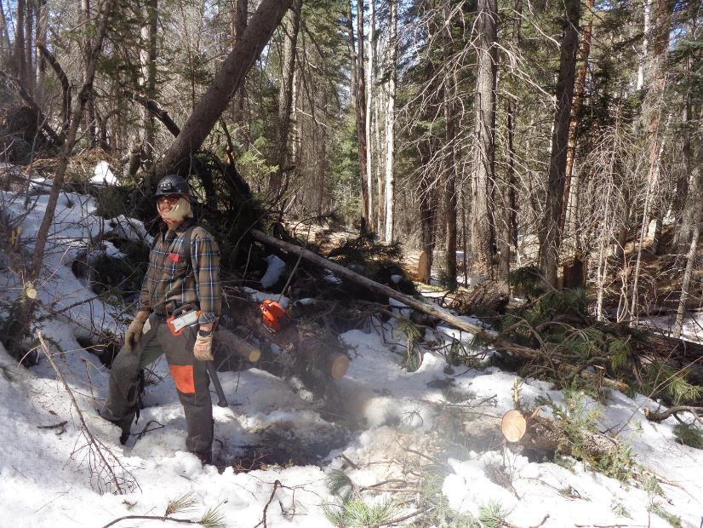

Michael is now on the east side of the pile of branches and has cut three small logs near where he is standing. We did not work

on the pile of branches or the log under them, because we were concerned that the leaning tree would fall on us.

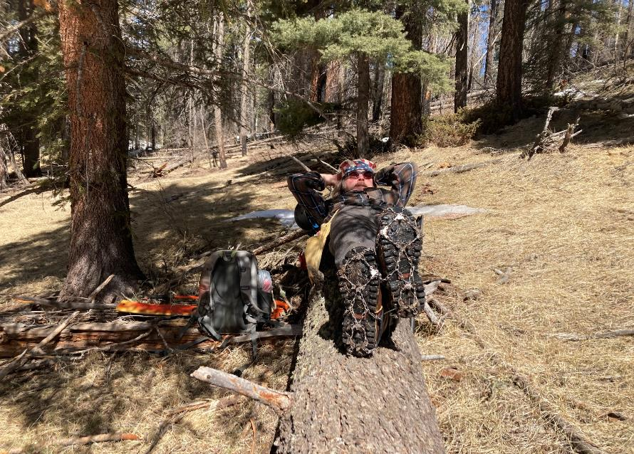

Michael resting after we ate lunch. Note the traction devices (flexible crampon spikes) secured by heavy rubber loops on his boots.

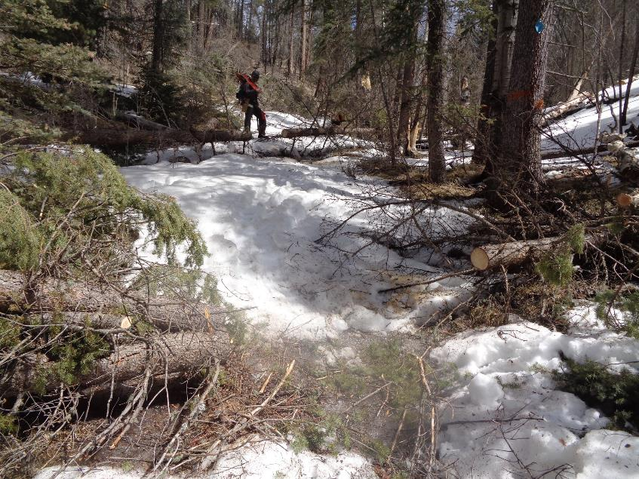

Michael cut these two small logs across the lower part of the steep Elk Ridge Trail up to the power line at the saddle.

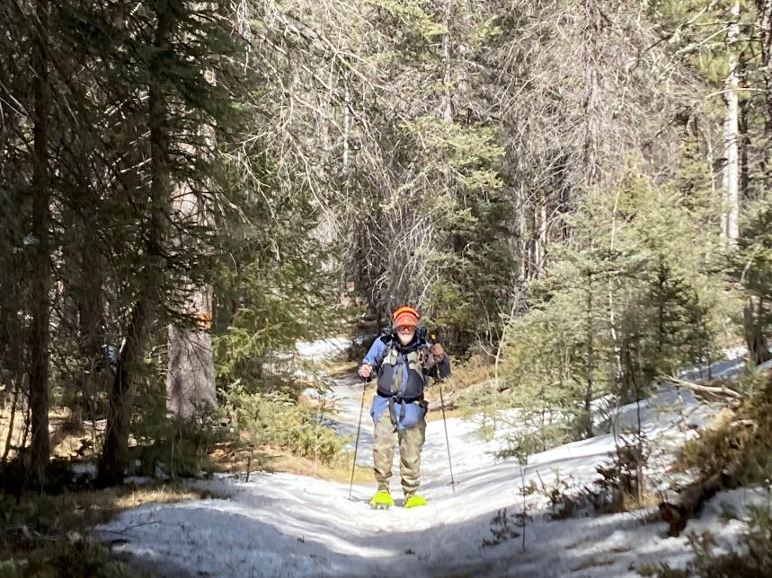

Sam walking up Elk Ridge Trail using Michael’s snowshoes. Photo by Michael Arndt

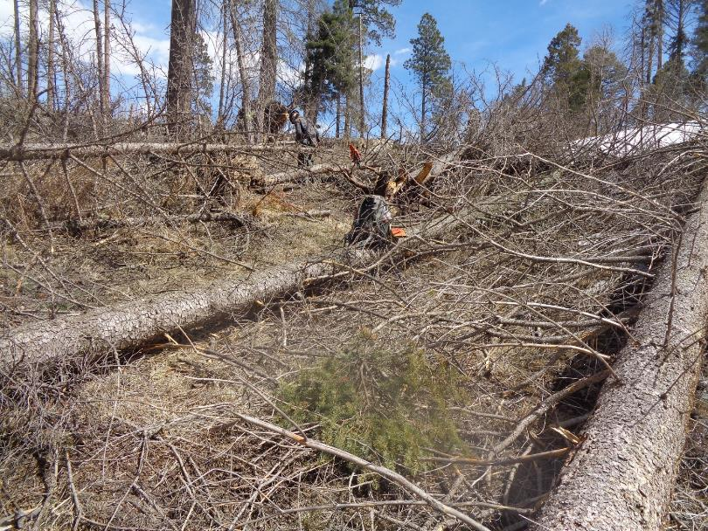

Michael preparing to cut three trees on Elk Ridge Trail that were blown over in the high wind event in the Jemez Mountains

several weeks ago. This site is just west of the saddle where the power line crosses Elk Ridge Trail.

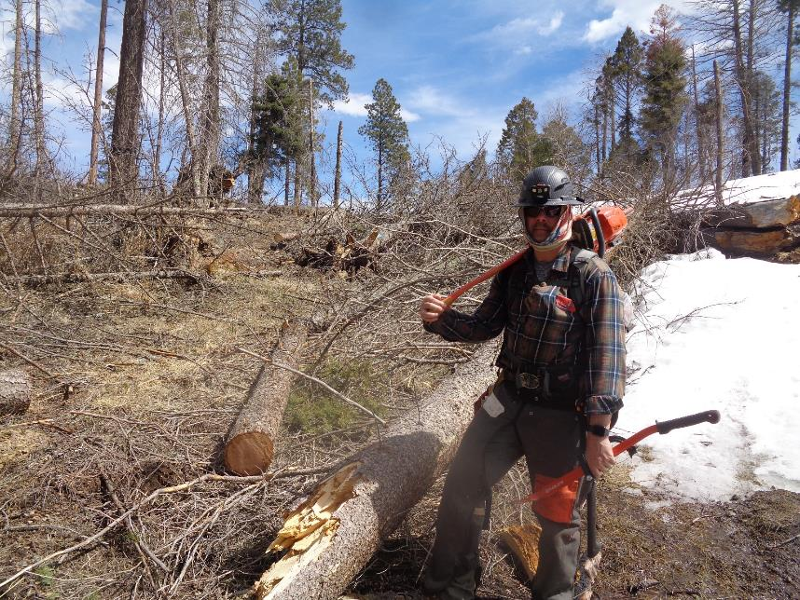

A route is now open through the down trees.