**Report of Maintenance of the East Fork East Loop Trail**

**in the Jemez Mountains on Sunday, October 23, 2022**

Sam Beard

On Sunday, October 23, Michael Arndt, Bet Gendron, and Sam Beard removed 10 fallen trees from the East Fork East Loop Trail in the Jemez Mountains between Redondo Campground and Valle Grande. The largest log diameter was about 12 inches. After hiking the loop, the crew hiked to the west along the East Fork Ridge Trail to the junction with Mistletoe Canyon Trail where they turned to the south and returned to the vehicles parked at the Los Griegos Mountain parking lot. The temperature was 37F, and rain began to fall shortly before we returned to the vehicles.

This trail is very popular, because the snow conditions on the north slopes of the east-west ridge are almost always excellent.

Photographs and more narrative are presented below.

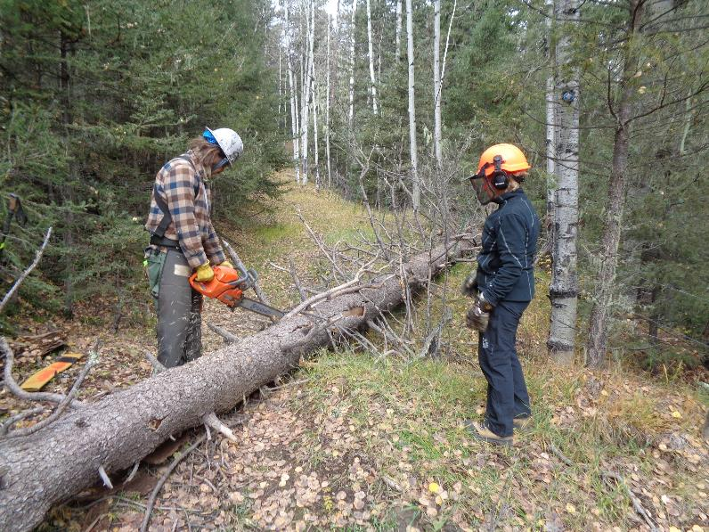

Michael Arndt limbing the first log on the north side of the ridge hiking in a clockwise direction.

Bet Gendron is observing and waiting to help move the cut piece of the log. All photos by Sam Beard unless noted otherwise

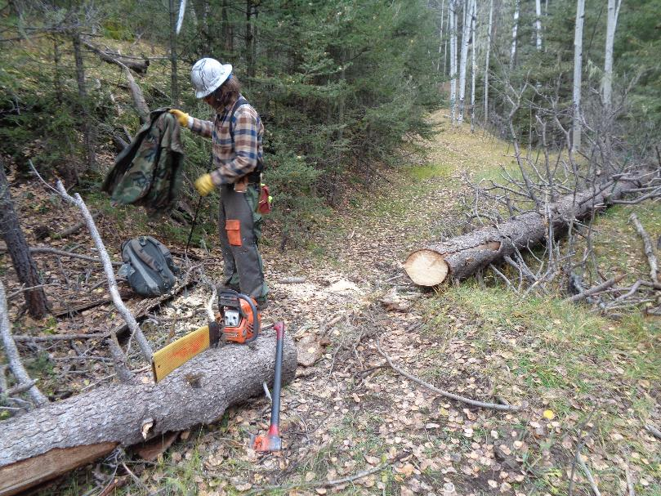

The log is cut and the trail is ready for skiers.

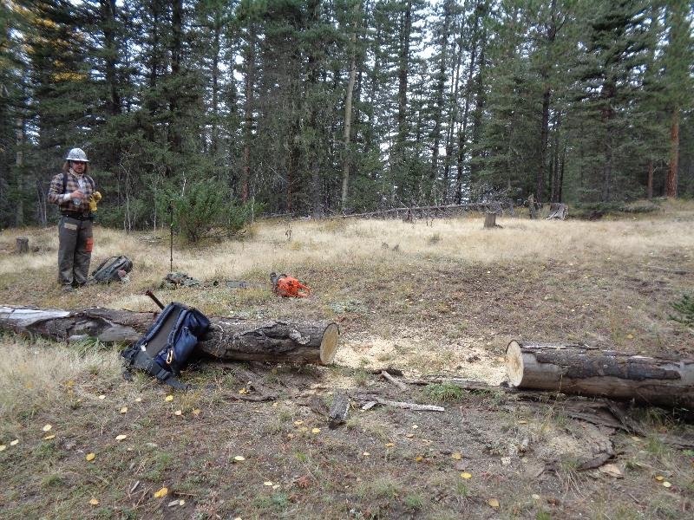

Michael drinking water after bucking this log.

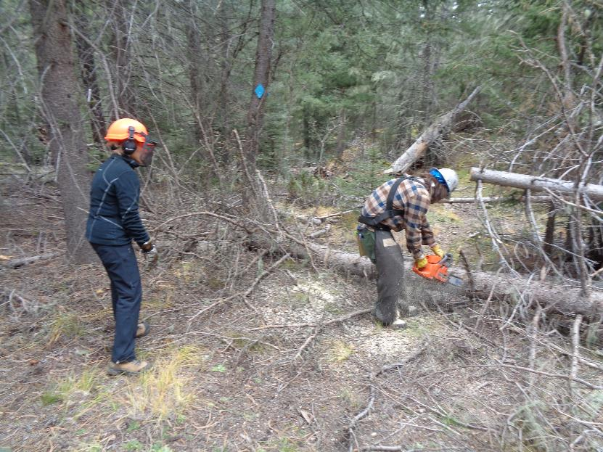

Michael bucking this log located near the old pumice mine.

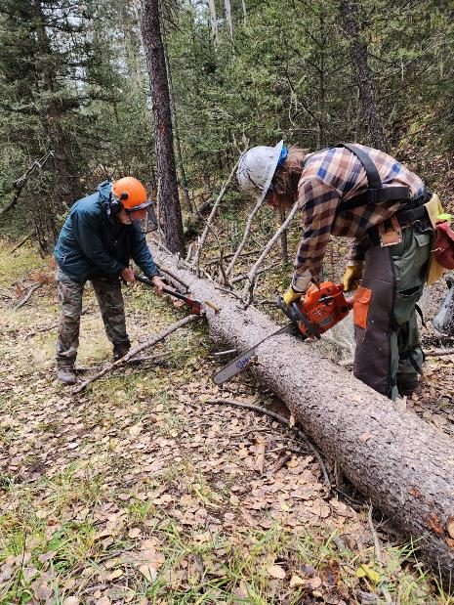

Michael bucking a spruce log while Sam is limbing.

Photo by Bet Gendron

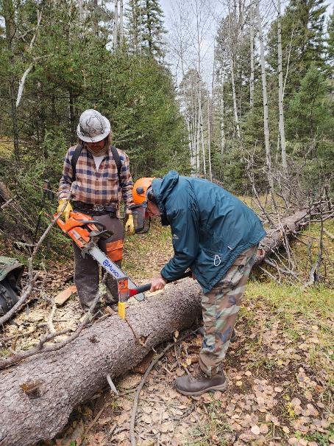

Sam driving a wedge so that the bar will not be bound in the kerf.

Photo by Bet Gendron

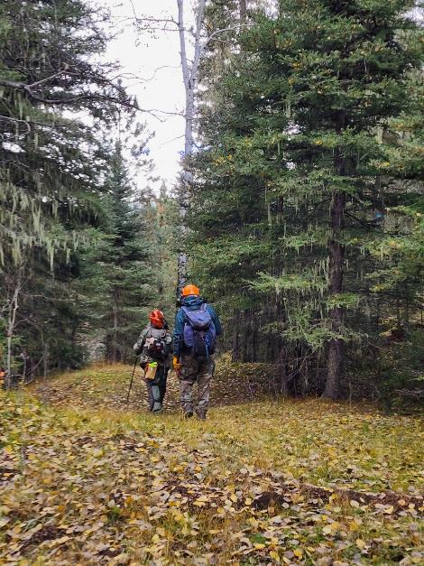

Michael and Sam hiking down the trail to the next log. Photo by Bet Gendron

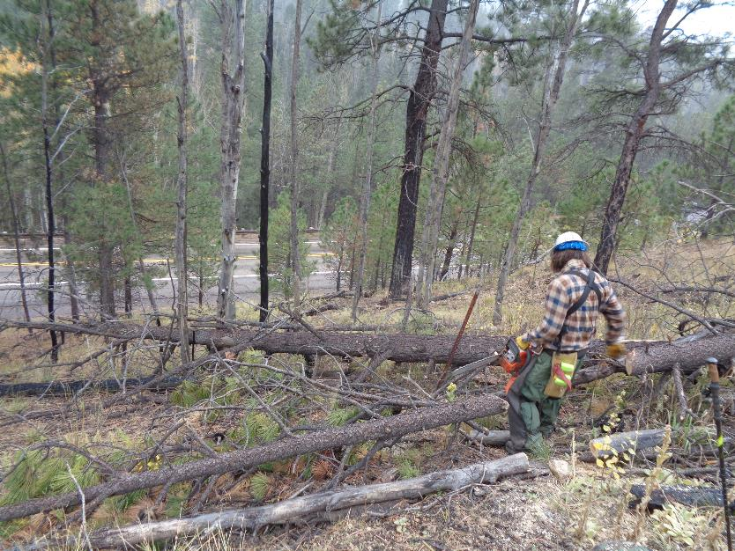

Michael cutting logs to make access to the fence where the fallen tree has pushed the barbed wire down.

This location is just above NM-4 where the vehicles were parked at Los Griegos Trailhead.