**Report of FOSM Project to Remove Down Trees from Trails near Sandia Crest**

**on Wednesday, October 26, 2022**

Sam Beard

On Wednesday, October 26, seven volunteers removed fallen trees from the following trails near Sandia Crest: Kiwanis Meadow Road, upper part of South Crest Trail, Crest Nature Trail, and Switchback Trail above the lower intersection with Buried Cable Trail.

Apparently, a high wind event felled many trees in the Sandia Crest and Kiwanis Meadow area. The trunks and green branches were buried in the snow, and removing them was difficult. Approximately three dozen down trees were removed from the four trails. The largest bucked tree was 20 inches in diameter. Jerry Carroll drove his pickup down Kiwanis Meadow Road to haul fuel and equipment. We walked in about 2 inches of snow all day.

The volunteers were Byron Garner, Jerry Carroll, Steve Roholt, Dennis Crowther, Dan Benton, Cliff Giles, and Sam Beard.

Photographs and additional narrative are presented below.

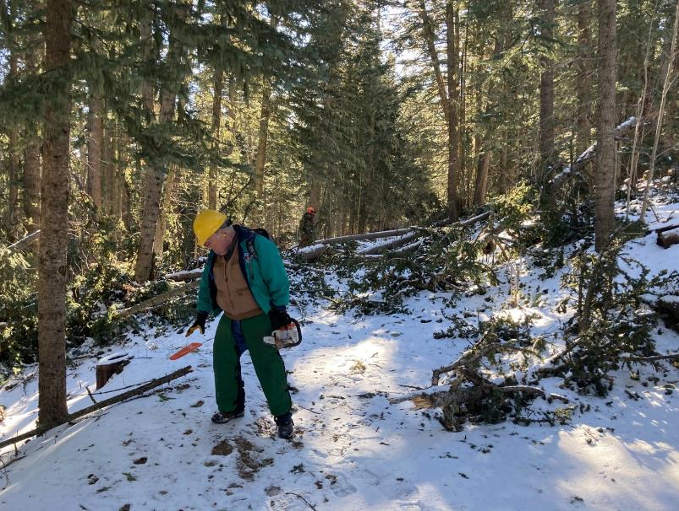

Dennis Crowther preparing to use his electric chain saw to remove fallen trees on Kiwanis Meadow Road.

Note the large number of trees down on the road behind Dennis.

All photos by Cliff Giles unless noted otherwise

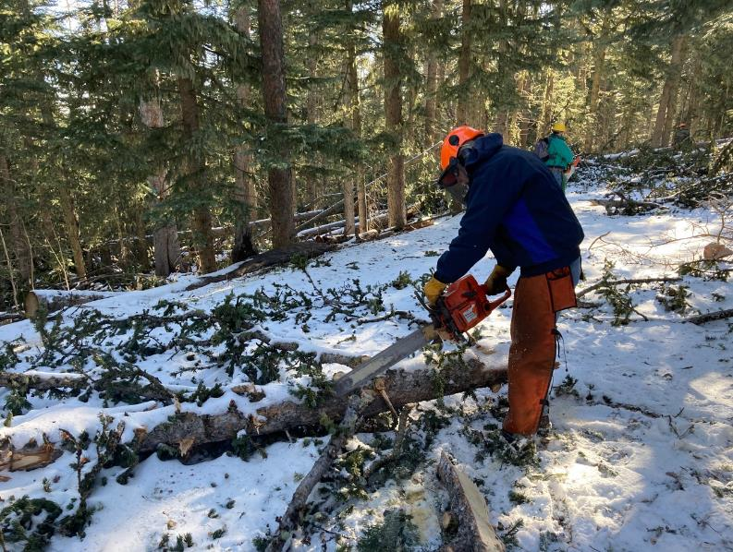

Byron Garner removing a tree from Kiwanis Meadow Road.

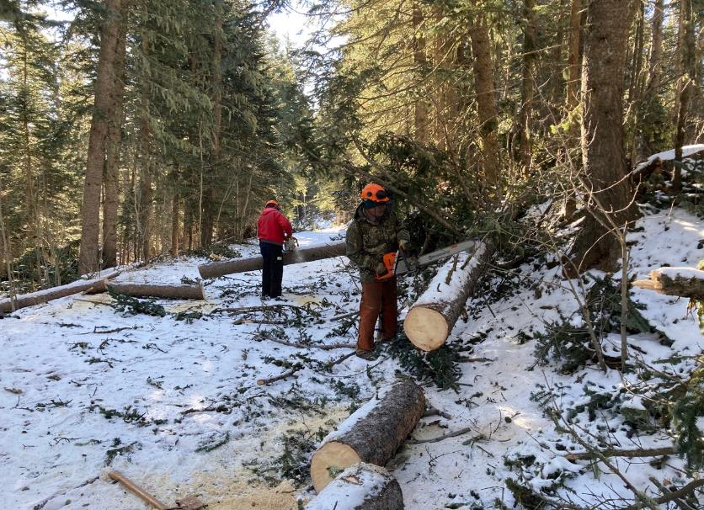

Jerry Carroll and Dan Benton bucking trees on Kiwanis Meadow Road.

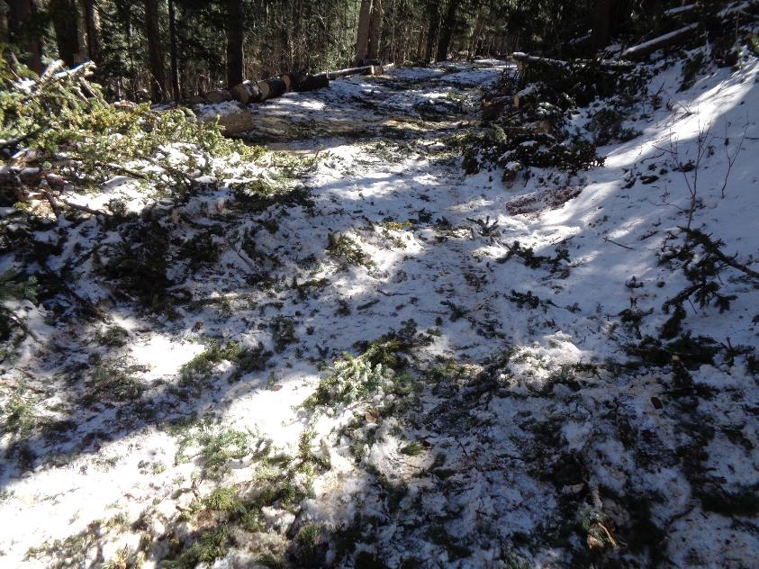

Branches and snow on Kiwanis Meadow Road after the fallen trees were removed. Photo by Sam Beard

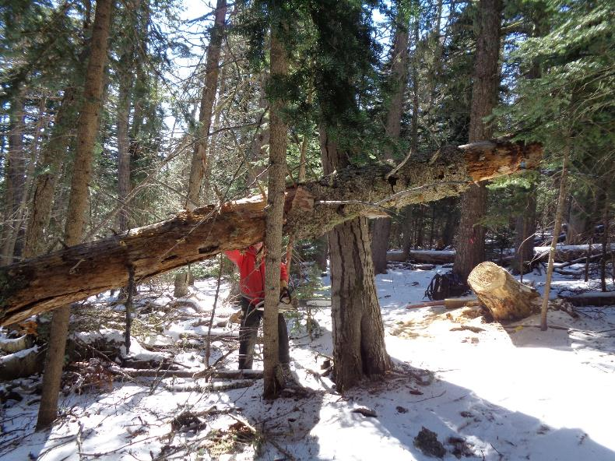

Jerry Carroll removing a hang-up on the upper part of Switchback Trail. When Jerry cut this large tree at the stump on

the right side of the picture, the tree rotated up to this position. The tree was then supported by two large trees

and the small tree in front of Jerry. Photo by Sam Beard

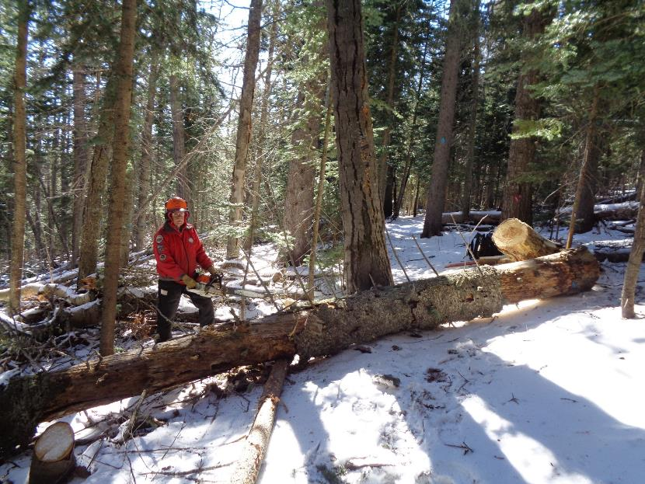

After Jerry cut the small tree, the large log fell to the ground. Photo by Sam Beard

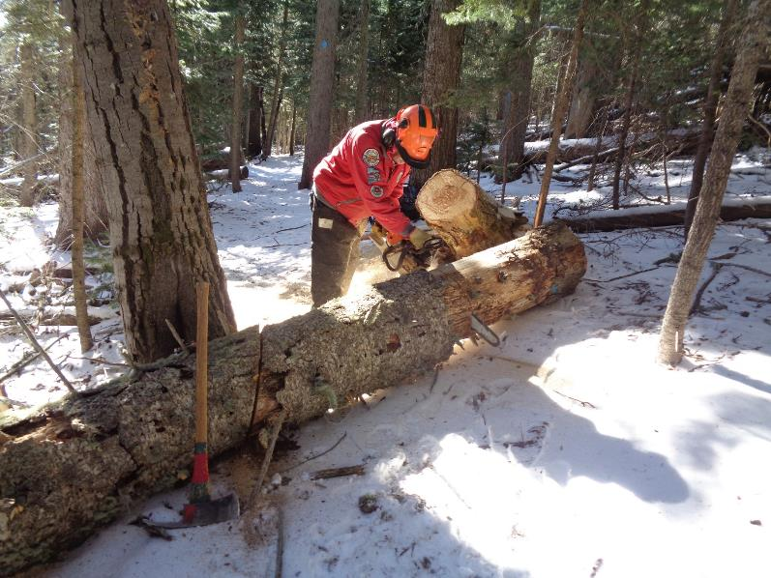

Jerry is bucking the log so that pieces can be removed from the trail. Photo by Sam Beard

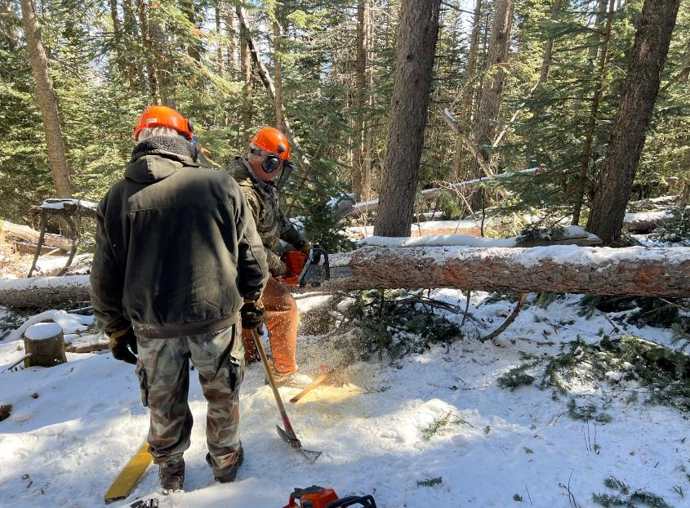

Dan Benton bucking a log while Sam Beard observes. Photo by Steve Roholt

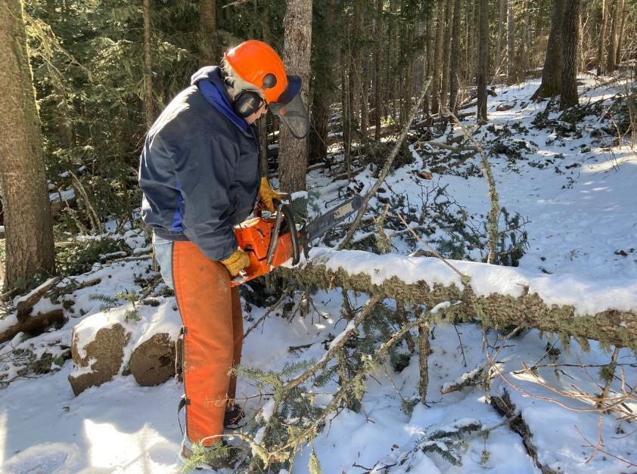

Byron removing a tree on upper South Crest Trail.

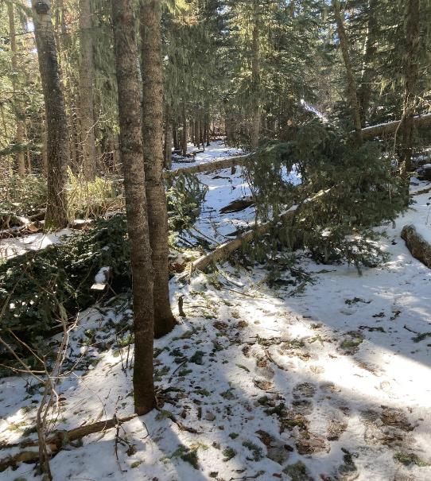

Trees blocking upper South Crest Trail.

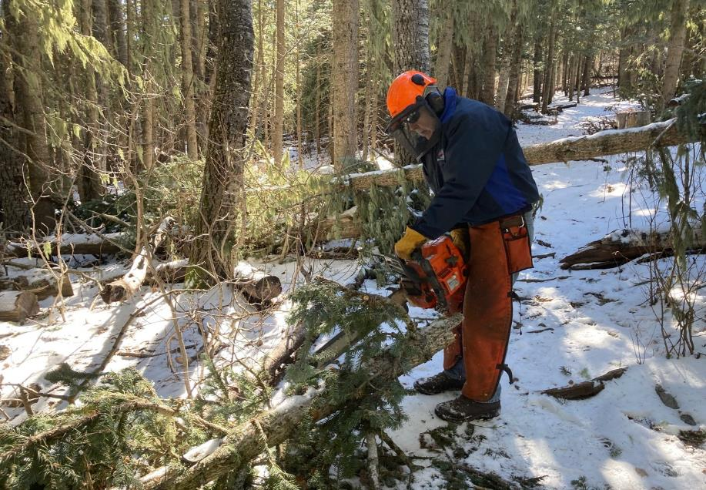

Byron removing first tree on South Crest Trail.

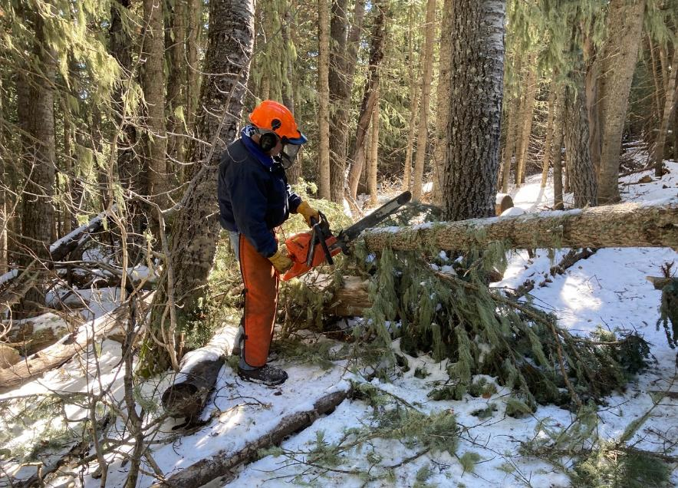

Byron removing second tree.

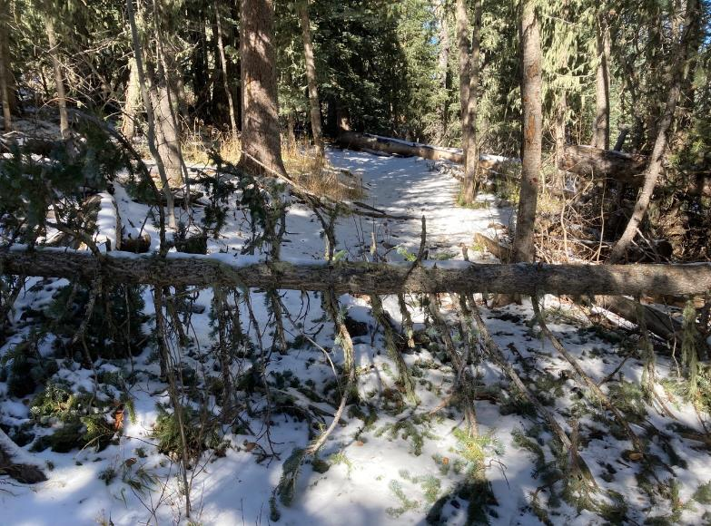

Tree blocking Crest Nature Trail.

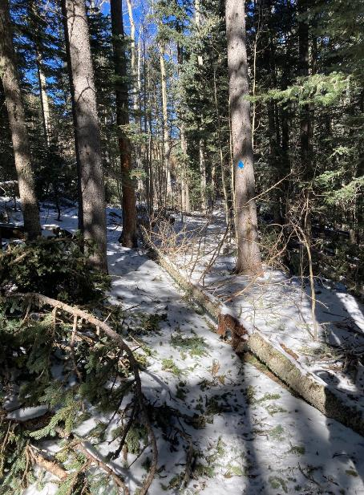

Tree on Switchback Trail near the upper trailhead before Byron removed it.

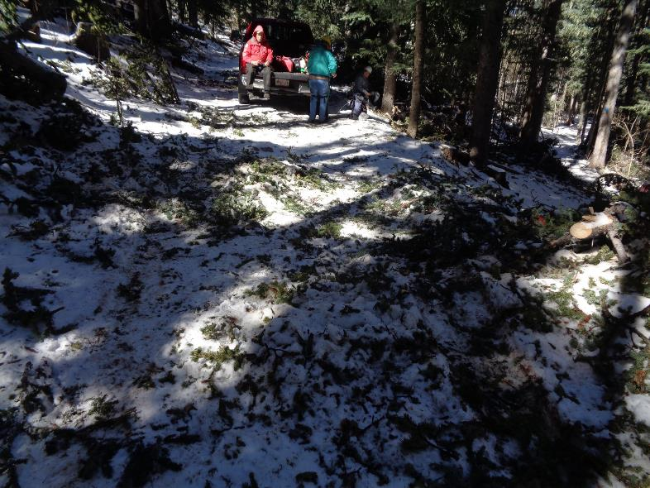

Volunteers eating lunch on the tailgate of Jerry Carroll’s pickup. Switchback Trail upper trailhead

is on the right side of the picture. Photo by Sam Beard