**Report of Work on Ladera Trail and Elk Ridge Trail in the Jemez Mountains**

**on Sunday, October 30, 2022**

Sam Beard

On Sunday, October 30, Ski Club members Michael Arndt, Leslie LaBry, David Torney, and Sam Beard worked on ski trails on Los Griegos Mountain in the Jemez Mountains. David lives just west of Los Griegos Mountain near where the many mail boxes are located on NM-4.

The group parked at the Los Griegos parking lot and hiked up Ladera Trail and did not find much across the trail until past the power line. About a quarter-mile past the power line, we found numerous large trees across the trail. See the photos following this report. We decided that there were too many trees to cut considering the time that we had for the task.

We decided to return the vehicles and drive east about one-half mile to just past Elk Ridge where the highway shoulder is wide and there is a throw-down barbed wire gate leading to an area thinned a couple of years ago. Michael and I had hiked here earlier, and we knew that Elk Ridge Trail was clear for about one-half mile where we lost the trail on our other trip.

We hiked Elk Ridge Trail to where the trail was covered with down trees killed in the Cajete Fire. We very carefully searched for the trail route, removed a few down trees, and found where this trail crosses Lover Road. Here we had lunch and then followed blue diamonds through the two long traverses of Ladera Trail leading to Griegos Junction. We removed several trees across the trail leading to this clearing where our Lunch Log is located, and we took a break to rest.

From Griegos Junction, we followed the upper part of Lower Road over numerous large berms back down to the junction of Lower Road and Elk Ridge Trail. We then hiked down Elk Ridge Trial to the power line and around the hill there to the highway where the vehicles were parked.

The results of the outing were that (1) We learned that the middle part of Ladera Trail is blocked by numerous large logs, (2) Elk Ridge Trail from near the thinned area to Lower Road and upper Ladera Trail is open and skiable, (3) Ladera Trail from the junction with Elk Ridge Trail is skiable, (4) The route down the upper part of Lower Road is probably not skiable due to down trees adjacent to the berms, and (5) The lower part of Elk Ridge Trail from the junction with Ladera Trail to the power line is probably skiable. We removed logs from this lower part of Elk Ridge Trail in the past.

See the photos and additional narrative below.

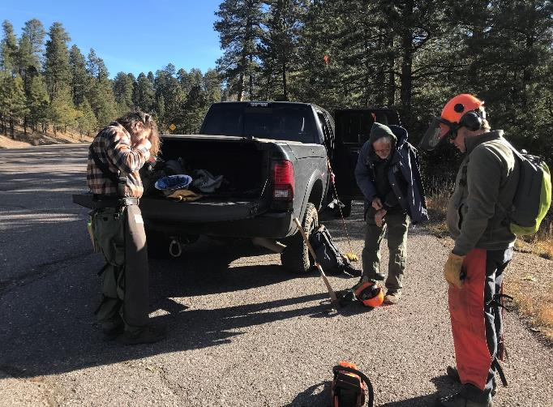

Getting ready to leave Los Griegos parking lot. L to R: Michael Arndt, Sam Beard, and David Torney.

All photos by Leslie LaBry unless noted otherwise.

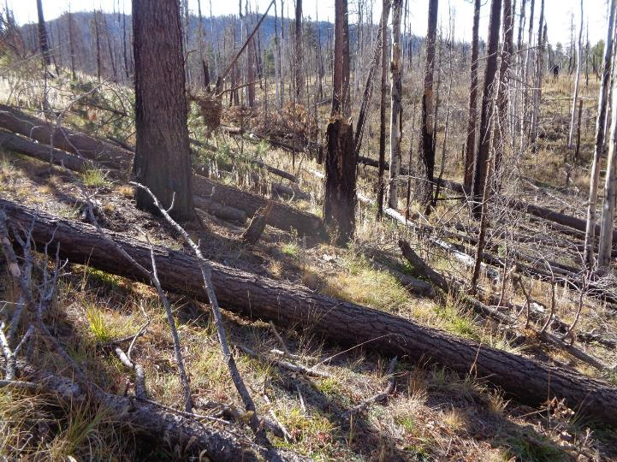

Many trees across Ladera Trail south of the power line where we turned around and decided to hike up

Elk Ridge Trail. Photo by Sam Beard

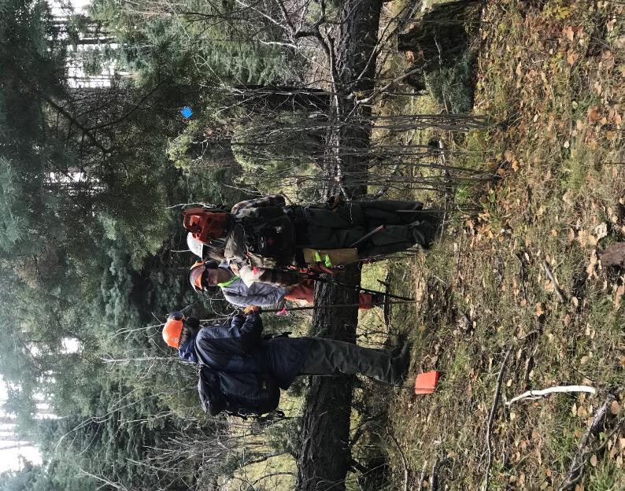

L to R, Sam, David, and Michael discussing the trail route. Note the blue diamond marking the route.

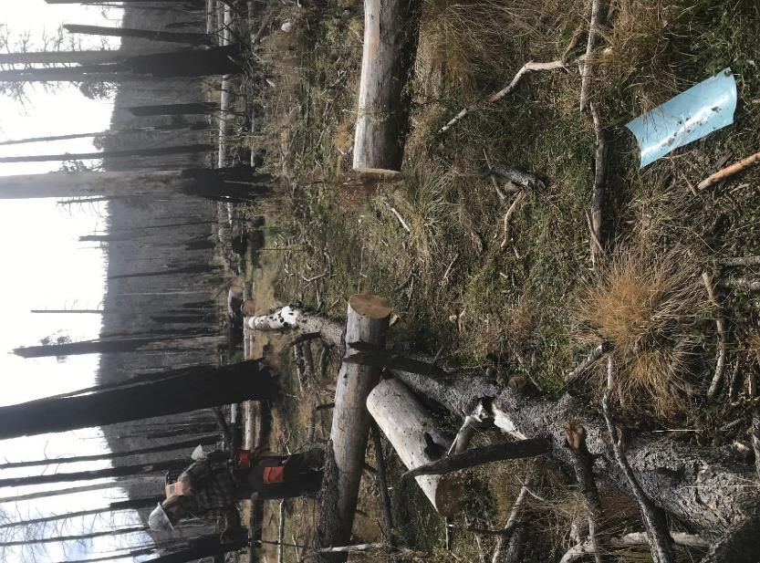

Clearing the trail route leading from the Elk Ridge Trail junction with Lower Road.

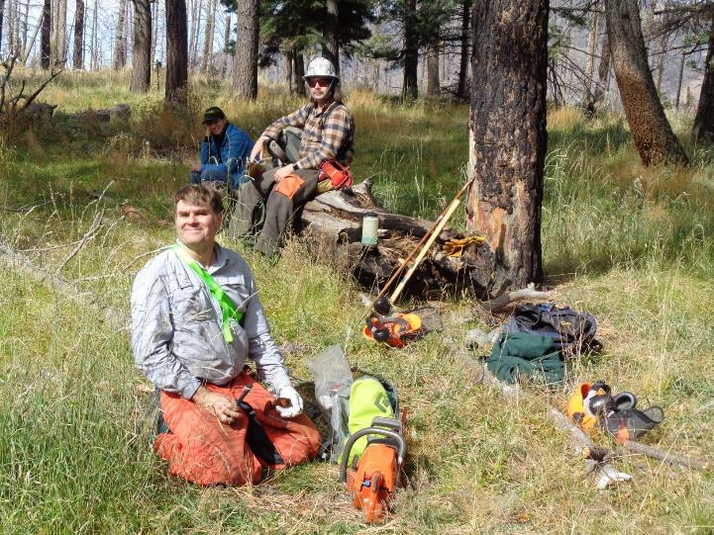

L to R: David Torney, Leslie LaBry, and Michael Arndt having a rest at the Lunch Log at Griegos Junction in the Jemez Mountains. Note the burned trees in the back ground. Photo by Sam Beard

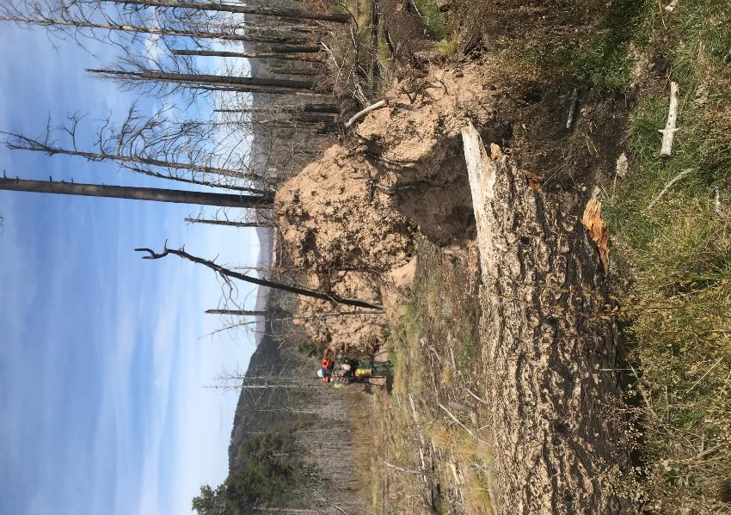

Root balls of down trees along Lower Road below Griegos Junction.

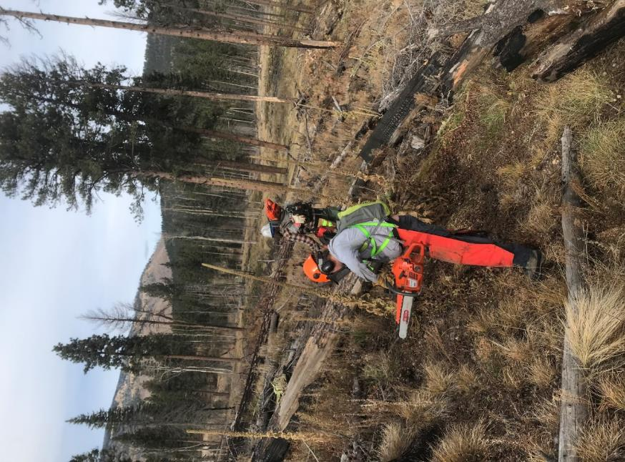

Hiking across the thinned area just east of Elk Ridge and south of NM-4 and north of the powerline.

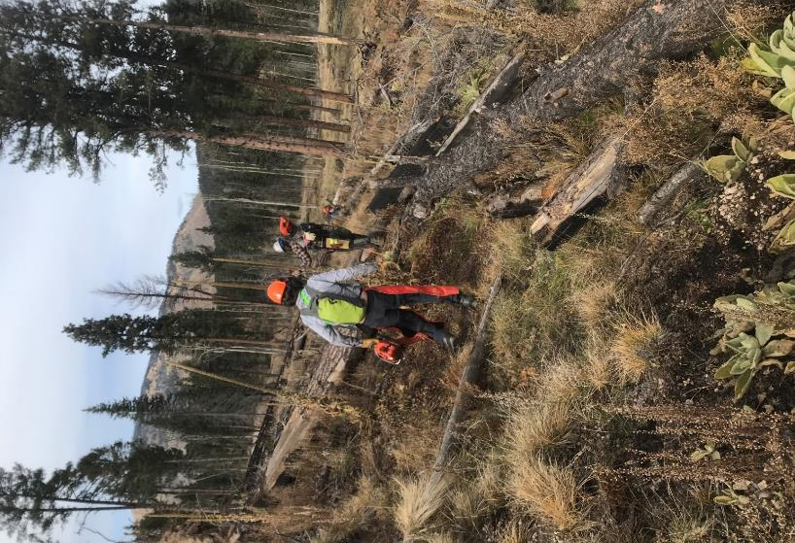

Another view of the most direct route leading to the NM-4

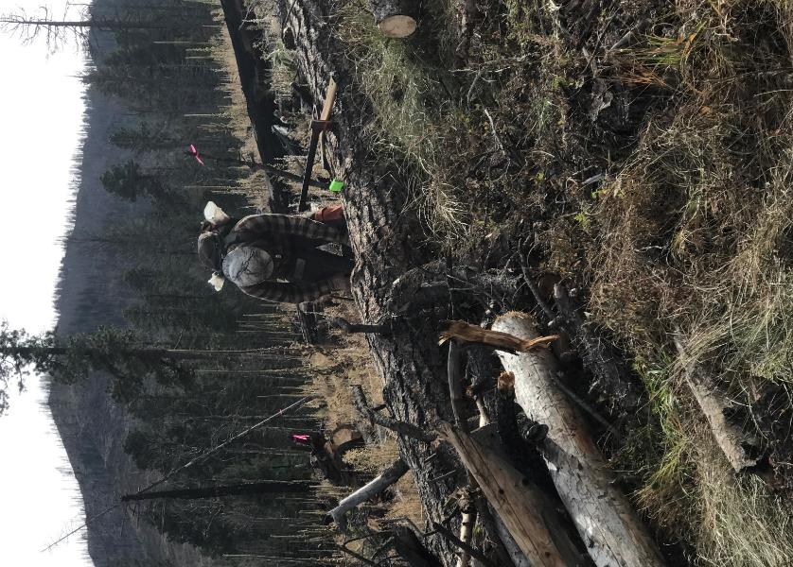

Michael cutting a 22-inch diameter log in the thinned area so that we can ski around the hill and not over it.

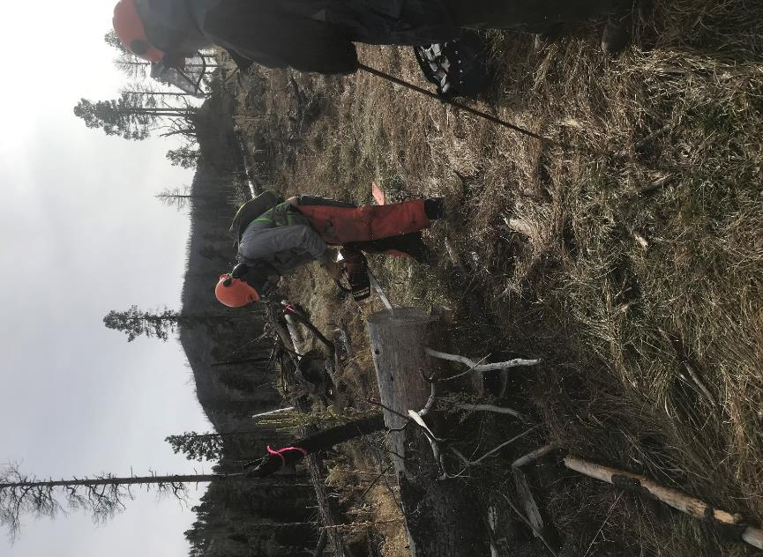

David marking a log so that we can find this route in the snow. This route was marked with pink flags.

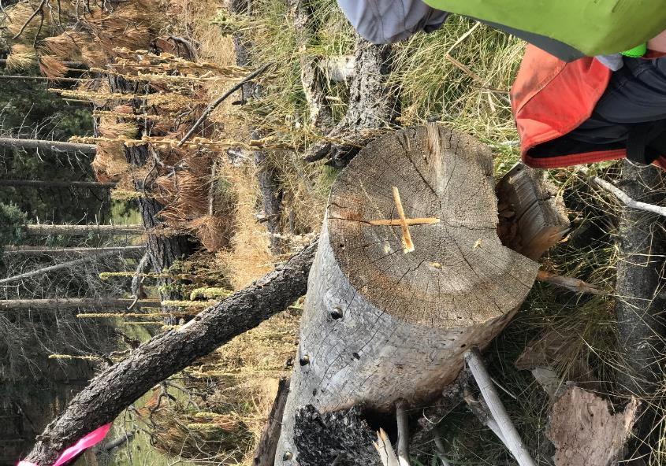

The marked end of a log in the thinned area.

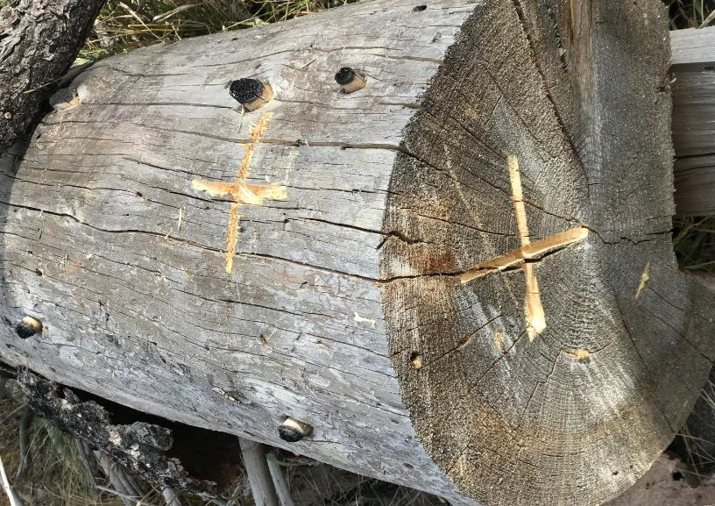

David marked the end and top of this log located beside the road used in the thinning operation a few

years ago. The problem with skiing here is that no highway parking is plowed most of the winter.

We must wait until the snow on the wide shoulder either melts or is plowed.