**Report of Maintenance of Upper Corral Canyon Trail by New Mexico**

**Cross Country Ski Club Volunteers on Sunday, November 6, 2022**

Sam Beard

Nov. 8, 2022

On Sunday, November 6, Michael Arndt, David Torney, and Sam Beard removed 22 fallen trees from the upper part of Corral Canyon Trail in the Jemez Mountains south of NM-4 and southwest of Valle Grande. The diameter of the largest log was 22 inches.

Michael and Sam rode with David who drove his Volkswagen all-wheel drive van from the Corral Canyon Trailhead on NM-4 up FR-280 to Junction Meadow. The volunteers then hiked up Corral Canyon east of the road to FR-282 and around the ridge to the SW to Tee Intersection at the junction of FR-280, FR-281, and FR-282. From here they hiked FR-280 back to Junction Meadow, and David drove down FR-280 to the highway.

Photos of the project with additional narrative are presented below.

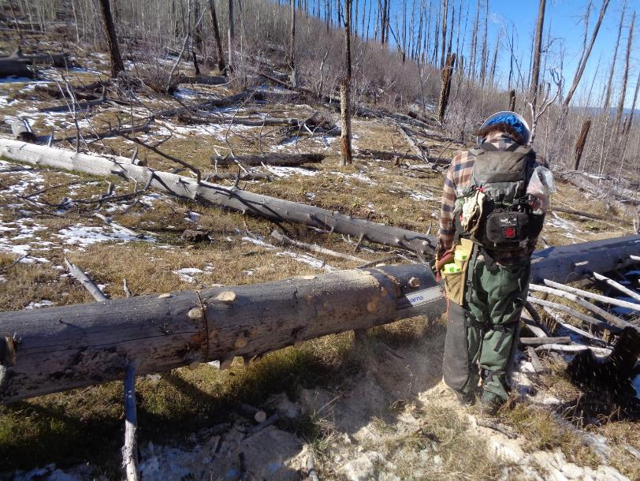

Michael Arndt bucking a 14-inch diameter log on upper Corral Canyon Trail between Junction Meadow and FR-282. Note the standing

dead trees killed in the Los Conchas Fire in 2011. The many young trees are aspens.

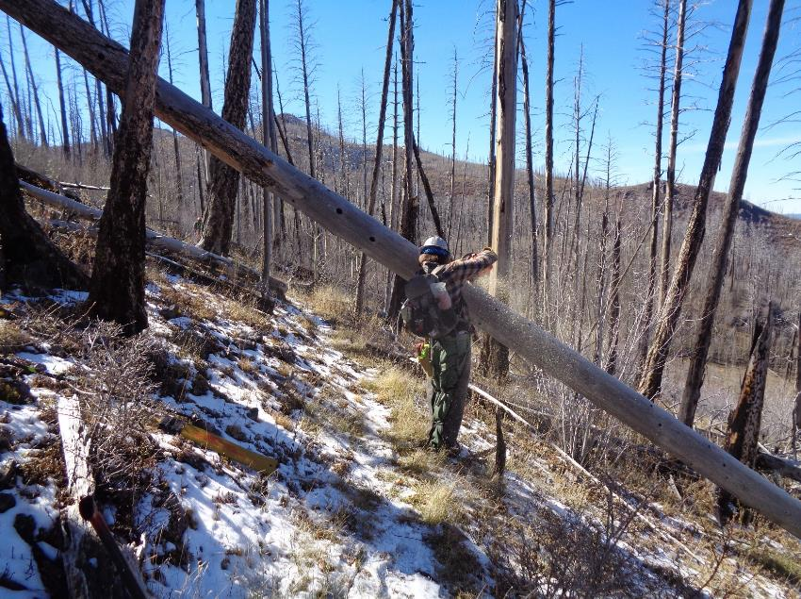

Michael Arndt bucking a high log on upper Corral Canyon Trail between FR-282 and Tee Intersection.

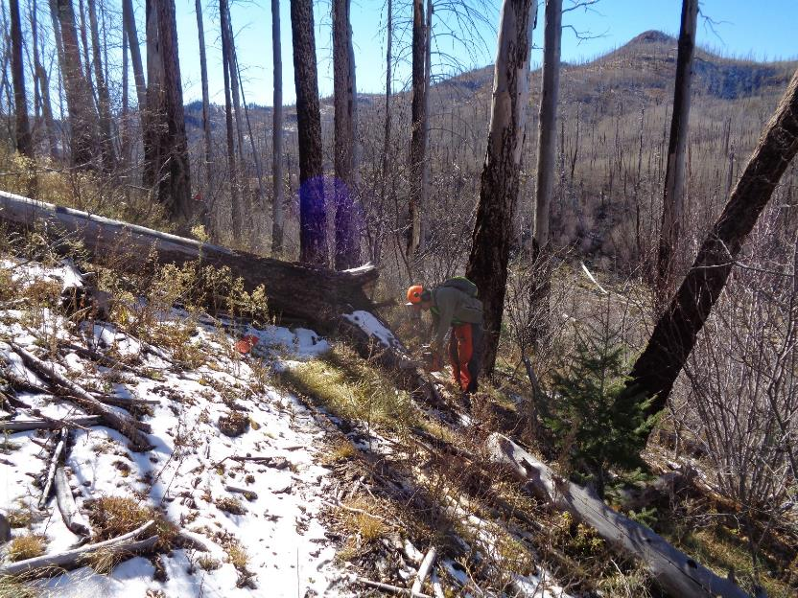

David Torney cutting a root so that skiers can go around this large log on upper Corral Canyon Trail

a short distance north of Tee Intersection.

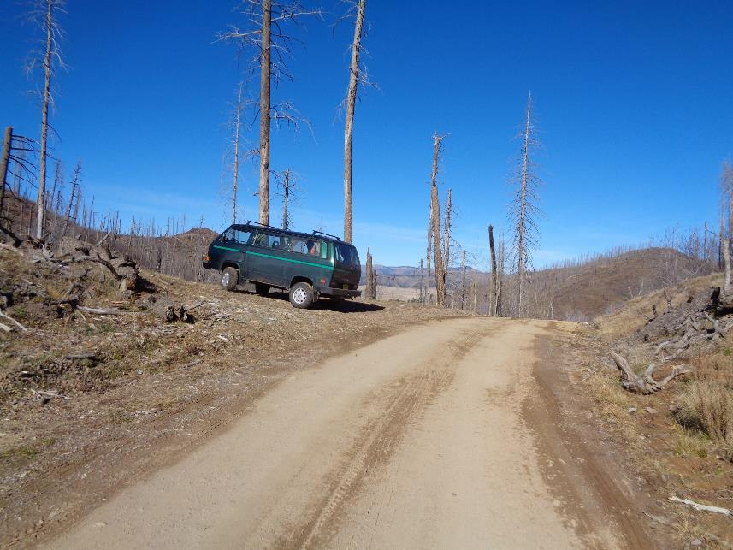

David’s Volkswagen all-wheel drive van parked near Junction Meadow with Valle Grande in the back ground.