**Ski Trail along Old Road West of Coyote Call Loop**

**on the Valles Caldera National Preserve in Jemez Mountains**

Sam Beard and Michael Arndt

November 19, 2022

On Saturday, November 19, 2022, Michael Arndt and Sam Beard hiked an old road to the WSW from the Coyote Call Trailhead on NM-4 on the Valles Caldera National Preserve (VCNP) in the Jemez Mountains. This easy trail has only one 10-inch tree across it, and after there is about 1 foot of snow, skiers should be able to easily cross it. This trail appears to be Old Highway 4 and crosses a few meadows and groves of trees just south of NM-4. This trail lies on north-facing slopes, and there are no steep segments.

This 1.6-mile trail will be excellent for beginning skiers and lies close to the highway in the event that anyone has problems. The west trailhead is located across NM-4 from the first pullout on the highway east of the VCNP Main Gate. Whereas most trails in the Jemez Mountains have significant elevation changes, this trail has very gentle slopes with very little elevation change.

Currently, the snow depth is only about 2 inches, but after there is adequate snow, we will be leading Class I or easy tours on this trail.

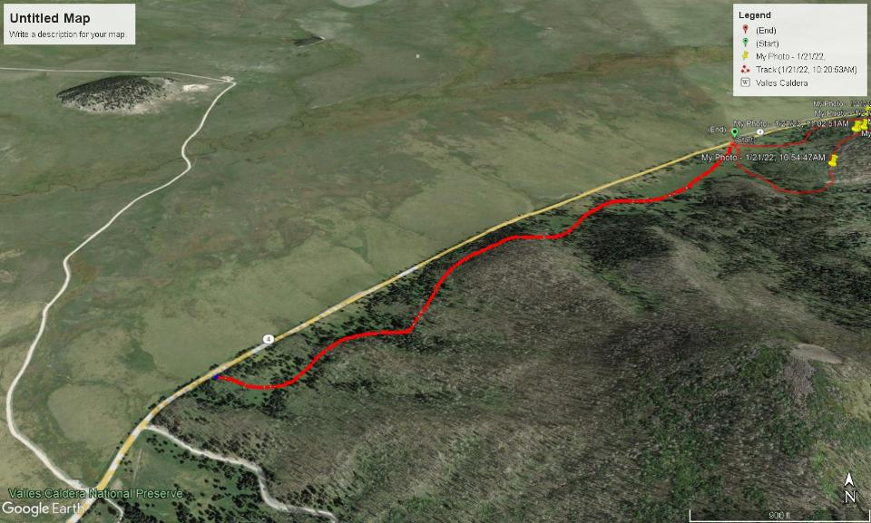

Very easy ski trail along old road west of Coyote Call Loop Trail on NM-4 in the Jemez Mountains. The very large meadow north of the highway is

Valle Grande. The Coyote Call West Trail (or Old Hwy 4 Trail) begins at the Coyote Call Trailhead on the right side of this Google Earth Satellite Photo where

the loop trail parking area is located. From this trailhead at the small green dot, the trail goes to the WSW just south of NM-4. The one-way distance is

1.6 miles, and the trail follows an old road that may be Old Hwy 4. It crosses multiple meadows and passes through several forested areas. The west trailhead is located at the first highway pullout east of the Main Gate at the Valles Caldera National Preserve.