**Maintenance of the Middle Part of Ladera Trail near the Power Line**

**on Los Griegos Mountain in the Jemez on Saturday, November 26, 2022**

Sam Beard

On Saturday, November 26, Michael Arndt, Leslie LaBry, Mike Meier, and Sam Beard removed about two dozen down trees from the middle part of Ladera Trail south of the power line and Lower Road. In this area several very large pine trees had been blown over during a high wind event a few months ago. In addition to these trees, dead trees killed by the Cajete Fire had fallen.

We had worked on clearing a route through this area earlier by zigzagging through openings between the logs, but on Saturday, the approach was to use large saws to cut the large trees and clear the original route. In the future, we will try to use this approach in order to avoid returning so many times to the same part of a trail.

Photos taken by Leslie are presented below.

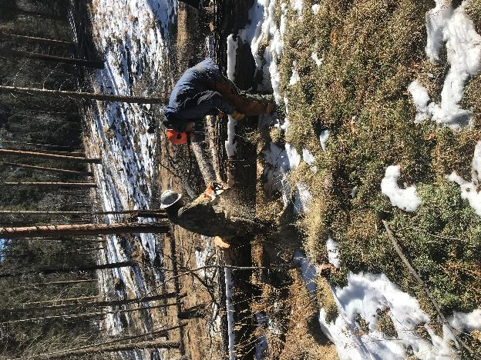

Michael bucking a 23-inch diameter tree with the Ski Club Stihl MS-362 saw with a 24-inch bar.

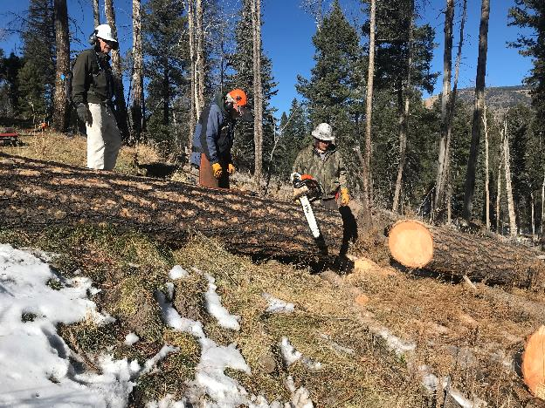

L to R: Mike Meier, Sam Beard, and Michael Arndt at the first and largest log that we cut.

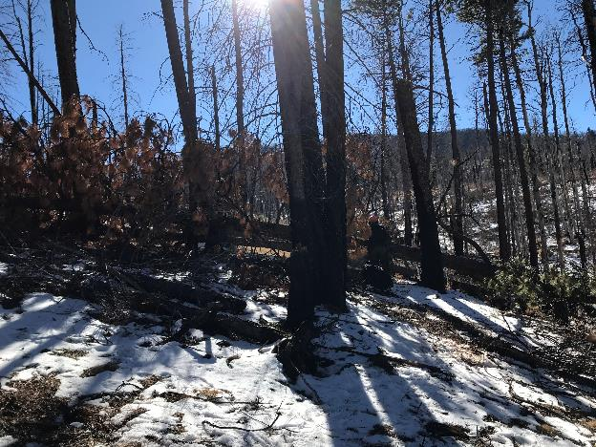

Large pine trees down across the original Ladera Trail. We removed several of these large logs from the trail.

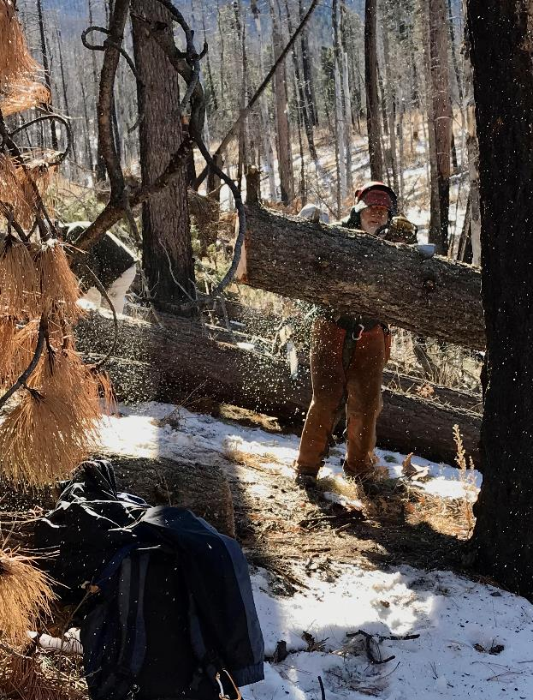

Sam cutting a large log with a Stihl MS-261 saw with an 18-inch bar.

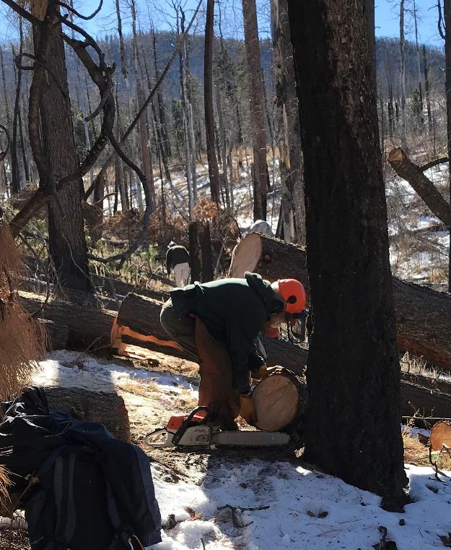

Sam rolling the cut piece off the trail. Mike is working on another tree in the background.

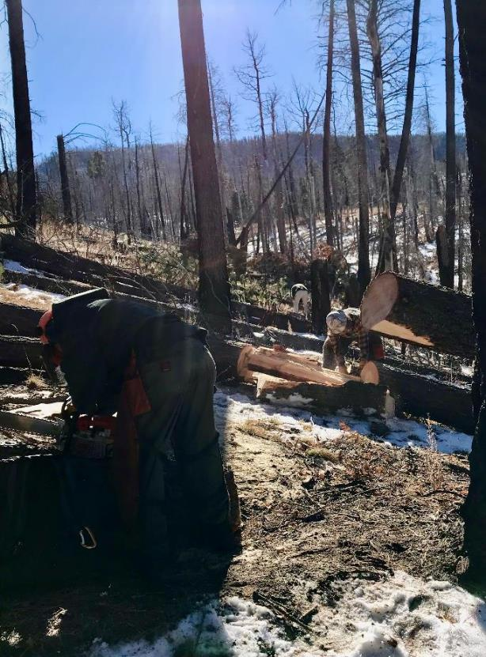

Michael has just cut a large tree that broke into two pieces when it fell. On the left, Sam is putting a

sharp chain on the MS-261 saw.

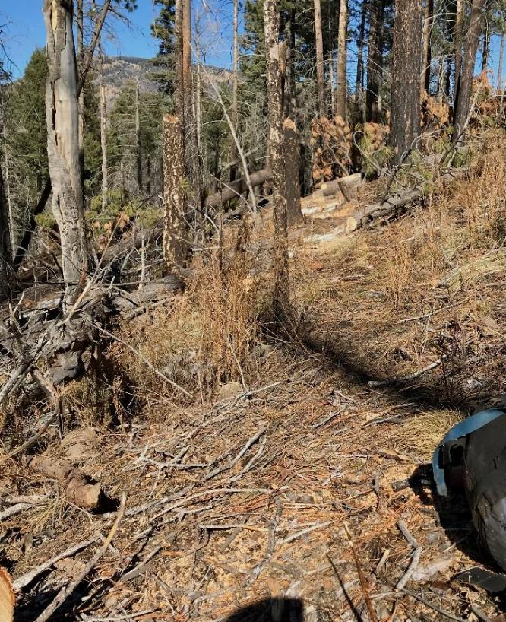

Looking back along the trail where several logs have been cut.

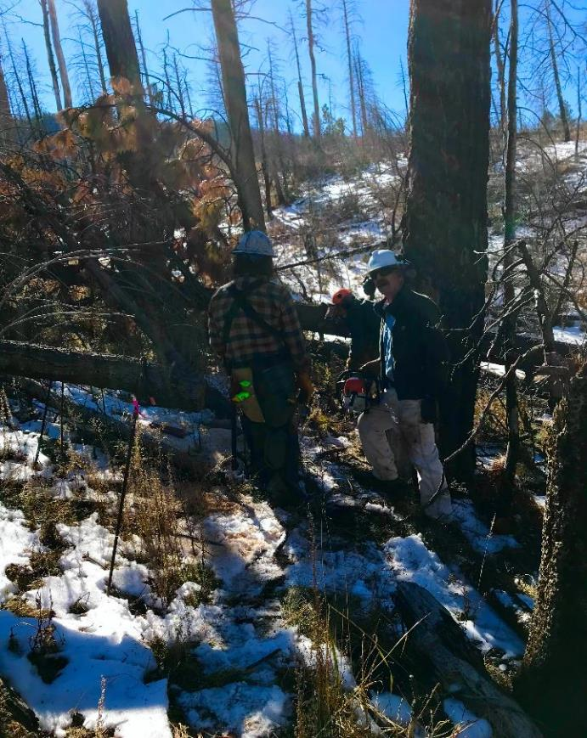

Michael and Mike discussing where a log should be cut to open this part of the trail.

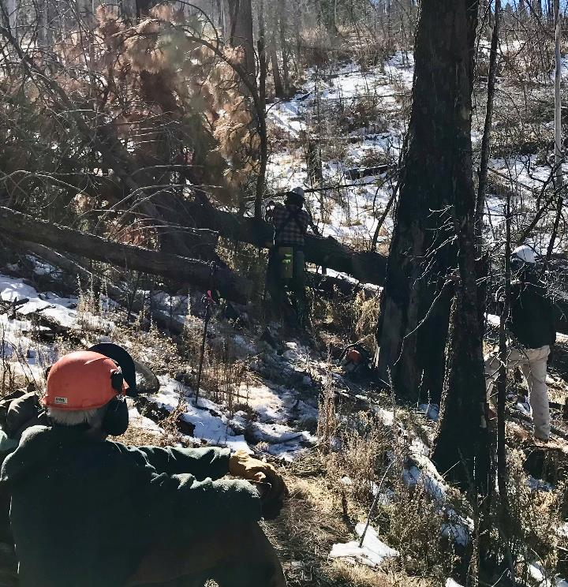

Sam and Mike observing Michael cutting a large pine tree.

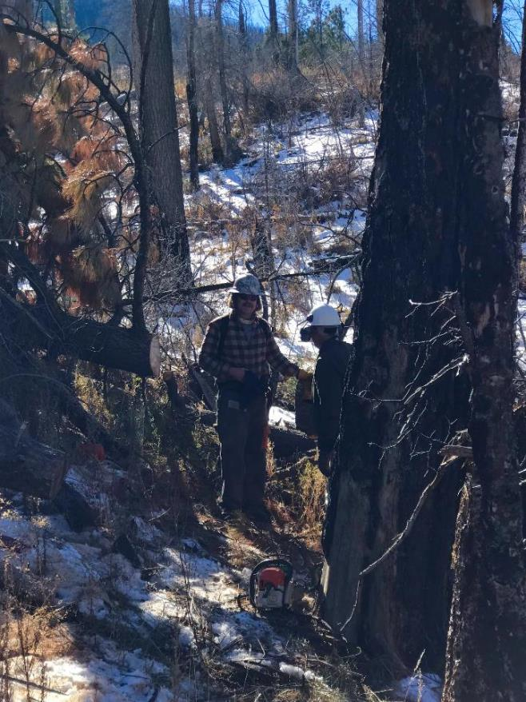

Michael and Mike at a log that has been cut.

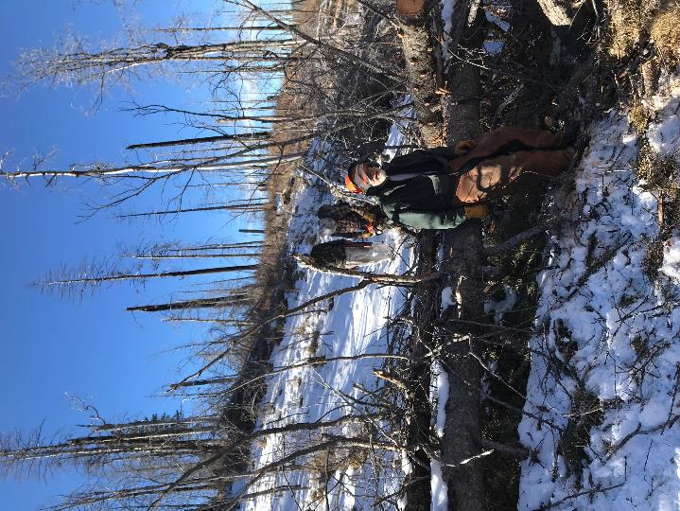

Sam has just cut the branches on the log to his left, and he is waiting for Michael and Mike

to come to cut the larger log.

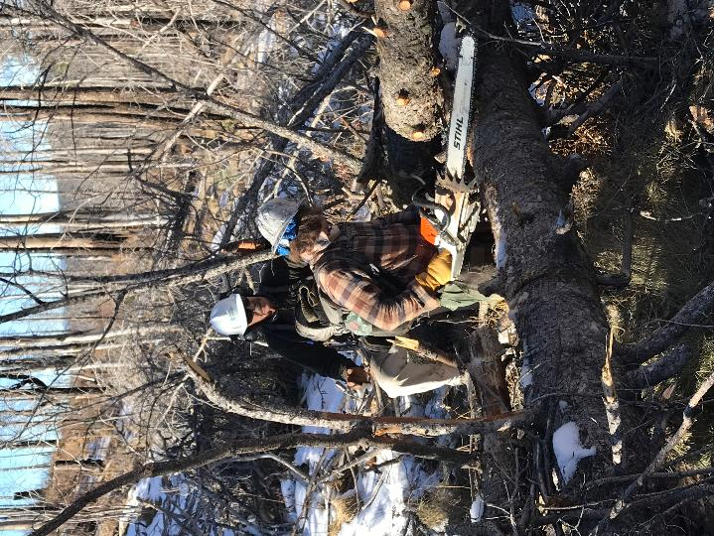

Michael cleaning out an escape route while preparing to cut the large log.

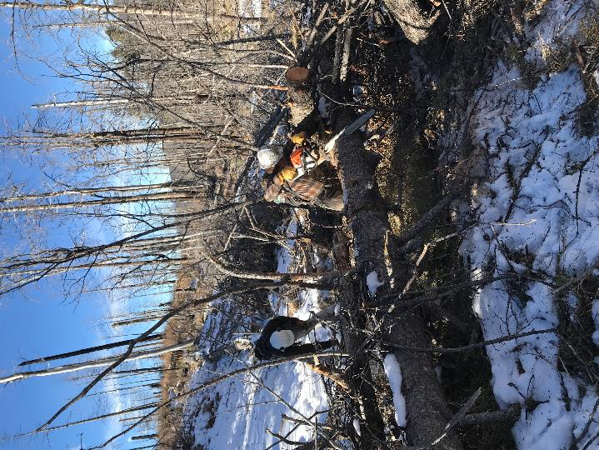

Michael cutting the last log to open the route to the top of the hill in the background. Note the many dead

trees killed in the Cajete Fire several years ago.