Report of Ski Outing to Coyote Call Area on the Valles Caldera National Preserve in Jemez Mountains

on Monday, January 2, 2023

Sam Beard and Michael Arndt

On Monday, January 2, Michael Arndt and Sam Beard skied in the Coyote Call Area on the Valles Caldera National Preserve in the Jemez Mountains. The weather was overcast with blowing snow and cold with a temperature of 23F. The powder snow was excellent for skiing, and the depth varied from 4 inches to 10 inches. We were the only people skiing there on Monday.

From the trailhead we skied to the southwest to the west end of Coyote Call Loop and started up Rabbit Ridge Trail. After skiing about one-quarter mile on this trail, we went to the west on Log Landing Road that leads about one-half mile to a large clearing where logs may have been loaded on large trucks. After skiing about one and one-half hours to this destination, we returned to the trailhead in only one-half hour and ate lunch.

After lunch, we skied about one-half mile to the west on Coyote West Trail with blowing snow in our faces. Near the stock tank, a pond holding water for wildlife and, originally, livestock, we skied a short distance to the south on a road until we saw about a half-dozen logs across it. This route will eventually lead up the mountain to the log landing. We returned to the pickup and came home. The highway had been plowed by three NMDOT trucks from San Ysidro. Due to the snow blowing onto the highway, they were making several passes over that part of NM-4.

Photographs of the outing are presented below.

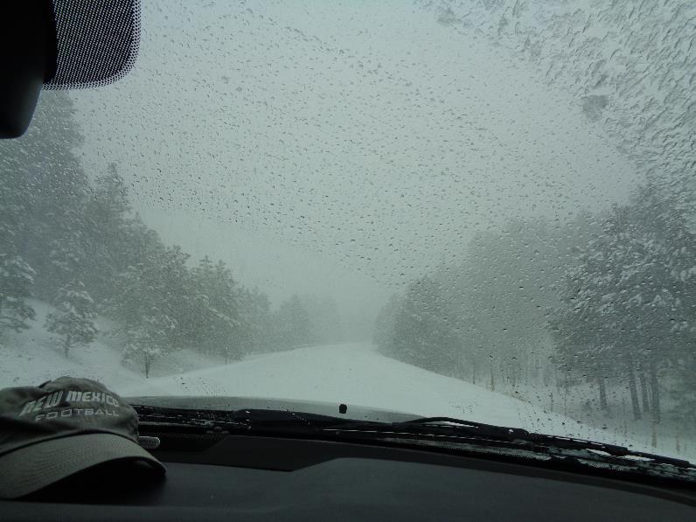

View of NM-4 east of Redondo Campground before it was plowed. Driving was difficult due to the falling snow and the unplowed highway.

All photos by Sam Beard

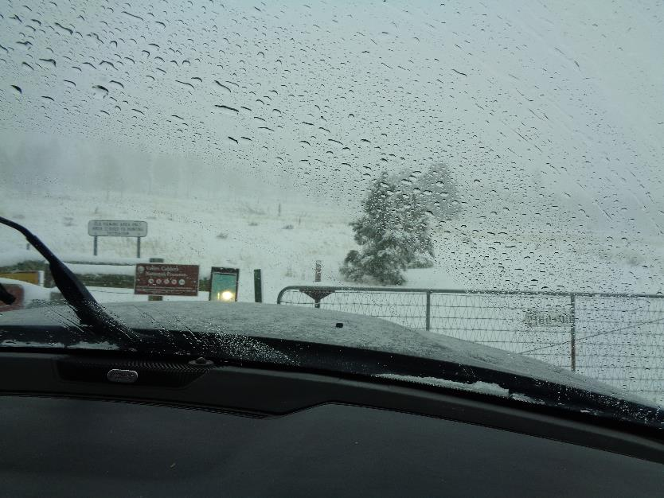

Coyote Call Trailhead in semi-whiteout conditions.

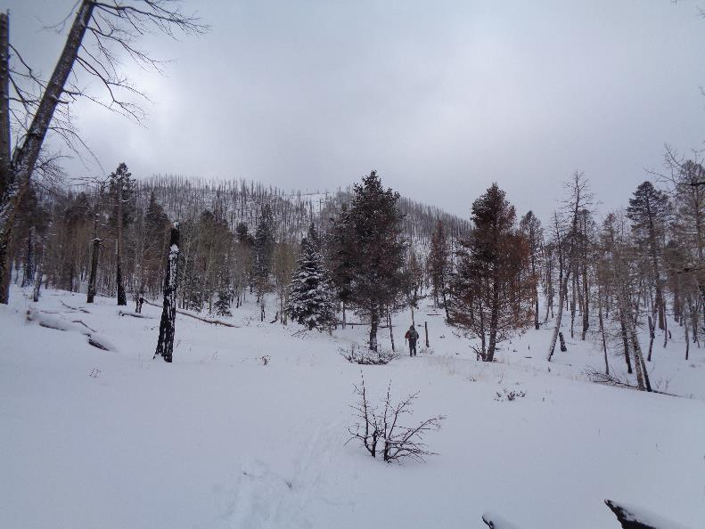

Michael Arndt at west end of Log Landing Road. The white triangle on top of Rabbit Mountain in the background is felsenmeer.

Felsenmeer is German for “sea of rock” or a mountainside covered by large boulders. Some geologists suggest that the sides

of the Valles Caldera were originally covered with felsenmeer.

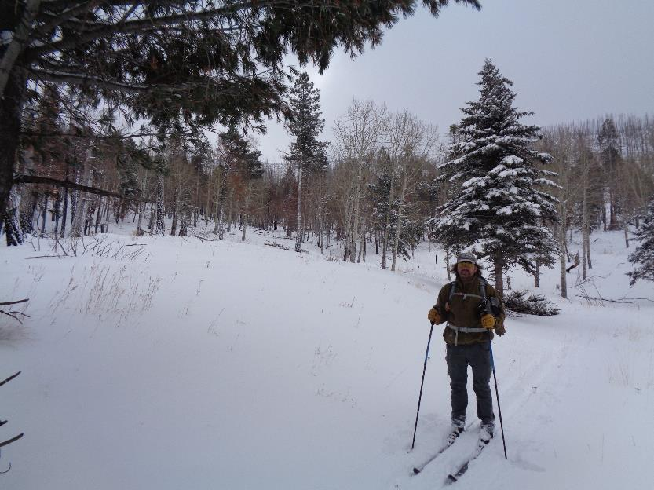

Michael at the large clearing that we have named Log Landing. Logs may have been skidded here and then loaded

on large logging trucks.

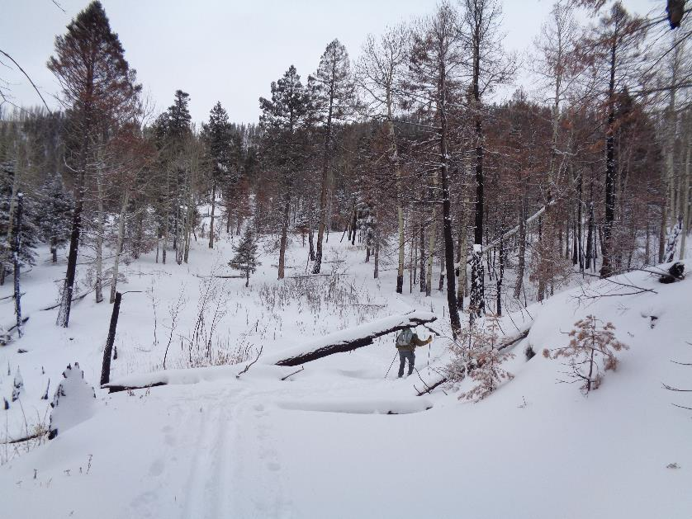

Skiing back along Log Landing Road. Michael is ducking under a large log over the trail.

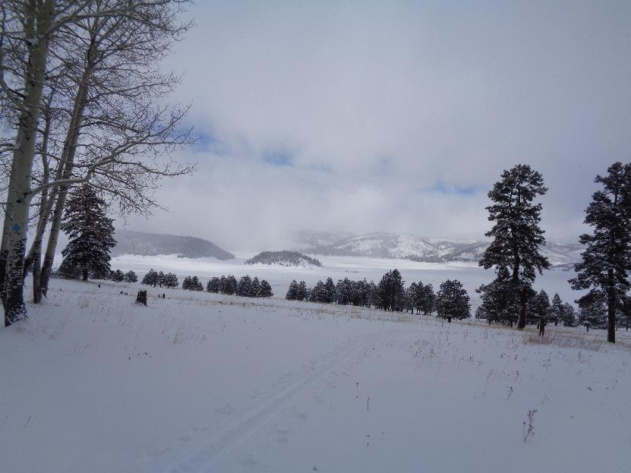

View of South Mountain (large mountain on the left) and small Cerro La Jara from Coyote Call Trail. The Valle Grande Stagging Area

is just to the right of Cerro La Jara and is presently where visitors check in to the Preserve.

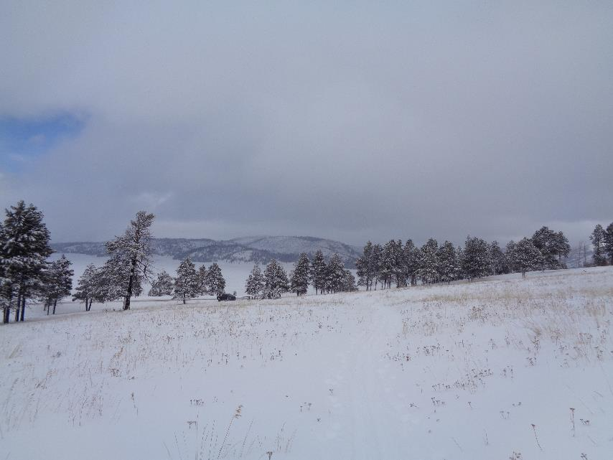

Valle Grande lies between the Coyote Call Trailhead and Cerro del Medio on the horizon. Michael’s pickup is parked at the trailhead.