**Report of the New Mexico Cross Country Ski Club Outing to the Redondo Campground Area**

**on Sunday, January 15, 2023**

Sam Beard

On Sunday, January 15, fourteen Ski Club members enjoyed skiing in the Redondo Campground area in the Jemez Mountains. We were in falling snow most of the day, and occasionally the wind would blow a large cloud of snow off of the large pine trees onto the skiers. The temperature was near 32 F. NMDOT snow plows from San Ysidro were plowing the highway.

Michael Arndt led a “fast” group on the loop trail in the forest around the campground. After eating lunch south of the campground near the highway, Michael led a group of about a half-dozen skiers to the Crater Spur Trail along which they passed two hydro-thermal explosion craters. The larger crater is 200 to 300 feet in diameter and about 100 feet deep. The explosion is caused by the rapid heating of ground water when it comes in contact with very hot magma. There are six of these craters in the campground area, and one is about 200 feet from the parking lot on the same side of the highway.

Sam led the “slow’ group around the loop trail and back to the vehicles where the skiers ate lunch. The undisturbed snow depth was about 12 inches.

The skiers were Jennifer Burns, Susan Wolterstorff, D. Lee Tayler, Debbie McGrew, Melinda Gonzalez-Hibner, Amy Near, Jack Loer, Aliza Algozino, Michael Arndt, Brandon Bower, Tom Katonak, Lynda Katonak, and David Torney.

Photographs are presented below.

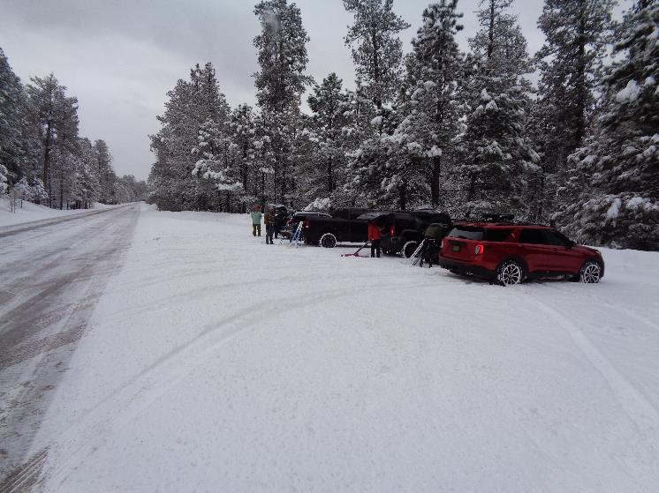

Parking across the highway from Redondo Campground at the San Diego Canyon Overlook. Photo by Sam Beard

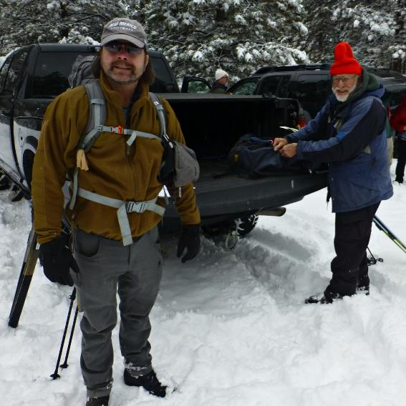

L to R: Michael Arndt and Sam Beard at Michael’s truck. All photos by Tom Katonak

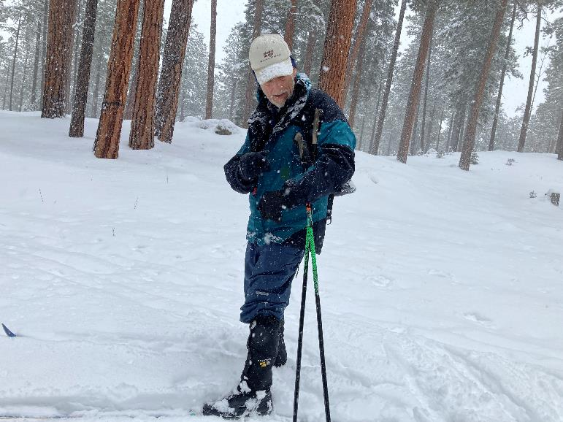

Tom Katonak skiing in the large ponderosa pines.

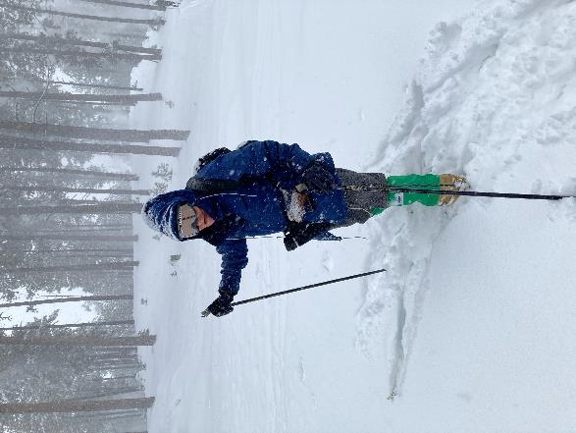

Lynda Katonak in the falling snow.

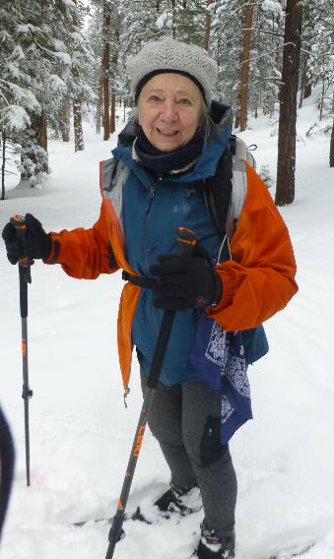

Amy Near in snow-covered forest.

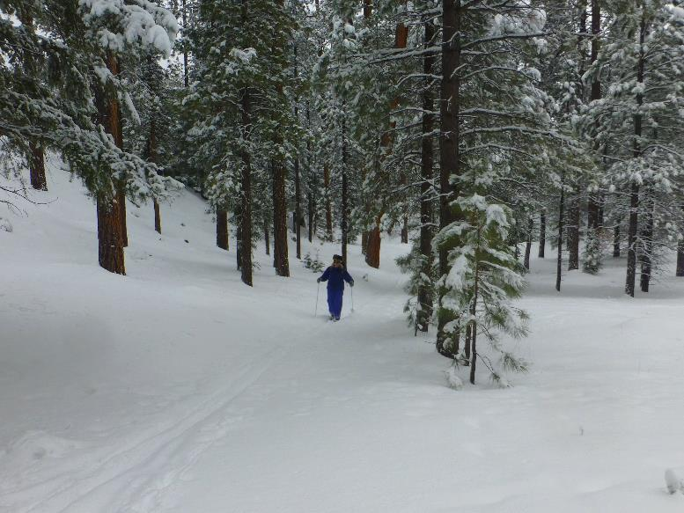

Debbie McGrew coming out of the forest.