**Report of Removing Trees and Installing Blue Diamonds on Challenge Trail**

**near 10K South Trailhead on Sunday, December 31, 2023**

Sam Beard and Michael Arndt

On Sunday, December 31, Michael Arndt and Sam Beard snowshoed about 0.4 mile up Challenge Trail from 10K South Trailhead and removed four hang-ups between the trailhead and the first highway switchback above the trailhead. In addition to removing these trees, approximately a dozen blue diamonds were nailed to trees to better define this segment of the rerouted trail. After carrying the equipment on snowshoes, nailing diamonds, removing the four hang-ups, and eating lunch, we were too tired to continue up the trail toward Ellis Trailhead. When we skied here last weekend, we had not found any other trees down on the trail.

The weather was sunny with temperatures a little above freezing. No other visitors passed us on the trail, and the 10K Trailheads were not very busy. Several long segments of the highway in the shade were partially covered with packed snow and ice. We chatted with Steve Roholt who had been shoveling snow on the trails groomed by the Sandia Nordic Ski Club.

Project photographs are presented below.

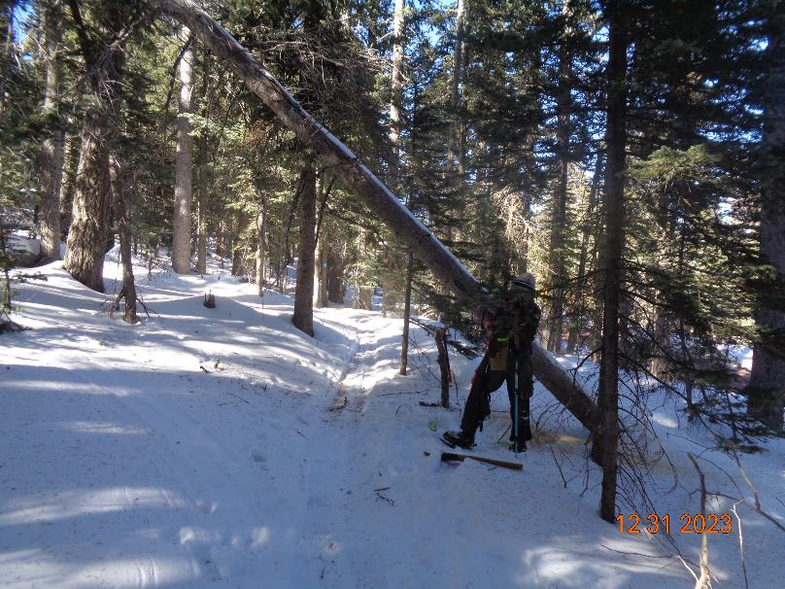

Michael is making the first cut on this 8-inch hang-up over the rerouted Challenge Trail above 10K Trailhead.

All photos by Sam Beard

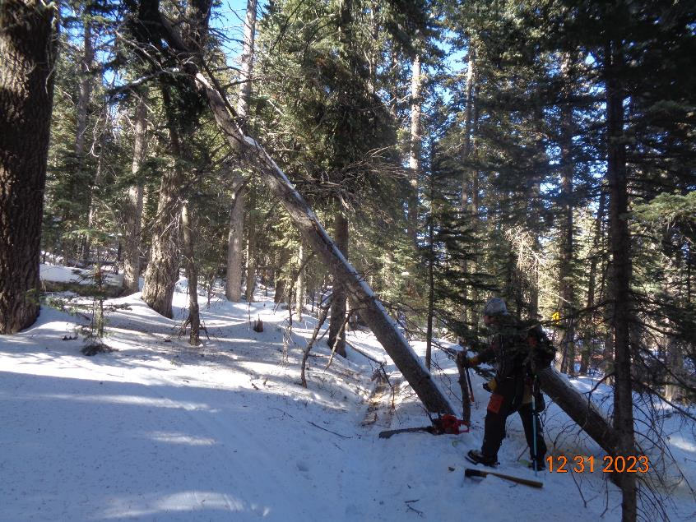

The cut end of the tree fell closer to the trail tread and was still over the trail.

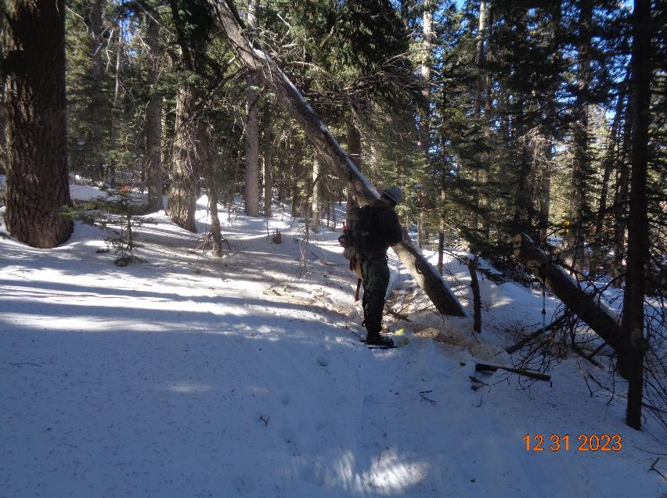

Michael is making the second cut on the hang-up with his Husqvarna chain saw.

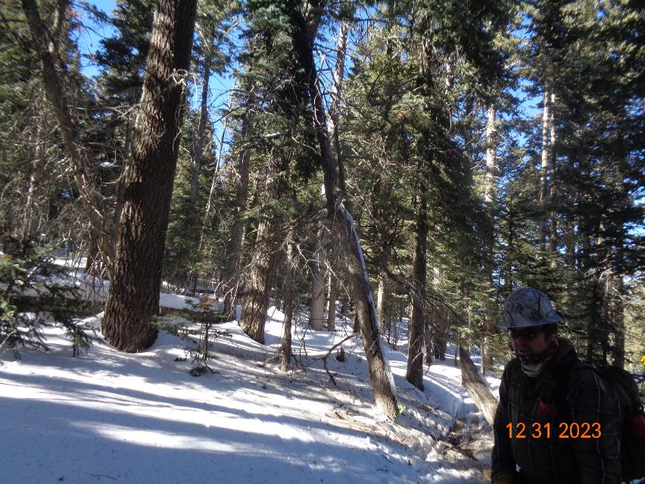

The hang-up is no longer over the trail.

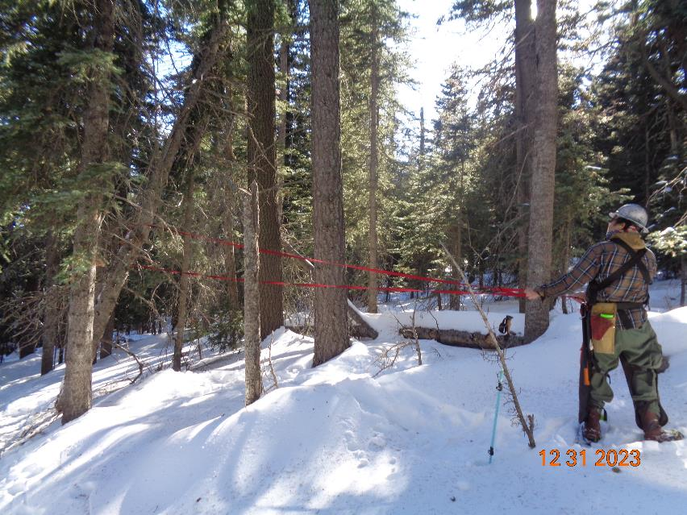

Michael is pulling the tree with a long strap, but it would not fall.

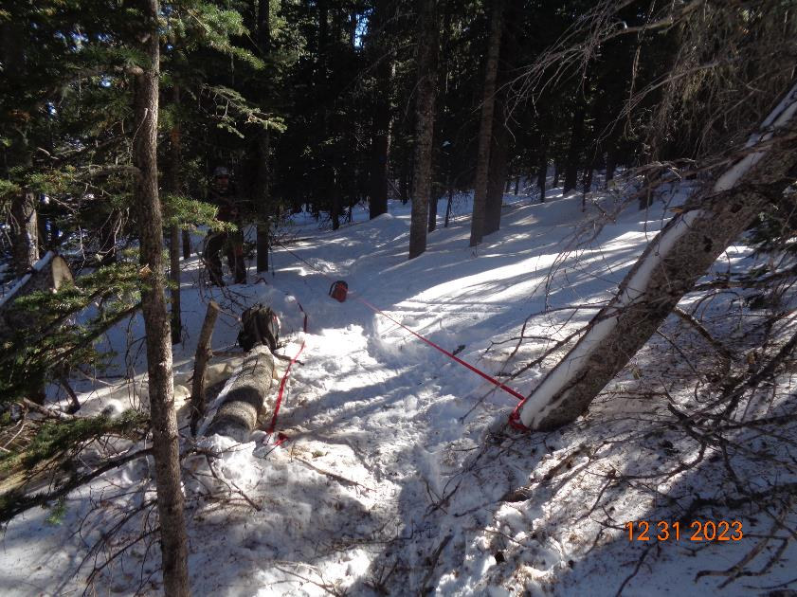

Michael could not move the lower end of the hang-up. The tree appeared to be stable, and we left it hanging on two adjacent trees.

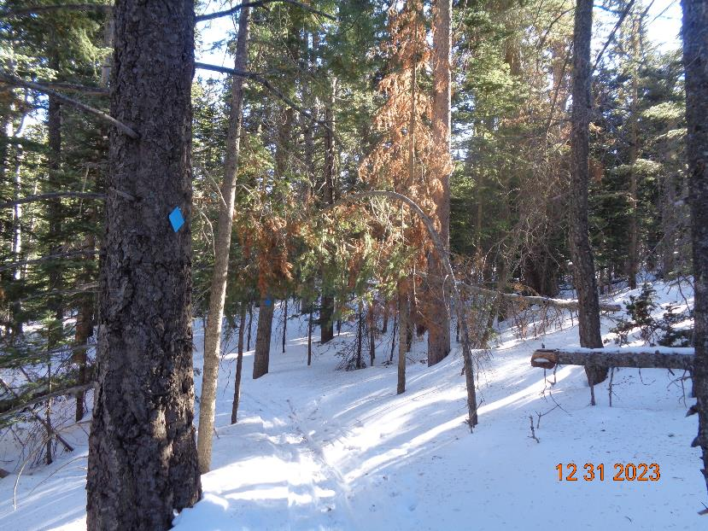

After lunch near the highway switchback, we found two small trees hanging over the trail.

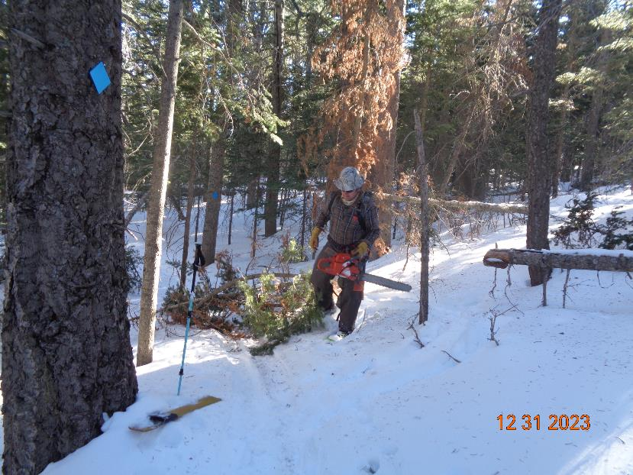

Michael cut these two small trees, and the branches were lying on the trail tread.

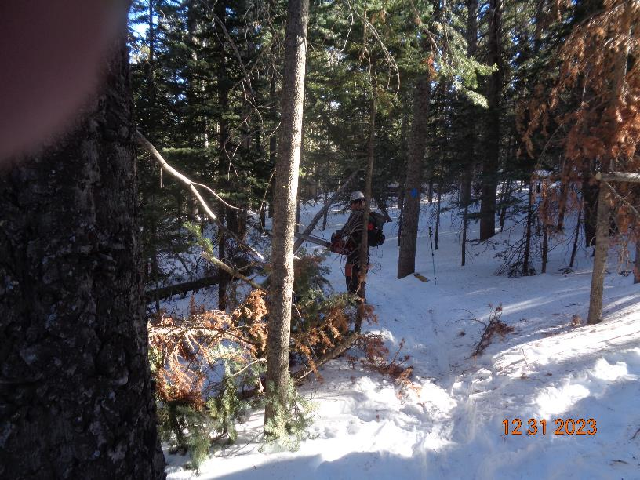

We removed the branches from the trail tread, and Michael is now cutting another small tree leaning over the trail.

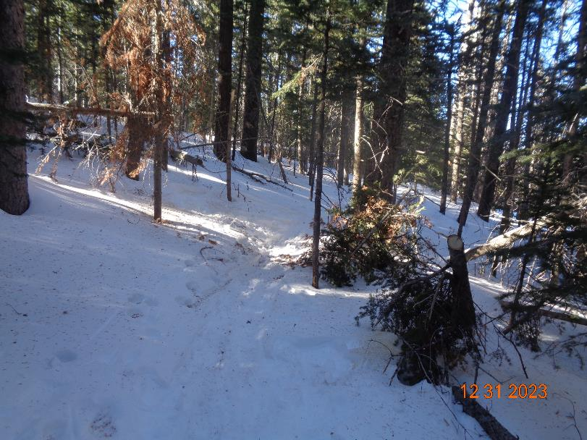

This part of the trail is now open.