**Report of the Ski Club Outing to the Redondo Campground Area**

**on Sunday, January 21, 2024**

Sam Beard

On Sunday, January 21, seven Ski Club members skied two trails in the Redondo Campground area. Originally, the outing was to ski to Redondo Meadow from NM-4 at the large curve west of the campground, but the location was changed to the campground in order to have better snow conditions. We parked at the San Diego Canyon Overlook parking lot and went to the trailhead across the highway. We had very light snow falling occasionally, and the temperature was near freezing. We skied the loop trail in the forest around the campground, had lunch at the highway, and skied Crater Spur Trail as far the log across the trail at the smaller crater. The Club members on the tour were John Griessen, Gale Borkenhagen, Eric Jeffries, Melinda Gonzalez-Hibner, David Torney, Michael Arndt, and Sam Beard.

The six hydrothermal craters in the Redondo CG area were created by the explosive interaction of ground water with magma below the cooled lava from the Banco Bonito vent about 40,000 years ago.

Pictures of the outing are presented below.

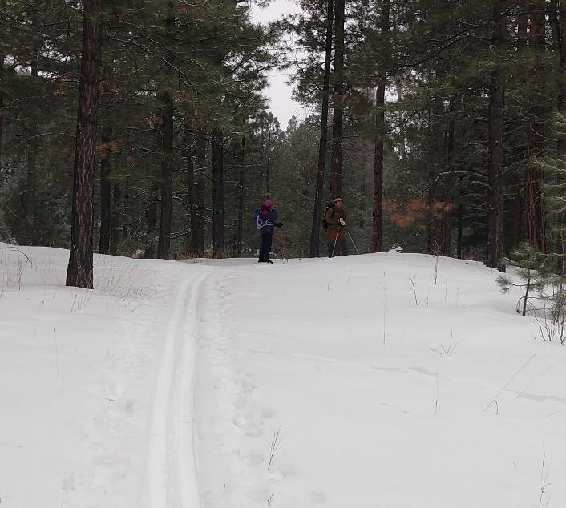

Gale Borkenhagen and Michael Arndt on the Redondo Loop Trail. Photo by John Griesse

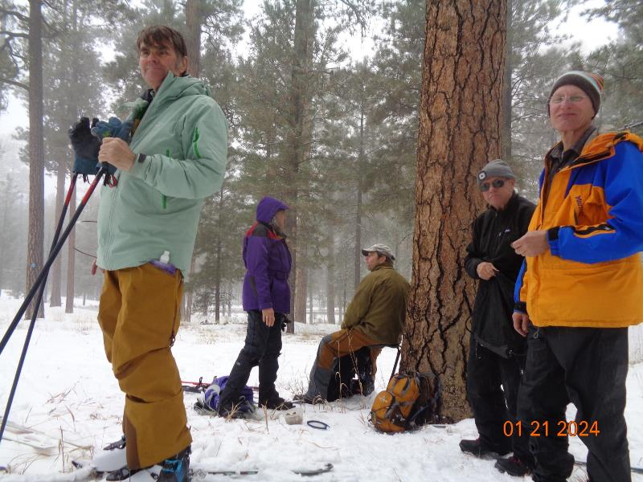

Skiers at junction of Redondo Loop Trail and Crater Spur Trail after lunch. L to R: David Torney, Gale Borkenhagen,

Michael Arndt, Eric Jeffries, and John Griessen. Photo by Sam Beard

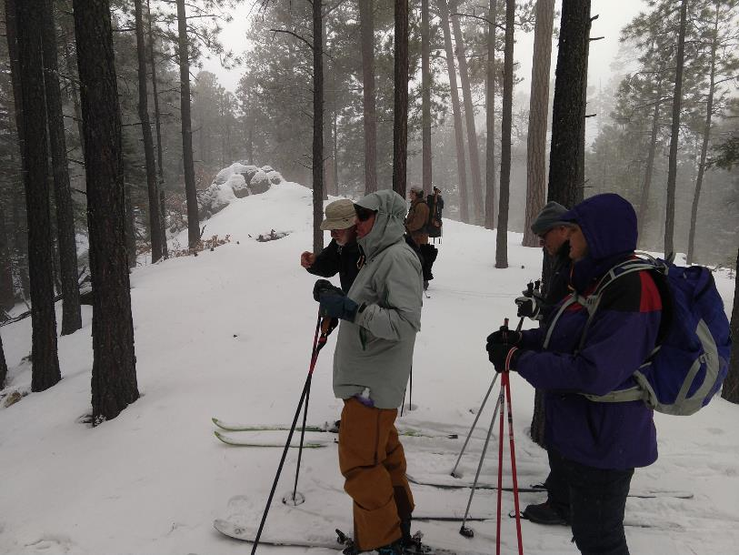

Skiers on the north rim of the large crater on Crater Spur Trail. L to R: Sam Beard, David Torney, Michael Arndt, Eric Jeffries,

and Gale Borkenhagen. Photo by John Griessen

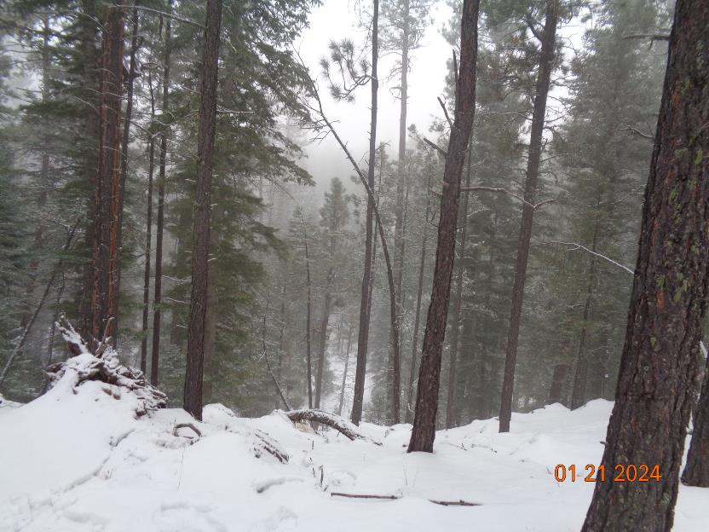

Looking down at the bottom of the large hydrothermal explosion crater and across to other side in the fog. Photo by Sam Beard

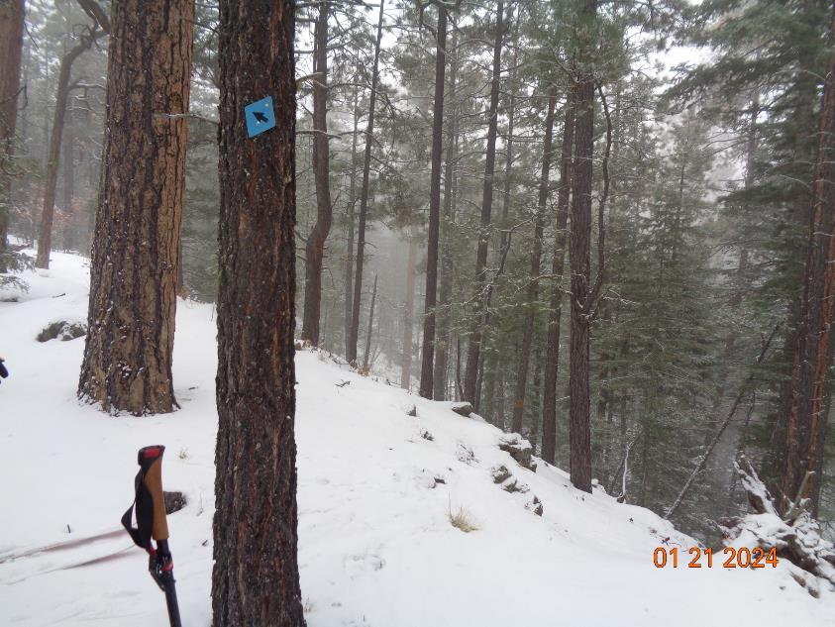

Interior slope of large crater to the left of the overlook. Photo by Sam Beard

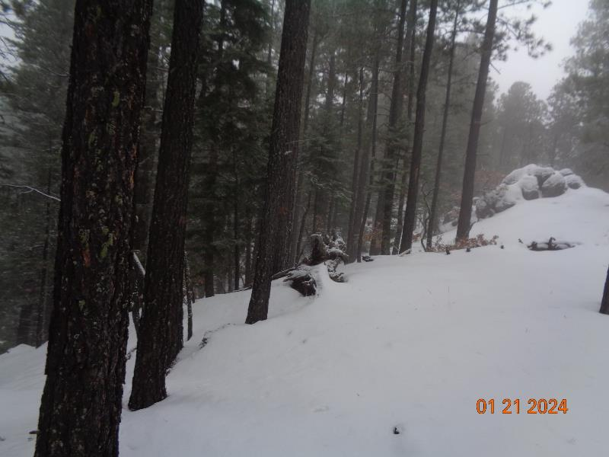

Interior slope of crater to the right of the overlook. Photo by Sam Beard

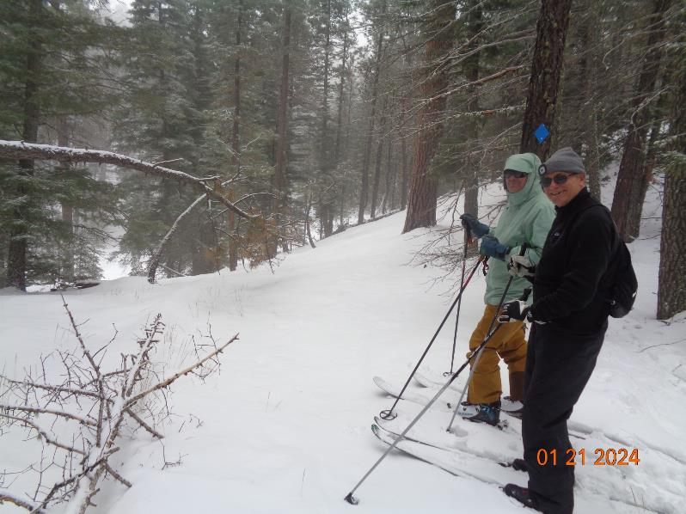

David Torney and Eric Jeffries at the small crater on the Crater Spur Trail. The log on the crater interior wall is

across the trail to the right of David. Photo by Sam Beard