**Report of Ski Club Outing to the East Fork East Loop Trail**

**in the Jemez Mountains, Sunday, January 28, 2024**

Sam Beard

On Sunday, January 28, Michael Arndt and Sam Beard led a group of 14 skiers on a tour of the East Fork East Loop. From Los Griegos parking lot, the group hiked a short distance east on NM-4 and skied up Burn Trail to the turn to the right that leads to the saddle west of the loop. After skiing clockwise around the loop with excellent powder snow on the north side and having lunch at the overlook, they skied west on the East Fork Ridge Trail. At the junction with Mistletoe Canyon Trail, they skied to the south on a ridge where they climbed over a fence and hiked to the cars. The weather was sunny and relatively warm. The snow varied from about 24 inches deep to an inch or two in the sun under thick tree canopies.

The skiers were David Williams, Janis Whitfield, Amy Mathis, Phyllis Pryor, Catherine Waters, Holly Noland, Nancy Shane, Mary K. Gallagher, Kristen Little, Peter Gowen, Diane Marasciulo, Pam Reynolds, Michael Arndt, and Sam Beard.

Outing photographs are presented below.

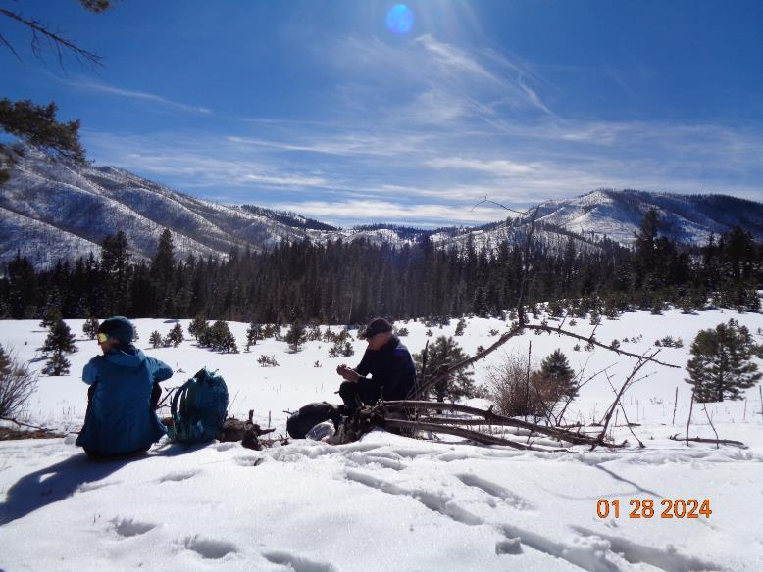

Two skiers eating lunch with Los Griegos Mountain in the background on the right. The open area in the

center of the picture was the location of a pumice mine several years ago.

Photo by Sam Beard

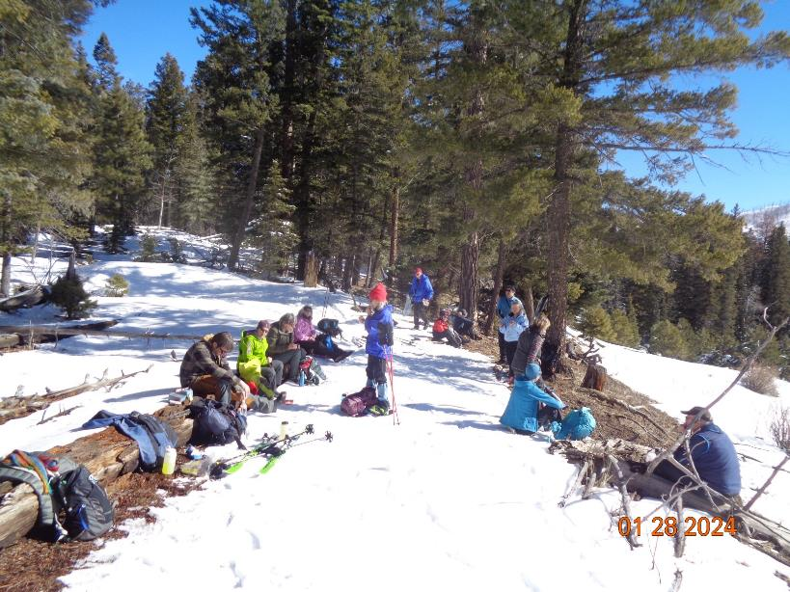

The group having lunch where the Loop Trail overlooks the former pumice mine.

Photo by Sam Beard

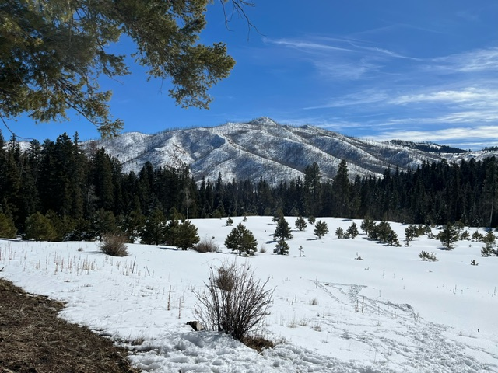

Las Conchas Ridge on the south side of NM-4. Many years ago, the Club would ski a trail

around this ridge from Peralta Canyon to Los Griegos Mountain. Photo by Amy Mathis

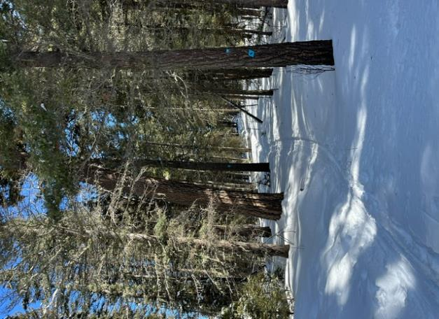

An easy part of the East Fork Ridge Trail.

Photo by Amy Mathis

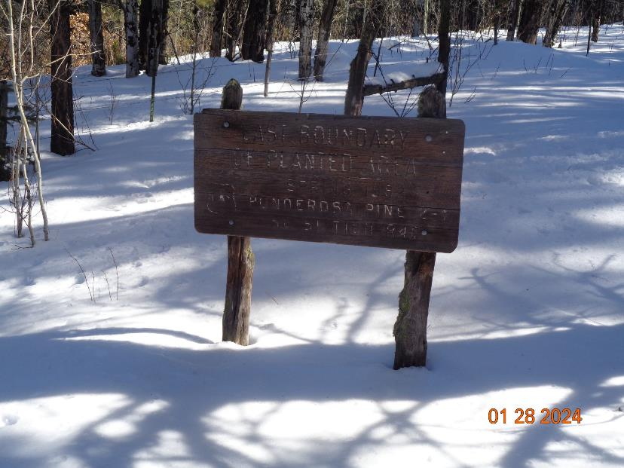

Sign states: East Boundary of Planted Area, Spring 1982, Ponderosa Pine.

The text on this sign marks the east side of a burned area where trees were later planted. Photo by Sam Beard

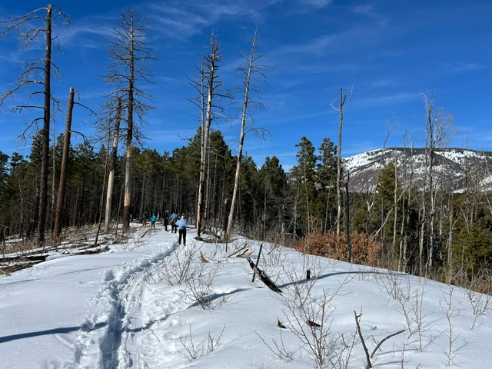

Skiing through an area that burned several years ago. Redondo Peak is on the right.

Photo by Amy Mathis

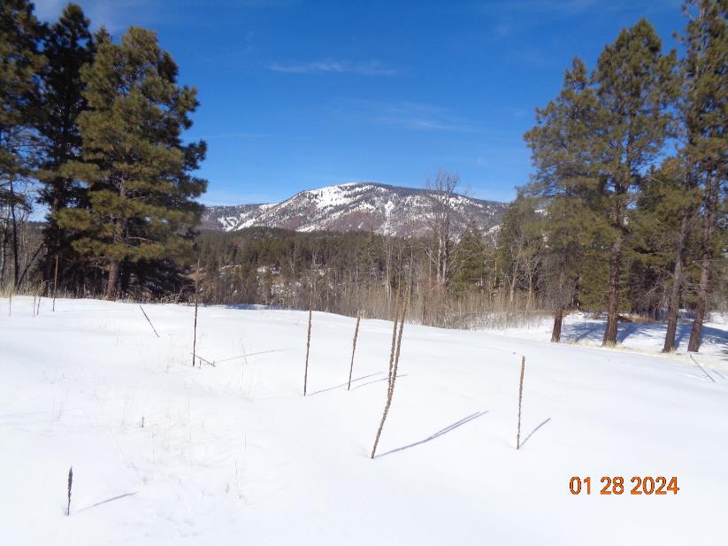

Redondo Peak is a resurgent dome that formed after the Valles Caldera eruption 1.25 million years ago.

The elevation of the peak is 11,254 feet. Photo by Sam Beard

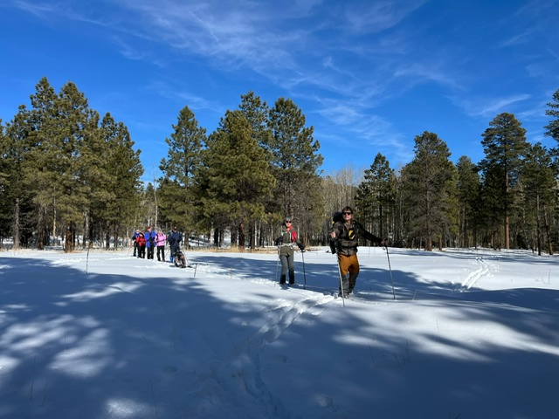

Michael is leading his group toward the highway from the meadow at the junction of the Ridge Trail

with Mistletoe Canyon Trail. Photo by Amy Mathis

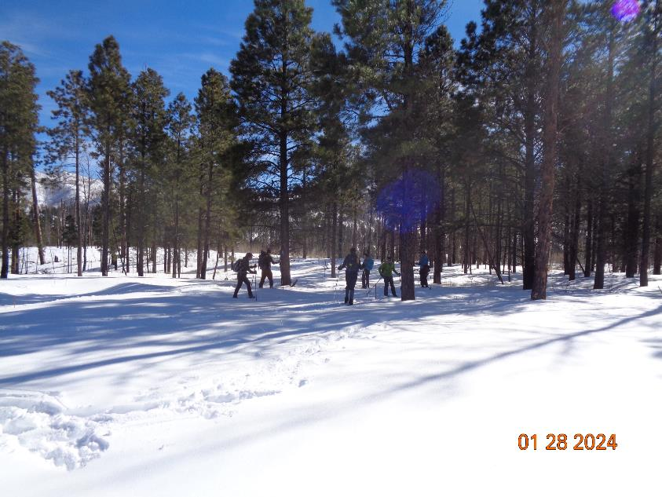

Other skiers preparing to ski to the highway from the meadow. Photo by Sam Beard