**Report of Ski Club Outing to Corral Canyon Trail in the Jemez Mountains**

**on Sunday, February 4, 2024**

Sam Beard

On Sunday, February 4, Michael Arndt and Sam Beard led a Ski Club outing to the Corral Canyon area in the Jemez Mountains. The first half-mile of the tour was very firm wind slab that was difficult to ski. The snow on the remainder of the route was mixed with some crust and some soft snow. The total length of the tour was about 4 miles, and the elevation change was 810 feet.

From the trailhead we skied up Corral Canyon to Junction Meadow, crossed the Forest Service Road and skied up to Forest Road 282. From here we skied to the west to an overlook with a view of the Sandia Mountains where we had lunch. We then skied down the north side of the ridge and around to Tee Intersection of FR-280 and FR-282. The route back to the highway was along FR-280 (Peralta Canyon Road).

The ten members on the outing were Ken Baugh, Jim Whitfield, Perrianne Houghton, Phyllis Pryor, Mary K. Gallagher, Michael Arndt, David Torney, Joe Kobliska, Dana Price, and Sam Beard.

Photographs of the tour are presented below.

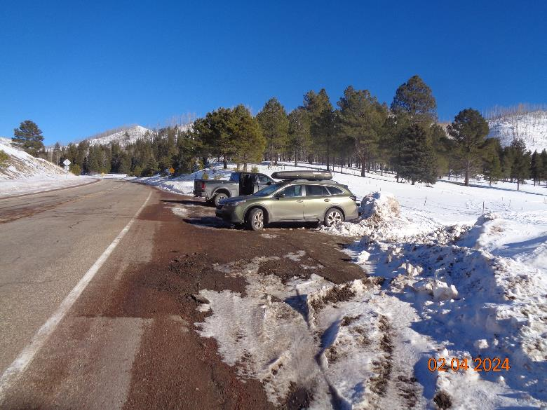

Corral Canyon Trailhead parking lot. Photo by Sam Beard

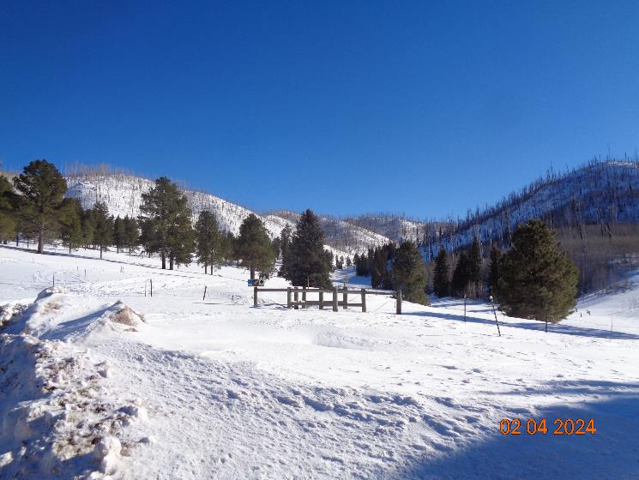

Looking up Corral Canyon from the parking lot. We had about 24 inches of snow and could step over the fence. Photo by Sam Beard

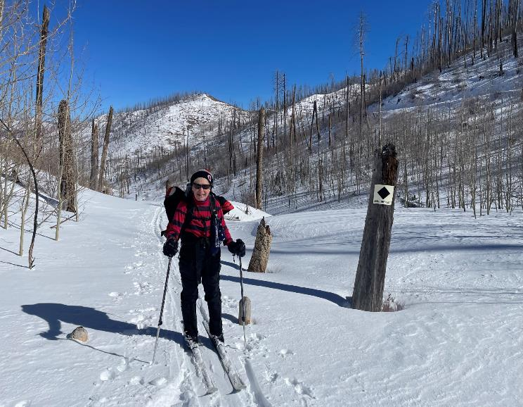

Phyllis Pryor skiing down Forest Road 280. Photo by David Torney

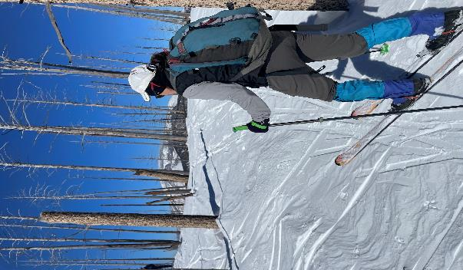

Dana Price skiing up on the packed snow. Photo by David Torney

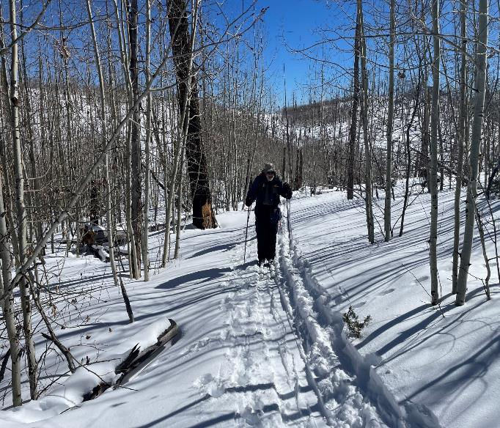

Sam Beard skiing toward the overlook where the skiers ate lunch. Photo by David Torney

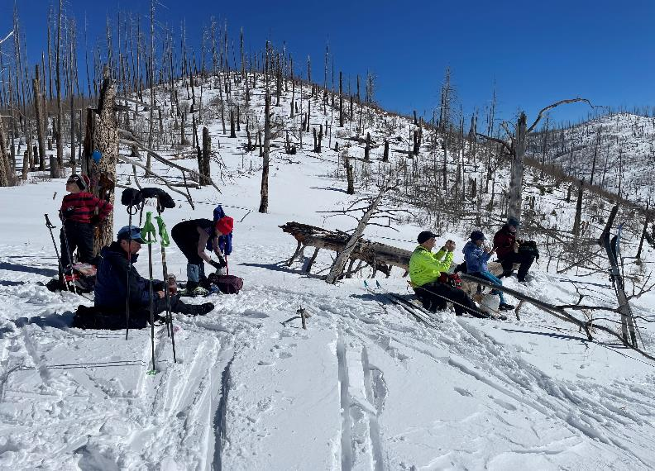

Skiers eating lunch on the ridge overlooking Peralta Canyon. Photo by David Torney.

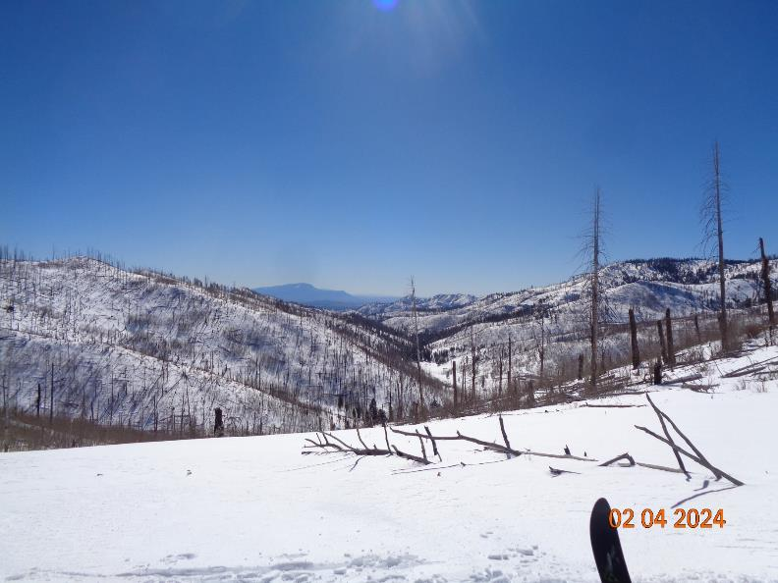

Looking down Peralta Canyon to the Sandia Mountains in the distance. Photo by Sam Beard

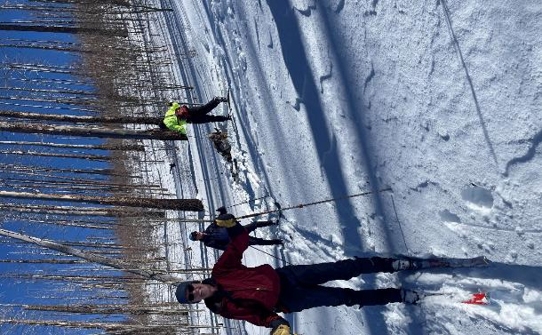

Skiers making the turn after skiing down the north side of the ridge where we had lunch.

Photo by David Torney

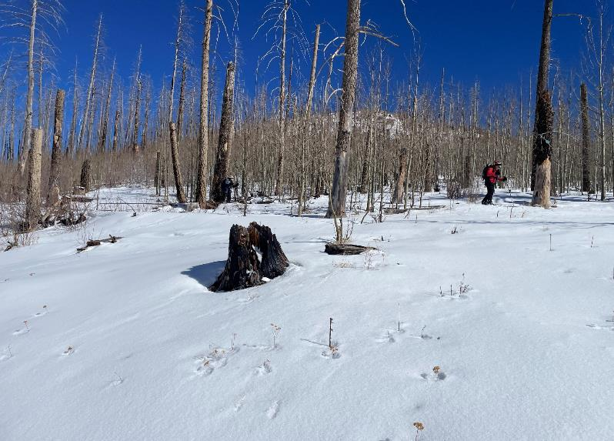

Phyllis Pryor skiing past a grove of young aspens at Tee Intersection. Photo by David Torney

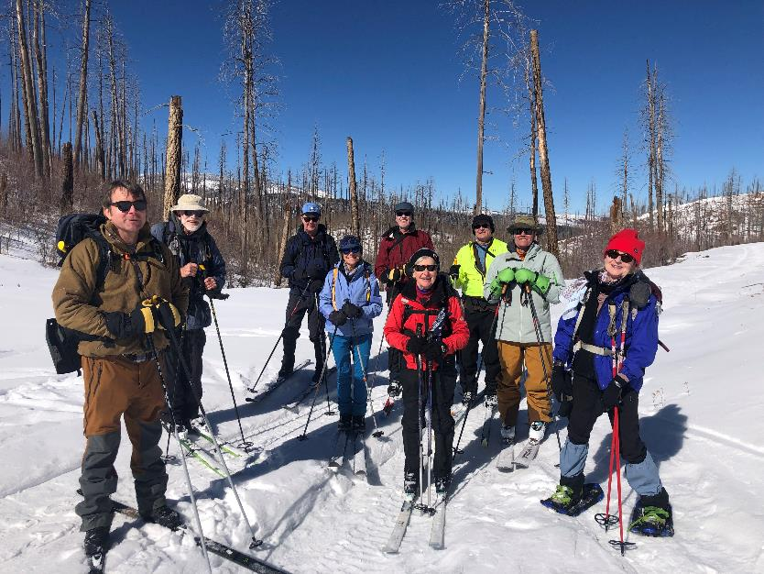

Ski Club members at Tee Intersection on Forest Road 280. L to R: Michael Arndt, Sam Beard, Ken Baugh,

Perrianne Houghton, Joe Kobliska, Phyllis Pryor, Jim Whitfield, David Torney, and Mary K. Gallagher. Photo by Dana P

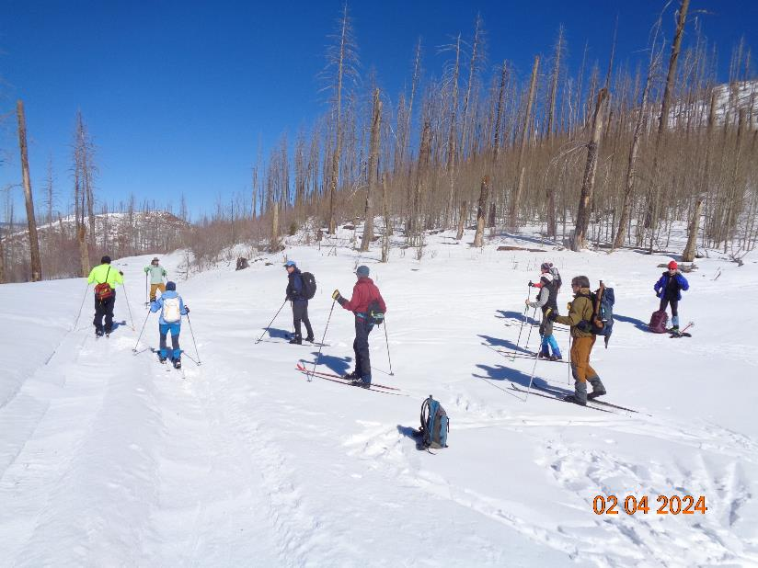

Skiers at Tee Intersection ready to ski down Forest Road 280 to the highway. Photo by Sam Beard

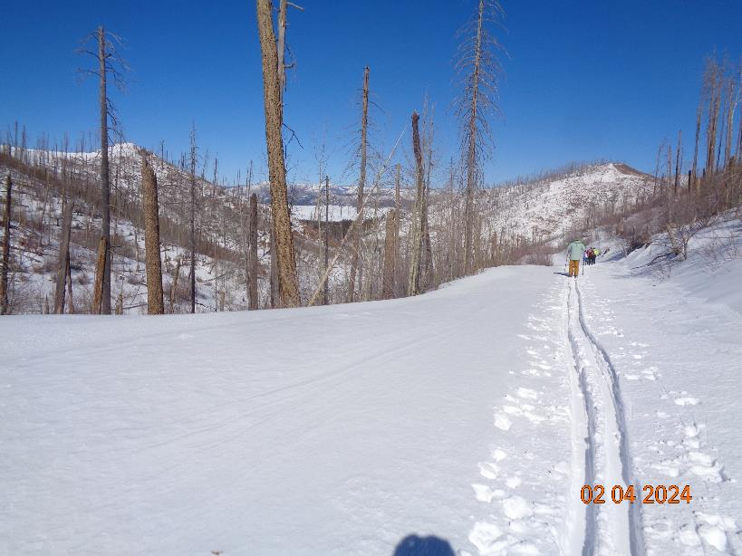

Looking down the canyon toward Valle Grande with skiers on the road to the highway. Photo by Sam Beard

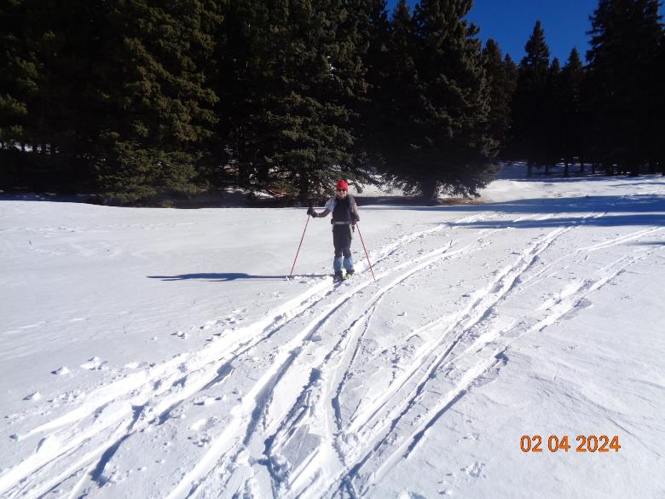

Mary K. Gallagher snowshoeing across a meadow to the highway. Photo by Sam Beard

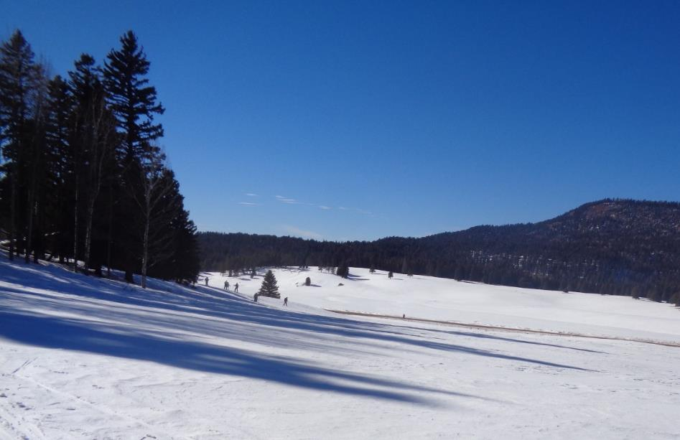

Skiers at the west end of the meadow just south of the highway (the thin brown line across the center of the picture). Photo by Sam Beard