**Report of Ski Club Outing to Valles Caldera National Preserve on Sunday, February 25**

Sam Beard

On Sunday, February 25, eleven Club members skied in the west end of Valle Grande on the Valles Caldera National Preserve in the Jemez Mountains. We had originally planned to ski to the east end of Valle Grande from the Coyote Call trailhead, but the snow was too crusty to descend safely into the valley at this location. We decided to drive to the National Park Service Check-In Station at the west end of Valle Grande. We then skied to the southwest past small La Jara Mountain toward South Mountain Trailhead.

Michael Arndt led the “fast” group of eight skiers almost to South Mountain Trailhead where they had lunch. They returned to the Check-In Station by the route past the east end of South Mountain and La Jara Mountain. Sam Beard led a group of three “slower” skiers who skied to the valley north of South Mountain and then turned to the west and went to a road leading to the cabin area. Here they waited until Michael gave them a ride back to the Check-In Station in his pickup.

Everyone enjoyed the skiing in very warm conditions. We saw several snowshoers but only one other skier.

The skiers on the outing were Alan Shapiro, David Torney, Lena Patterson, Sam Beard, Michael Arndt, Chris Gwin, Lisa Chai, Mike Gaffney, Phyllis Pryor, Matt McBatra, and Irene Walkiw.

Photos taken during the outing are presented below.

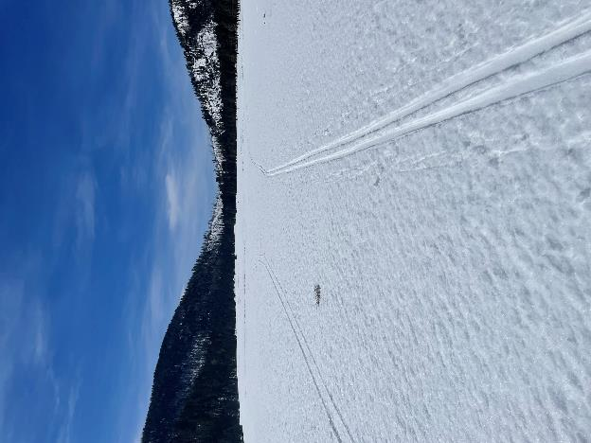

Skiing toward South Mountain Trailhead southwest of the Check-In Station.

All photos by David Torney

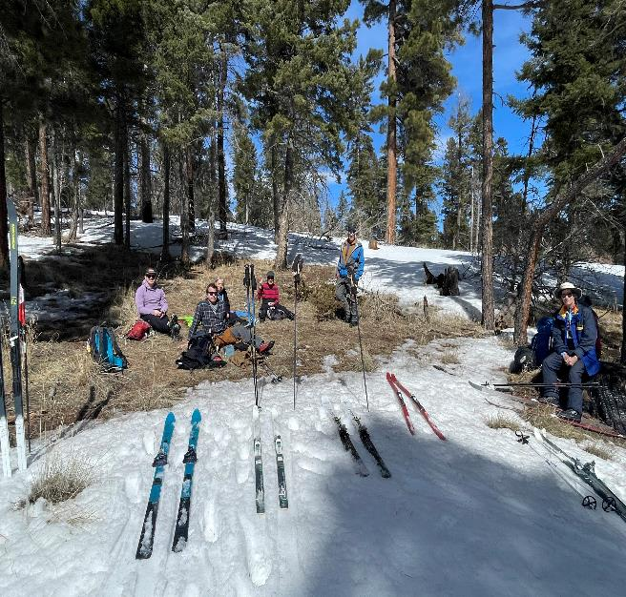

Michael Arndt’s group having lunch on a sunny slope near South Mountain.

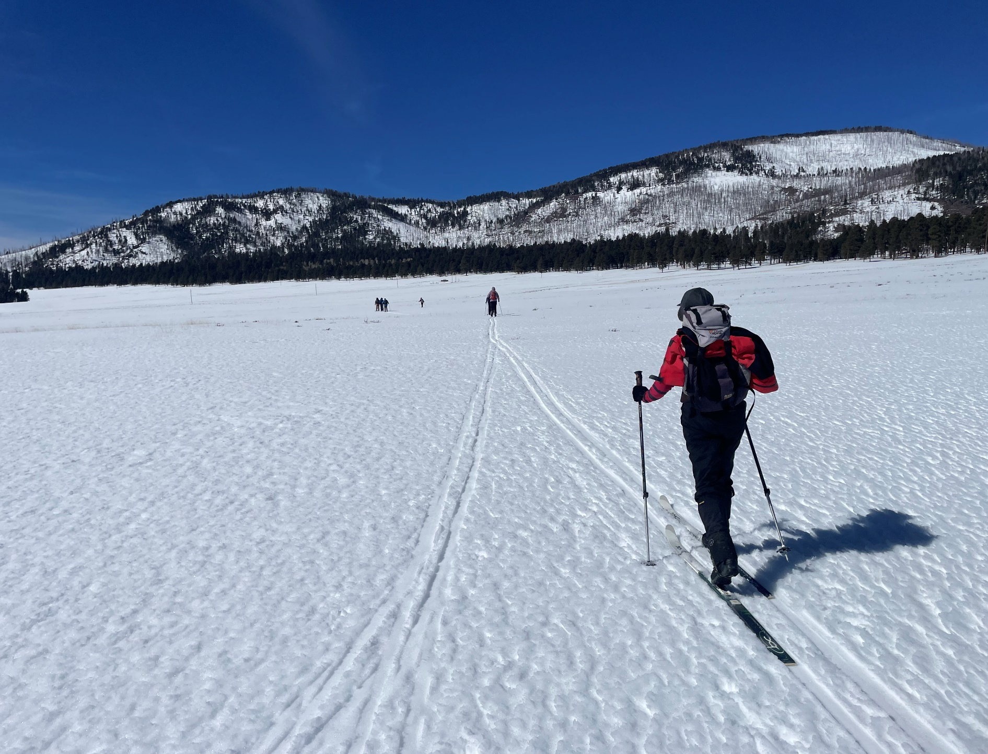

Skiing back to the Check-In station in the afternoon.

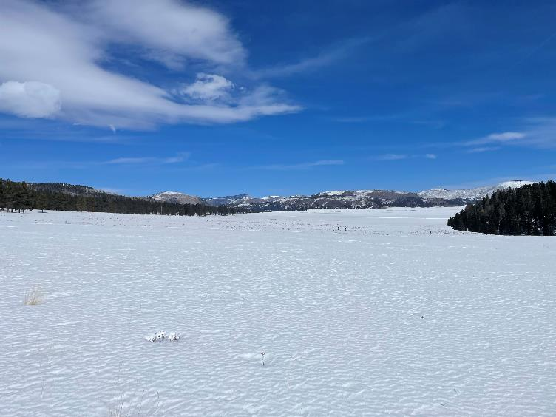

West end of Valle Grande on the return trip.

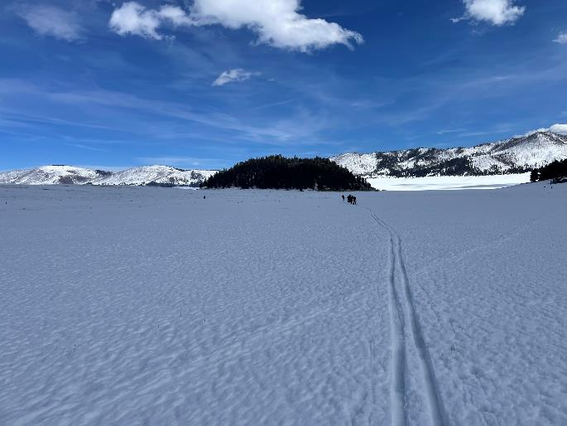

Skiers approaching La Jara Mountain with the east rim of the caldera in the back ground.

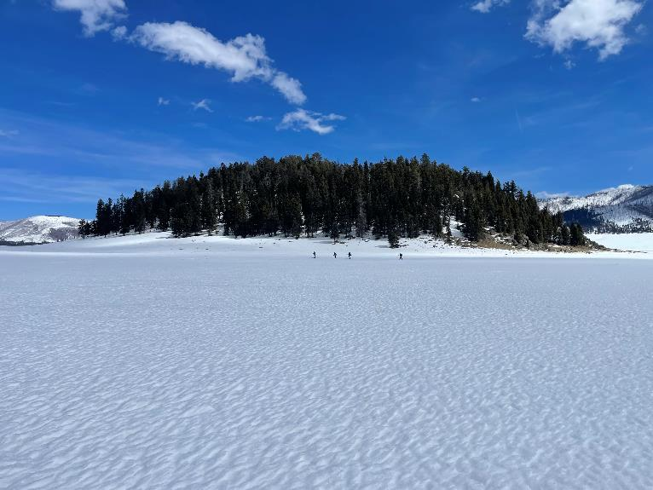

Another view of La Jara Mountain. The Check-In Station is at the left end of this small mountain, one of seven volcanoes

that erupted along the caldera ring fracture after the Redondo Peak resurgent dome was formed.