**Report of Maintenance of East Fork Trails in the Jemez Mountains**

**by Ski Club Members on Friday, October 18**

Sam Beard

On Friday, October 18, Michael Arndt, Scott Christenson, and Sam Beard performed annual maintenance on two trails in the East Fork Area of the Jemez Mountains. After parking at the Los Griegos Mountain trailhead, the crew hiked a few hundred feet to the east along NM-4 to the Las Conchas Burn Trailhead. They hiked up this trail and removed several logs before reaching East Fork Ridge Trail. They removed several more logs as they hiked to the saddle at the west end of the East Fork Loop Trail. After deciding that there was not enough time to work on the Loop Trail, they hiked out on the short connecting trail leading back to the Burn Trail. A total of 32 logs were removed from the trails with the largest log having a diameter of 17 inches.

Project photos are presented below.

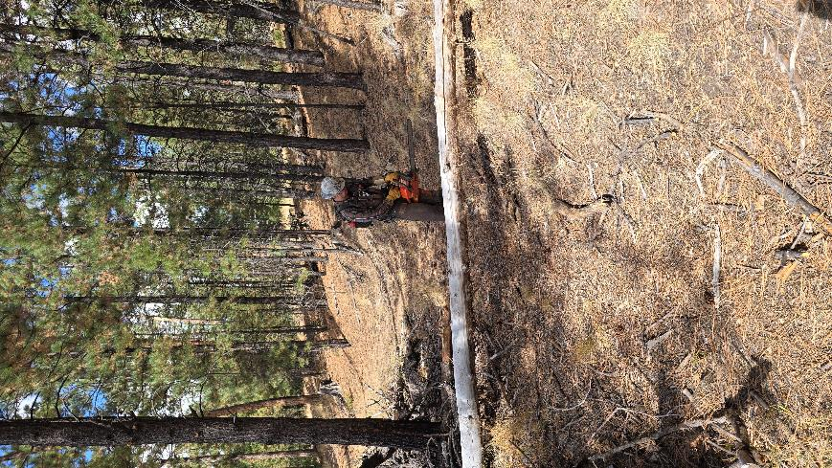

Michael Arndt preparing to cut a small log.

All photos by Scott Christenson unless noted otherwise

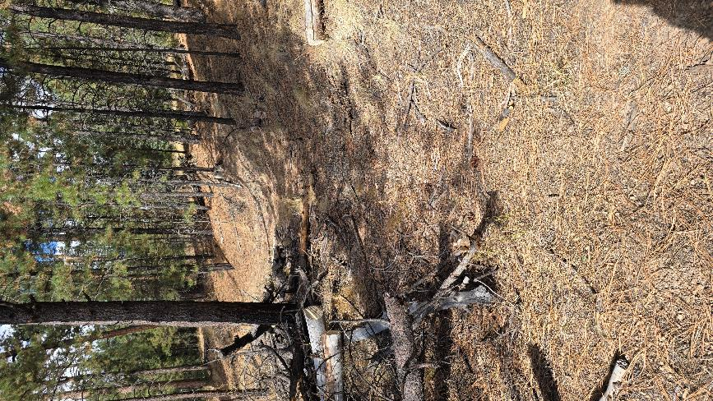

The log has been removed, and the trail is clear.

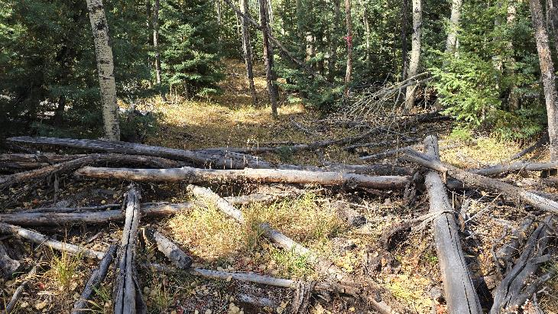

Many logs across Las Conchas Burn Trail not far below East Fork Ridge Trail.

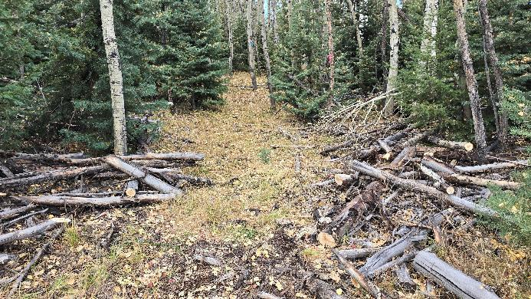

The logs have been removed, and the trail is ready to be skied after snow has fallen

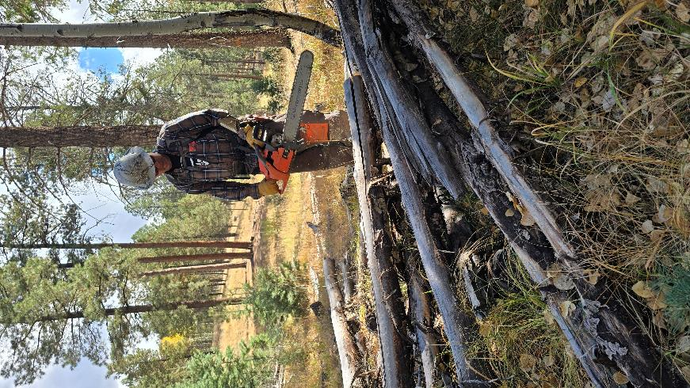

Michael preparing to cut another pile of small logs.

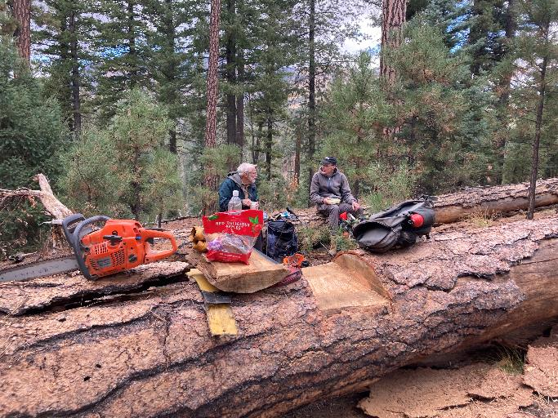

Sam Beard and Scott Christenson eating lunch in the East Fork area.

Michael cut the seat in the large log.

Photo by Michael Arndt

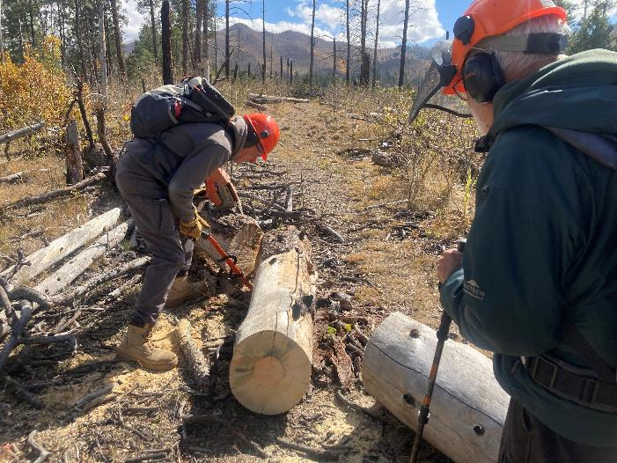

Scott using a short cant hook to roll a cut log off the East Fork Ridge Trail.

Photo by Michael Arndt