**Report of Removal of Down Trees on a Jemez Logging Road**

**with Very Hard Crusty Snow Conditions on Sunday, January 5, 2025**

Sam Beard

On Sunday, January 5, Michael Arndt and I hiked about 4 hours on very hard crusty snow and grass on three logging roads that we enjoy skiing. We removed the three logs shown in the photos below using a couple of crosscut saws. The longer saw was 42 inches long with a perforated lance teeth pattern, one of the last tooth patterns in crosscut saws before chain saws became popular. The other 36-inch saw had teeth that were only about one-half long, because it was an old saw with teeth that had been sharpened many times. We did not see anyone hiking or trying to ski on the crust and grass.

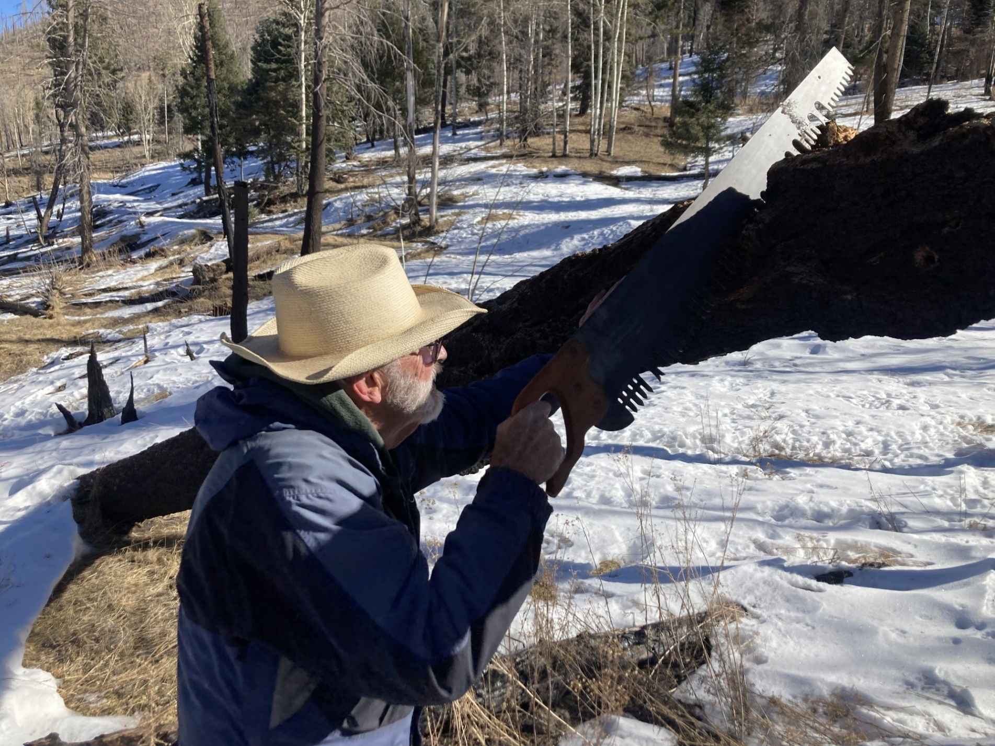

I am wearing Michael’s hat in an effort to shade my eyes, because I was looking directly into the sun when I was trying to cut this burned log.

All photos by Michael Arndt

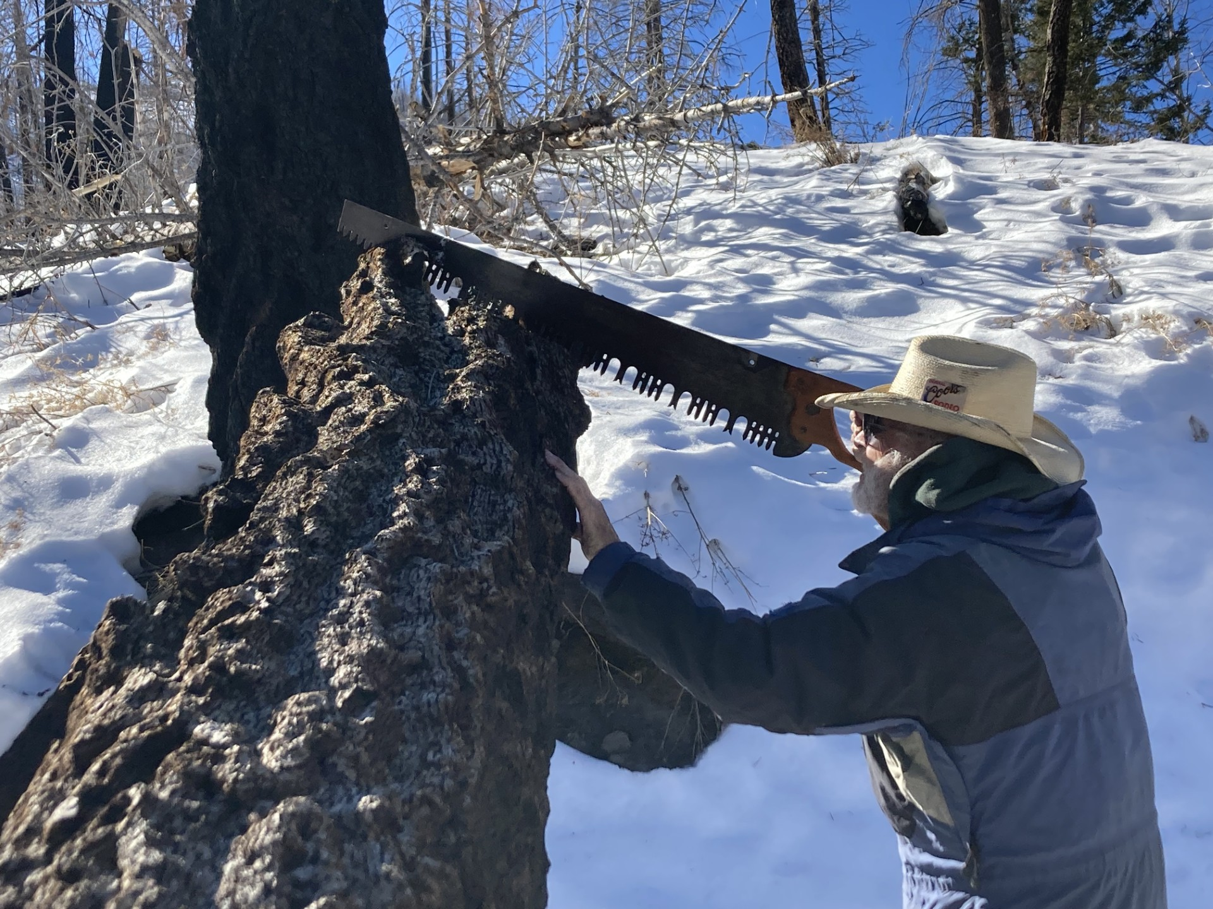

This photo shows the perforated lance tooth pattern on this saw very well. Michael completed cutting the end off this log so that we

would not have to duck under it.

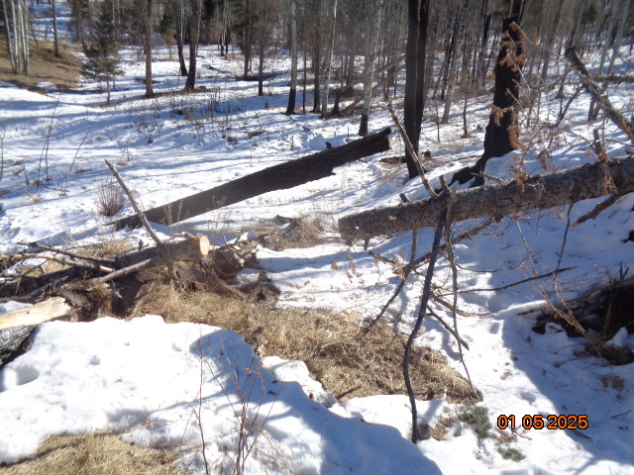

Michael had earlier cut the small log so that we would not have to go under it. The larger burned log is in the background.

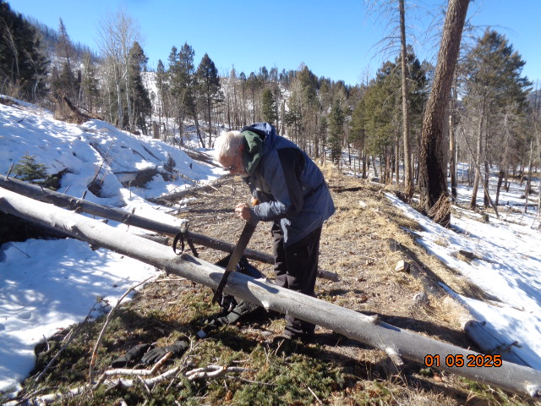

Sam is using the old saw with very short teeth to cut this small log across the trail.

The snow had melted on places where the sun had been shining directly on the snow.